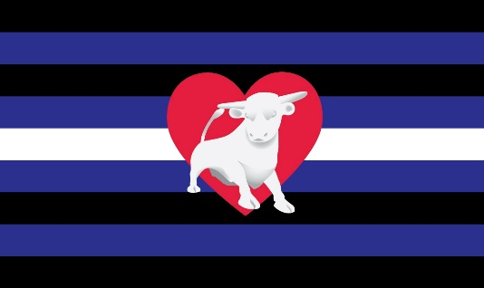

**Heart of England Leather**

**Code of Conduct**

We believe that our events and online spaces should be free from harassment, bullying and hate. We are dedicated to providing a harassment-free experience for everyone, regardless of gender, gender identity and expression, sexual orientation, disability, neurotype, physical appearance, age, race, ethnicity, nationality, socio-economic status, language, religion or any other characteristic. It is our priority that everyone has fun, within a safe space. Everyone who participates at HEL has a responsibility to help us create a safe space and must agree to our code of conduct. This includes all attendees, organisers and volunteers.

Unacceptable behaviour includes (but is not limited to):

* Unwelcome sexual attention or physical contact (wearing gear does not equal consent)
* Deliberate intimidation, bullying, harassment
* Stalking and/or following
* Offensive verbal comments
* Violence and/or threats of violence
* Promoting extreme, offensive political views, either visually or verbally
* Other behaviour deemed inappropriate, offensive, threatening or harmful.
* Instigating or encouraging any of the behaviours set out above is also unacceptable

A note on symbology from hate groups:   
As above, the promotion of any extreme, offensive political views are not tolerated by this group and they have no place at any of our events. We define hate symbology as a recognised item included in the Anti-Defamation League’s [Hate Symbols Database](https://www.adl.org/resources/hate-symbols/search). The group uses the database as a resource only but adopts its view that some symbols (e.g. Norse iconography, numeric symbols, etc) need to be considered within a certain context.

How to report an incident/concern : If you believe you’re experiencing unacceptable behaviour as outlined in the code of conduct, or you observe a potentially dangerous situation, someone in distress, or violations of these guidelines, even if the situation is not happening to you; please speak to an organiser (they will be wearing a HEL Lanyard and will be visible) or in case of online spaces, they are identified as admin (for example on Facebook, right click and report to admin)

We can only have a safe space with your help. Thank You - 'Team H.E.L.'