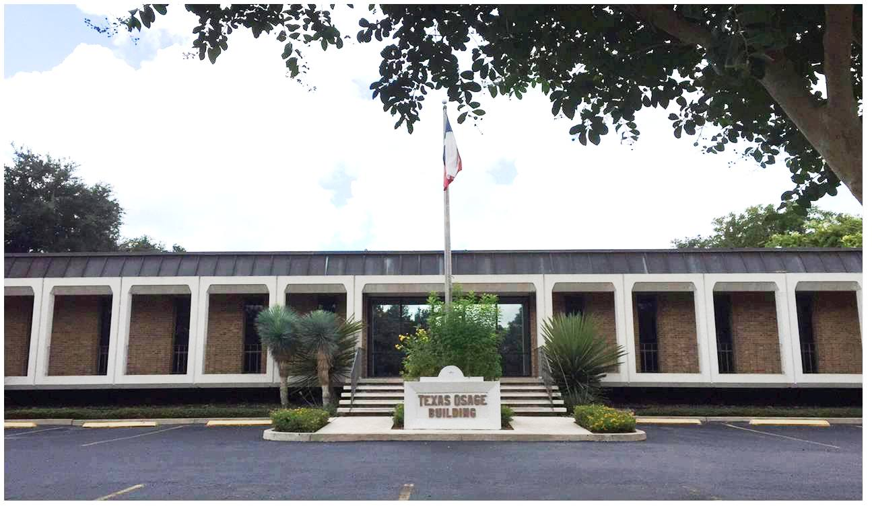

Leasing

To discuss leasing our minerals, or if you have questions regarding our interests, please contact:

James A. Cauthorn
President

or

Angela J. Ramirez
Registered Landman

(210) 223-1111

