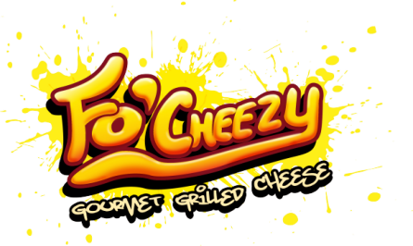
Grilled Cheese Sandwiches and Hot Dogs
Fo’Cheezy – Our namesake. Ain't nothing regular about it! Made with real cheddar and mozzarella cheeses- 7
Fo’Bacon - 3 strips of bacon, cheddar and mozzarella cheeses - 11
Fo'Mac – Greatness of a Grilled Cheese and Mac n’ Cheese all in one - 10
Make it a Bacon Mac grilled cheese for 3 bucks more. Staff fav!
Fo'SpinDip - Spinach, artichoke, onion, sweet pepper and asiago all shredded together with cream and mozzarella cheeses - 10
Fo’Shroom Melt- 3 kinds of Mushroom, spring onion, sundried tomatoes, mozzarella with a zest of lemon - 10
Fo'Popper - Roasted Jalapenos, cream cheese, mozzarella cheese, sweet corn, spring onion. Tasty, Spicy and Messy! (You've been warned) - 10
Fo' Chic Pesto - Pulled chicken, basil, sundried tomato & mozzarella - 12
Fo’ABC – Our signature sandwich - Apple Butter, Bacon, Cheddar - 12
GF bread and non-dairy cheese available
Viking Dog Nordic style - Pretzel bun - 11" hotdog - condiments - 11
Lil' Dog - kids hotdog - white bun - choice of condiments - 7
Fo' Dog - 11" wiener with a grilled cheese sandwich as the bun - 11
Piggies in Blanket - 11" wiener - bacon - cheese - grilled tortilla - 12
Roasted Red Pepper and Tomato Soup - 5

