**[](https://www.MedicareStop.com) A to Z Medicare CHECKLIST** Created by…

We provide a FREE (1) page step-by-step checklist of everything you will need to know, and how to apply for all of the following:

* Medicare Parts A & B
* Medicare Supplements Visit Our Website Today!
* (MAPD) Medicare Advantage [www.MedicareSTOP.com](http://www.MedicareSTOP.com)
* Part D Prescription D
* And Much More!

NOTE: Part A (Hospital Insurance) is FREE.  
 Part B (Medical Insurance) will cost approximately $144.60/month

“Aging in?” (AKA turning 65 soon?) You can start the process as soon as 3 months before your 65th birthday for a Guaranteed Issue policy.

We make it easy for our clients! Helping all of CA since 1998.

**Thanks for using MedicareSTOP.com – If you have any questions, contact us anytime at 949-709-5998**

1. Apply for Part A and Part B:
2. CALL Social Securityat **(800) 772-1213** (M-F 7am – 7pm) or,
3. Apply Online:
4. Watch the 2 minute [**Welcome Video**](https://www.ssa.gov/hlp/video/iclaim_r01.htm)
5. Go to the [**Social Security Apply for Benefits**](https://secure.ssa.gov/iClaim/rib) page
6. Click “**Start a New Application**” under the Apply & Complete section  
     
   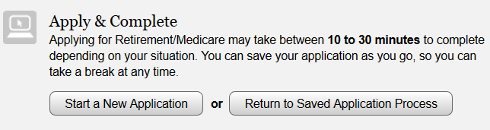
7. Create a ***my*** **Social Security** account to check the status of your completed application.  
   (Click Here): <https://www.ssa.gov/myaccount/>
8. Direct Link to Create a New Medicare Part A & B Online Application.  
   (Click Here): <https://secure.ssa.gov/RIL/>
9. Fill out our Online Medicare [**CONSULTATION**](https://medicarestop.com/consultation) Form at MedicareSTOP.com
10. Speak with one of our agents to review all of your options, and pick a plan with the best value based on your unique situation.
11. Complete our Medicare Online [**APPLICATION**](https://medicarestop.com/apply).
12. Your agent will prepare your application to sign / date, and help you submit it to the insurance carrier, or provide you instructions to print out a hard copy application.
13. We will follow up with you on the status of your application. If you would like to contact us, you can call or email us anytime for the status.
14. Visit our [**PART D**](https://medicarestop.com/part-d) Prescription Drug page and start the process.
15. We can help you select a Prescription Drug plan if necessary.
16. Look at Dental, Vision, and Life insurance options if you would like. Be sure to let us know.
17. Tell all of your family, friends, co-workers, and neighbors about your agent and the MedicareSTOP.com Team. If you are happy with our service, please take 2 minutes and complete our [**REFERRAL**](https://medicarestop.com/referral) Form.