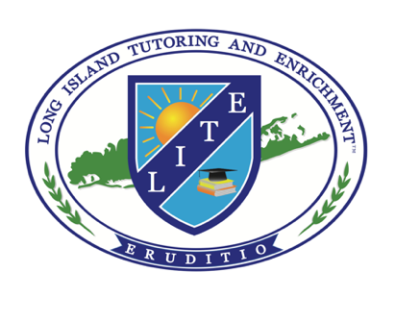

One-on-One College Essay Writing Assistance Registration Form

Date: ____________

Contact Information
Student’s Last: Student’s First: Middle Initial:

Home Address: City: State: ZIP:

Home Phone #:

Mother’s Name:

Father’s Name:

Student’s Cell Phone #:

Mother’s Cell Phone #:

Father’s Cell Phone #:

Student’s Email Address:

Mother’s Email Address:

Father’s Email Address:

Emergency Contact (Name/Phone #):

How did you hear about our program?

Academic Information
Student’s Home School:

School Address: City: State: ZIP:

Student’s Approximate GPA:

Does your child have an Individualized Education Program (IEP)?
If so, please indicate the student’s special needs.

Did your child take AP English Language, Literature, or another advanced English course?
If so, please indicate/estimate the grade for each.

Extra-curricular Activities:
List all clubs/teams/organizations, work/volunteer experience, positions held, etc.:

College Readiness
List all possible college/university choices (Please rank them in order of preference if possible):

Your tutor is: Paul Brower
When is the earliest date that the student can start his/her sessions?

Please indicate below which days of the week you prefer to meet with your tutor:

Fees
One-hour Writing Consultation: $175.00

Essay revision:
- More than 400 words: $200.00
- 400 words or less: $100.00

Common App Essay Writing Package: $350.00

Resume Writing Package: $600.00

Please complete the form and email it to LITE at
pbrower19@gmail.com

Or, you can mail your completed registration form to the address below:

Long Island Tutoring and Enrichment
c/o Paul Brower
931 Walt Whitman Road, 2nd floor
Melville, New York 11747

We will contact you after your registration is complete to discuss when your son/daughter will begin his/her sessions.
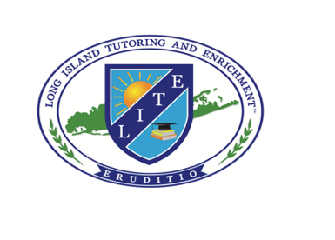
If you have any questions, feel free to contact us:
Paul Brower’s cell: (516) 317-0525
Paul Brower’s email: pbrower19@gmail.com

