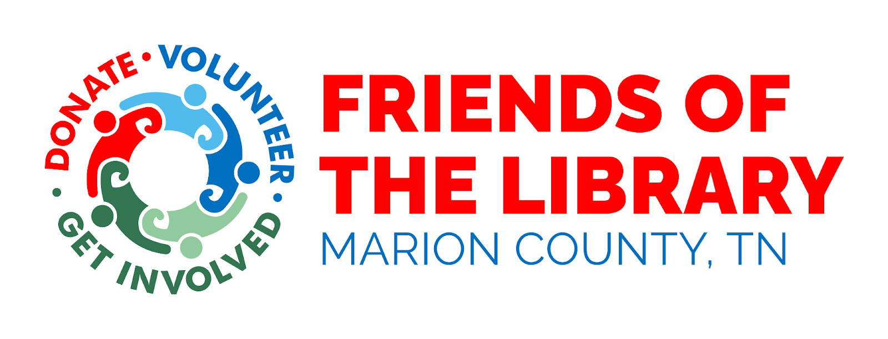
Who are we:
We are a non-profit volunteer organization working to further the goals of the Marion County Public Libraries. Working with the public library directors, we foster fellowship among persons interested in books and libraries and support the services of the libraries.
Our Mission:
Build awareness, appreciation and support for our county libraries through fundraising, volunteer services and advocacy.
When do we meet:
Once a year all members are invited to our General Meeting.
How to join:
Cut and fill out the membership form below, and mail it together with your fee to: Friends of the Library
Or, drop it off in our blue drop box at your library, in a sealed envelope. P.O. Box 72
Annual memberships renew every January. Jasper TN 3734

If you have any questions, send us an email to: info@friendsmclibraries.org

Marion county public libraries are a wonderful resource for the communities. Some of the programs our libraries offer are quilting, senior citizens, crafts, children’s story time, and summer reading. They also provide services like copies, fax, computers for public use, and others.

Carolyn Stewart Public Library 14 West 2nd. Street, Jasper TN 37347 ph. (423) 942-3369
Beene-Pearson Public Library 208 Elm Avenue, South Pittsburg TN 3738 ph. (423) 837-6513
Orena Humphreys Public Library 13535 TN HWY 28, Whitwell TN 37397 ph. (423) 658-6134

Support your local library, join us!!
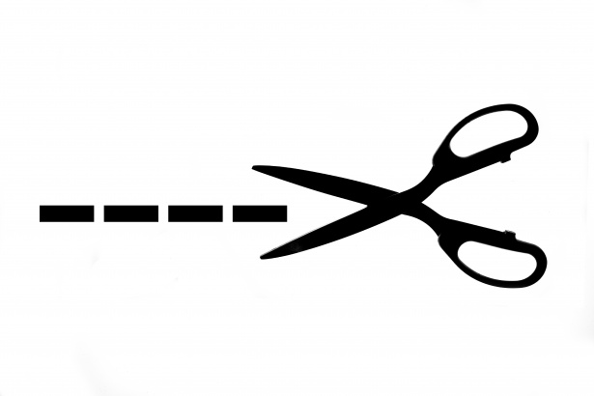
Cut here, keep the top part
_ __ _ _ _ _ _ _ _ _ _ _ _ _ _ _ _ _ _ _ _ _ _ _ _ _ _ _ _ _ _ _ _ _ _ _ _ _ _ _ _ _ _ _ _ _ _ _ _ _ _ _ _ _ _ _ _ _ _ _ _ _ _ _ _ _ _ _ _ _ _ _

Membership/Donation Form New: __ Renewal: __
Name: ___________________________________________________ Date: _____________
Address: _____________________________________________ City: ___________________

Cell Phone: ____________________________ Other Phone: ___________________________

Email Address: ________________________________________________________________
___ I would like to Volunteer: __ Occasionally __ Regular Basis Annual Membership
___ Individual $ 5
Volunteering Interests: ___ Family $ 10
___ Hospitality ___ Book Shelving ___ Business $ 50
___ Summer Reading Prog. ___ Fundraising ___ Lifetime $ 100
___ Children’s Activities ___ Book Sale ___ Donation $___________
___ Young Adults’ Activities ___ Publicity / Social Media

Any professional skills, talents or hobbies: (checks to: Friends of the Library)
_________________________________________________________________________________________
_________________________________________________________________________________________
Friends of the Library – Marion County, TN is a 501 (c)(3) nonprofit organization.

