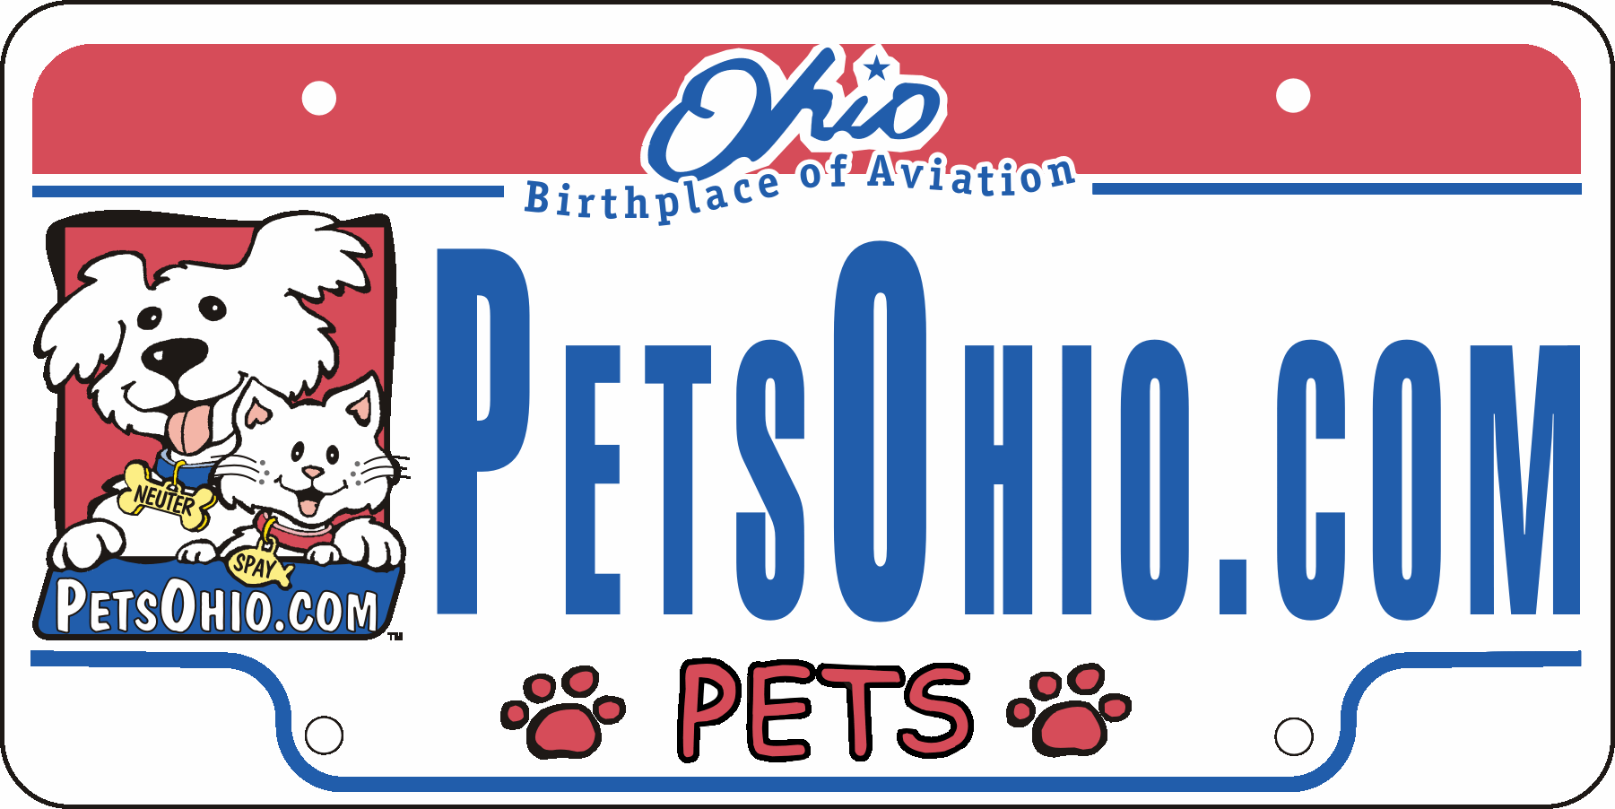

Ohio Pet Fund Grant Utilization Report

Organization Name:

Grant Amount:

Date of Grant:
Amount of Grant Money Used: __________________
Amount of Grant Money Unused & Returned: _______
- # of cats spayed with grant funds: ______
- # of cats neutered with grant funds: ______
- # of dogs spayed with grant funds: _____
- # of dogs neutered with grant funds: ____

Numbers of Animals/Owners qualifying per category:
______1 Number of dogs or cats sterilized but still awaiting adoption
______2 Number of feral cats sterilized and returned to managed colonies
______3 Certificate of adoption showing that the animal was obtained from a licensed animal shelter or pound.
______4 Certificate of adoption showing that the animal was obtained from a nonprofit corporation.
______5 Section 8 housing voucher
______6 Schedule letter from Ohio Works First
______7 Ohio Medicaid card
______8 Letter from Veteran Benefits Administration acknowledging service-related disability
______9 Ohio Direction Card (for food stamps)
_____10 WIC card (Women Infants and Children nutrition program)
_____11 Benefit letter documenting Supplemental Security Income
_____12 Benefit letter documenting assistance from Social Security Disability
_____13 Tax return showing owner’s family income does not exceed 150% of the Federal Poverty
Guidelines established by the United States Department of Health and Human Services.
_____14 Other evidence that the owner or pet qualify via Sec. 955.201(C)(1) of the Ohio Revised Code.

Documentation of individual surgeries does not need to be sent to the Ohio Pet Fund, and may be discarded after two years.
____ Check here if funds were granted for an education program pre-approved by the Ohio Pet Fund board; describe the use of funds for education on the back of the form.

Signature __________________________________________

Printed/Typed name _________________________________

Title _____________________________________________

Please return this completed form to the Ohio Pet Fund at:
The Ohio Pet Fund, 2280 Henderson Road, Suite 207, Columbus, Ohio 43220
or email it to Bertani@rrohio.com

If you need to request a time extension to utilize the grant money,
address a request to Dr. Leanne Bertani, Bertani@rrohio.com

