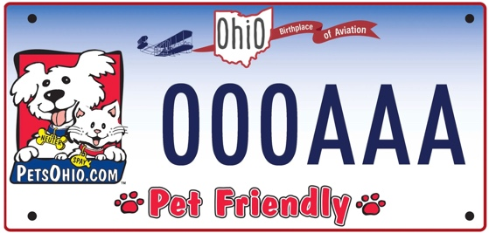

Organization Name:

Grant Amount:

Date of Grant:
Amount of Grant Money Used: __________________
Amount of Grant Money Unused & Returned: _______
- # of cats spayed with grant funds: ______
- # of cats neutered with grant funds: ______
- # of dogs spayed with grant funds: _____
- # of dogs neutered with grant funds: ____

Numbers of Animals/Owners qualifying per category:
______1 Number of dogs or cats sterilized but still awaiting adoption
______2 Certificate of adoption showing that the animal was obtained from a licensed animal shelter or pound.
______3 Certificate of adoption showing that the animal was obtained from a nonprofit corporation.
______4 Section 8 housing voucher
______5 Schedule letter from Ohio Works First
______6 Ohio Medicaid card
______7 Letter from Veteran Benefits Administration acknowledging service-related disability
______8 Ohio Direction Card (for food stamps)
______9 WIC card (Women Infants and Children nutrition program)
_____10 Benefit letter documenting Supplemental Security Income
_____11 Benefit letter documenting assistance from Social Security Disability
_____12 Tax return showing owner’s family income does not exceed 150% of the Federal Poverty
Guidelines established by the United States Department of Health and Human Services.
_____13 Other evidence that the owner or pet qualify via Sec. 955.201(C)(1) of the Ohio Revised Code.

Documentation of individual surgeries does not need to be sent to the Ohio Pet Fund, and may be discarded after two years.
____ Check here if funds were granted for an education program pre-approved by the Ohio Pet Fund board; describe the use of funds for education on the back of the form.

Signature __________________________________________

Printed/Typed name _________________________________

Title _____________________________________________

Please return this completed form to the Ohio Pet Fund with the following year’s application. If your organization is not applying for the following year, please submit this form to the email below within one year of receipt of the grant.

If you need to request a time extension to utilize the grant money,
address a request to Dr. Leanne Bertani, leannebertani@gmail.com

