e/kSiqjk tokgj T;ksfr egkfo/kky;
eekj[kiqj ] cuokjhiqj csxwljk;
tehu nkunkrk
College code:- 84014
Website:- mjjcollegebanwaripur.com
Email id:-mjjcollegebanwaripur1979@gmail.com

dz0l0 | uke | QksVks
01 | Jh jkenso jk; | 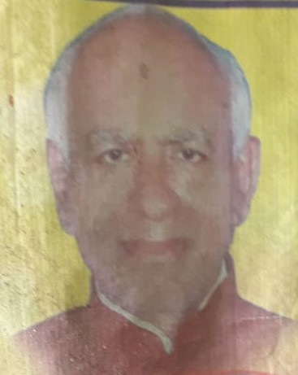
02 | Jh t;d`".k >k | 
03 | Jh jktho dqekj flag | 

