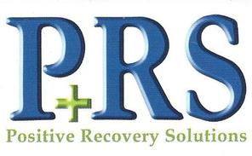
5320 E. Main St.
Suite 800
Columbus OH 43213
Office (614) 604-8231
Fax (614) 604-8312

Dear Provider:

We have a mutual patient. In the interest of continuity of care, we ask that the behavioral health provider verify via fax the following information regarding the patients care. We need this information to ensure that the patient is compliant with their drug and alcohol counseling and to secure the prior authorization for the medication.

Please include the following details:

Date that treatment began
Frequency in which the patient is seen
Confirmation that they are being counseled specifically for drug and alcohol
The date of the next scheduled appointment

We ask that you fax this information 1x/month

PRS is strictly the medical side of treatment. We believe strongly that medication alone is not the answer for our patients. We greatly appreciate your time and attention to this matter. If you have any question or comments please contact our office at the listed number above.

Thank you,
Positive Recovery Solutions

