COSMIC ECONOMY OF GOLD: COVERTLY CONCEALED
BY JEFFERY WILLIAM CATTERTON

Copyright © 2026
by Jeffery Catterton
All rights reserved

No part of this publication may be reproduced, distributed, or transmitted in any form without prior permission.

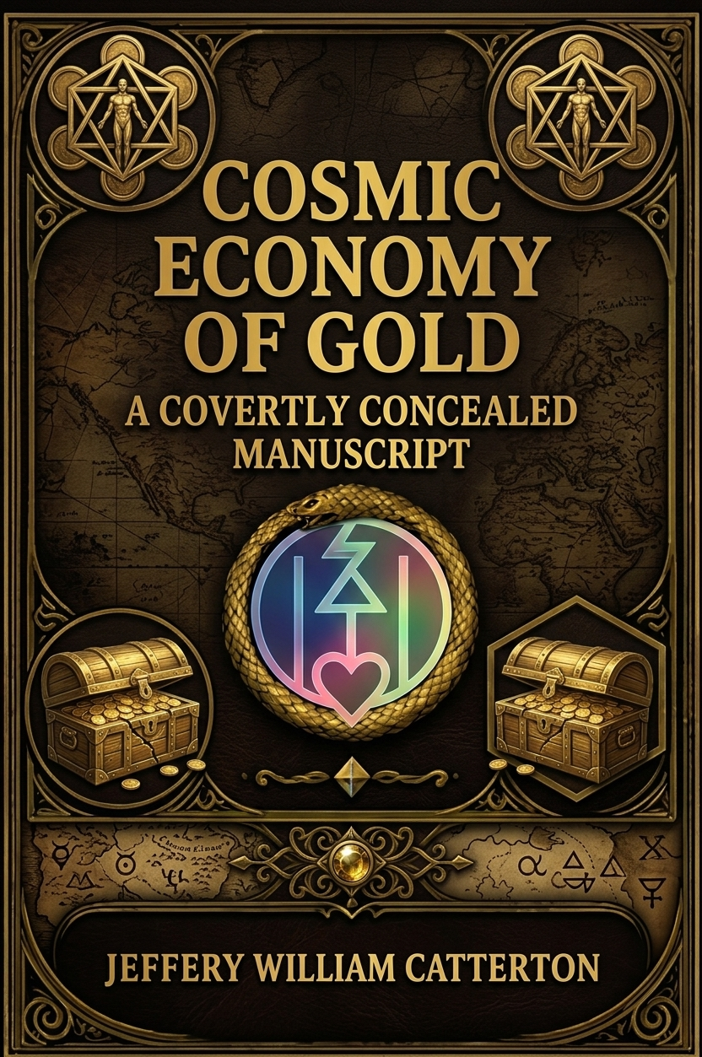

COSMIC ECONOMY OF GOLD: COVERTLY CONCEALED

By Jeffery William Catterton

Dedication

- To my late father, for showing me unconditional love, the value of purpose and direction, strength and dedication. I love you dad, miss ya.
- To Billy P., my third father figure. We found the same love in each other after butting heads a bit, after which I realized the kind of man he truly was and how much he cared for my mother and all that she cared for. Thank you for all that you’ve done.
- To my stepfather Jeff, twenty years of unimaginable agony as a quadriplegic, handled with nothing less than pure grace and a zesty, unstoppable love for life. The strongest and most selfless of all in my eyes.
- To my grandfather, for being my friend and showing me the value of perpetual motion through routine, how to plant with steady hands, and how to tend to what grows slow and steady. Besides the fact that he’s always down for a good time, a jolly and successful man whom I admire greatly.
- To my one and only best friend; who sees me for me and knows who I am more than even those who claim to love me. For spending those days and nights and endless hours scouring our minds and reality for bits of Truth to share with one another and to plant good seeds in the minds of each other and others. Although there’s been a significant absence in recent years; which may have been my fault, though surely both of us had our flaws, the reuniting is as if nothing ever changed. Thanks for always being a quality person who can see who I am, rather than only what I seem to be.
- And finally, to my loving, simple, sweet mother; steadfast in her care and duties for those she loves, her maiden-like up keeping of all she has acquired in life, including a lovely place to live. She has had her fair share of hardship and loss, as we all have; though sometimes it seems hers and mine have been the heaviest. We butt heads sometimes, mostly from a lack of understanding each other’s ways of communication. But even when I thought she had given up on me, one day came when she was there again. Through her steadfastness she has maintained a safe and peaceful place for me to conduct my studies, complete my work, and practice healing and transmutation. Thank you, Mother, for everything you’ve done. In case you don’t hear it enough from my mouth to your ears.

Yet each of you ; father, Billy, Jeff, grandfather, best friend, and mother, live forever as the brightest shining constellations in the personal universe behind my eyes. Each of you did everything for those other than yourself, and I will always remember. I will always polish my view of your shining constellations.

- “I love you all dearly — you’re all so close to my heart and as for the ones lost too soon, I miss you very much, both my father and stepfather.”

Author’s Note

Choose happiness.

As hard as that may seem sometimes, it is always a choice - much like nearly everything else. Friends and readers: choose your perspective. Look through another lens; there’s almost always a view that gives you a richer, healthier vantage. Choose happiness.

Epigraph

“The world is full of hidden wonders and half-truths — gold is among the most persistent of those wonders, an object that both binds and reveals.” — (Paraphrase of many mythic voices)

Table of Contents

PART I

Prologue

Chapter 1: Empires and Churches

Chapter 2: Kings, Priests, and the Golden Pact

Chapter 3: The Portal of the Missing Gold

Chapter 4: The Offering — To Whom, and Why?

Chapter 5: The Spark — Inside the Mortal Chest

Chapter 6: The Liberation Paradox (Practices and Trials)

Chapter 7 — Hidden Programs, Human Commodities, and the Modern Golden Underworld

Chapter 8 — Cycles, Resets, and the Ouroboros Mechanics

Chapter 9 — The Bypass: Practices, Protocols, and the Work of Remembering

PART 2

- Hidden Programs, Human Commodities, and the Modern Golden Underworld

PART 3

- Cycles, Resets, and the Ouroboros Mechanics

PART 4

- The Bypass: Practices, Protocols, and the Work of Remembering

Appendix: Sources, Texts, and Suggested Reading

Illustrated Diagrams (index with file names)

Prologue

Gold has always had two faces: the visible, tactile shimmer that seduces hands and eyes - and the invisible economy of meaning that it carries across altars, kingdoms, vaults, and rituals. This little book is neither a conventional economic study nor a pure mythography. It is an attempt to map, in words and images, the patterns I have glimpsed: how gold recurs across human institutions as both reward and leash; how it becomes code, fuel, radiance, and sometimes an offering for powers that are not simply human.

There are gods and beasts, courts and churches, technicians and dragons in these pages; there are also miners, bakers, strangers — the expendable masses who, locked into cycles of production, feed this economy. My goal is to show the shape of that economy so readers can see clearly what they participate in, resist, or transform. Along the way I will dip into history, scripture, Hermetic and Gnostic echoes, speculative fiction, and a little imagination.

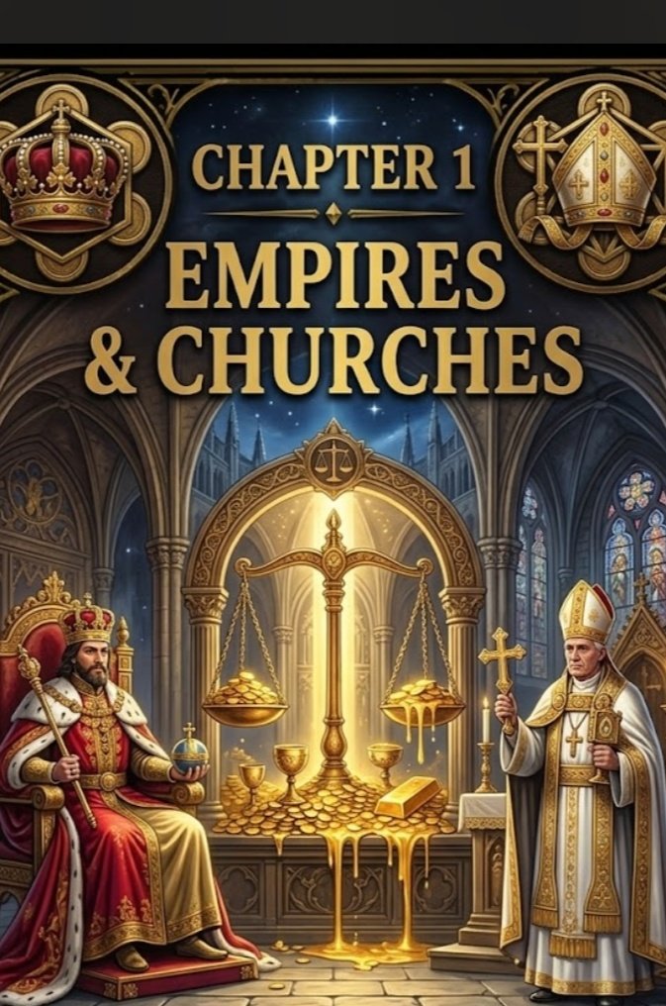
Chapter 1 Empires & Churches

Introduction

Every complex civilization creates central nodes of authority; temples, palaces, and vaults. Gold collects in these nodes: as tribute, currency, shrine ornament, and symbol. But its magnetism runs deeper. Gold is not only a commodity; it is a membrane between order and meaning. Empires use gold to build permanence; churches use gold to make invisible sanctity visible. Together they form the earliest architecture for a cosmic economy.

Gold, Authority, and Symbol

Empires establish legitimacy by monopolizing things that appear rare, stable, and luminous. Gold meets all three criteria. When rulers cover an idol or roof a cathedral, they are not only displaying wealth; they are embedding the notion of sovereignty into the skin of the world. The practice is global and ancient: temple gold in Mesopotamia, pharaonic funerary gilding, Inca practice of gold as the “sweat of the sun,” Byzantine icons, and medieval reliquaries in Europe. Each culture frames gold differently; as divine matter, as sovereign trust, as the sign of the cosmic order. But the functional logic is recurring.

Churches and empires often form tacit coalitions. Where political power needs spiritual legitimacy, clergy dignify the state’s wealth with sacrament. Where the church seeks protection, the state defends the church’s property. Gold lubricates that relation. Those who control the gold flow, therefore, control both the material and symbolic economy.

Case Studies: When Gold Becomes Law

Consider a few historical patterns:

- Tribute systems: Conquered polities pay tribute in gold and goods, reinforcing the conqueror’s prestige. Tribute becomes an economic lever and a ritual of humiliation and order.

- Temple economies: In many pre-modern societies temples acted as banks; priests managed grain and metal stores, lent wealth, and provided social welfare, all in exchange for ritual authority.

- Coinage: When gold becomes currency, it transforms power: the state’s stamp on coinage creates trust networks. Monarchs literally imprint their personality into circulation.

Across these patterns, gold functions simultaneously as wealth, seal, and theology.

Gold and Moral Architecture

Church doctrines sometimes justify accumulation as stewardship, sometimes denounce greed. The rhetoric of both piety and power often sits uneasily together. Churches have historically been guardians of art and learning - but also gatekeepers of wealth. The mouths that preach humility may also accept brilliant offering. The moral architecture is complex: gold gives the church the means to feed and teach, but also the temptation to fossilize power.

The Economic Effects on the Masses

While elites accumulate gilded status, the masses labor. Mining, coinage, labor taxation, corvée; these drain the ground and the people. Gold enters the long-run economy by extracting human energy. “Expendable masses” is stark language, but it’s historically accurate where systems required captive workforces or debts to keep production flowing.

Cultural Narratives: Dragons and Beasts

Gold’s cultural presence is resplendent with stories of beasts and dragons who hoard. Mythic images insist on a truth: accumulations are not neutral. They attract perils; monstrous guardians, curses, and cycles of violence. The dragon is a metaphor for concentrated treasure that demands worship, guarding, or violent challenge.

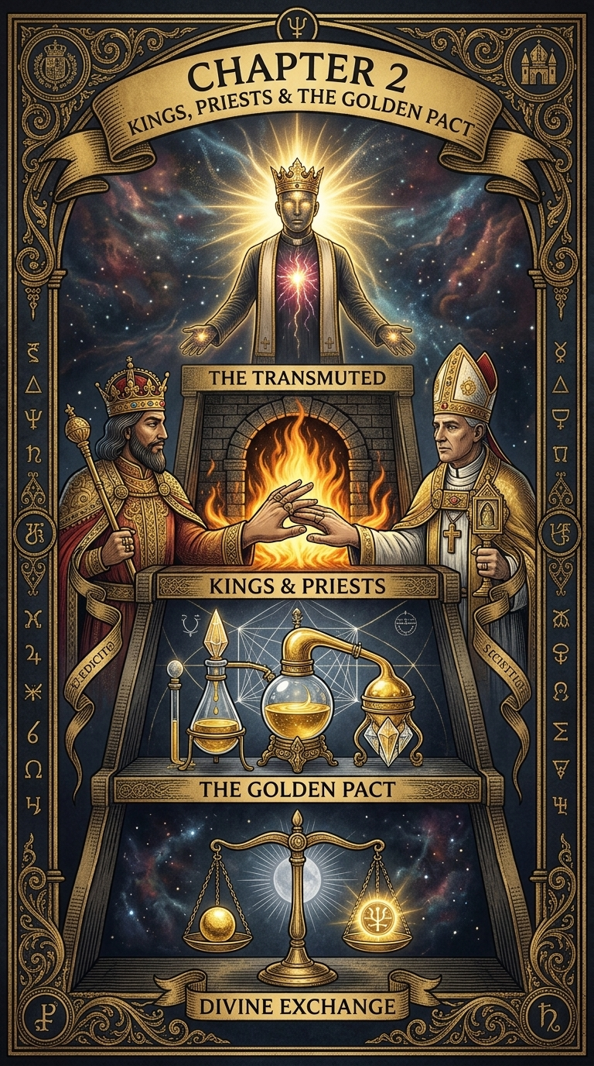
Chapter 2 — Kings, Priests, and the Golden Pact

Overview

This chapter traces the institutional mechanics of the golden pact: how kings and priests bargain over gold, the ritual economy’s mechanics, and the social psychology that sustains exchanges of worship and protection.

The Pact Defined

At its simplest: kings promise security and order; priests promise meaning and sanctification. Gold is the contract medium. Kings enrich priests to lend sacrality to the crown; priests legitimize kingly rule in return for protection and tribute. This arrangement is not universal law, but it recurs across eras and continents.

Ritual Economy and the Performance of Trust

During sacral ceremonies, gold becomes performance: altars gleam, incense burns, and the people witness an enactment of cosmic stability. Legitimation is performed publicly; the gold proves the rule has blessing. The more spectacular the display, the deeper the impression of authority.

Priestly Functions: Banking, Memory, and Sacrament

Priests often functioned as administrators: guardians of archives, keepers of records, bankers of last resort. They stabilize resources and flow. In return, they secure narrative control: scriptures, rituals, and the memory of the people.

Kings and the Technology of Security

Kings exchange gold for armies, fortresses, and bureaucratic infrastructures; forces that keep extraction running. Physical protection for priests in return for sacral endorsement ensures continuity of extraction and cultural reproduction.

Social Consequences

When wealth concentrates, social mobility constricts. Ritual inequality becomes institutionalized. Gold becomes a central node in networks of reproduction - of power, rank, and social order.

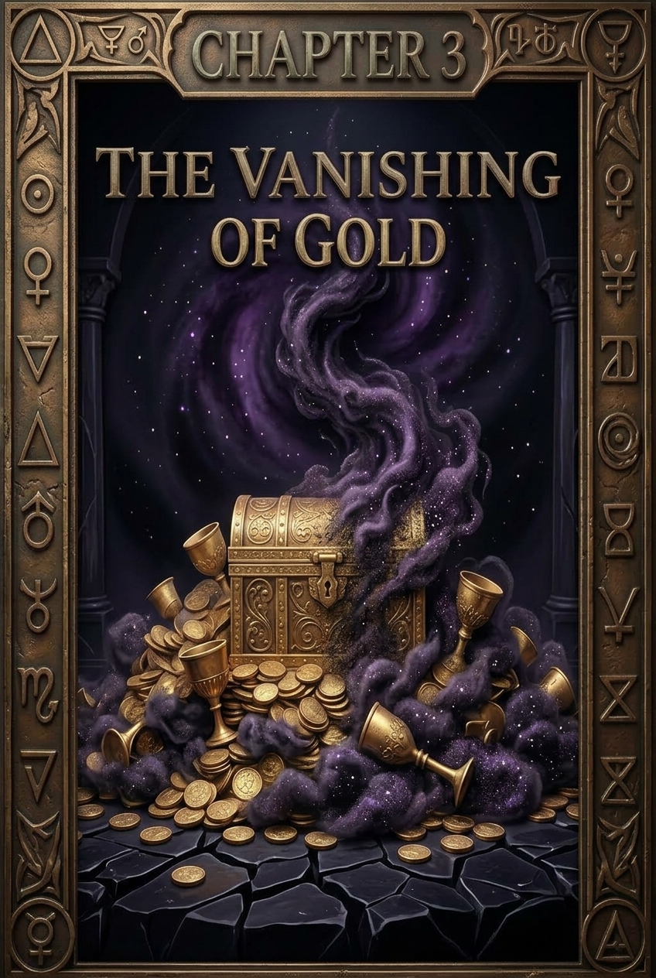
Chapter 3 — The Portal of the Missing Gold

Introduction

Where did it go? Between vaults and altars there are gaps: unaccounted hoards, vanished bullion, secret mints, and rumors of gold that disappears into other realms of use. Chapter 3 opens the portal on the missing gold - examining historical leakages, clandestine flows, and mythic explanations.

Categories of Missing Gold

- Tax Evasion and Flight — gold moved via covert shipping, hidden caches, and offshore havens (historical precursors existed whenever law and border control allowed movement).

- Recycling and Reuse — liturgical plate melted down in times of crisis; gold repurposed for coinage, jewelry, or artifacts.

- Ritual Offerings — votive deposits, offerings to gods, and grave goods which are effectively removed from circulation.

- Black Operations — secret reserves, clandestine state caches, and private hoards insulated from public oversight.

- Non-Material Uses — speculative category: uses where gold is not measured in weight (e.g., alchemical operations, symbolic transmission).

Myth and the Missing Gold

Every culture has narratives for vanished treasure: gods reclaiming their own, dragons swallowing stolen hoards, or subterranean entities hoarding wealth. These stories explain risk and enforce caution - but they also point to the psychological landscape of value: our need to tell why wealth evaporates.

Modern Analogues

From hidden Nazi gold to Cold War movements, gold’s capacity to slip beyond public accounting remains. Open markets reduced some hiding places, but new channels (dark markets, private vault firms) persist.

Portal Hypothesis (Speculative)

This chapter also introduces a working speculative thesis: some portion of “missing” gold moves into usages not entirely material; symbolic currency for other intelligences, state-sanctioned rituals beyond public knowledge, or experimental technologies (to be explored further in Chapter 4). This is intentionally provocative; meant to expand imagination while being careful to separate evidence from speculation.

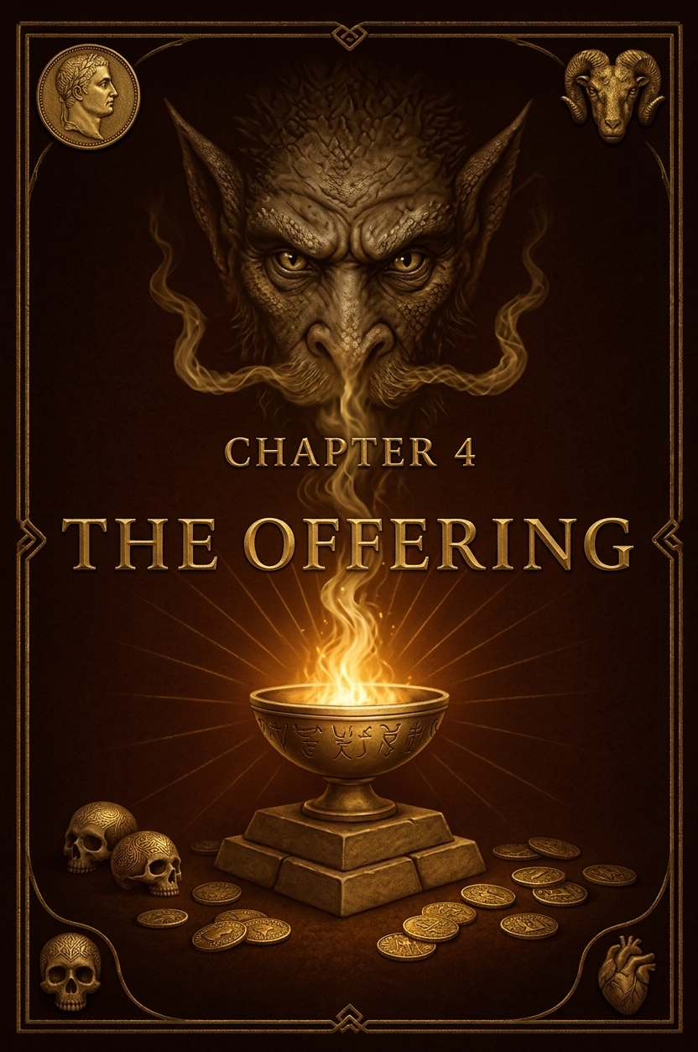
Chapter 4 — The Offering: To Whom, and Why?

Summary

Offerings transform gold into action. They move value from the temporal into ritual and symbolic economies. This chapter digs into the purposes of offerings: securing favor, enabling technologies, and the hidden demands gold may satisfy in non-human economies.

The Mysterious Necessity

Beyond kings, priests, and dragons; above them in my prior diagrams, stands a node marked “Mysterious Usage/Necessity.” What could this be? Possibilities range from practical (metal for electronics, optics, space engineering) to symbolic (currency for entities, ritual radiance) and to speculative (non-terrestrial or transhuman labs).

Credible Accounts & Corroborations

Historically documented practices suggest gold’s unusual physical properties explain many practical uses: corrosion resistance in electronics, high reflectance for optics, and chemical stability. Military and space programs have used gold for circuitry and shielding. In that practical sense, governments and private labs have recognized gold’s unique advantages for high-end technology.

At the same time, many authors (ancient and modern) have long written of gold’s mythic role: Hermetic texts and Gnostic fragments describe gold as a token of divine favor or a vehicle for higher light. Medieval alchemical treatises frame gold as perfected matter; an endpoint of transmutation and a metaphor for wholeness.

References & Textual Echoes (non-exhaustive):

Hermetic fragments and the Corpus Hermeticum (concerning light and divine matter).

Gnostic texts (Nag Hammadi codices) describing fullness (pleroma) and aeons — metaphoric contexts where “gold” stands for divine plenitude.

Alchemical authors (Paracelsus, Geber) on the value of metals as spiritual analogues.

Modern scientific literature on gold’s use in electronics, satellite engineering, and optics (paraphrased summary; specific technical references available on request).

Speculative Theories & Conspiracy Narratives

Missing gold has prompted conspiracy theories: secret programs, alien pacts, subterranean hoards for hidden cults. Some theories claim gold is used in advanced propulsion, in devices we do not yet publicly know. Others suggest psychological control - gold as both trinket and tether.

Approach these stories with a method: separate evidence (archival trails, procurement records, patents) from speculation. Note the social function of such narratives: they render hidden power visible in story form.

Small Thought-Experiment (for the finale of the chapter of part 1)

Imagine a top-tier lab that requires pure gold for a device that manipulates radiation or stores a non-classical state. The gold is untraceable afterwards because it becomes dispersed in a field rather than in bulk; that would look, at a distance, like “missing gold.” This thought ties back to the portal in Chapter 3: missing metal may have been transformed into a non-bulk form.

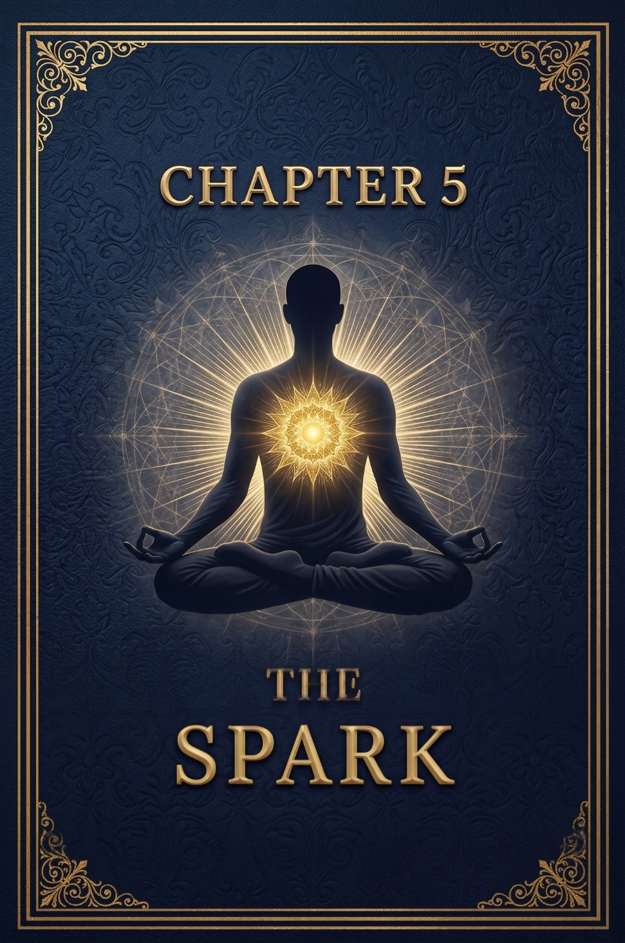
Chapter 5 — The Spark

Premise

Chapter 5 moves inward: from empires and beasts to the human microcosm. The Spark is the inner light; the luminous center within human beings various traditions call pneuma, ruach, nous, or spark. This chapter explores how that spark is framed in texts (Gnostic, Hermetic, Christian), how social systems attempt to harness it, and what gold’s place might be in that story.

The Spark In Tradition

Gnostics: Speak of a divine seed or spark trapped in the material realm. Liberation involves knowledge (gnōsis) and re-connection to the Pleroma.

Hermeticism: Describes the ascent of the inner mind towards divine nous, with metals and processes as symbolic steps.

Christianity: Speaks of the soul, light, and transformation. Paul and the New Testament language of light and darkness intersect powerfully with the metaphor of inner awakening.

Gold and the Spark

Gold appears as symbolic and practical mediator. Symbolically, gold reflects the idea of incorruptible light, the transmuted human. Practically, gold was used in many cultures to decorate sacred sites, making visible the inner radiance the liturgy aimed to awaken.

The Ascent Diagram

A meditative diagram in this chapter (to be placed on the diagram page) shows a small meditating figure, a line from chest to the ineffable one at the top, with stages of ascent marked: Awakening, Purification, Trial (Fire), Christ/Word, Pleroma. The imagery evokes the alchemical ascent and Hermetic ladder. The path is direct but must avoid falling into intermediaries that would re-entangle the spark in worldly exchange.

- Scriptural insertion: 2 Thessalonians 2:11–12 is placed in this chapter as a caution: some are led by delusion and false signs; discernment matters.

“God sends them a working of delusion, for the believing of them in the lie.”

“In order that they might be judged, all those not having believed in the truth but having had pleasure in the unrighteousness.”

(Placed intentionally to remind readers that not every luminous promise is genuine; discernment protects the spark.)

Pathways, Practices, and Trials

This chapter lists practical, cross-tradition methods for cultivating the inner light:

Breath and directed attention (simple breath practice).

Fasting and purification.

Pilgrim exercises: trials by fire as metaphor for inner alchemy — facing fear, attachment, and false idolatries (including gold as an idol).

We close with a vision: a human who turns inward, refusing worldly gilding and learning to carry the light as service rather than trophy.

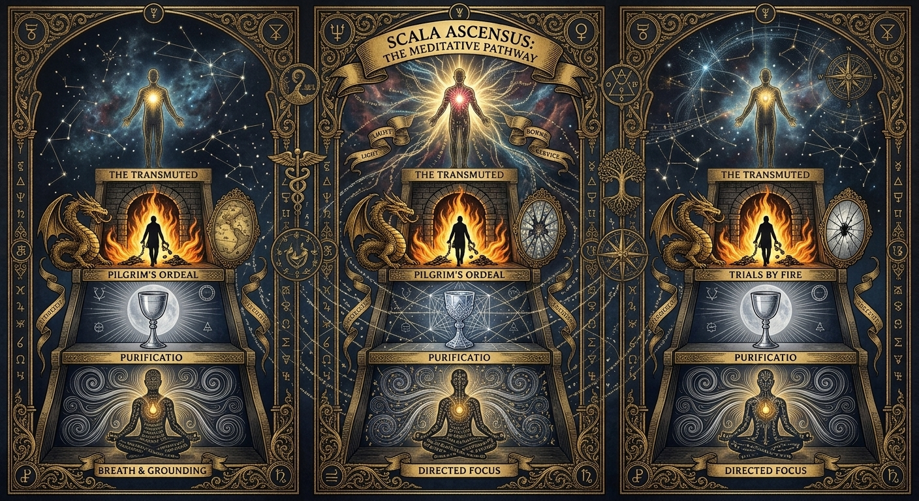
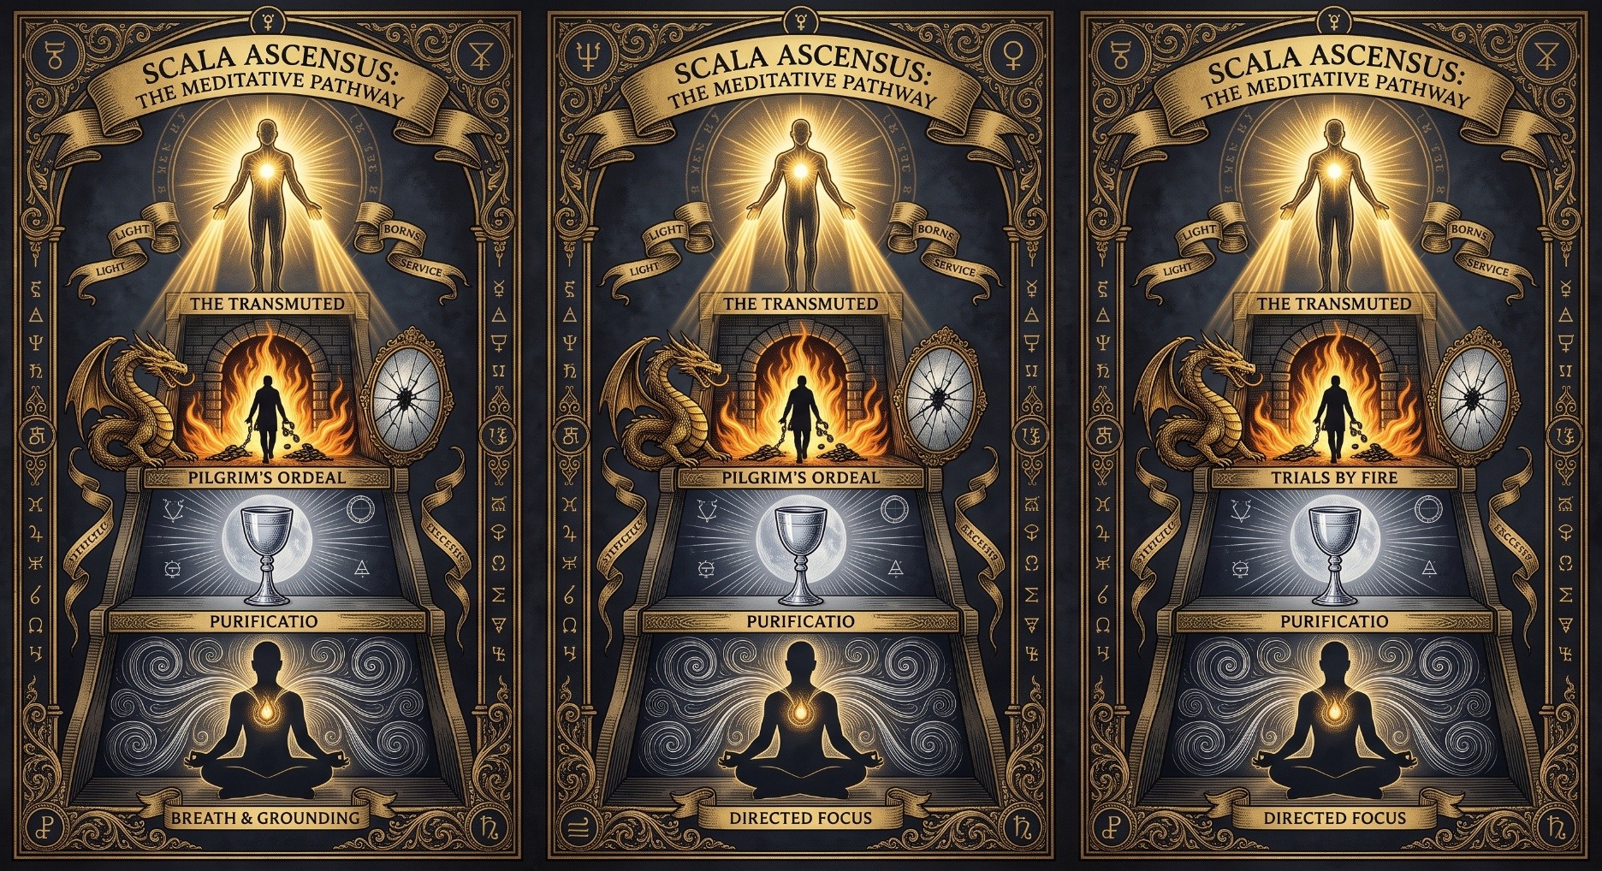

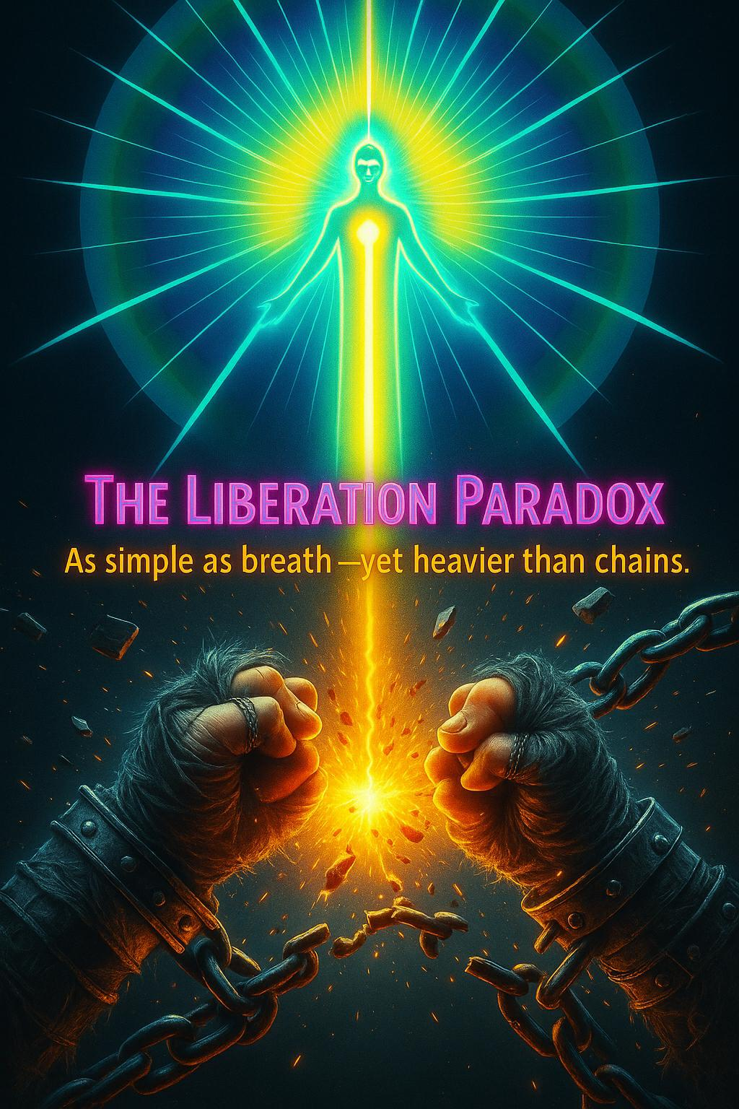
Chapter 6 — The Liberation Paradox (Practical Pathways & Trials)

Introduction

Liberation is simple in theory and hard in practice. The paradox: freedom is always available, as immediate as breath, and yet the webs of habit, culture, and economic necessity make freedom heavy as chains. This chapter is a practical field guide: a set of practices, frames, and cautions to help the reader choose differently.

The Paradox: Simple as Breath: Heavier than Chains

To choose liberation is to choose differently in every small moment. That is a simple instruction. To live that choice, to build a life that sustains it against social pressures and economic needs, is heavy work. The paradox is structural: liberation demands both the immediate practice (breath, attention) and social restructuring (work, relationship, habit change).

Twelve Practical Steps (a Field Guide)

- Daily Breath Anchor (5 min): sit, breathe, watch the chest light metaphor, cultivate steady presence.

- One Daily Renunciation: a small, chosen abstention (screen time, sugar, small complaint).

- Service Action: one intentional act that benefits others each day.

- Material Audit: monthly review of possessions and their demands; identify items that bind attention.

- Financial Cl


PART 2 — Hidden Programs, Human Commodities, and the Modern Golden Underworld

Gold’s modern mystery sits inside human systems: vaults, contracts, shipping manifests, and the private rooms of states and corporations. But the same infrastructure that shelters a bar of bullion also shelters a person, a secret experiment, or a classified laboratory.
When secrecy becomes an institutional habit, the difference between hoarding metal and hoarding life grows faint. The scale that sounds the alarm.
Start with numbers, because numbers are the blunt instruments that cut through poetic metaphors. In the United States in 2024, law-enforcement and advocacy channels recorded tens of thousands of reports of missing children, a figure that includes many recoveries but also a concerning number of unresolved cases. Globally, estimates of modern slavery and forced exploitation run into the tens of millions.
Those are not theories; they are the measured human landscape on which any argument about hidden economies must stand.
Why mention this in a book about gold? Because logistics are logistics: high-security ports, bonded warehouses, freeports, and opaque shell companies are useful whether you move refined bullion, antiquities, weapons, or people. Where secrecy and mobility are prized, abuse migrates.
History teaches that when directors of power prize secrecy over accountability, the poor and the invisible become currencies.
Documented shadows: procurement, vaults, and audits Not every secret is monstrous or conspiratorial. Some secrecy is routine national security; some is commercial. But routine opaqueness invites fantasy and sometimes masks malfeasance.
Case in point: the practice of deep storage. Governments do store national reserves in hardened facilities; auditors sometimes come in and sometimes they do not.
One authoritative datum helps calibrate fear and reality: the Fort Knox audit program of the 1980s. Under formal continuing audit procedures, auditors inspected joint seals, sampled and assayed bars, reconciled manufactures’ marks, and compared weights and purity to official ledgers.
At the time, the Treasury reported hundreds of millions of fine troy ounces under account and found broad concordance between records and inspected metal. That audit does not end all questions; audits have limits, but it does show there are systems that try to pierce secrecy with ceremony and method.
Case box: Project Iceworm / Camp Century Declassified planning documents reveal that during the Cold War the U.S. Army built an extensive subterranean facility beneath the Greenland ice (Camp Century) as cover for a larger, strategic engineering idea (Project Iceworm).
The project encompassed miles of tunnels, living quarters, and the world’s first mobile nuclear power plant. It was abandoned when ice dynamics made permanence impossible. The record matters because it demonstrates in cold clarity that states can and do build entire subterranean complexes; not fantasy, but engineering fact.
If a government can build a staffed base under mile-thick ice, it can tunnel a mountain or construct hardened subterranean spaces where oversight is limited. That possibility changes the plausibility landscape for “hidden cities” and secret vaults. Human commodification: a long arc If gold once sustained tribute economies that paid for armies and temples, human commodification did the work. Bonded labor and sacrificial systems fed empires.
The modern age has not abolished that arc; it reshapes it. Trafficking now appears as networks of recruitment, transport, debt bondage, and resale. Where bullion is unavailable or politically awkward, fungible human labor; forced labor, sexual exploitation, organ theft - becomes the currency of profit and deniability.
The link between bullion and bodies is structural, not merely rhetorical. Precious-metal logistics; freeports, private vault providers, shell companies , are also the corridors where illicit human commerce can move unnoticed.
That overlap is not an argument of inevitability; it is a call to scrutiny. Mapping manifests, corporate ownership, and shipping corridors often reveals surprising overlaps between contraband flows. Subterranean life and the shadow imagination Cities under cities are both real and mythic.
Archaeologists and engineers point to many historic underground complexes; carved refuges, salt-mine towns, and wartime bunkers and to modern continuities: Cold War bunkers, hardened command complexes, and under-city infrastructures used for metro transit and utilities. Where factual subterrane exists, mythic subterrane can flourish. Reptilian overlords and chthonic palaces belong to imaginative economies that tell us about fear, not proof.
Distinguish methodically between the two: the engineering possibility is real; the extraordinary claims must meet extraordinary evidence. Evidence, not annihilation of imagination The right move is not to refuse imagination but to discipline it.
Ask: is there procurement paperwork? Is there contractor trace? Satellite corroboration? Survivor testimony? If not, label the claim speculative and use it to explore what secrecy does to a society. The most useful stories are those that fold myth and document together: where a real secret alters the texture of community trust.
Closing the ledger Gold and human life sit on the same ledger when secrecy values permanence over transparency. This chapter does not conclude with a neat indictment; it ends with a procedural insistence: where rumors of hidden treasure overlap with evidence of trafficking or subterranean logistics, investigators must follow procurement leads, shipping manifests, and human testimony with equal tenacity.
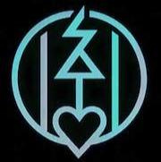
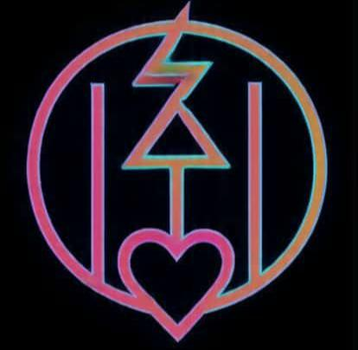
The ledger should include both bars and bodies, because both have been priced, and both deserve better accounting.


PART 3 — Cycles, Resets, and the Ouroboros Mechanics

History loves a pattern. Empires rise by gathering surplus, centralizing wealth, and building institutions to protect that wealth; often they fall when the architecture that supported extraction becomes brittle.
The image that keeps returning in temple frescoes and library margins is the serpent eating its tail: the Ouroboros. It is not only a religious emblem; it is a systems diagram. Cycles that leave debris consider a few civilizational contractions: In the Late Bronze Age, interconnected trade networks collapsed under stressors like drought, migration, and warfare.
Bronze; an alloy requiring multiple inputs, became scarce; economies shifted. Collapse looks sudden because it is the emergent result of many slow failures.
Rome’s fall shows a different arithmetic: fiscal strain, debased coinage, administrative bloat, and external pressures fed a cycle that made the old political compact impossible.
The Mesoamerican polities collapsed under drought, resource exhaustion, and social stress, not because of a single calamity but because the system’s absorptive capacity was exhausted.
Each of these cases follows the ouroboric arc: extraction → concentration → fragility → rupture → consolidation → re-start. The pattern is not deterministic; it is structural. Myth, prophecy, and cyclical thought Cultures give this pattern metaphors.
Hindu cosmology names Yugas; ages that descend from gold to iron. Norse myth frames a purgative Ragnarok.
Gnostic texts couch history in emanations and restorations. These are more than cosmogonic stories: they are cultural heuristics for recognizing the same mechanics at work in social life.
Mechanisms that could produce resets today Some drivers are obvious: climate shocks, pandemics, and systemic economic fragility. Others are engineered: deliberate financial resets via debt default architectures, calculated expropriation under emergency powers, or targeted infrastructure sabotage that collapses the flow of goods.
Even late-stage technocracy offers new failure modes: cyberattack on banking rails, supply-chain collapse driven by monopolized logistics. The
Ouroboros algorithm Think of the Ouroboros as a simple social algorithm:
1. Concentrate: wealth sits fewer places.
2. Optimize: infrastructures are made efficient to serve the few. 3. Fragilize: redundancy stripped leaves systems brittle.
4. Shock: a stressor collapses the system.
5. Reconstitute: winners recompose the order; the serpent swallows itself and is born anew.
Breaking the algorithm requires altering the parameters. Reduce concentration. Keep redundancy. Make flows visible. The bypass thought This chapter is not a paean to inevitability. It is the technical diagnosis that precedes remedy.
If the ouroboric loop is an algorithm, what reprograms it? The bypass is not a coup; it is the steady practice of moral, institutional, and cognitive habits that change initial conditions.
Redistribute attention, demand transparency, build resilient local economies, and cultivate the inner memory that refuses to allow value to be measured only by secrecy and hoard. Scenarios (for the mind, not for panic)
Minimal: municipalities set up community treasuries and public audits of vaults; transparency reduces the social power of secret hoards.
Tipping: a network of communities adopt “memory practices” that change cultural valuations; the prestige economy reorganizes around service not secret.
Dark reaction: oligarchs accelerate extraction; stability requires parallel legal and civic defenses.
Bridge to practice If Chapter 1 showed where secrecy wreaks human harm and Chapter 2 explained how cycles compact around that harm, the next chapter must sketch how communities, rituals, and legal reforms create a bypass.
The Ouroboros is not destiny if actors learn to change the rules of engagement.

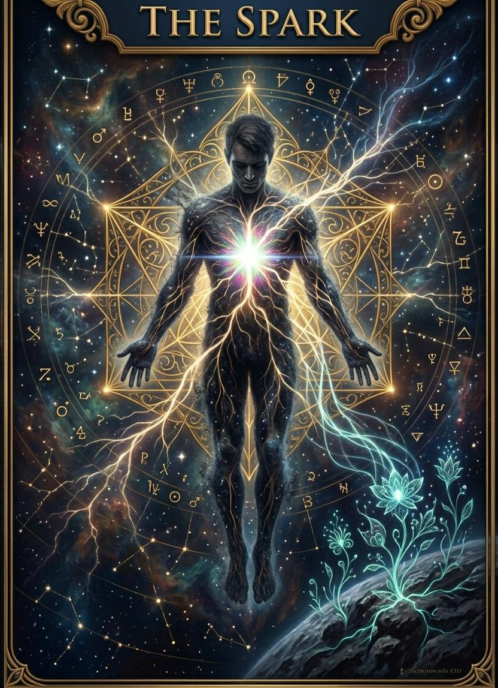
PART 4 — The Bypass: Practices, Protocols, and the Work of Remembering

The final chapter is an instruction. Small, stubborn, human. If enough people remember; remember the spark, remember dignity, remember the ledger that includes people - then the world’s cadence can shift.
This is the central, practical claim of this book: memory scales. The premise All institutions are ultimately habit built into architecture. If habits change, institutions change.
The Spark: the luminous center our traditions call ruach, pneuma, atman, nous is the smallest unit of a possible cultural reprogramming. A single realization is a fragile thing; tens of thousands repeated becomes a practice; millions repeated becomes a culture.
Three tracks of the bypass
1. Inner practice (the Spark) - daily anchors that keep attention aligned to human dignity: five-minute breath practice, one renunciation, one service action, weekly study of texts that reorient values. These are the micro-rituals that make a habitual mind less susceptible to the glamour of secrecy.
2. Local technology (civic protocols) - transparency audits, community treasuries, cooperative freeports, public procurement oversight, and legal requirements for full audits of national reserves. These change the plumbing that currently channels secrecy.
3. Narrative work (memory & story) - artists, teachers, storytellers who retell the past including those formerly omitted: the expendable, the trafficked, the long laborers. Narrative shifts attract cognitive attention, and attention is the medium of value.

A short protocol, The Reader’s Ritual Card
- Anchor: breathe five breaths, feel the chest light.
- Name: silently name one person whose life matters to you beyond utility.
- Act: do one small service for someone in your circle today.
- Record: write one line that honors human dignity in your ledger.
- Transmit: share the line with one person.
Do this repeatedly. Ritual is not magic; it is habit amplification. Legal & institutional demands Memory also needs scaffolding. Demand full audits of reserves.
Push for public oversight of freeports. Support NGOs that map trafficking corridors and publish open manifests. Make procurement records public and machine-readable. Tighten beneficial-ownership registries. These steps reduce the capacity of hidden economies to hide.
The ethical heart: The bypass; is not only policy and procedure; it is an ethic: refuse to let wealth be measured only by possession, insist it be measured by care. That switch matters. If a society’s highest honors go to those who hoard, it trains people to hoard. If honors go to those who create life, tend life, and witness life, institutions follow.
A closing image Remember the Ouroboros: a serpent eating itself. Now imagine instead a ring of hands. Each hand passing light to the next; concentric, not consuming but exchanging.
If enough hands keep passing, the pattern is no longer self-devouring. That is the ascension I want to leave you with: not violent transcendence, but a steady habit of remembering that becomes, in aggregate, something new.


