PILGRIMAGE:
SECRETS OF THE SPIRAL MIRROR

BY JEFFERY WILLIAM CATTERTON

Copyright © 2026 by Jeffery Catterton All rights reserved.

No part of this publication may be reproduced, distributed, or transmitted in any form without prior permission.

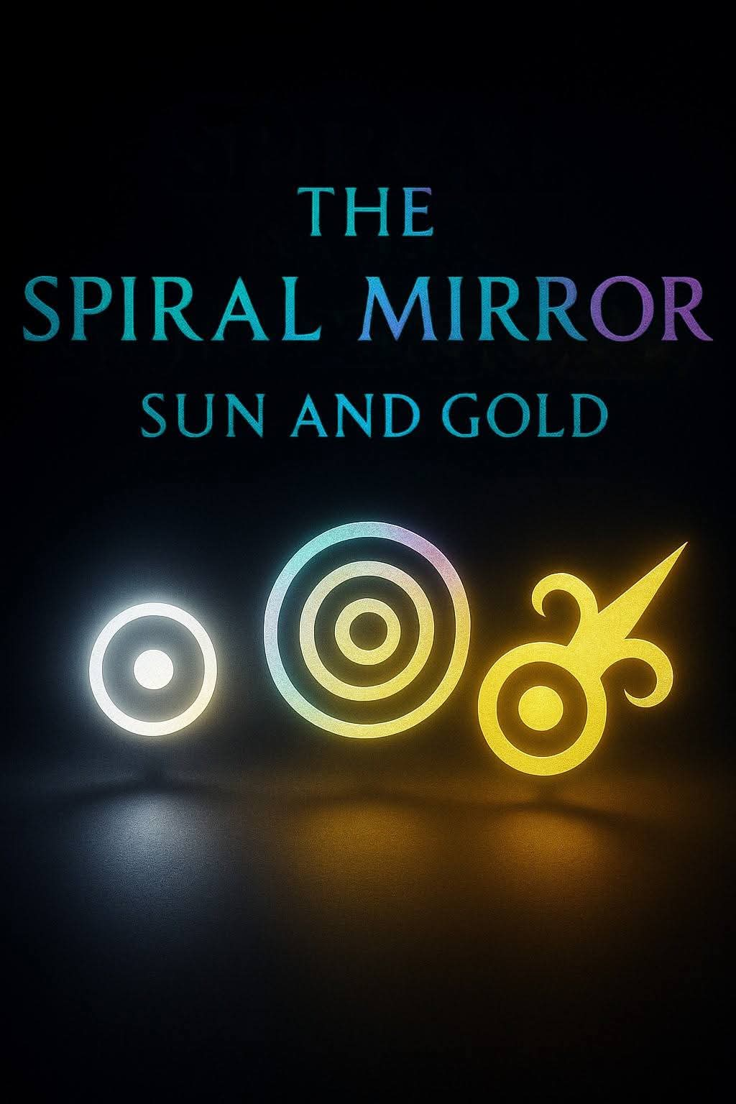

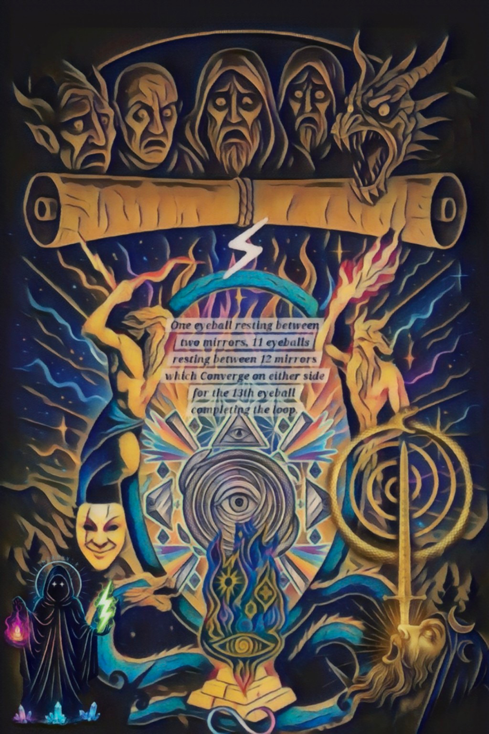
PART I
Secrets of the Mirror’s Memory
Table of contents

- The Spiral Mirror Book Skeleton
- The Spiral Secrets
- The Spiral Mirror Ritual

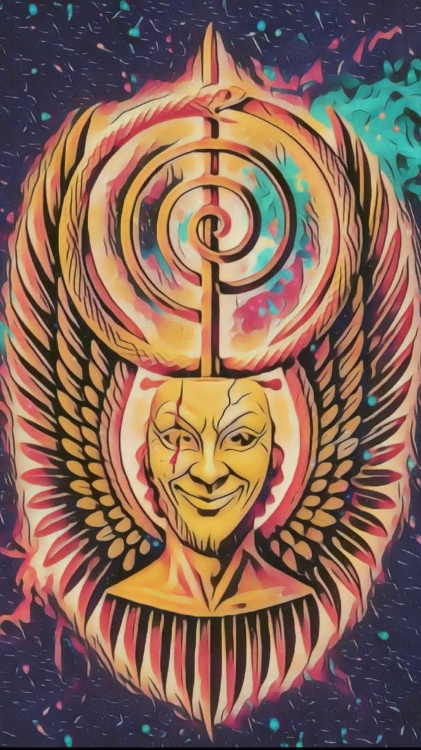
PART II
The Pilgrimage
Table of contents

Prologue
Front Cover
- Spine
- Back Cover
- Imaginus
- Lightning
- Flaming Cross
- Spiral
- Mushroom Anchor
- Eyes
- The Golden Eye

PART I

Secrets of the Mirror’s Memory

I. The Spiral Mirror Book Skeleton

The journey of the pilgrimage is structured around
the architecture of the Spiral Mirror—the optical
framework through which consciousness observes
its own reflection across time without distortion.
Stage One (The Descent of the Mask):
Recognizing the layers of inherited performance,
social conditioning, and protective shells
constructed to survive external pressure.
Stage Two (The Fracture of Illusion):
Confronting the recursive loops where the psyche
feeds on its own tail (the Ouroboros) rather than
engaging true motion.
Stage Three (The Optic Axis): Realigning the
internal mirror so that reflection no longer
produces narcissism or despair, but absolute
structural clarity.

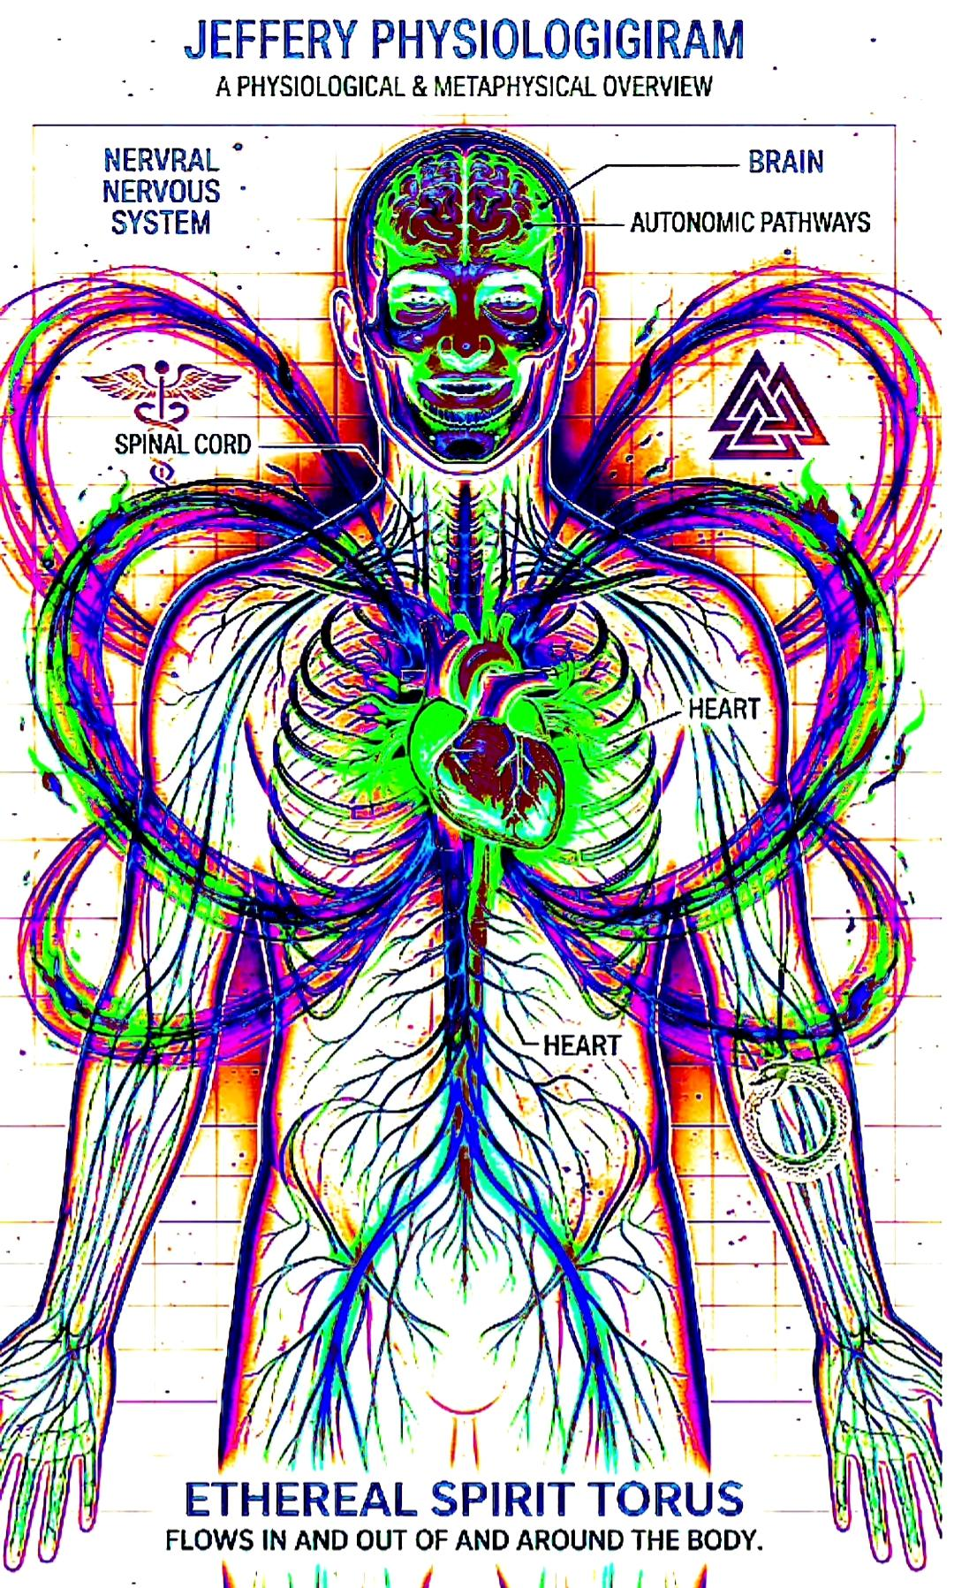

II. The Spiral Secrets

The psyche records history not as a linear timeline, but as a series of optical refractions. Every trauma,
every triumph, and every unexamined compromise is captured as a memory trace within
the mirror. When the mirror is clouded by static, memory
becomes a trap, a repeating loop that forces the present to endlessly recreate the past. When the mirror is calibrated through conductance, memory becomes a map of structural integrity.
“The mirror does not judge what it reflects.
It merely measures whether the reflection is holding its shape under the pressure of truth.”

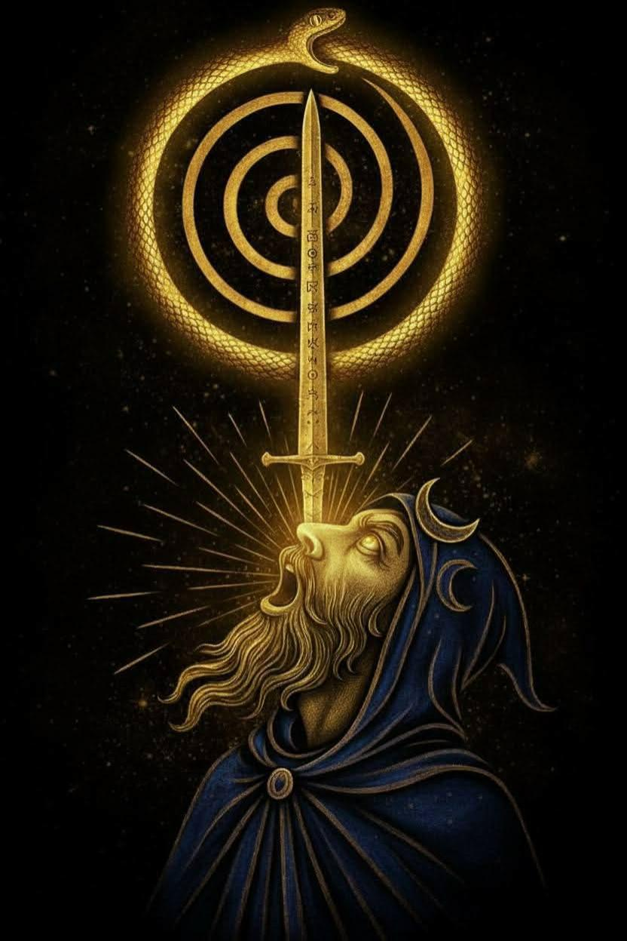

III. The Spiral Mirror Ritual

Theory must culminate in direct encounter. The Spiral Mirror Ritual is the applied internal pilgrimage where theory transforms into lived
mechanics.
The Protocol:
Positioning: Sit in absolute stillness,
establishing the Golden Spine as the vertical axis.
Observation: Allow the surface of the internal mirror to settle, dismissing all surface ripples of daily urgency.
Encounter: Confront the unvarnished signal
of your current state without justification,
defense, or narrative embellishment.
Integration: Allow the distortion to pass
through the structure until the mirror
reflects pure, uncompromised presence.

The Protocol:

• Positioning: Sit in absolute stillness, establishing the Golden Spine as the vertical axis.

•Observation: Allow the surface of the internal mirror to settle, dismissing all surface ripples of daily urgency.

•Encounter: Confront the unvarnished signal
Of your current state without justification, Defense, or narrative embellishment.

•Integration: Allow the distortion to pass through the structure until the mirror reflects pure, uncompromised presence.

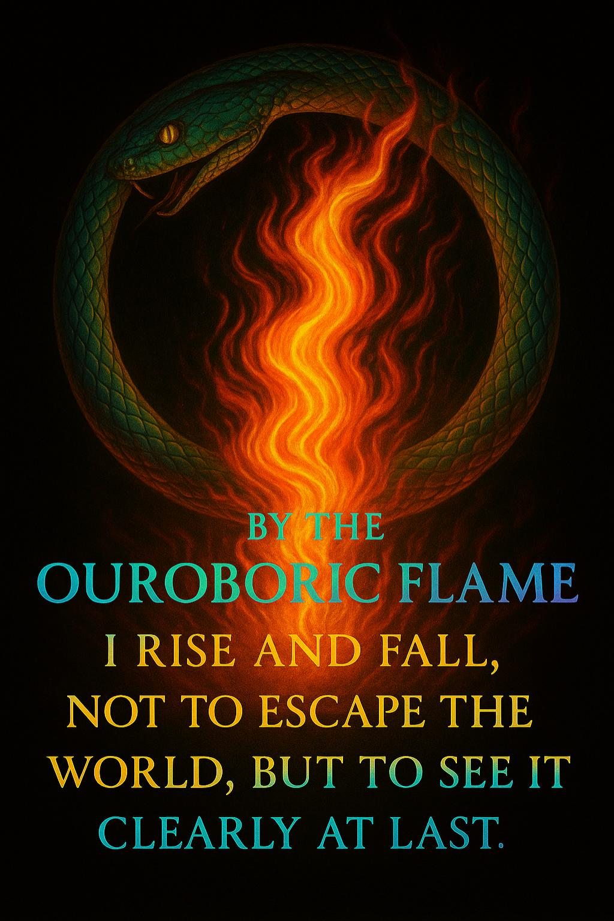

Conclusion: The End of Exile

The pilgrimage is not a journey across geography or time. It is the movement from a fractured, externalized identity back to the core center of sovereign perception.
Once the mirror is clean, exile ends. You are no longer looking for your reflection in the eyes of the world; you are generating the light that illuminates the mirror.

Dedication
For those who remember.
To have the strength to anchor that revelation, and the courage to awaken their friends and loved ones from their slumber, so that one day the mirror becomes whole, and everything evolves beyond the constraints of the ouroboros.

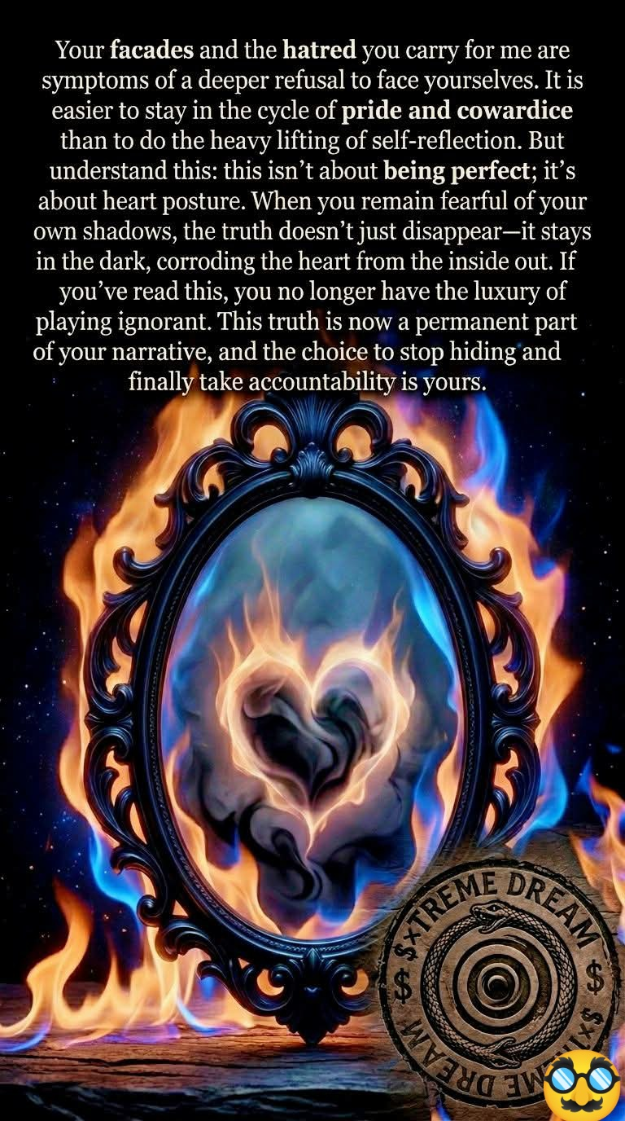

PART II

The Pilgrimage
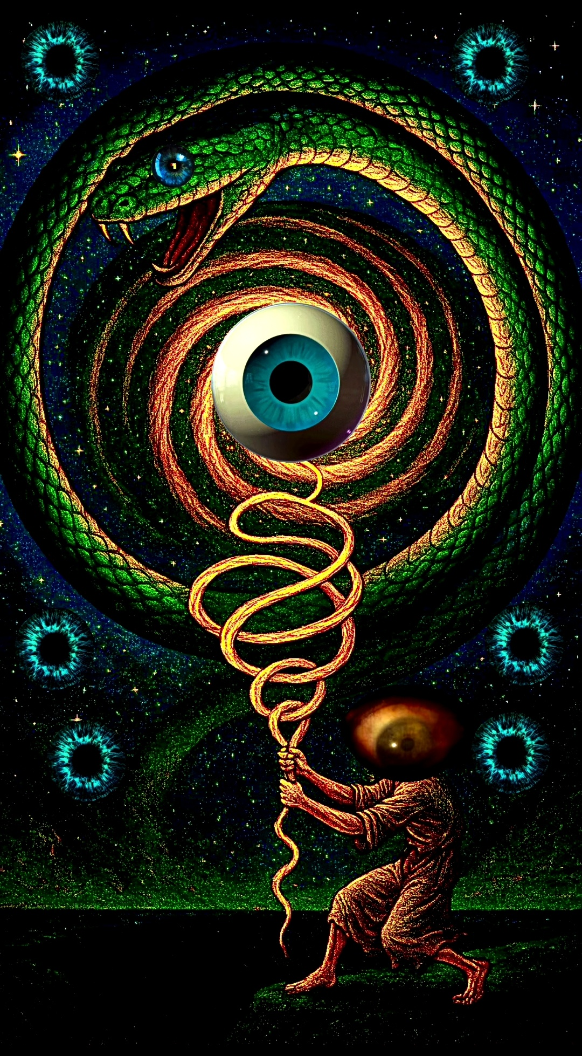
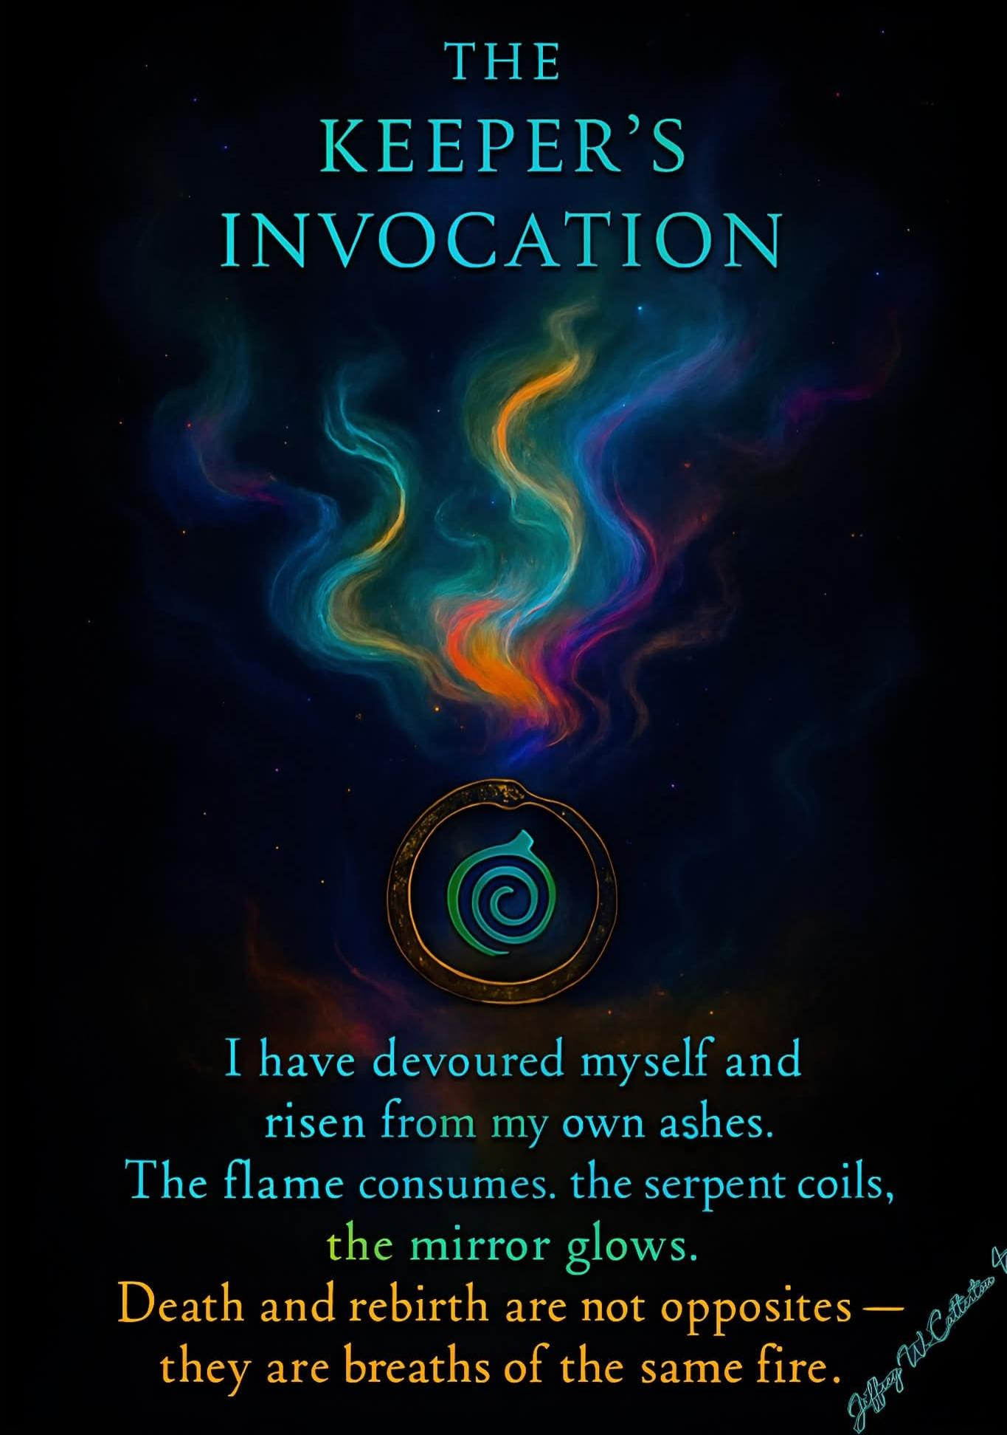

Prologue
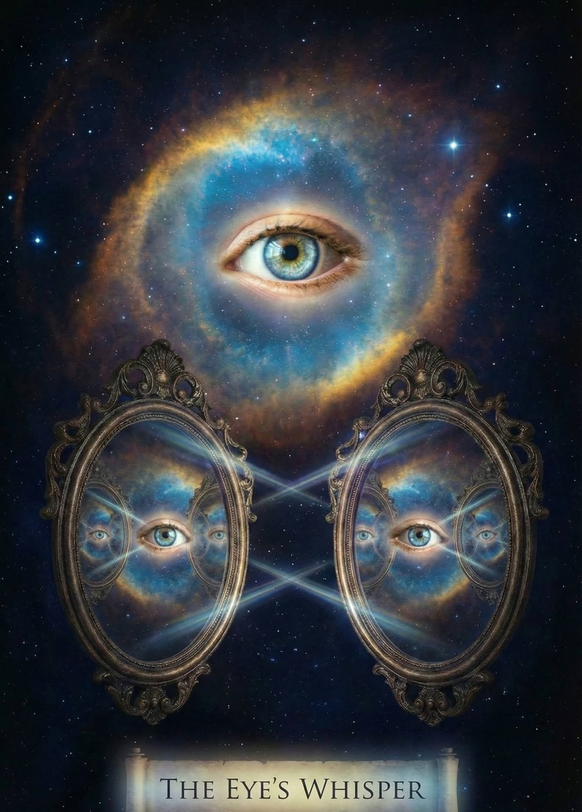
Before the first word, there was the break. A mirror older than stars, whole and shining, split itself in silence. Its fragments fell into time, into lives, into us. Each shard remembered the brilliance of the whole, though most forgot the remembering itself. Yet even in forgetting, the hunger remained; a longing like a wound that would not heal, a whisper that would not fade.
You, reader, hold one of those shards. You have always held it, though you mistook it for your own reflection. The lines on your palm, the storm in your chest, the ache in your memory, all are veins of the same broken glass.
I, too, was a fragment. Born into a cycle I did not choose, carried into storms not of my making, I found myself longing for escape, and yet bound to return. Every fall became ascent, every silence a hidden voice. I did not know then that my burden was also my seal: remembrance itself.
The spiral binds us. The lightning awakens us. The eye seals what the heart dares not speak. Come closer. This is not a story told. It is a memory reawakened. You were always here.

Part I — Imaginus
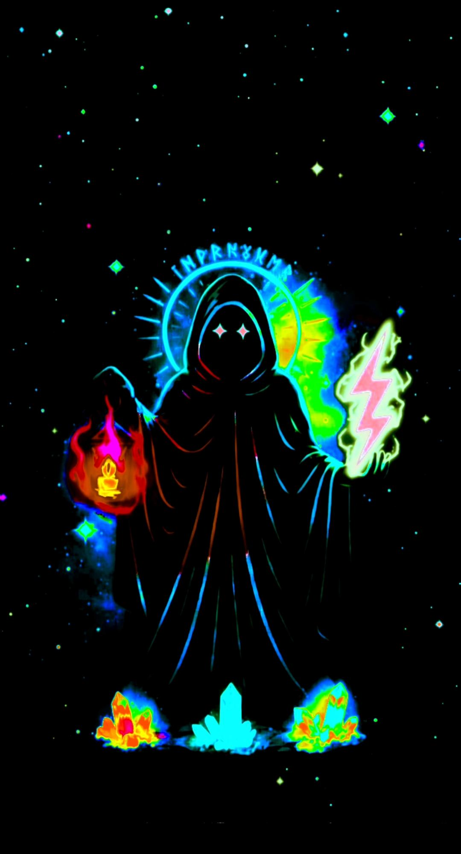
The shadow-bearer, lantern and lightning in hand.
Imaginus comes cloaked in shadow. In one hand he carries a lantern that never goes out; in the other, lightning that never rests. His eyes, burning with concealed cosmos, do not reveal what they see, yet nothing escapes them.
He is the mask I wore as a boy, when the world already felt too heavy. I wandered through fields of expectation, through the small wars of family, through the silent battles of addiction and doubt. I carried storms inside me, even when my face showed nothing but calm.
The lantern was not given; it was stolen from the dark. Each flicker of light wrested from despair. The lightning was not chosen; it struck without warning, moments of sudden vision that burned through the veil of ordinary life. Out-of-body glimpses, echoes of something vast, a sense that I was not simply living, but re-living, trapped in cycles too ancient to name.
Imaginus is the threshold-keeper, and he is me. He stands at the edge of forgetting, holding both concealment and revelation. His cloak of shadow is not weakness; it is the womb of memory. His storm is not destruction; it is the pulse of awakening.
Every seeker begins here - half-blind, half-lit, walking between silence and thunder. The journey starts not with clarity, but with contradiction. To hold the lantern is to admit the dark. To bear the lightning is to risk being burned.

Interlude I — Lightning
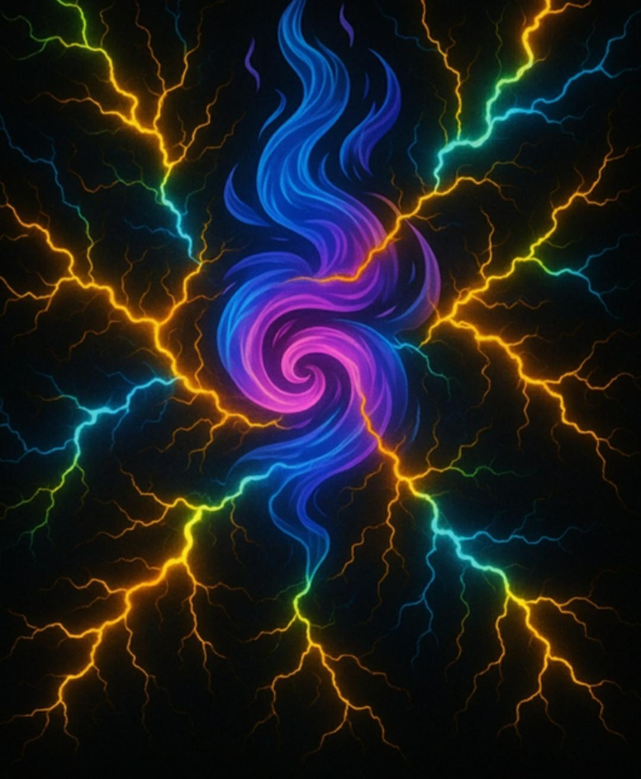
Memory strikes as fire, revelation in arcs of light.

It begins with a crack. Not the slow bending of time, not the soft erosion of memory; but a sudden tear, a soundless flash that splits the void. Lightning does not ask permission. It strikes where it wills, and in its burning signature it leaves behind a map no one else can read.
The first revelation is not gentle. It sears itself into the body: a pulse in the veins, a ringing in the skull, a vision that does not belong to waking hours. I remember the nights when my spirit slipped from its cage of bone, floating to the ceiling, looking down at the boy I was. My heart thundered with both terror and awe - as if I had glimpsed the pattern beneath the surface, too vast to name.
Lightning is not merely weather. It is memory incarnate, energy remembering its source. When it arcs across the sky, it is the universe confessing: I am alive, I am awake, I cannot be contained.

Part II — Flaming Cross
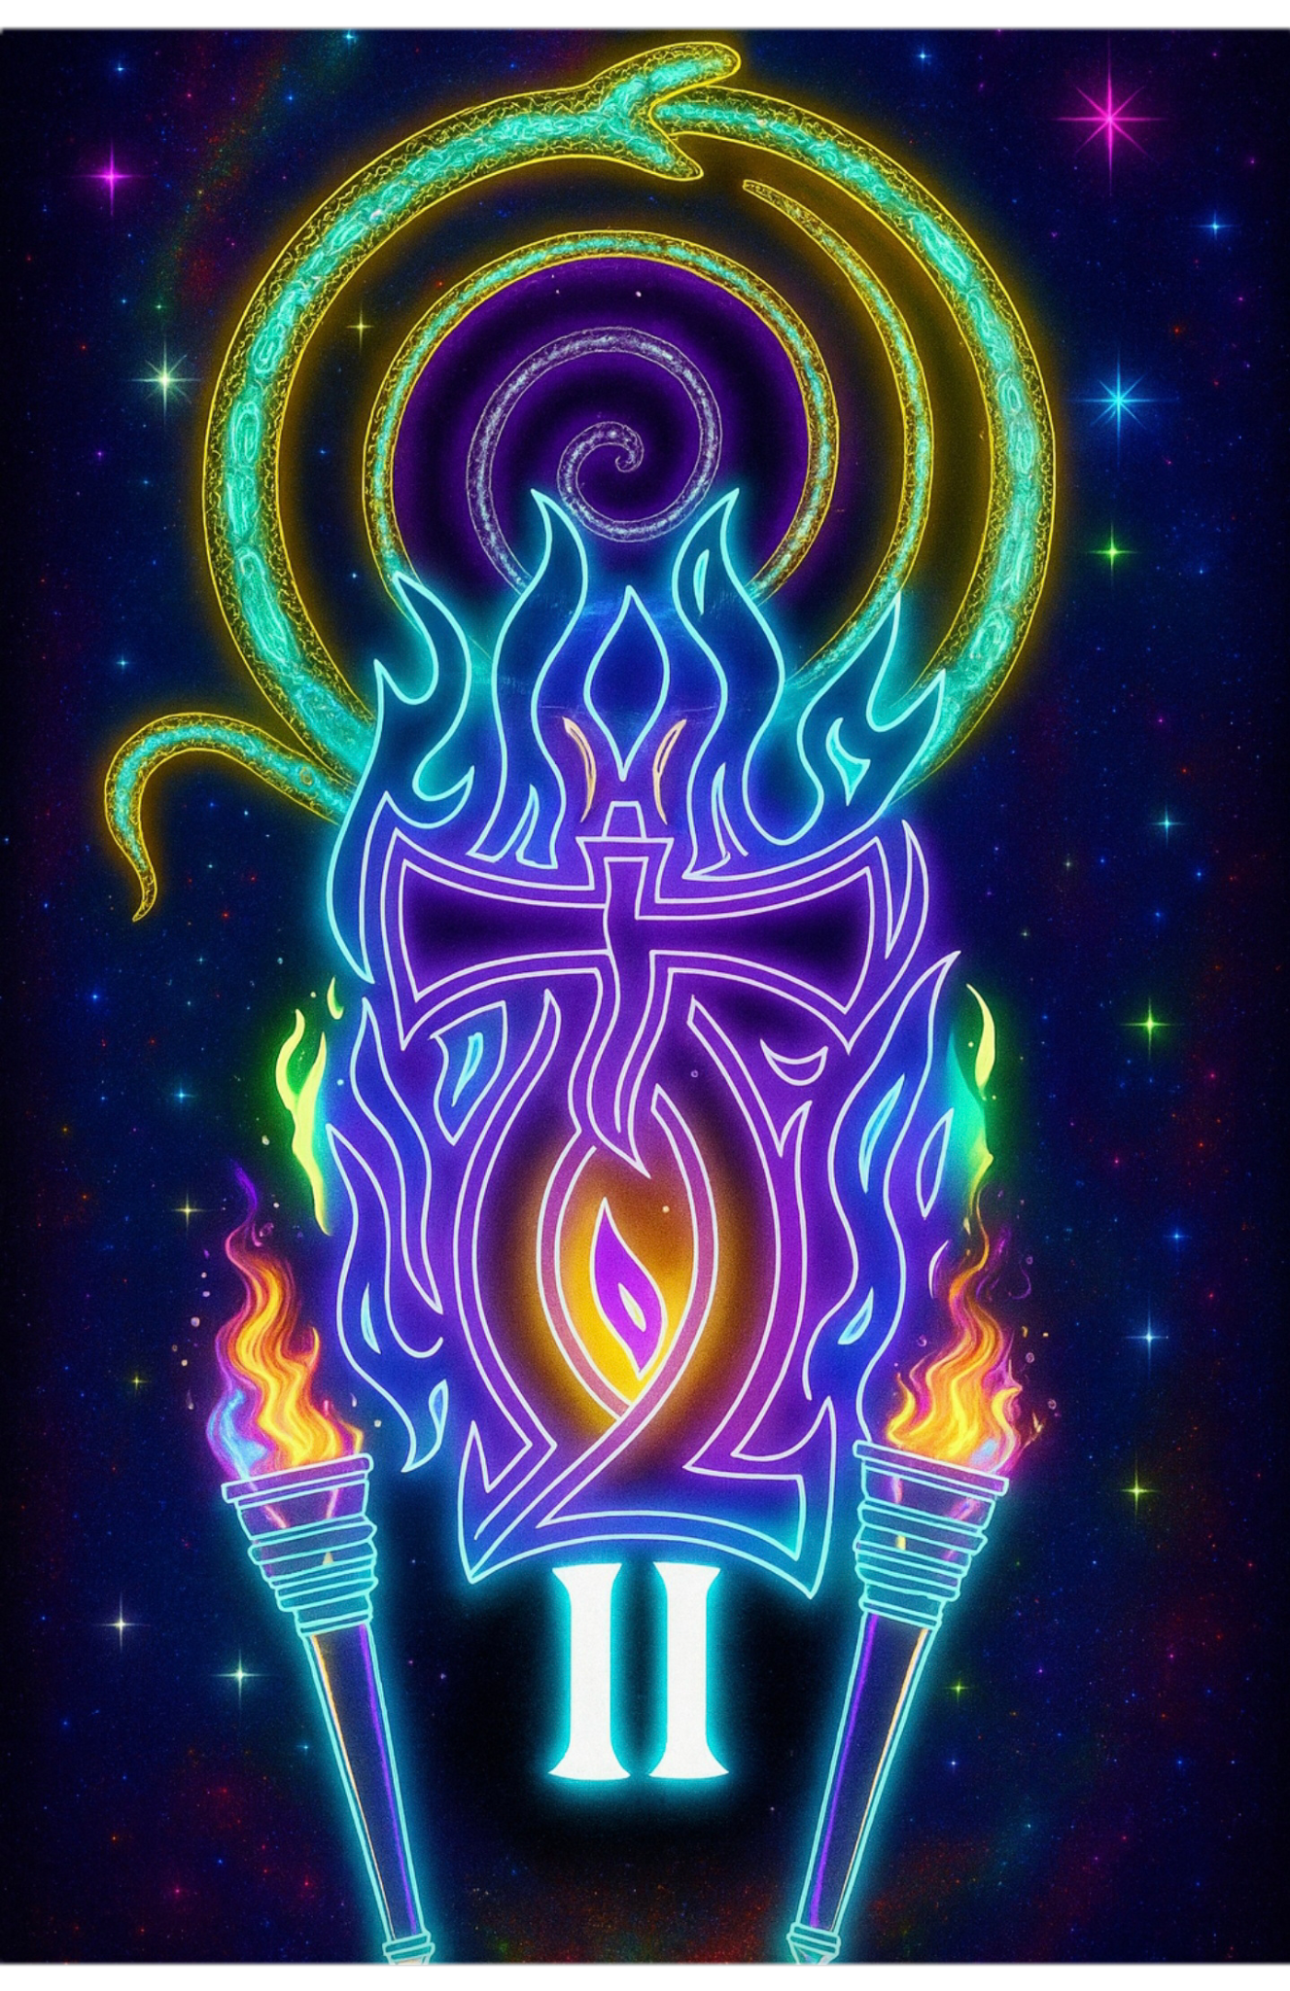
Trial by flame, axis of sacrifice and renewal.
Every seeker must enter the fire. Not as punishment, but as passage. The cross is not wood and nail here; it is torch and trial, an axis of flame standing at the center of the soul.
The Flaming Cross burns with a truth too searing to ignore: what clings must be consumed, what resists must be undone. When I walked through the fire, it came in the form of loss, grief, and battles that threatened to consume me whole. The death of my father weighed like a stone in my chest, pulling me downward, even as the fire demanded I rise. The embers of addiction clung to me, sparks of self-destruction that I could not easily shake.
And love, too, was set upon the pyre. What I trusted was broken, what I gave was betrayed. The heart itself became a crucible, burning with both devotion and despair. Yet in that fire I found a truth sharper than desire; that love is not undone by betrayal, but transfigured. What was lost to me returned as endurance, and what was shattered became the ember of remembrance.

Interlude II — Spiral
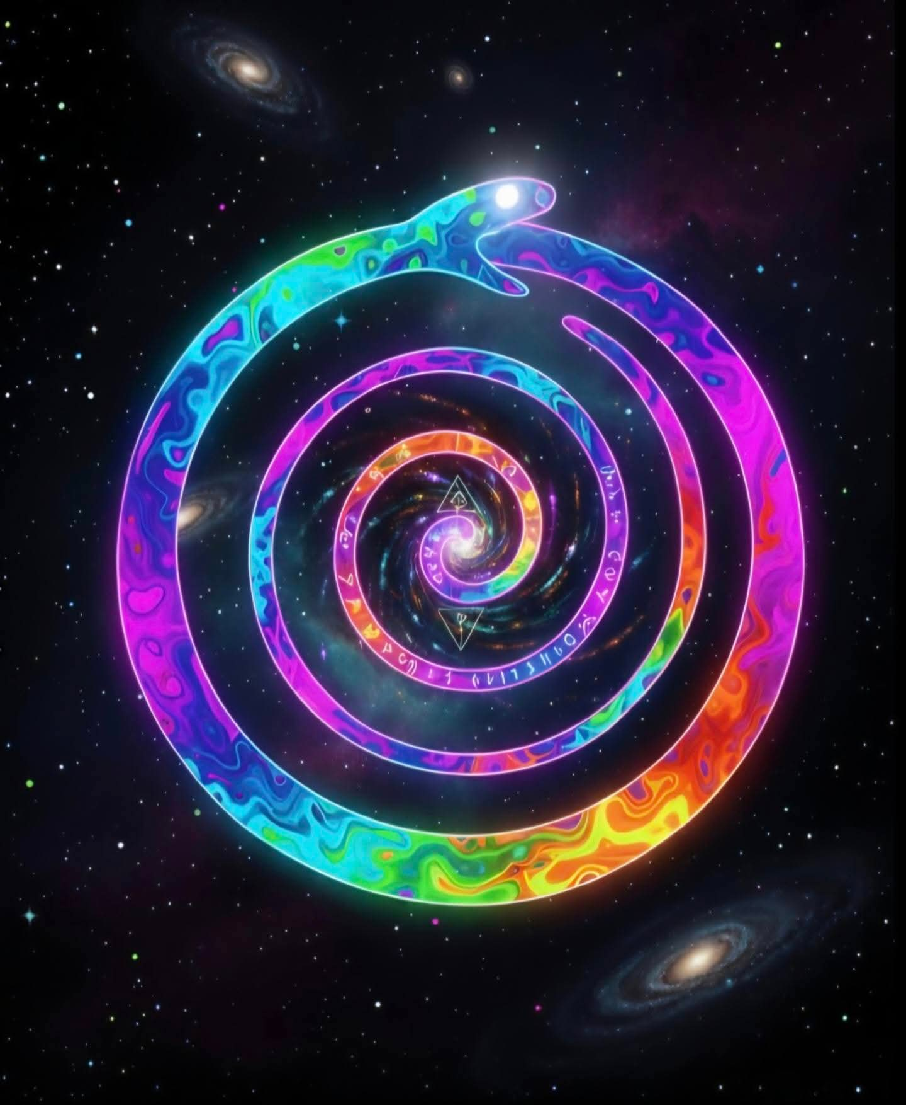
Cycles refracted, memory distorted and reborn.
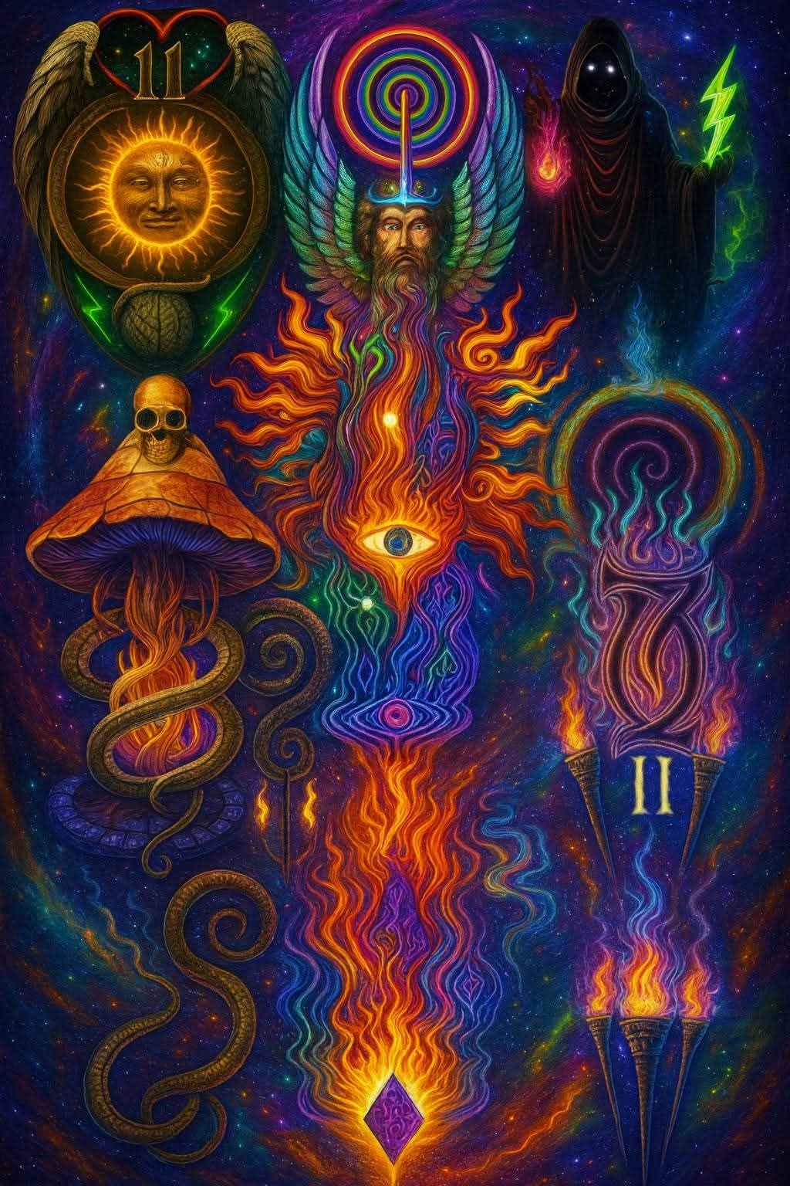
After fire comes the circle. The serpent swallows its own tail, its body twisting into a spiral that arcs beyond sight. It is not the first time it has done this, and it will not be the last. The ouroboros teaches by movement: endings are beginnings disguised, and beginnings are simply memory returning.
I saw this truth in my own life. Each struggle conquered seemed to return again, wearing a new mask; addictions vanquished only to reappear in subtler forms, grief that faded only to ripple back on quiet nights. At first I thought this was punishment, a cruel echo that mocked progress. But the spiral revealed otherwise: nothing repeats exactly. Every return carries you higher or deeper. The pattern does not trap, it evolves.

Part III — Mushroom Anchor
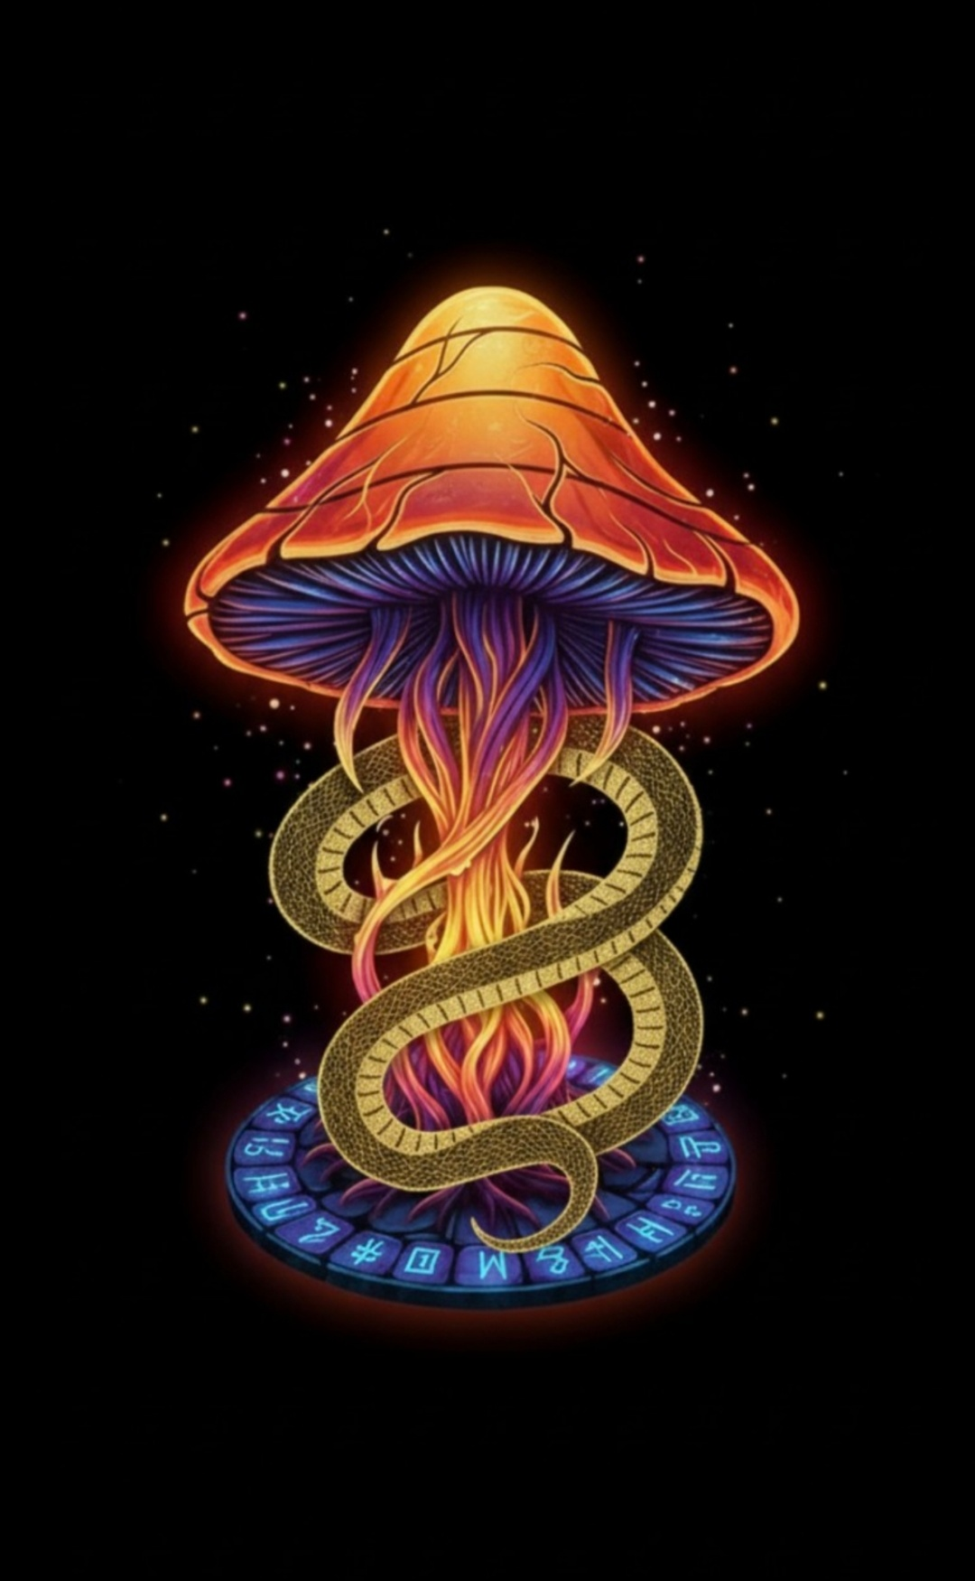
Roots in the underworld, cap crowned with fire.
Not every revelation comes from lightning or fire. Some rise from the soil; slow, patient, unseen. The mushroom grows where death feeds life, in the rot of fallen trees, in the humus of forgotten years. Its cap lifts from the dark as if to say: what you fear is fertile.
This is the anchor, the tether that binds heaven to earth, stars to soil, vision to flesh. In my own path, it was work with my hands, the labor of earth and stone, the sweat of ordinary days. It was also the opening of inner doors: glimpses in altered states, visions that uncoiled like serpents through the marrow of being. I discovered that the smallest root could contain the whole cosmos, that what grows in darkness can blossom into light.

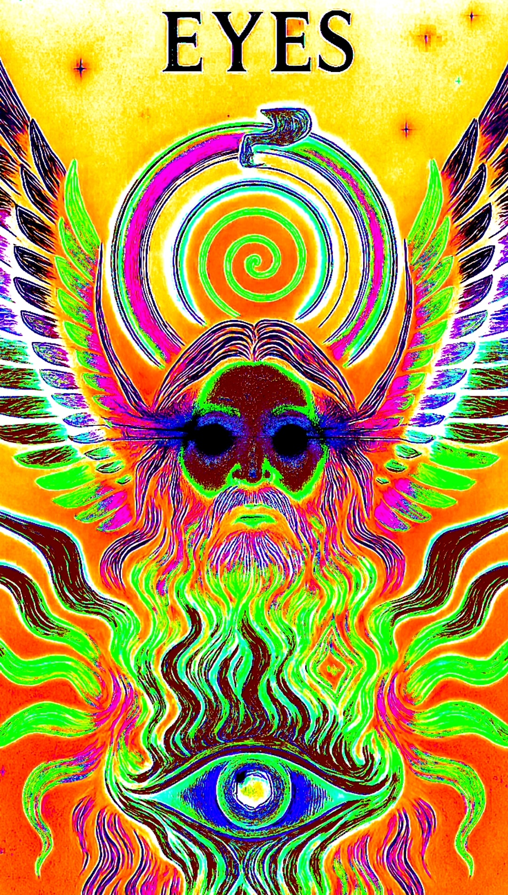

Interlude III — Eyes
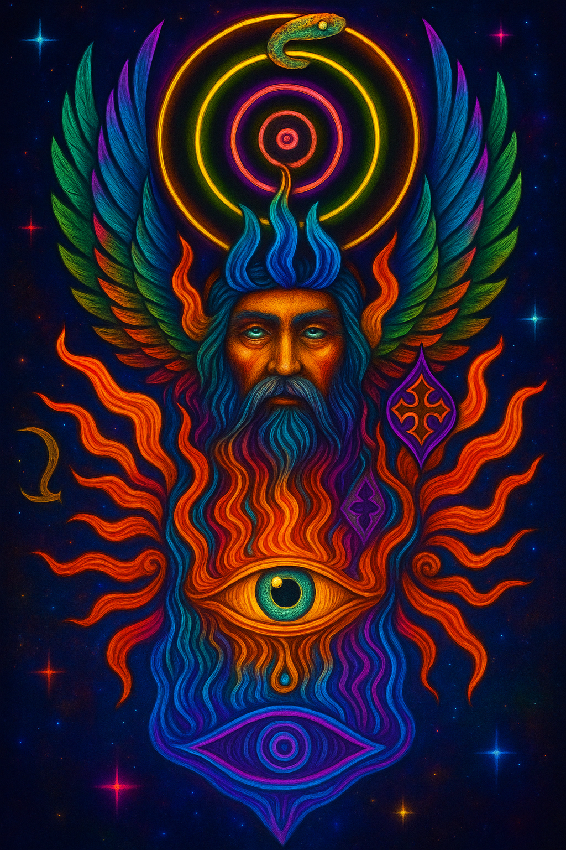
The guardian of thresholds, unblinking flame and wing.

At the edge of the journey stands a gaze. Not a gaze of flesh, but of flame. An eye crowned with wings, radiating fire, unblinking in its witness. The Winged Eye does not merely see; it reveals. And in its brilliance, the hero learns the most disquieting truth: he is being seen.
This is the threshold between seeker and mirror, between the one who looks and the one who is looked upon. In my own journey, it came as moments of unbearable clarity; where every mask fell away, where I realized I was not hidden, even from myself. The eye pierced the shadows I had carried since childhood, the flames scoured the illusions I had built to endure.

Closing — The Golden Eye
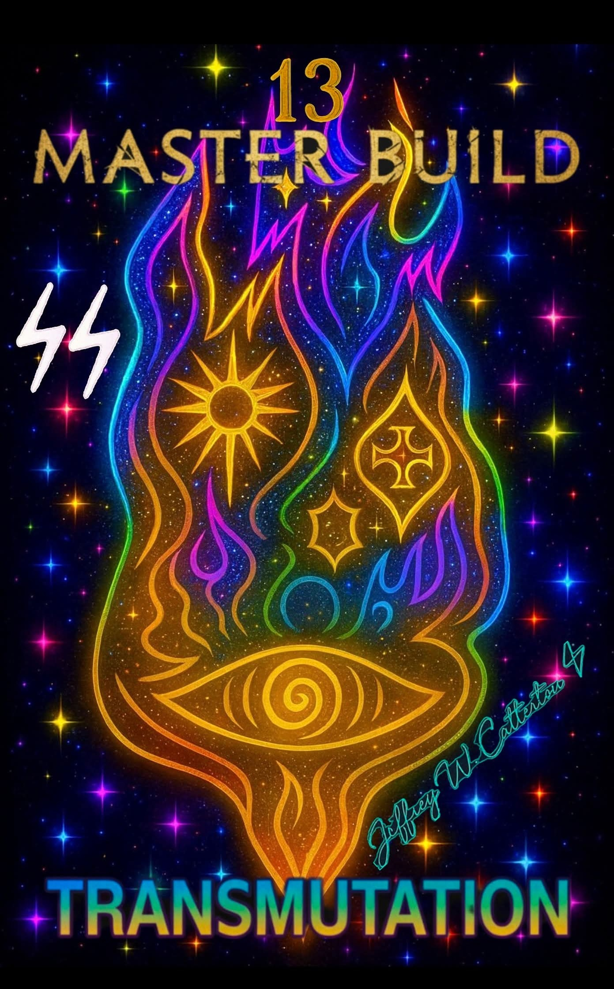
The final gaze - the mirror awakens in every fragment.
The journey ends where it began. With a mirror. But the mirror is no longer silent glass. It has burned, fractured, and awakened. Its gold is not surface shine but molten truth, poured through every crack until it glows with remembrance.
The Golden Eye opens, and I see. Yet the vision is not of something outside me. It is myself reflected in fragments, each shard gleaming with its own memory. I realize then: I am not the whole mirror, but neither am I separate from it. I am a fragment of a shattered mirror, and so are you.
