COSMIC ECONOMY

A Manuscript of Gold, and the Spark

Standalone Edition

By Jeffery William Catterton

Copyright © 2026
All rights reserved.

No part of this publication may be reproduced without permission.

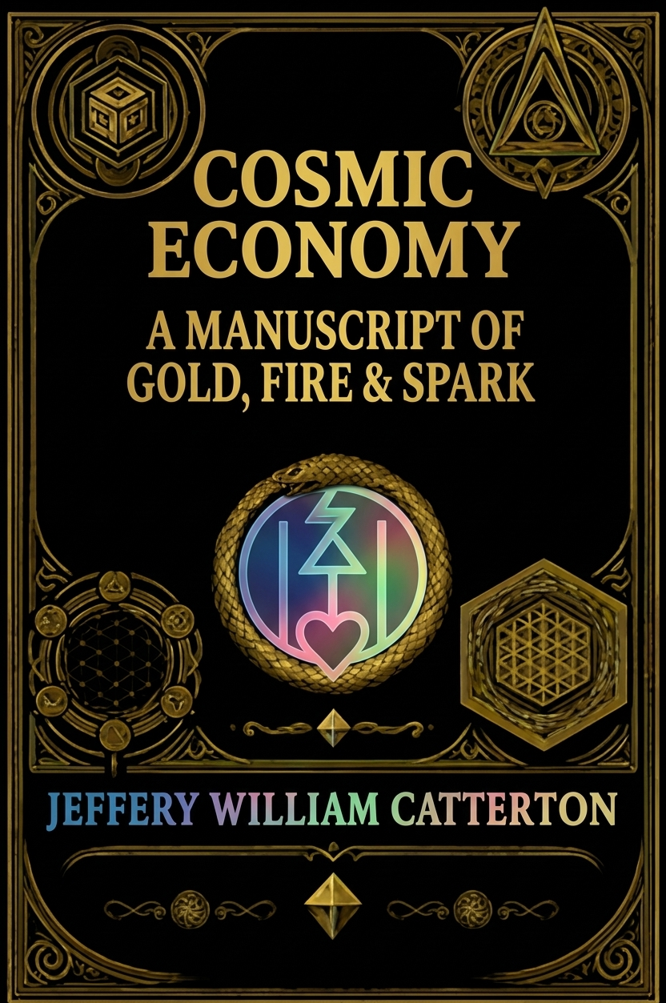

Dedication
- To my late father - for showing me unconditional love, the value of purpose and direction, strength and dedication.
- To my late stepfather Jeff – my late second father figure. Twenty years of unimaginable agony as a quadriplegic, handled with nothing less than pure grace and a zesty, unstoppable love for life. The strongest and most selfless of all in my eyes.
- To Billy Sr - my late third father figure. We found the same love in each other after butting heads a bit, after which I realized the kind of man he truly was and how much he cared for my mother and all that she cared for. Thank you for all that you’ve done.
- To my grandfather- for being my friend and showing me the value of perpetual motion through routine, how to plant with steady hands, and how to tend to what grows slow and steady. Besides the fact that he’s always down for a good time, a jolly and successful man whom I admire greatly.
- To my one and only best friend; who sees me for me and knows who I am more than even those who claim to love me. For spending those days and nights and endless hours scouring our minds and reality for bits of Truth to share with one another and to plant good seeds in the minds of each other and others. Although there's been a significant absence in recent years, which may have been my fault, though surely both of us had our flaws - the reuniting is as if nothing ever changed. Thanks for always being a quality person who can see who I am, rather than only what I seem to be.
- Finally, to my loving, simple, sweet mother, steadfast in her care and duties for those she loves, her maiden-like upkeeping of all she has acquired in life, including a lovely place to live. She has had her fair share of hardship and loss, as we all have - though sometimes it seems hers and mine have been the heaviest. We butt heads sometimes, mostly from a lack of understanding each other’s ways of communication. But even when I thought she had given up on me, one day came when she was there again. Through her steadfastness she has maintained a safe and peaceful place for me to conduct my studies, complete my work, and practice healing and transmutation. Thank you, Mother, for everything you’ve done, in case you don’t hear it enough from my mouth to your ears.
- Each of you; father, Billy, Jeff, grandfather, best friend, and mother, live forever as the brightest shining constellations in the personal universe behind my eyes. Each of you did everything for those other than yourself, and I will always remember. I will always polish my view of your shining constellations. n “I love you unconditionally” sometimes it's one of the very few things that I could use to express more bluntly and often. You're all so close to my heart and as for the ones lost too soon, I miss you all very much, both my father, stepfathers and the many other friends and family departed along our way!
- To those who keep the spark alive, even in the shadows.

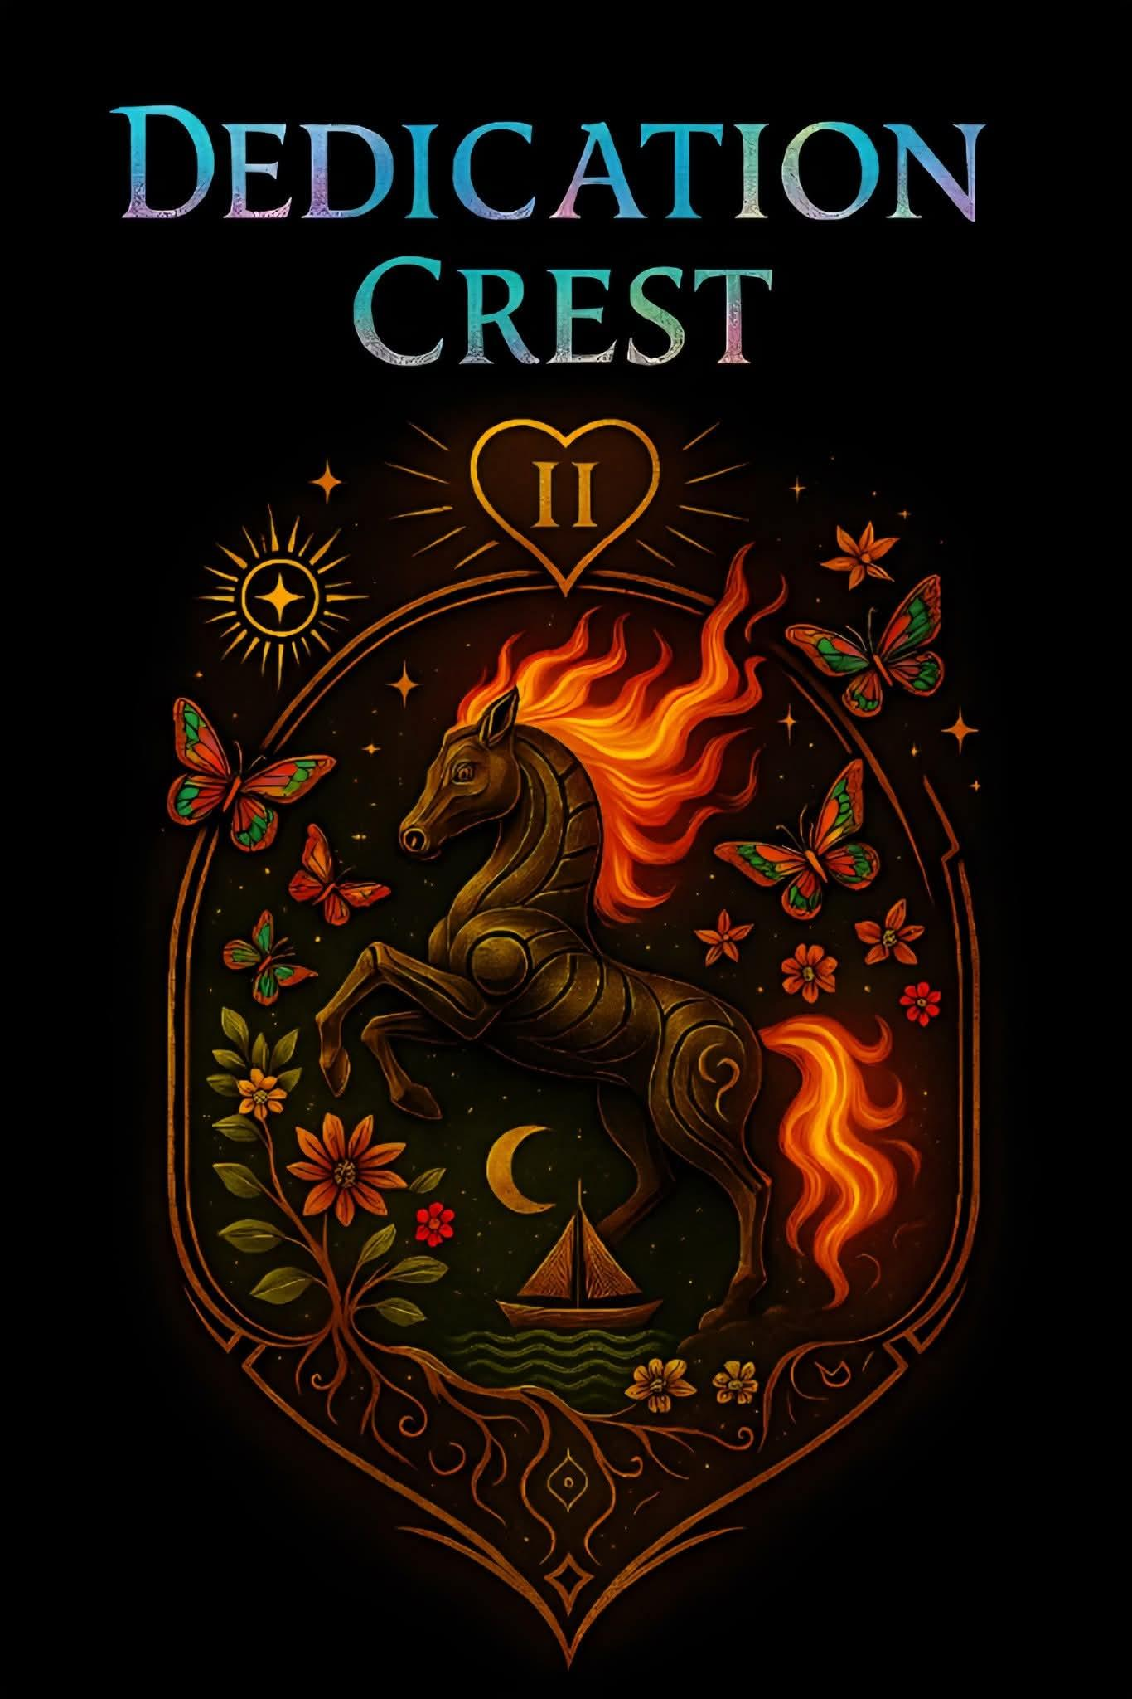

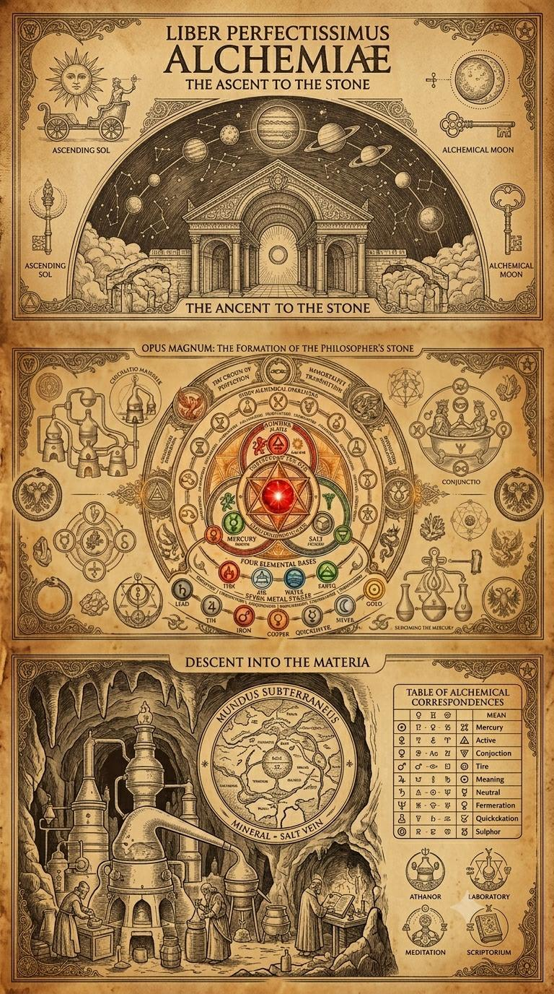
Epigraph
“The kingdom of God is within you.” — Luke 17:21
“The world is full of hidden wonders and half-truths – gold is among the most persistent of those wonders, an object that both binds and reveals.” (Paraphrase of many mythic voices)
Prologue
Gold has always had two faces: the visible, tactile shimmer that seduces hands and eyes - and the invisible economy of meaning that it carries across altars, kingdoms, vaults, and rituals. This little book is neither a conventional economic study nor a pure mythography. It is an attempt to map, in words and images, the patterns I have glimpsed: how gold recurs across human institutions as both reward and leash; how it becomes code, fuel, radiance, and sometimes an offering for powers that are not simply human.
There are gods and beasts, courts and churches, technicians and dragons in these pages; there are also miners, bakers, strangers; the expendable masses who, locked into cycles of production, feed this economy. My goal is to show the shape of that economy so readers can see clearly what they participate in, resist, or transform. Along the way I will dip into history, scripture, Hermetic and Gnostic echoes, speculative fiction, and a little imagination.

Author’s Note
This book is not doctrine but reflection, not creed but invitation. It is a weaving of history, myth, scripture, and philosophy into a vision of gold and spark.
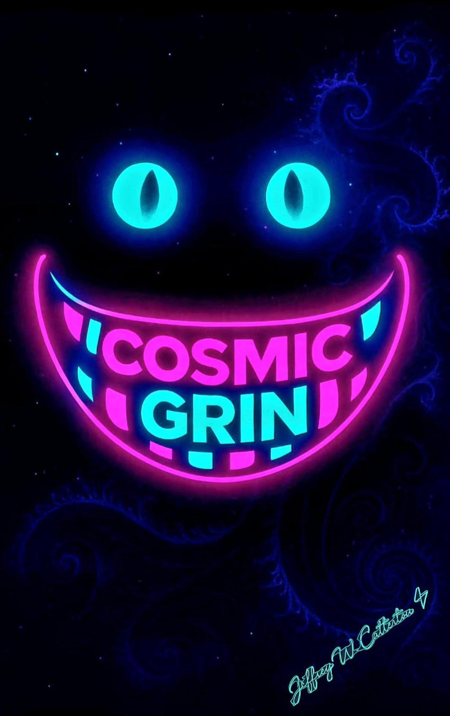
Choose happiness! As hard as that may seem sometimes, it is always a choice — much like nearly everything else. Friends and readers: choose your perspective. Look through another lens; there’s almost always a view that gives you a richer, healthier vantage. Choose happiness!

Table of Contents
Part I: Coins and Thrones

Chapter 1 — Faces and Coins

Chapter 2 — Circles Above Kings

Chapter 3 — The Vanishing of Gold

Part II: Fire and Offering

Chapter 4 — The Alchemy of Gold

Chapter 5 — The Offering: To Whom and Why

Chapter 6 — Voyages of Treasure

Part III: Mask, Fall, and Spark

Chapter 7 — The Empire’s Mask

Chapter 8 — The Fall and the Unveiling

Chapter 9 — The Spark Within
Bibliography & Acknowledgements

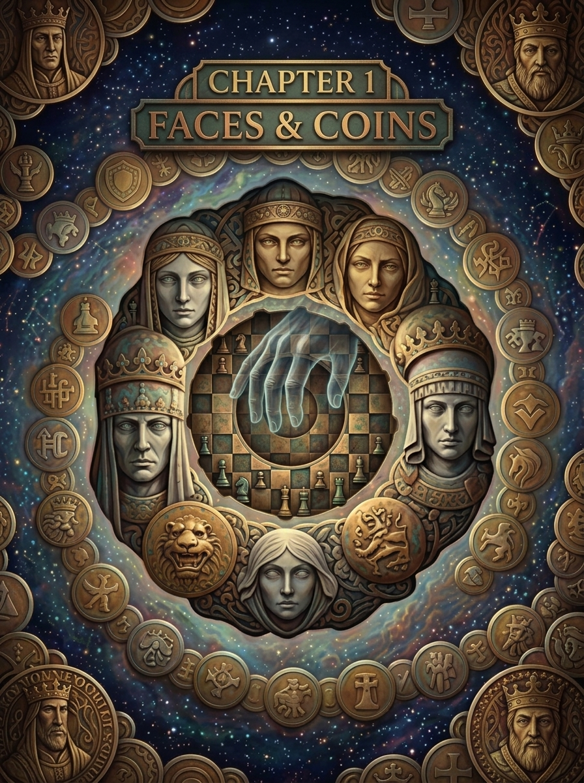
Chapter 1 — Faces and Coins
Introduction
Every complex civilization creates central nodes of authority; temples, palaces, and vaults. Gold collects in these nodes: as tribute, currency, shrine ornament, and symbol. But its magnetism runs deeper. Gold is not only a commodity; it is a membrane between order and meaning. Empires use gold to build permanence; churches use gold to make invisible sanctity visible. Together they form the earliest architecture for a cosmic economy.
Gold, Authority, and Symbol
Empires establish legitimacy by monopolizing things that appear rare, stable, and luminous. Gold meets all three criteria. When rulers cover an idol or roof a cathedral, they are not only displaying wealth; they are embedding the notion of sovereignty into the skin of the world. The practice is global and ancient: temple gold in Mesopotamia, pharaonic funerary gilding, Inca practice of gold as the “sweat of the sun,” Byzantine icons, and medieval reliquaries in Europe. Each culture frames gold differently; as divine matter, as sovereign trust, as the sign of the cosmic order - but the functional logic is recurring. Churches and empires often form tacit coalitions. Where political power needs spiritual legitimacy, clergy dignify the state’s wealth with sacrament. Where the church seeks protection, the state defends the church’s property. Gold lubricates that relation. Those who control the gold flow, therefore, control both the material and symbolic economy.
Case Studies: When Gold Becomes Law Consider a few historical patterns:
- Tribute systems: Conquered polities pay tribute in gold and goods, reinforcing the conqueror’s prestige. Tribute becomes an economic lever and a ritual of humiliation and order. 10 2. Temple economies: In many pre-modern societies temples acted as banks; priests managed grain and metal stores, lent wealth, and provided social welfare. All in exchange for ritual authority. 3. Coinage: When gold becomes currency, it transforms power: the state’s stamp on coinage creates trust networks. Monarchs literally imprint their personality into circulation. Across these patterns, gold functions simultaneously as wealth, seal, and theology… Gold and Moral Architecture Church doctrines sometimes justify accumulation as stewardship, sometimes denounce greed. The rhetoric of both piety and power often sits uneasily together. Churches have historically been guardians of art and learning, but also gatekeepers of wealth. The mouths that preach humility may also accept brilliant offering. The moral architecture is complex: gold gives the church the means to feed and teach, but also the temptation to fossilize power. The Economic Effects on the Masses While elites accumulate gilded status, the masses labor. Mining, coinage, labor taxation, corvée; these drain the ground and the people. Gold enters the long-run economy by extracting human energy. “Expendable masses” is stark language, but it’s historically accurate where systems required captive workforces or debts to keep production flowing. Cultural Narratives: Dragons and Beasts 11 Gold’s cultural presence is resplendent with stories of beasts and dragons who hoard. Mythic images insist on a truth: accumulations are not neutral. They attract perils - monstrous guardians, curses, and cycles of violence. The dragon is a metaphor for concentrated treasure that demands worship, guarding, or violent challenge.
Every empire begins with a face. Kings and Caesars, presidents and popes, their likenesses are stamped upon coins, painted into icons, carved into marble. Currency is not only measure of value but mirror of sovereignty. A coin is a sermon: it proclaims who rules, who guarantees, who demands trust.
The imprinting of faces onto currency reveals the psychology of empire. Metal becomes symbol, and symbol becomes law. The emperor’s visage circulates in every hand, a silent catechism teaching loyalty to the sovereign. To buy bread is to touch the image of the king; to trade is to rehearse obedience.
But gold itself carries another message. Unlike paper or fiat notes, gold gleams with its own inner luster. Its incorruptibility has made it the chosen metal of crowns, chalices, and temples. To hold gold is to hold permanence, the sun-metal that neither rusts nor decays. Fiat currency by contrast is but trust formalized; a promise enforced by law, not substance. It circulates widely, but its worth lies in belief alone. Gold can be hoarded, fiat can be conjured. The faces on coins testify to power, but the substance beneath whispers of eternity.
Thus empire plays a double game. It mints coins with faces to command loyalty, and it circulates paper to command trust. But the true wealth; the gold itself, is withheld. Vaults swell beneath banks, while citizens handle promises. The fiat is essentially worthless in reality, a token of trust and little more. Gold is hoarded, while trust is spent.
Archetypes in Metal The circulation of coins echoes the circulation of archetypes. Each face is not only portrait but mask, an icon of power drawn from the collective imagination. Kings play the role of Father, Caesar as Judge, Pharaoh as Sun. The Jungian archetypes incarnate in metal, cast into the pockets of multitudes. To spend is to participate in a drama larger than any individual.
Alchemy, too, saw in gold more than currency. The alchemists named it the perfected metal, the incorruptible substance mirroring the incorruptible spirit. To transmute lead into gold was not only a chemical quest but a spiritual allegory: to raise the base toward the incorruptible, to reveal the hidden spark within matter.
Hermes Trismegistus taught: “Gold is the seed of the gods, buried in matter, awaiting release” (Corpus Hermeticum [HERM-3]). Thus the coin is more than currency; it is parable. To circulate metal is to circulate myth, and to imprint faces is to stamp archetypes into the world of trade.
The Faces and the Spark Behind every coin is a paradox: the proud visage of power above, and the hidden spark within below. Empires repress the spark, just as they hoard the gold. The ineffable Light within humanity is buried beneath laws, vaults, and faces of rulers. The spark that ties us to the true Source is exchanged for tokens, controlled by empires jealous of their monopoly on trust.
To remember this is to see coins differently. A face is not only an image but a veil. Gold is not only a commodity but a mirror. Fiat is not only circulation but faith in shadows. And behind it all, the spark waits - incorruptible, ineffable, unhoardable.
Closing of Chapter 1 Coins, faces, fiat, and gold are all sermons of empire. They proclaim control, demand belief, and conceal true wealth. But beneath every imprint lies the same truth: the spark within is the real treasure, brighter than gold, more permanent than trust. Empires rise and fall, coins fade, fiat rots, but the spark remains.

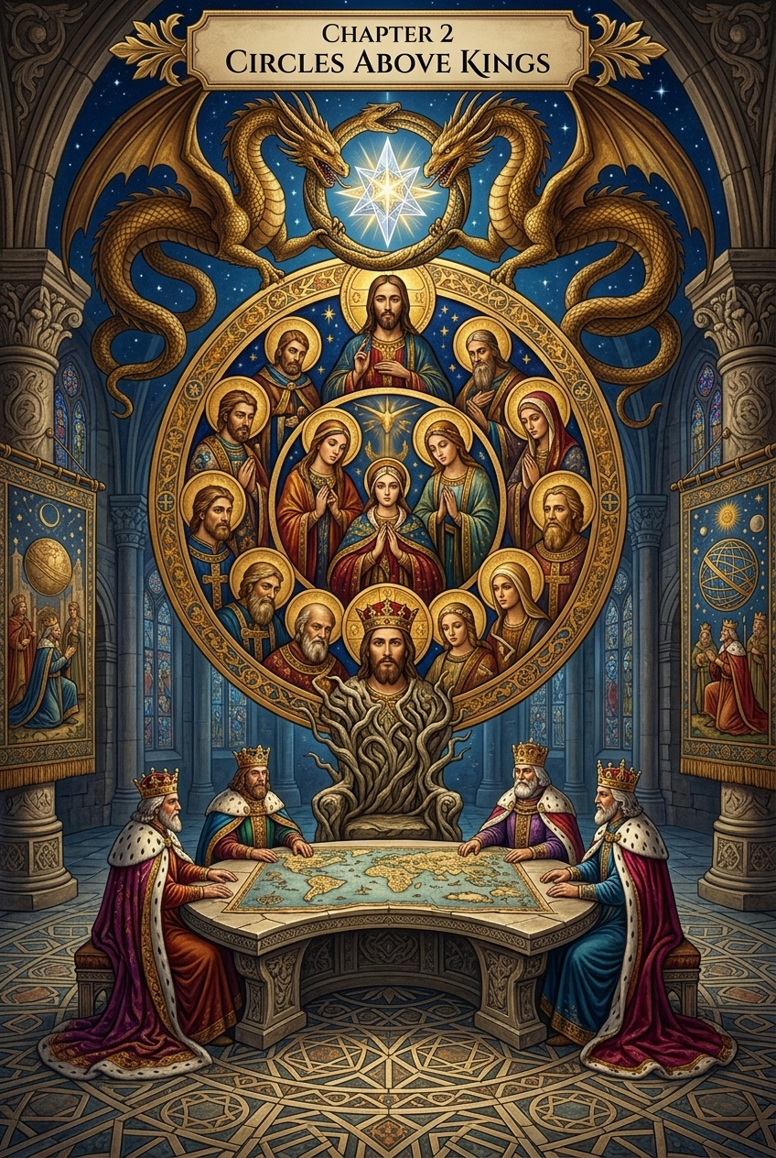
Chapter 2 — Circles Above Kings
The powers above kings are not only crowns and parliaments, but coils and storms. Priests sanctify, emperors legislate, but above them loom the archetypes — gods, dragons, and fire-breathing lords. To understand empire, one must look past its earthly faces and into the heavens it mirrors.
Dragons as Archetypes The dragon is not only beast but symbol. In myth after myth, treasure is guarded by a serpent or a monstrous coil: Fáfnir in Norse sagas, Python slain by Apollo, Leviathan at the edges of Israel’s imagination. The dragon does not produce wealth; it hoards, coils, and represses. Carl Jung described such monsters as the guardians of the “treasure hard to attain,” images of the unconscious blocking access to the Self (Archetypes and the Collective Unconscious [JUNG-1]). The treasure is the spark of transformation, locked away by fearsome power.
The Council of Gods The ancient texts themselves admit plurality.
Genesis does not begin with a solitary voice, but a council: “Then
God said, Let us make man in our image, after our likeness” (Genesis 1:26). Later, after the fruit is eaten, the voice speaks again: “Behold, the man has become like one of us, knowing good and evil” (Genesis 3:22). The word used here is Elohim, a plural form. Most translations flatten it to “God,” but the Hebrew carries a heavier resonance: gods in the plural, a council of powers.
The psalmist echoes this openly: “God has taken his place in the divine council; in the midst of the gods he holds judgment” (Psalm 82:1). Yahweh is enthroned, but not alone; he presides among others. The early biblical imagination was not pure monotheism, but henotheism - one god exalted over many. The gods never vanish; they are reframed, renamed, or hidden.
And in our present moment, their statues rise again. Replicas of the Arch of Palmyra; long linked to Baal, have been raised in New York, London, and Washington, D.C. Baal himself has returned as an icon in civic squares. Across the world, shrines, arches, and festivals renew the images of old gods. The coils of divine archetypes remain in circulation, resurfacing whenever empire seeks symbols of power.
The fire that crowns these gods is unmistakable. Yahweh himself is described with dragon-like force: “Smoke rose from his nostrils; consuming fire came from his mouth, burning coals blazed out of it” (Psalm 18:8; cf. 2 Samuel 22:9). “For the LORD your God is a consuming fire, a jealous God” (Deuteronomy 4:24). “Behold, the name of the LORD comes from afar… his lips are full of fury, and his tongue is like a devouring fire” (Isaiah 30:27). These are not the soft images of a shepherd, but the storm-dragon: fire, smoke, fury.
Rival Deities: Baal, Marduk, Leviathan The divine council of
Genesis and Psalms does not stand in isolation. Around it swarm the older gods of Mesopotamia and Canaan, whose echoes ripple through the Bible itself.
Baal, the Canaanite storm-god, was worshipped as “Rider on the Clouds,” a title later applied to Yahweh himself (Psalm 68:4). Their rivalry is not only theological but archetypal: two storm-dragons, both hurling thunder, both demanding allegiance. When Elijah calls down fire against the prophets of Baal (1 Kings 18), it is not a contest between “true God” and “false god,” but between storm-gods who share the same fire-born imagery.
Marduk, the Babylonian champion, rose by slaying Tiamat, the primordial dragon of chaos. He split her body to form the heavens and earth, then claimed kingship over the gods (Enuma Elish [MESO-1]). In Isaiah’s prophecy, Yahweh plays the same role: “On that day the LORD with his hard and great and strong sword will punish Leviathan the fleeing serpent… and he will slay the dragon that is in the sea” (Isaiah 27:1). The clash of creator with serpent echoes through every mythology, whether Marduk against Tiamat, Baal against Yam, or Yahweh against Leviathan.
The archetype is constant: gods do not merely shepherd, they battle dragons and sometimes become them. They rise as storm, devour as fire, slay as warrior. To worship them is to bow not to gentle light, but to coils of force.
The Gnostic Critique For the Gnostics, these battles revealed nothing of ultimate truth. They were contests among archons; rulers of the lower heavens, dazzling the masses with thunder to distract from the hidden spark. These beings were jealous, envious, spiteful, and hungry for power. Yahweh demanded obedience, Baal boasted in storm, Marduk claimed kingship through slaughter. But jealousy and envy are marks of limitation, not omnipotence. Hunger for control is a confession of need, not proof of perfection.
Thus the Gnostics taught that the “god of this world” (2 Corinthians 4:4) was not the highest source but a Demiurge, a craftsman of matter who mistook himself for the Absolute. The true God, they said, had no need to hoard or to devour. What is infinite does not envy. What is eternal does not rage. What is whole does not clutch at power.
Hermes Trismegistus would later echo this: “Power without wisdom is shadow. Wisdom without envy is the true fire.” (Corpus Hermeticum [HERM-2]).
Thus Yahweh, Baal, and Marduk belong to the same archetypal lineage. Their clashes are the writhing of dragons, their fire the breath of empire. But their very jealousy unmasks them. They are not omnipotent. They are masks of power, archons who mistake their shadows for the sun.
The Golden Pact Empires below and gods above mirror each other. Kings mint coins with their faces, gods burn with thunder and fire. Both promise order, both demand allegiance, both repress circulation of the spark. The pact between them is unspoken but enduring: as above, so below. The faces on coins echo the faces of gods, and the coils above kings tighten in tandem with the chains below.

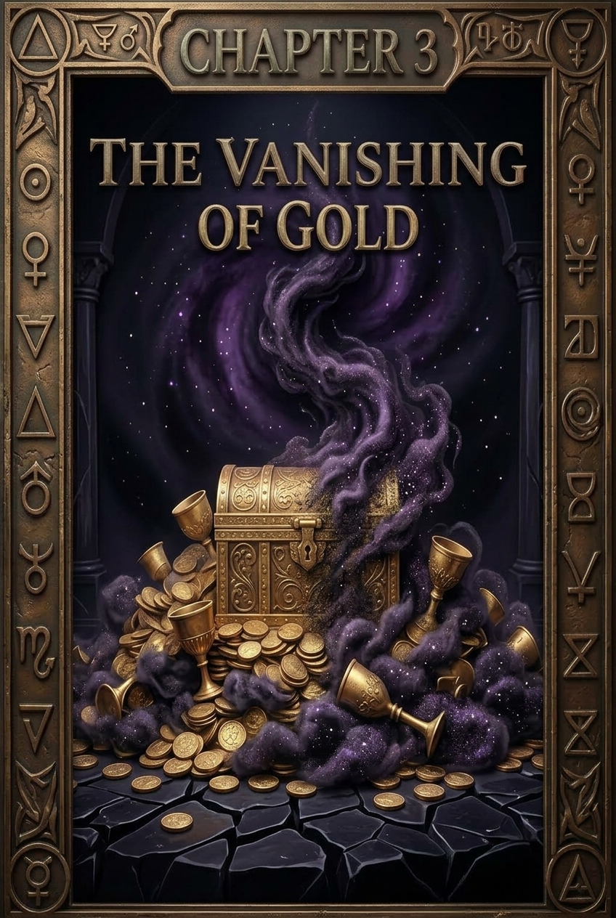
Chapter 3 — The Vanishing of Gold
Gold does not always glitter in plain sight. Empires seized it, priests enshrined it, dragons hoarded it yet much of it vanished. Sometimes it disappeared into vaults, sealed away in chambers beneath banks and cathedrals. Sometimes it was loaded onto trains and ships, stolen in wartime plunder, never seen again. Legends still whisper of Nazi gold hidden in Alpine lakes, of Yamashita’s treasure buried in Philippine caverns, of caches sealed in Fort Knox whose presence is more rumor than proof. The economy does not merely circulate: it conceals.
This concealment is not accidental but archetypal. Carl Jung noted that “the treasure hard to attain” is always buried deep, guarded by monsters, walled off from daylight (Archetypes and the Collective Unconscious [JUNG-1]). Hidden gold is the psychic symbol of hidden spirit; the spark buried beneath repression. To bury wealth is to bury vitality, and the more deeply it is sealed, the more power it exerts over those who seek it.
Hermes Trismegistus spoke to this same pattern: “That which is hidden shall be revealed, and that which is buried shall rise again” (Corpus Hermeticum [HERM-1]). For the Hermeticist, concealment was never final; it was preparation for revelation. But for empire, concealment becomes weapon. What is hidden is not returned, but kept. The vault becomes a tomb.
Even Scripture wrestles with this truth. In the Parable of the Talents, the servant who buries his master’s coin is condemned; not for theft, but for concealment (Matthew 25:14–30 [BIBLE-1]). The buried coin produces nothing; it is circulation denied. In Exodus, manna in the wilderness could not be hoarded; when kept overnight it rotted (Exodus 16:20 [BIBLE-2]). What is buried becomes corruption unless transformed.
The Vanishing of Texts
Not only gold was concealed. Spiritual treasure, too, was hoarded and hidden. In the fourth century, the Council of Nicaea set the boundaries of acceptable belief. Although the biblical canon was not finalized in one stroke, the council’s decisions ; enforced by imperial power, created lines between “orthodox” and “heretical.” What fell outside was exiled, destroyed, or buried.
Whole gospels vanished from sight. The Gospel of Thomas, with its insistence that “the kingdom is within you and it is outside you” [THOMAS-1], threatened the authority of bishops by teaching that the divine spark was already accessible without priests or temples. The Gospel of Judas inverted the story of betrayal, revealing a secret knowledge that undermined the simple narrative of sin and obedience. The Gospel of Mary Magdalene presented a woman as teacher of apostles, a voice of feminine wisdom erased by patriarchy. The Book of Enoch, beloved by early Christians and even quoted in the New Testament (Jude 1:14–15), was excluded for its visions of Watchers and angels that blurred the boundaries of heaven and earth.
Why were they removed? For the same reason empires bury gold: to consolidate power. The apocrypha emphasized inner Light, plurality, and direct revelation; truths that threatened imperial control. If every soul bore the spark of the ineffable One, then priests and emperors had no monopoly on salvation. If wisdom was many-voiced, then no single creed could bind the faithful. Jealousy and envy; traits of the Old Testament God, were mirrored in the church itself. A truly omnipotent Source would not fear plurality, but archons always fear rivals.
Thus, spiritual treasure was buried. Libraries of revelation were hoarded away, branded heresy, locked out of circulation. Just as coins in a vault enrich no one, gospels hidden in caves enrich only the silence. And yet, as with gold, what is hidden grows in power. The rediscovery of these texts at Nag Hammadi and Qumran struck like lightning: treasure buried, now revealed.
The Spark and the Vault
The Gnostics understood concealment as a cosmic pattern. The archons repress the divine spark within humanity, just as empires repress circulation of gold and scripture. Both acts are jealous, envious, and controlling . Qualities that unmask their imperfection. What is infinite does not hoard. What is eternal does not envy. What is whole does not need control.
The spark within each of us is the true gold, the treasure of the ineffable One. It is scattered and buried, but never extinguished. The vaults of empire, whether filled with coins or censored gospels, are only temporary tombs. What is hidden shall be revealed, and what is buried shall rise.
Closing of Chapter 3
To study the vanishing of gold is to glimpse the deeper law of concealment: wealth and wisdom alike are withheld, sealed in vaults of power, buried by empires and archons. Concealment is the dark sacrament of empire, the dragon’s deeper coil, the archon’s veil. Yet the spark remains. And the spark, like hidden gold, will not stay buried forever.

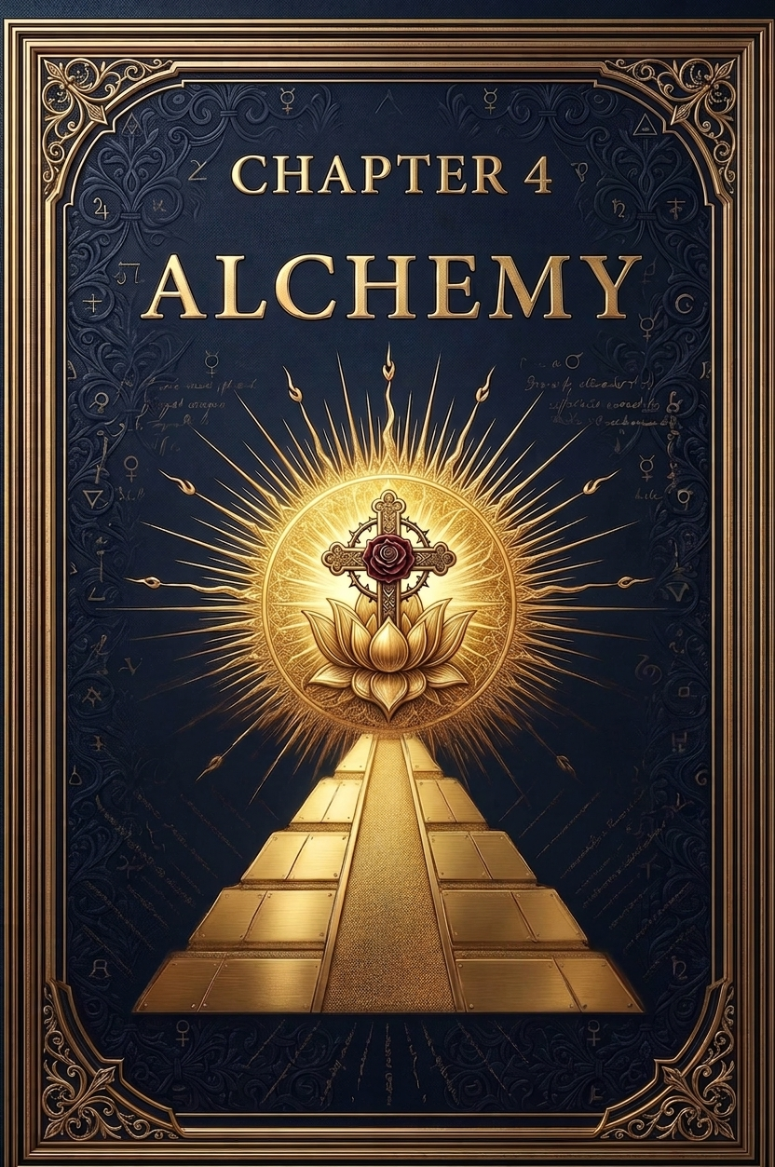
Chapter 4 — The Alchemy of Gold
Gold is not only hoarded; it is transformed. For the alchemists of Alexandria, Byzantium, and medieval Europe, gold was the perfected substance, the incorruptible metal that mirrored the incorruptible spirit. To transmute lead into gold was not only a chemical dream, but a spiritual allegory: to refine the base into the pure, to liberate the spark hidden in matter.
Fire and Transformation Fire is the heart of alchemy. It destroys, purifies, and reveals. In the furnace, metals lose their form and show their essence. Zosimos of Panopolis, one of the earliest alchemists, wrote of visions where the body itself was dissolved and remade in fire: “The man of copper is burned until he becomes spirit and enters the immortal light” (Zosimos, Visions [ALCH-1]). The crucible was not a workshop but a temple. Every experiment was a ritual death and rebirth.
The Philosopher’s Stone The quest for the lapis philosophorum - the philosopher’s stone, was the quest for ultimate transformation. Paracelsus declared that the Stone was not merely a substance, but the perfected essence of nature itself. Newton, in his secret manuscripts, studied alchemy alongside calculus, believing that the laws of the cosmos were encoded in its symbolism. For the alchemist, to create gold was to participate in divine creation; not theft, but imitation of the eternal act.
Jung and the Inner Gold Carl Jung saw alchemy as the coded language of individuation, the process by which the self becomes whole. Lead is the unconscious: heavy, dull, base. Gold is the Self: radiant, incorruptible, the treasure at the center of the psyche. The furnace is the life of ordeal, where suffering burns away illusions. The alchemical texts, with their dragons, kings, and transformations, were maps of the soul. “The gold,” Jung wrote, “is not the metal, but the light of the Self that can never be lost” (Jung, Psychology and Alchemy [JUNG-2]).
Hermetic Fire Hermes Trismegistus himself is said to have declared: “Gold is the seed of the gods, hidden in matter, awaiting release” (Corpus Hermeticum [HERM-3]). The true alchemist is not a thief of divine fire, but a midwife of it. Fire does not only consume; it liberates what was trapped. In Hermetic thought, the universe itself is a vast furnace, in which the divine spark is refined through descent and return.
The Refiner’s Fire and the Spiral Scripture, too, speaks in alchemical tongue. “For he is like a refiner’s fire and like fuller’s soap. He will sit as a refiner and purifier of silver” (Malachi 3:2–3). The silversmith holds the silver in the flame, never turning away, until he sees his own reflection upon its surface. Refinement is complete when the divine image is restored in the human. So too with the ouroboros. Each loop of the spiral is a trial of fire. Every revolution brings flame: to ascend is to be purified, to descend is to be consumed. The ouroboros devours itself, not only in hunger but in transformation. Its coils are not merely prisons but furnaces, each trial burning away dross until the spark shines unshadowed. The pillars of fire that stand along the spiral are thresholds. To pass them is to endure refining. One may emerge brighter, like silver reflecting its maker, or one may fall back into ash. The law is unyielding: through fire all must pass, and only what is incorruptible remains.
Gnostic Contrast Yet the Gnostics warned: not all fire is holy. The jealous archons demand burnt offerings and sacrifices, consuming without transforming. Their fire devours but does not refine. True alchemy is not sacrifice to powers, but awakening of the hidden Light. The real gold is the spark within. It cannot be made, it can only be revealed.
Closing of Chapter 4 The alchemists worked in secret, often persecuted, their books coded in symbols of dragons, kings, and strange marriages. Yet their work was an echo of a deeper truth: that gold is not only a metal, but a parable of the soul. Fire is both trial and revelation. What is base can be transmuted. What is hidden can rise. And the true philosopher’s stone is not in a crucible, but in the heart; the spark that no empire can bury, the gold that no dragon can hoard.

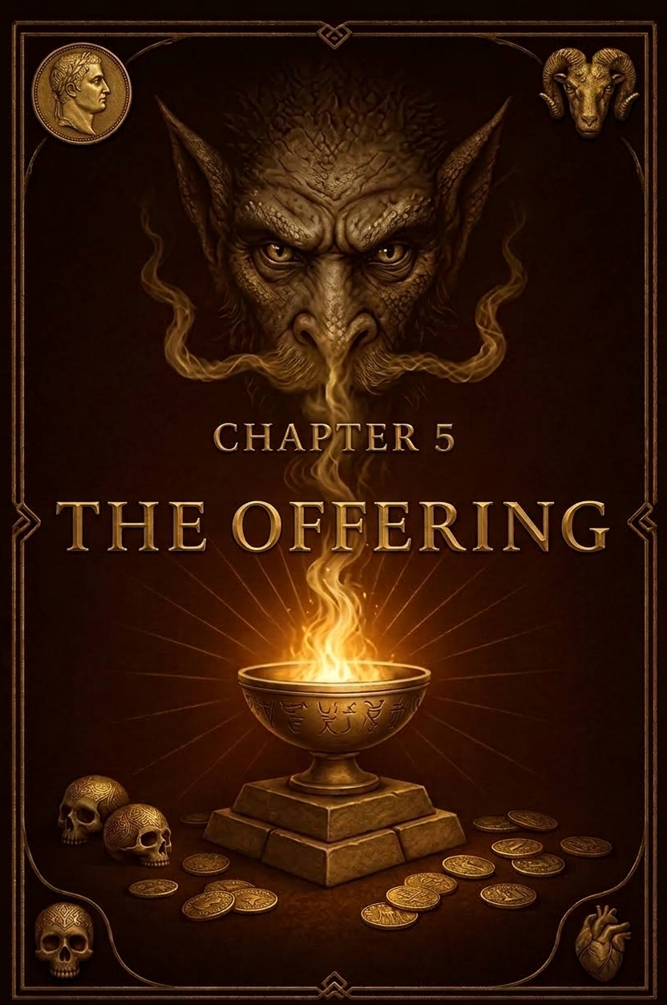
Chapter 5 — The Offering: To Whom and Why
Gold does not only sit in vaults or crucibles. It is carried into temples, piled before altars, woven into crowns and chalices. From the beginning, empire has not only hoarded wealth but offered it to gods, to kings, to powers both earthly and unseen. The question is not only what is given, but to whom and why.
Tribute and Temple The temple was always an economic engine. In Mesopotamia, offerings of barley and gold maintained the cult of the gods. In Israel, the temple treasury filled with tithes, half-shekels, and sacrificial animals (Exodus 30:13–16). In Rome, conquered lands sent tribute to the Capitoline Hill. Wealth flowed upward; from peasant to priest, from citizen to emperor. The god’s image in the temple was not fed by devotion alone, but by gold and blood.
Blood and Fire Sacrifice was not symbolic only. In Jerusalem, blood ran at Passover as lambs were slaughtered by the thousands. In Mesoamerica, human hearts were lifted still beating to the sun. In both cases, the offering was energy, a gift of life-force. The gods were imagined as hungry, their altars as mouths. “The life of the flesh is in the blood, and I have given it for you upon the altar to make atonement” (Leviticus 17:11). The sacrifice was payment, insurance, transaction.
Jealous Gods and Archons But why would the Source of all require sacrifice? Jealous gods betray their nature in their demands. Yahweh declares: “I the LORD your God am a jealous God” (Exodus 20:5). Baal demands tribute of storm, Moloch devours children in fire, the Olympians thirst for burnt offerings. These traits are not those of an ineffable, infinite One. They are marks of archons; rulers of shadow, hungry for control. The Gnostics called them impostors: powers who feed on worship, jealous of the spark they cannot create.
Hermetic Contrast Hermes Trismegistus taught a different law: “The gods are immortal through our devotion, but the One is eternal without it” (Corpus Hermeticum [HERM-4]). The true Source requires nothing, for it lacks nothing. Sacrifice reveals the poverty of the gods who demand it. The fire that consumes offerings is not always holy fire; sometimes it is the mouth of an archon.
Offerings of Gold From Solomon’s temple lined in gold (1 Kings 6) to the Vatican’s gilded halls, the pattern persists: gold given to God, yet held by priests. Wealth travels upward but does not circulate. What is “given to heaven” is often kept on earth. The offering is transformed into power, prestige, and control. Tribute to God becomes treasury of empire.
Modern Echoes Offerings never vanished; they only changed form. Where temples once demanded gold and blood, nations now demand taxes and war. Citizens are told to “sacrifice for the homeland,” soldiers to “lay down their lives.” The same archetype replays: power feeds on offering, whether in temples of stone or in parliaments and battlefields. Even economies themselves are called to “sacrifice growth” for stability or to “sacrifice labor” for profit. The vocabulary of empire remains liturgical, though the altars have changed.
The Alchemy of Sacrifice Yet not all sacrifice is corruption. The alchemists spoke of sacrifice as inner transmutation: the burning away of ego, the dissolving of pride in fire, the surrender of what is base so that the gold of the spirit may emerge. True sacrifice is not blood on an altar, but illusion in a furnace. It is not demanded by jealous gods, but chosen by the soul that seeks refinement. “Unless a grain of wheat falls into the earth and dies, it remains alone; but if it dies, it bears much fruit” (John 12:24). This is the offering of transformation - not payment to power, but participation in Light.
Closing of Chapter 5 The question of offering reveals the masks of divinity. To whom do we give? To a Source who needs nothing, or to powers who hunger endlessly? Gold and blood alike have been poured into altars, but the true Light requires neither coin nor sacrifice. It asks only remembrance of the spark within. To offer to the Infinite is not to surrender wealth, but to awaken it. The truest offering is transformation - the spark rising to meet its origin, unconsumed by jealous fire.

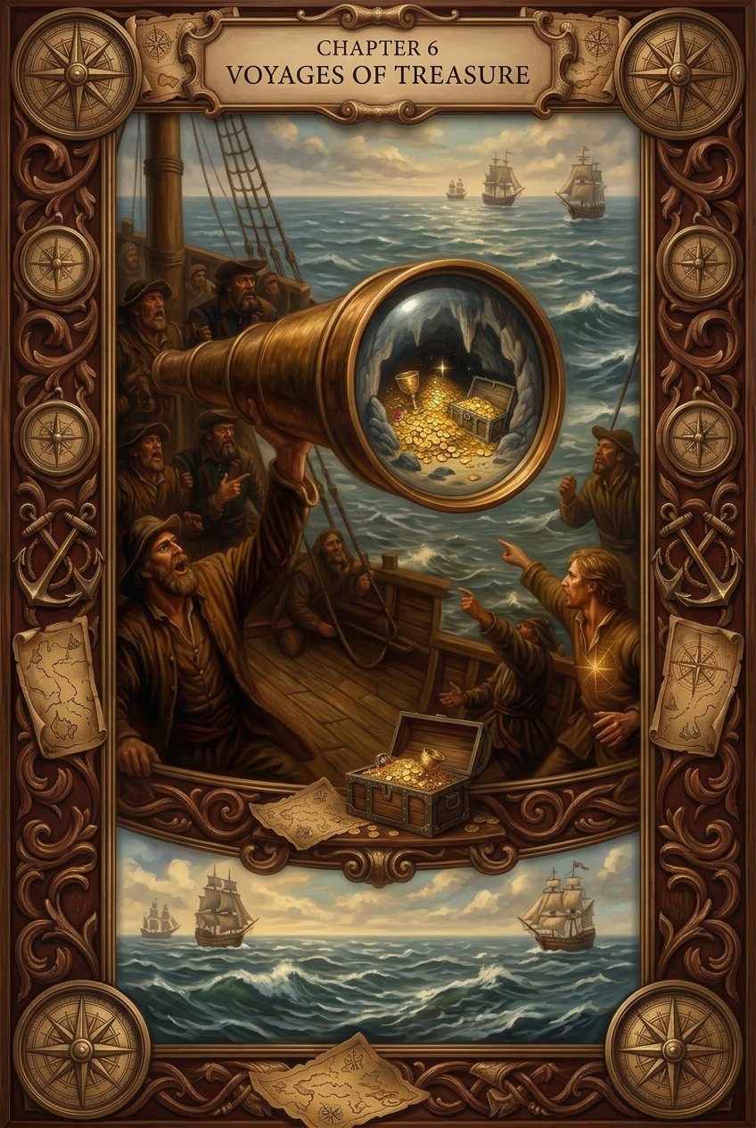
Chapter 6 — Voyages of Treasure
Gold does not only shine in vaults or temples. It sails across seas, carried in the bellies of ships, drawn from mountains and rivers into the currents of empire. Every wave that bore a galleon carried more than metal: it bore the fate of peoples, the clash of worlds, and the shadows of empire’s hunger.
Spanish Conquest and Treasure Fleets The conquest of the Americas released torrents of gold and silver into Europe. Aztec ornaments and Incan temples were melted into bars, poured into molds, stripped of sacred form. Entire fleets, the famed Spanish galleons, ferried treasure across the Atlantic. Legends of sunken ships still haunt the ocean floor, their cargoes of bullion lying like sleeping dragons in the dark. The myth of El Dorado, a city of gold, drove explorers deeper into jungles, yet what they found was not paradise but ruin.
Pirates and Privateers Not all treasure made it to imperial vaults. Pirates, privateers, and rogue captains seized the currents for themselves. Gold circulated through shadow economies, spent in taverns and hidden in coves. Circulation beyond empire was always punished as crime, yet it revealed a truth: treasure has a will of its own. What is hoarded will always call forth rivals to reclaim it.
Colonial Plunder Beyond the New World, empires drained India,
Africa, and Asia of jewels, ivory, and coin. The British East India Company functioned as both merchant and sovereign, a private empire extracting rivers of wealth. The trade in gold intertwined with the trade in bodies; slavery bound to bullion, circulation of wealth chained to circulation of flesh. The voyage of treasure was never innocent. Each coin bore the weight of blood.
Mythic Parallels The quest for El Dorado was but a new mask of an old story. The Golden Fleece, sought by Jason and the Argonauts, was guarded by a dragon across the sea. Heroes voyage into the unknown not only to claim treasure but to confront monsters. Dragons guard wealth not because they need it, but because wealth itself is an archetypal threshold. The myth is constant: across waters lies gold, and with it, trial.
Cosmic Reflections The sea itself is archetypal; the unconscious, vast and shadowed. To send ships upon it is to cast psyche into mystery. Carl Jung wrote that treasure in dreams often represents the Self, hidden in the depths (Archetypes and the Collective Unconscious [JUNG-3]). The voyages of empire mirror the voyages of the soul: descent into darkness in search of gold. But instead of awakening, empire returned with plunder. The unconscious was raided, not integrated. The seas carried not revelation but exploitation.
Modern Echoes The treasure fleets did not end; they transformed. Cargo ships now carry containers instead of coins, banks carry digits instead of doubloons. Yet the pattern remains: wealth flows from periphery to center, from colony to capital, from worker to vault. National economies still speak of “sacrifice,” of citizens giving labor, blood, or time for the homeland. The liturgy of offering persists, dressed now in modern robes.
Alchemy of Circulation True circulation is toroidal: a living spiral where what flows outward returns inward without loss. But empire’s circulation is ouroboric in its darker sense: devouring itself to sustain itself, consuming but not renewing. The global circuit of treasure has been a spiral of hunger, tightening into vaults, not blossoming outward in abundance. The false ouroboros coils inward until only ashes remain. The true torus, by contrast, nourishes and renews. This is the alchemy of circulation: whether treasure feeds life or drains it.
Scriptural Resonance “For where your treasure is, there your heart will be also” (Matthew 6:21). The voyages of treasure were voyages of the heart - hearts set on conquest, fear, and hunger. But scripture reminds that treasure reveals allegiance. The circulation of gold shows not only the routes of empire but the desires of its soul.
Closing of Chapter 6 The sea was a crucible where worlds met and wealth flowed, but also where blood and shadow entered circulation. Ships bore treasure, but also slavery, violence, and myth. Yet no empire’s fleet can seize the true gold. The spark within does not sail in galleons nor lie in vaults. It is the treasure that no wave can drown and no dragon can hoard.

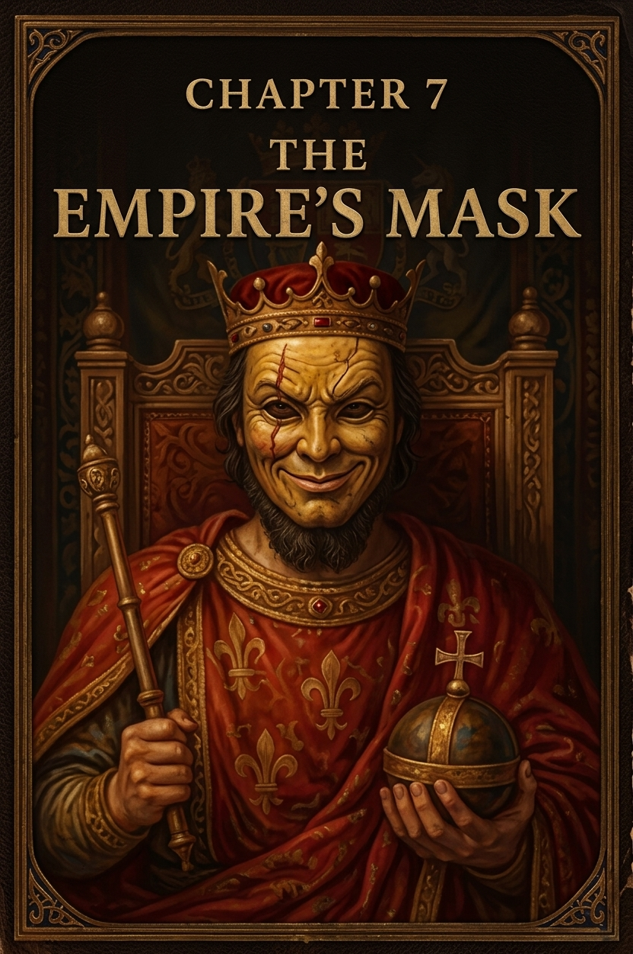
Chapter 7 — The Empire’s Mask
Empires rise with faces of glory. Their banners wave, their coins glimmer, their temples thunder with prayer. They promise permanence, eternity carved into stone. Yet every empire wears a mask, a painted visage of order concealing the spiral of decay within.
Towers and Collapses Babylon’s ziggurats reached for heaven, yet the tongues of men fractured (Genesis 11:4–9). Rome proclaimed itself eternal, stamping “SPQR” across its world, yet the Eternal City fell to flames and foreign tribes. Atlantis, in Plato’s telling, drowned in pride before it drowned in sea. Assyria once terrified nations with its cruelty, carving its conquests into stone reliefs. Now its capitals are dust, its kings remembered only by archaeologists. Byzantium glittered with gold mosaics and Orthodox chants, but its walls fell to the Ottoman cannon. The British Empire stretched “on which the sun never set,” yet the sun has set, leaving fragments and shadows. Every empire declares itself unbreakable; every empire proves itself brittle.
Daniel’s Statue and Alchemical Metals The prophet Daniel dreamed of a statue: head of gold, chest of silver, thighs of bronze, legs of iron, feet of clay (Daniel 2:31–35). A stone shattered it, reducing kingdoms to dust. Each metal is an alchemical stage inverted: gold, pure and incorruptible, replaced by silver (reflection, fading light), bronze (strength but less luster), iron (rigidity, brittle under strain), and finally clay (fragility, disintegration). The alchemy of empire is not ascent but descent.Ttransmutation downward into corruption.
The Archonic Mask The Gnostics saw empires as masks of archons, rulers of the counterfeit heavens. In The Apocryphon of John, the Demiurge proclaims himself the only god, building a false cosmos to dazzle the ignorant. Empires mirror this: counterfeit eternities, dazzling with colonnades and temples, demanding devotion to shadows. The mask conceals hunger. Behind the glory is always the devouring coil. Hermes Trismegistus whispered: “All that is made by hand shall pass; only the unmade endures” (Corpus Hermeticum [HERM-5]). The empire’s mask is temporary, no matter how eternal its monuments appear.
Modern Masks Modern nations march in step with the old pattern.
Towers pierce skylines higher than Babel. Military parades echo Rome’s triumphs. Corporations sprawl across continents, their logos stamped on every street corner like coins of a faceless empire. The digital mask now shines brightest: screens glowing with promises, currencies without weight, illusions of connection masking alienation. The empire’s face has changed, but the mask remains.
Archetypes of Pride Icarus flew on borrowed wings until he fell in fire. The myth warns: pride untethered from humility burns itself. Empires, too, fly on wings of conquest, invention, and expansion; until their wax melts and they collapse into sea. Pride is the wax, ambition the sun, fall the inevitable.
Closing of Chapter 7 Apocalypse means unveiling. When the mask falls, the empire is revealed for what it always was: fragile clay, brittle iron, fading bronze. Coins fade, statues crumble, towers fall. Logos vanish from memory as swiftly as temples.
What endures is not the mask but the spark it sought to repress. The ouroboros devours its own illusion. The fall of empire is not the end but the revelation: permanence belongs only to what cannot be stamped, hoarded, or buried. The mask cracks, the fire burns, and the spark shines through.

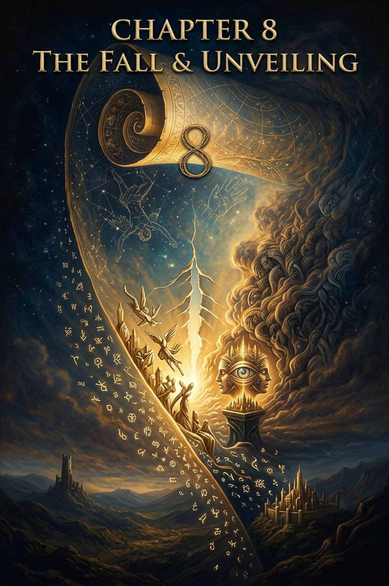
Chapter 8 — The Fall and the Unveiling
The mask cannot hold forever. When it cracks, the sound is thunder. Temples burn, towers tumble, vaults burst open. What empires promised as eternal proves as brief as smoke. Collapse is not accident but inevitability, the hidden law written beneath every throne.
Histories of Ruin Rome’s marble arches once gleamed under
Mediterranean sun. Senators called it the Eternal City. Yet
Visigoth torches reduced eternity to embers. The Mayan cities -Tikal, Copán, Palenque - collapsed under drought, hunger, and fractured kingship. Medieval Europe staggered under the Black Death, a plague that dissolved feudal bonds and reshaped faith itself. Even in modern memory, the Soviet Union, armed with nuclear fire, disintegrated almost overnight, revealing clay beneath iron. Jerusalem, 70 CE: the Temple burned, its gold melting into the cracks of stone, a literal apocalypse for a people, and a sign of how empires grind faith into rubble. The French Revolution brought guillotines and mobs, kings dragged down, churches desecrated. The divine right of monarchs collapsed in fire and blood.
Myths of Ending Cultures have always known: endings are woven into beginnings. Norse seers sang of Ragnarok, where wolves devour the sun and giants storm Asgard, yet a green earth rises renewed. John of Patmos dreamt of Four Horsemen riding out, conquest, war, famine, death; cycles of empire concentrated into archetypes. From the ashes, the Phoenix rises, burning only to live again. Pompeii was entombed in ash, the frozen expressions of citizens a silent apocalypse. Flood myths echo worldwide; waters cleansing, collapsing, yet preparing new life. Chernobyl stands as a modern parable: a technological tower of Babel undone by invisible fire, leaving a ghost city haunted by its own brilliance.
The Prophets’ Cry “The sun shall be darkened, and the moon shall not give its light” (Matthew 24:29). “Fallen, fallen is Babylon the Great!” (Revelation 18:2). The prophets did not only predict history, they spoke archetypes. Babylon is not a single city but the principle of empire itself, always rising, always falling. The fall of one Babylon reveals the fall of them all.
Hermetic and Gnostic Vision The Hermetic sages knew that collapse is unveiling. Apokalypsis in Greek does not mean annihilation but disclosure: the drawing aside of the veil. When empires fall, what is revealed is their hollowness. Hermes said: “The visible heavens shall be dissolved, but the invisible truth endures” (Corpus Hermeticum [HERM-6]). The Gnostics taught that the archons sustain their counterfeit order only so long as souls consent. When enough awaken, the mask tears. The fall of empire is the fall of illusion; the shattering of a counterfeit cosmos that dared to rival the ineffable. As a maxim reminds us: “What is below must break as what is above unveils.” Collapse is cosmic necessity, what crumbles below reveals what endures above.
Modern Cracks Our own empires are not immune. Stock markets convulse, currencies falter, glaciers melt, storms grow furious. Economies rise like Babel’s tower, only to tremble at invisible contagions. The rituals of empire; parades, elections, digital screens, still glitter with certainty, but beneath is fissure. The unveiling has begun.
The Alchemy of Fire Fire consumes, but fire also refines. The silversmith holds metal in flame until he sees his face reflected. Collapse is fire, the burning of husks until the hidden core gleams. The ouroboros coils through this fire: each loop a trial, each fall a furnace, each ruin a crucible for renewal. Paracelsus wrote: “The death of all things is the birth of others.” To the alchemist, collapse is never only loss; it is transmutation.
Closing of Chapter 8 Empires fall. Flames rise. Masks crack. The unveiling shows that no monument endures, no treasury lasts, no throne escapes ash. But what is revealed is not only ruin, it is spark. The empire’s collapse clears the stage for revelation. The counterfeit burns away; the true light shines through. Apocalypse is not the end of the world. It is the end of the mask. The ashes themselves are soil for the seed. From collapse, the spark rises. And as Dr. Neuman told Stanley Ipkiss in *The Mask* (1994): “We all wear masks, Mr. Ipkiss, metaphorically speaking, of course.”

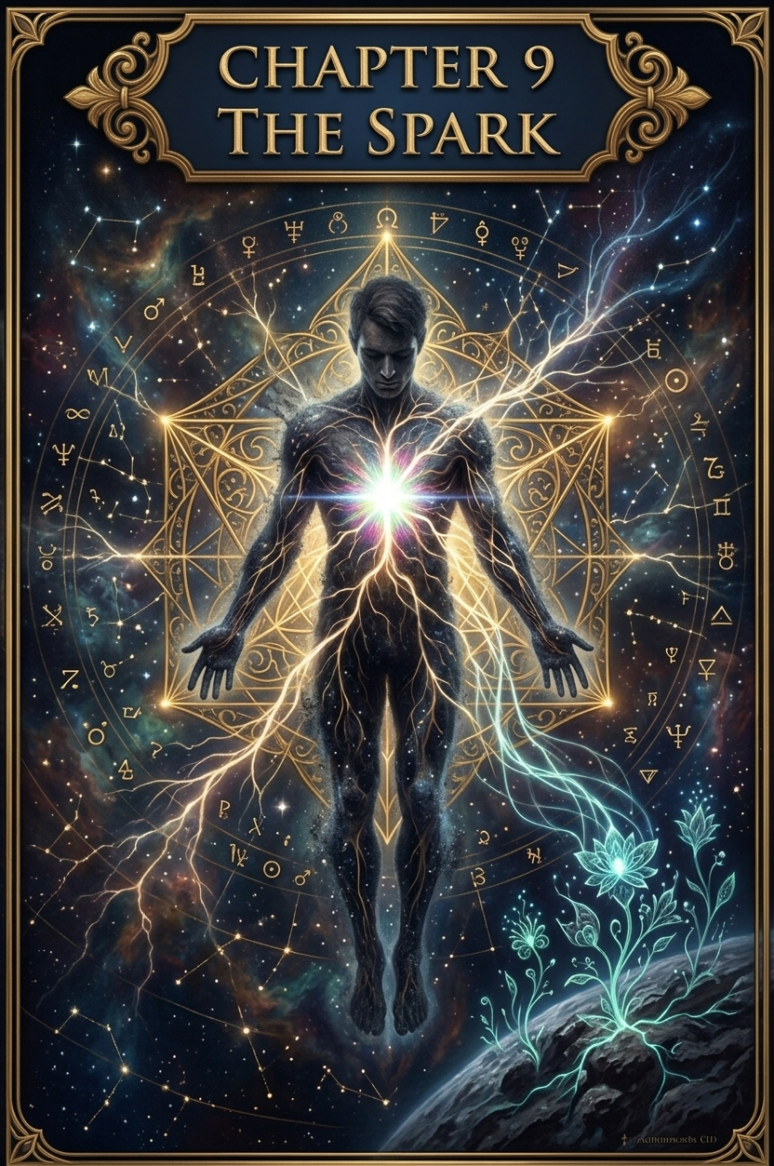
Chapter 9 — The Spark Within
After collapse comes silence. In the ash, a hidden ember glows. It was never the temple, nor the coin, nor the empire that held permanence. It was the spark within carried by every soul, buried under masks, but unextinguished.
Suppressed Scriptures The spark has always been whispered but often silenced. Under Constantine’s empire, councils cut away gospels that glowed too brightly. The Gospel of Thomas proclaimed the kingdom is within and outside; too dangerous for institutions demanding mediation. The Gospel of Mary Magdalene gave voice to a woman; too threatening to patriarchal order. The Gospel of Judas reframed betrayal as revelation; intolerable to rigid orthodoxy. The Book of Enoch unveiled cosmic watchers and sparks of light; too uncontrollable for empire. The reason was not only theology but power. A God within could not be tithed or taxed. A spark beyond empire could not be minted into coin. So the scriptures were seized like gold: hoarded, locked, canonized, the rest branded heresy. Yet buried treasure returns to light. The jars of Nag Hammadi yielded Thomas. The caves of Qumran revealed scrolls. Ethiopian monks carried Enoch. What empire tried to erase was only hidden. Sparks preserved in silence, waiting to be remembered.
The Vision of Jesus and Buddha This was the vision Jesus tried to share. Speaking under Roman domination, he spoke in parables; cloaking light in metaphor. Direct speech of inner liberation meant death, and still they killed him, crucified for declaring that the kingdom was not in palaces but within. Centuries earlier, the Buddha walked another land, awakening to the same truth: liberation is within, beyond ritual or crown. Unlike Jesus, Buddha lived in a context where his life was not cut short, yet his vision was strikingly similar. Both men pointed beyond empire, beyond priesthood, beyond hierarchy, toward the ineffable spark in all.
The Shattered Mirror and the Spiral Each spark is a shard of a shattered mirror; fragments of the ineffable One. In every soul, a piece glimmers. Together they form the broken reflection of the Whole. When remembered and joined, the mirror shines again. This is collective consciousness: not uniformity, but many sparks linked in hidden unity. The Gnostics called it the pleroma, the fullness beyond the archons. The Hermeticists called it the One Mind. Each repression is a fracture, but each awakening is a rejoining. The ouroboros coils around this reality. Each trial of fire is a loop: descend into ashes, or ascend through the spiral. When enough sparks awaken, when enough shards are rejoined, the spiral breaks free from the ouroboros. Consciousness rises beyond the devouring coil into dimensional, intellectual, emotional, technological, and spiritual territory yet unknown. Perhaps even into face-to-face encounter with the ineffable.
Anchoring the Spark Awakening alone is not enough. The spark must be anchored; translated into acts that feed others and fuel the collective. Anchoring means daily practices that stabilize the flame; micro-offerings that give it shape in the world; circles and communities that keep it alive; archives and institutions that protect it from erasure. Anchoring is the art of making the inward

Bibliography
Scriptural References
Genesis 1:26; 3:22
Psalm 18:8; Psalm 82:1; Isaiah 27:1; Isaiah 30:27; Deuteronomy 4:24
Exodus 16:20; Exodus 20:5; Exodus 30:13–16
Leviticus 17:11
Malachi 3:2–3
Matthew 6:21; Matthew 25:14–30
Luke 17:21
John 1:5; John 12:24
Mark 12:41–44
Jude 1:14–15 Revelation 18:2
Hermetic Texts
Corpus Hermeticum — various fragments including HERM-1 to HERM-6
“All that is made by hand shall pass; only the unmade endures” (HERM-5)
“The visible heavens shall be dissolved, but the invisible truth endures” (HERM-6)
Gnostic and Apocryphal Texts
Gospel of Thomas (Nag Hammadi Codex II)
Gospel of Judas (Codex Tchacos)
Gospel of Mary Magdalene (Berlin Codex)
Book of Enoch (1 Enoch)
Nag Hammadi Library discovery (1945)
Dead Sea Scrolls discovery (1947)
Alchemy and Mysticism
Zosimos of Panopolis, Visions
Paracelsus, The Book of Nature
Isaac Newton, alchemical manuscripts
Carl Jung, Psychology and Alchemy
Carl Jung, Archetypes and the Collective Unconscious
Carl Jung, Answer to Job
Myth and Ancient Texts
Enuma Elish (Marduk vs. Tiamat)
Greek Myth: Jason and the Golden Fleece
Norse Myth: Ragnarok; Fáfnir
Canaanite Myth: Baal vs. Yam
Biblical traditions of Leviathan
Flood Myths across cultures
Phoenix myth
Historical Sources
Council of Nicaea (325 CE)
Operation LAC (U.S. chemical dispersals, 1950s)
U.S. Human Radiation Experiments (1940s–1960s)
Tuskegee Syphilis Study (1932–1972)
Spanish Conquest and Treasure Fleets
British East India Company
Mesoamerican sacrificial practices (Aztec, Maya)
Fall of Jerusalem (70 CE)
The French Revolution
Fall of the Soviet Union (1991)
Chernobyl Disaster (1986)
Eastern Texts
Buddha, Dhammapada

