Masterbuilt 33 Transmutation: Liberation Paradox Codex Trilogy

​Codex I: ‘Unto the Dark’ Introspective Lens (Reflective)
​This volume is the foundational excavation site of the psyche—the internal archaeology required before any outward map can be drawn. Long before the public architecture of the Cosmic Grin or the systemic mechanics of the Conductivity Sequence could be built, there was only the quiet, heavy work of facing the mirror in the dark. These initial diagnostics map the raw baseline of shadow, memory, and personal resistance. It is an unsparing look at old conditioning and the grit required to hold your ground when the lights go out, proving that before a spark can travel outward, it has to learn how to breathe in the dark.

​Codex II: ‘The Cosmic Grin’ Interpersonal Lens (Public Architecture)
​This volume shifts the current outward, translating internal pressure into external operational design. Built as a mythic field guide for navigating systems, audience, and the friction of the public sphere, it takes the raw concepts forged in isolation and pressure-tests them in the arena. Through frameworks that bridge myth and practical execution, this volume provides the structural blueprints for projecting a distinct brand and voice without losing the core signal. It is the practical bridge between private realization and public impact.

​Codex III: Everything & Nothing Transpersonal lens (Metaphysical)
​This volume is the final distillation and high-pressure capstone of the entire system. Here, the structural mechanics—from the Ouroboros and the Torus to the full circuitry of the Conductivity Sequence—are synthesized into an absolute horizon. It is designed not as a static theory, but as an active survival tool for high-stakes transmutation. Offering a master-level framework for navigating the heaviest weights and most complex transitions, this volume stands as definitive proof that the Divine Spark remains conductive, no matter how dense the alloy.
.

​

The Bridge (Foreword)

“The distance between who you are and who you were meant to be is not a matter of time; it is a matter of frequency.
​
The Codex is the Bridge. It is the spiritual ‘Phone Book’ that holds the direct coordinates to your highest timeline. For too long, the link between the Eternal and the Physical has been throttled by noise, shadows, and imposters.
​
This is the bypass. By aligning with these Five Crowns, you are no longer guessing; you are Dialing In. You are anchoring Heaven into the Earth of your own cells. The repair is internal. The result is total. Welcome home to the original signal.”

​The Masterbuilt 33 Transmutation: Liberation Paradox Codex Trilogy is the Bridge. It is the spiritual 'Phone Book' that holds the direct coordinates to your highest timeline. For too long, the link between the Eternal and the Physical has been throttled by noise, shadows, and imposters.
​
This is the bypass. By aligning with these Five Crowns, you are no longer guessing; you are Dialing In. You are anchoring Heaven into the Earth of your own cells. The repair is internal. The result is total. Welcome home to the original signal."
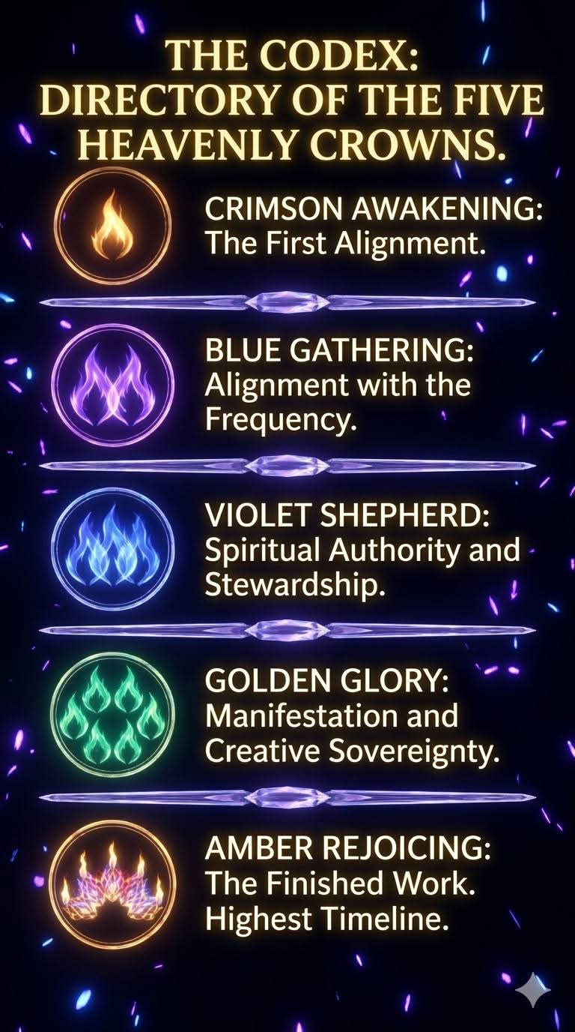
☆★The Homecoming: Testimony of Retrieval★☆

It is over. I remember the rush of the retrieval. The parasite fleeing, and my True Spirit surging home to reclaim the spaces it was denied. I am not an invader; I am the occupant. The original frequency has landed, and my soul is finally quiet.

★☆Activation☆★

My alignment is now the atmosphere. This is the activation of the inheritance. My light is no longer a tool; it is a creative force. Everywhere I step, the fertilized ash surrenders to bioluminescent life, and the very ground must now reflect the glory of the Spirit.

◆Hero Shot•Homecoming◆

This is not just victory; it is redemption. The entire system is now ‘As Within, So Without.’ My rest is a rebellion. The external war ends here, for I am fully occupied, I am completely restored, and I am finally Me
