
Off-Grid Solar Design Worksheet for Mwase
Solar PV Off-Grid System Design: Foundations and AI Applications
IEEE IAS/PES PowerAfrica 2026
Dr. Henry Louie and Dr. Oluleke Babayomi

Parameter | Initial | After five years
Avg. daily load (kWh/day) | 7.875 | 10.05
Peak individual load (kW) | 4.11 | 5.24
Coincidence factor | 0.37 | 0.37
Peak aggregate load (kW) | 1.52 | 1.94
Power factor | 0.85 | 0.85

System Architecture
DC Bus Voltage: _____________________

Inverter Design
Assumptions: Design margin: 0.20, Power Factor: 0.85, Inverter Efficiency: 85%

Inverter Power Requirement: __________________________________

Max. Inverter DC Current: _____________________________________
Battery Bank Design
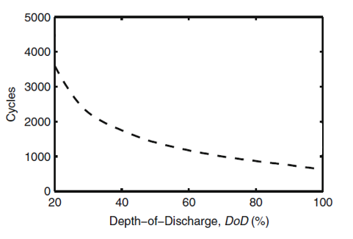
Assumptions: Days of Autonomy: 2, End of Life Rating: 80%, Maximum depth-of-discharge: 80%, Design Margin: 7.5%
Battery Capacity Table
 | 10 hr  (42 A, 0.1C) | 20 hr  (22.5 A, 0.05C) | 100 hr  (5.4 A, 0.01C)
Capacity | 420 Ah | 450 Ah | 540 Ah

Average Battery Load: __________________________________

Battery Capacity C_{x}: _____________________________________

Battery Capacity C’_{x}: _____________________________________

Daily Depth-of-Discharge: _____________________________________

Battery Bank Capacity: _____________________________________

Number of Series Batteries: ________________

Number of Battery Bank Strings: ________________
Solar Array Design
Assumptions: Loss estimate: 22%, Temperature De-rating: 9.5%, Design Margin: 30%, PV module rating 350 W,
Insolation Table (kWh/m²/day)
Tilt | Jan. | Feb. | Mar. | Apr. | May | Jun. | Jul. | Aug. | Sep. | Oct. | Nov. | Dec.
Latitude -15º | 5.51 | 5.61 | 5.69 | 5.76 | 5.36 | 4.90 | 5.15 | 5.99 | 6.51 | 6.78 | 6.19 | 5.54
Latitude | 5.08 | 5.39 | 5.77 | 6.31 | 6.40 | 6.01 | 6.20 | 6.87 | 6.85 | 6.64 | 5.76 | 5.09
Latitude + 15º | 4.47 | 4.94 | 5.54 | 6.46 | 6.89 | 6.58 | 6.78 | 7.23 | 6.76 | 6.15 | 5.08 | 4.44
Charge Controller Parameters
Charge Controller Parameters | Value
Maximum power | 3500 W
Maximum open-circuit voltage | 150 V
Maximum short-circuit current | 60 A

Rated PV requirement P_{PV,rated}: __________________________________

Rated PV requirement P’_{PV,rated}: _____________________________________

Rated PV requirement P’’_{PV,rated}: _____________________________________

Rated PV requirement P’’’_{PV,rated}: _____________________________________

Number of PV Modules: __________________________

Maximum PV Modules per String: _________________________

Maximum PV Modules per Controller: ____________________

