COMPREHENSIVE OUTDOOR RECREATIONAL PLAN
FOR THE FOUR TOWN AREA OF ASHLAND COUNTY, WISCONSIN
(TOWNSHIPS OF: GORDON, JACOBS, PEEKSVILLE, AND SHANAGOLDEN)
2021-2025 EDITION
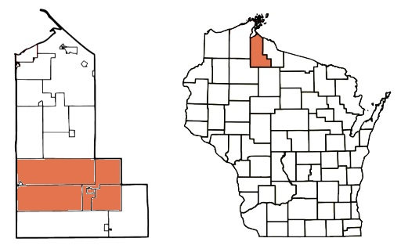
PREPARED BY: GLIDDEN AREA DEVELOPMENT CORPORATION
Table of Contents
- INTRODUCTION …………………………………………………………………………………. Page 4
- GOALS AND OBJECTIVES ……………………………………………………………………. Page 5
- DEFINITIONS AND TERMS ………………………………………………………………….. Page 6
- PLANNING PROCESS ………………………………………………………………………….. Page 8
  - Description of Process
  - Amending the Plan
- SUMMARY OF PAST OUTDOOR RECREATIONAL PLANS ….………..………… Page 9
  - Recent Projects
- DESCRIPTION OF THE PLANNING REGION …….……………………………………. Page 10
  - Social Characteristics of Planning Region
    - Size
    - Population Trends and Projections
    - Ethnic Background
    - Employment/Unemployment
    - Age
    - Economy
  - Physical Characteristics
    - Topography
    - Water Resources
    - Climate
    - Soils
    - Flora and Fauna
- OUTDOOR RECREATION SUPPLY INVENTORY …………………………………….. Page 15
  - Natural Resources available for Outdoor Recreation
  - Outdoor Recreation Facility Inventory
  - Accessibility for Persons with Disabilities
- OUTDOOR RECREATION NEEDS ASSESSMENT …..…….…………………………. Page 18
  - Public Input Assessment
  - Need Standards
    - Recreation Demand
    - Recreation Facilities
  - State Comprehensive Outdoor Recreation Plan (SCORP)
- RECOMMENDATIONS FOR OUTDOOR RECREATION PROVISION ….…….. Page 23
  - Action Program – Capital Improvement Schedule (CIS)
  - Operation and Maintenance
    - Existing Operation and Maintenance Responsibilities
    - Implications of CIS on Operation and Maintenance Capabilities
  - Funding Programs
    - Local Funds
    - Available Grant Funding Programs
  - Local Groups and Organizations
- PLAN REVIEW …………………………………………………………………………………….. Page 28
- APPENDICES ….…………………………………………………………………………………… Page 29
Appendix #1 – Township Boundaries and Town Labels
Appendix #2 – Topographical Map of the Four Townships
Appendix #3 – Lakes, Rivers, and Creeks
Appendix #4 – Chequamegon-Nicolet National Forest and Ashland County Forest
Appendix #5 – Ashland County Snowmobile Trails and Recreation Map
Appendix #6 – Soil Conditions
- FORMAL PLAN APPROVAL .………………….…………………………………………….. Page 35

- INTRODUCTION
The small town known as Glidden is located in the lower part of Ashland County. The town itself is situated mostly in the Township of Jacobs, but the surrounding area is also made up of the Township of Gordon, Township of Shanagolden, and Township of Peeksville. (See Appendix #1) Together these four townships offer a quiet retreat in the center of the Northwoods, while still offering a multitude of recreational activities such as hunting, fishing, camping, and trail riding.
You will find the small town of Clam Lake in the Western-most part of the Township of Gordon, and also the small Village of Morse in the Northeast area of the Township of Gordon.
This Local Comprehensive Outdoor Recreational Plan will serve as a guide to not only maintain what we currently offer, but also to enhance the area in multiple aspects. We hope that through enough correct moves that we will enhance the recreational abilities of our area, and in turn increase the outside appeal for tourism.
It is the full intent of the Glidden Area Development Corporation (GADC) to update this plan every 5 years, in part to remain eligible for park and recreation grants, and to ensure our plan remains relevant to the needs during that timeframe.

- GOALS AND OBJECTIVES

  - Handicap Accessible:
One of our main goals with any project is to have a major emphasis on handicap accessibility. The inclusion of anyone and everyone is extremely important in our area. The addition of hard surfaces like concrete and blacktop where allowed, along with needed ADA compliant ramps, will assist with that goal.

  - Protection:
Another goal is to protect natural areas, including wetlands, wildlife habitats, lakes, woodlands, open spaces, and groundwater resources.

  - Adequate Facilities:
We also expect to provide sufficient and acceptable facilities at our local parks while keeping the costs at manageable levels. Some examples are:
- Addition/Upgrade of needed buildings (restrooms, information, etc.)
- Designated activity areas
- Safe play areas for children
- New or updated trails (walking, biking, skiing, etc.)
- Proper lighting
- Adequate parking
- Create ample fishing piers, locations, and opportunities
- User-friendly boat launch/landings
- Better culverts and bridges

  - Maintenance and Access:
Through continued maintenance and enhancements of our buildings, parks, lakes, rivers, trails, and National Forest, we plan to keep waterways and trails both accessible and navigable.

  - Personnel:
We want to encourage the formation of special interest groups and clubs, as they can more easily identify potential projects and improvements. We will provide support to these groups to the best of our abilities.

- DEFINITIONS AND TERMS

In order to assist in the interpretation and implementation of the Four Town Area Outdoor Recreation Plan, the following selected terms have been defined utilizing standards from the “Park and Recreational Designs, and Recreation
Supply Levels (by Urban Peer Groups)” information included in the Appendix E of the Wisconsin Statewide Comprehensive Outdoor Recreation Plan (SCORP) 2019-2023.

    - Community Park – A park usually more than 25 acres in size designed to serve several municipalities or neighborhoods and to provide many recreational opportunities for people of all ages. They may include areas suited for intense recreational facilities such as athletic complexes and large swimming pools. Community parks may be an area of natural quality for outdoor recreation, such as walking, viewing, sitting, and picnicking. They may be a combination of the above, depending on the site and community need.
    - Neighborhood Park – A park usually 5 to 25 acres in size, designed to serve the needs of the surrounding neighborhood.
    - State Park - An area of land that is owned and protected by a U.S. state because of its natural beauty or its importance in history.
    - Neighborhood Playground – A facility often provided in conjunction with a community school. It is designed to serve the needs of the surrounding neighborhood and can accommodate a variety of informal or active athletic activities.
    - Specialized Recreation Area – Areas restricted by design to certain uses and may not always be available for use by the public. In some cases, they may serve a very small segment of the community’s population. Golf courses, historic sites and conservancy areas are examples of specialized recreation areas.
    - Open Space – Primarily land or water that is owned or managed by federal, state, or local governments, or a conservancy organization that is preserved for public use. Examples include: wetlands, woodlands, wildlife refuges, prairies/meadows, rock outcroppings, etc.
    - Recreation Trail – A travel way established through construction or use and is passable by the following, including but not limited to: foot traffic, bicycles, cross-country skis, off road recreation vehicles, snowmobiles, etc.
    - Boat Ramp – These are sites with a defined public boat launching facility which may or may not have parking.
    - Walk in Trail – These access sites are partially developed, excluding a boat ramp, and are entirely within public lands.
    - Roadside – These sites do not include any access developments. Public roads with a marked right-of-way extending to the water provide a limited degree of access.
    - Wilderness – Publically owned lands where a lake is in a wilderness area and there are no roads or buildings within 200 feet of the waterbody. Wilderness lakes have no defined walk-in trail to the water.
    - Waterway Access – An area of public access to a navigable body of water so as to provide the public the opportunity to canoe, fish, wade, ice skate, snowmobile, etc.
    - Wayside – Locations adjacent to a public highway that provide motorists with a convenient opportunity to stop and rest. Historical markers, restrooms, drinking water, picnic area, waste disposal are commonly found at waysides.

- PLANNING PROCESS

  - Description of Process

Over the past few years, the Glidden Area Development Corporation has been identifying projects and obstacles that can be improved upon in our area. We have had recent success with the aid of local organizations like the Glidden Athletic Association, Glidden Area Lion’s Club, and others, paired with local donations and many hours of volunteered time. We have reached a point to where the size of our projects have grown enough for us to request the assistance of larger grants.

Most of our projects follow the same process. We pinpoint an idea that will fill a want or need in our area. We then brainstorm ways to complete the project while taking into consideration the most common aspects that arise during most projects, such as: lack of finance, lack of man power, legal responsibilities and restrictions, and the timeline of the project. Once those aspects are answered to a respectable level, we will approach the town board and pitch the idea to them, take note of their comments and concerns, then move on accordingly. After all parties involved are satisfied with the project and process, we will start the fundraising step of the process.

The GADC headed a community survey on September 14th, 2017, in which 61 residents and 61 non-residents participated. This survey covered many aspects of life in our area, with recreation being a part of that.

The GADC also holds monthly meetings that are open to the public with a slot on the agenda dedicated to public input. This is a great time for anyone, resident or non-resident, to come in and present an idea that will stimulate recreational activities.

  - Amending the Plan – Future amendments of the plan will be made here.

- SUMMARY OF PAST COMPREHENSIVE OUTDOOR RECREATION PLANS
To our knowledge, neither our town nor county have had a past Comprehensive Outdoor Recreation Plan.
  - Recent Projects

With that said, here are a few of our most recent projects that we have taken on that should have qualified to be under this plan:

    - Mart Hart Athletic Field Upgrade – We added blacktop and concrete area to the spectator area of the baseball field to make it handicap accessible. This was completed in 2013.

    - Handicap Accessible Fishing Pier and Walkway – In 2015, we added a handicap accessible fishing pier between the Gordon Lake Beach and the boat launch area. In 2016, we connected that pier to the parking lot with a concrete sidewalk.

    - Chippewa River Clean-up – Started in 2019 (ongoing), we approached the DNR about the possibility of cleaning out the Chippewa River to make it more navigable for watercrafts. Our contact, Jennifer Murphy, informed us of the rules and guidelines that we followed during the course of the project. Due to pandemic, we were not able to continue our efforts in 2020, but we plan to resume again in 2021.

- DECRIPTION OF THE PLANNING REGION

  - Social Characteristics of planning region

    - Size

Per the 2010 census, there are 1,240 people living within the four townships. The total population has been trending downwards, after the consolidation of our public school and the loss of a mill in our town. These trends are why we are trying to enhance our area through recreation, in hopes of growing our community again.

    - Population Trends and Projections

 | Census  1990 | Census  2000 | Census  2010 | Census  2020 | Proj.  2030
Town of Gordon | 301 | 357 | 283 | 254 | 244
Town of Jacobs | 885 | 835 | 691 | 729 | 718
Town of Peeksville | 167 | 176 | 141 | 160 | 147
Town of Shanagolden | 172 | 150 | 125 | 113 | 120
Totals | 1525 | 1518 | 1240 | 1256 | 1229

    - Ethnic background

The majority of the population of the area is Caucasian (96.8%). Individuals of Hispanic decent make up 1.4 percent, while 1.7 percent are other. This is compared to the State of Wisconsin which is 8 percent Caucasian, 6 percent Hispanic, and <2 percent other. This data was gathered from the StatisicalAtlas.com.

    - Employment/Unemployment

Between the ages of 25 and 64 years old, our area current has 43.6 percent listed as employed, 2.9 percent listed as unemployed, and 39.1 percent listed as other. This is compared to the state of Wisconsin which has a 56.8 percent employment rate and a 3.8 percent unemployment rate. The median household income of the area is $36,000. This data was gathered from the StatisicalAtlas.com.

    - Age

The median age of Four Township Area residents is 49.2 years. This is compared to a median age of 42.6 years for the State of Wisconsin. Statistics show that 18.4 percent of the population in the Four Township Area is under the age of 18, while 81.6 percent are 18 years or older and 24.8 percent of the population is over the age of 65. The age class with the largest percent of the area’s population is the 50 to 59 year age class with 19.6 percent of the population. This data was gathered from the StatisicalAtlas.com.

    - Economy

The industry types that employ the most residents, between the ages of 18 and 65, are manufacturing at 13.7 percent, retail at 12.2 percent, healthcare at 8.7 percent, education at 7 percent, and construction at 6.5 percent. Of these industries, 56.9 percent are in the private sector, 16.8 percent are in the sole proprietor sector, and 11.9 percent are in the local government sector. This data was gathered from the StatisicalAtlas.com.

  - Physical Characteristics

    - Topography

Located on average between 1,500 and 1,600 feet above sea level, the landscape encompasses the area of 285.1 square miles. Of those 285.1 square miles, about 160.4 square miles (56.25%) are the Chequamegon-Nicolet National Forest. This accounts for about 7 percent of the entire 2,397 square miles of the Chequamegon-Nicolet National Forest. Ashland County Forest makes up about another estimated 36.3 square miles, or about 11.5 percent of our landscape.

The four township area is mostly wooded forest with many rivers and creeks zig-zagging the land and connecting numerous glacial lakes. You can also find remote areas of uplands, bogs, wetlands, muskegs, pine savannas, and meadows. (See Appendix #2)

    - Water Resources

Named Lakes (33 total) | Surface Area (Acres) | Public Access | Lake Type | Most Recent Year Stocked with Fish
Town of Gordon  Beaver Lake  Cranberry Lake  Day Lake Flowage  Dry Lake  Gordon Lake  Knab Lake  McCarthy Lake  Mud Lake  Spider Lake  Spillerberg Lake  Summit Lake  East Twin Lake  West Twin Lake  Woodtick Lake  Zielke Lake | 24  8  632  18  142  9  42  10  103  75  91  110  44  12  21 | Boat Ramp  Boat Ramp  Trail  Trail  Boat Ramp  Boat Ramp  Boat Ramp  Wilderness  Wilderness  Roadside | Seepage  Seepage  Drainage  Drainage  Drainage  Drainage  Seepage  Drainage  Drainage  Seepage  Seepage  Seepage  Seepage  Drainage | 1982  2019  2020  2015  1995  1998
Town of Jacobs  Augustine Lake  Cammerer Lake  Ditmans Lake  Wolf Lake | 166  19  3  5 | Boat Ramp  Boat Ramp | Seepage  Seepage  Seepage  Seepage | 2004  2020
Town of Peeksville  Cycle Lake  Little Butternut Lake  Meyer Lake  Sells Lake | 37  10  14  16 |  | Seepage  Drainage  Seepage  Drainage
Town of Shanagolden  Gates Lake  McLaren Lake  Muskellunge Lake  Pelican Lake  Pole Lake  Seagels Lake | 22  66  22  40  13  7 | Boat Ramp  Trail  Wilderness  Waterway Access  Trail | Seepage  Seepage  Drainage  Drainage  Seepage  Seepage | 2016  1999  1977  2019
Shared (Gordon & Shanagolden)  Dead Horse Slough  Little Clam Lake  Torrey Lake  Upper Clam Lake | 87  144  30  166 | Trail  Boat Ramp  Boat Ramp | Seepage  Seepage  Drainage | 2016  2020
Note: Most information in this table is from “Wisconsin Lakes” published by the WI DNR in 1991 (PUBL-FM-800 91) and the Fish Stocking Summaries by the WI DNR Bureau of Fisheries Management.
Of the 84 named lakes in Ashland County, 33 of them are located within our four townships. Our area also harbors many rivers, creeks and brooks that maneuver throughout the four townships before flowing either north towards Lake Superior or south into the Mississippi River. (See Appendix #3)

Rivers (6): Bad River, Chippewa River (East Fork), Brunsweiler River, Iron River, Moose River, Torch River (East Fork).

Creeks and Brooks (25 named): Augustine Creek, Bear Creek, Black Creek, Brush Creek, Camp Fifteen Creek, Camp Fourteen Creek, Dingdong Creek, Dorns Creek, Dryden Creek, Edies Creek, Hildebrandt Creek, Knab Creek, Magee Creek, Meyers Creek, Minnie Creek, Minnow Creek, Muskellunge Creek, Nelson Creek, Reins Creek, Rocky Run, Schraum Creek, Silver Creek, Spider Creek, Spillerberg Creek, Spring Brook.

    - Climate

 | Avg High Temp | Avg Low Temp | Avg Rain | Avg Snow | Avg Sunshine
January | 18°F | 6.1°F | .94” | 6.57” | 2 hours
February | 21.6°F | 8.1°F | .98” | 5.98” | 2.1 hours
March | 35.2°F | 20.7°F | 1.34” | 4.96” | 4.3 hours
April | 47.5°F | 31.3°F | 2.48” | 5.91” | 6.2 hours
May | 63.9°F | 43.2°F | 2.99” | 1.06” | 8.2 hours
June | 73.8°F | 51.4°F | 2.72” | 0” | 9 hours
July | 78.4°F | 56.8°F | 2.13” | 0” | 9.7 hours
August | 75.7°F | 55°F | 1.85” | 0” | 9.1 hours
September | 67.3°F | 48.4°F | 1.46” | 0” | 7.8 hours
October | 50.9°F | 38.1°F | 2.36” | 1.69” | 4.3 hours
November | 36°F | 25.2°F | 1.3” | 5.83” | 3.6 hours
December | 23.2°F | 13.5°F | 1.3” | 7.56” | 2.2 hours
Note: Information was collected from weather-us.com.
The month with:
    - the highest average high temperature is July (78.4°F)
    - the lowest average high temperature is January (18°F)
    - the highest average low temperature is July (56.8°F)
    - the lowest average low temperature is January (6.1°F)
    - the highest average rainfall is May (2.99”)
    - the lowest average rainfall is January (0.94”)
    - the highest average snowfall is December (7.56”)
    - the lowest average snowfall are Jun, Jul, Aug, and Sept (0”)
    - the most average sunshine per day is July (9.7 hours)
    - the lowest average sunshine per day is January (2 hours)

    - Soils

Our area is considered to be on the Glidden Loamy Drift Plain. Most soils formed in non-calcareous dense loamy sand till or in outwash sands and gravel, some with a loamy alluvium mantle. They are dominantly moderately well drained, with moderately slow permeability and moderate available water capacity. Most lowland soils are very poorly drained acid peat or nonacid muck, but include poorly drained outwash. (See Appendix #6) (Source: Wisconsin Department of Natural Resources. 2015. The ecological landscapes of Wisconsin: An assessment of ecological resources and a guide to planning sustainable management. Chapter 12, North Central Forest Ecological Landscape. Wisconsin Department of Natural Resources, PUBSS-1131N 2015, Madison.)

    - Flora and Fauna

TREES: Native tree species include maple, oak, aspen, beech, basswood, and birch. Coniferous trees include pine, white spruce and balsam fir. Tamarack bogs, cedar swamps and alder thickets are common.
BERRIES: Blueberries, raspberries, blackberries, cranberries are also common.
FLOWERS: Many wildflowers and shrubs grow in the area, as well as various ferns, mosses, cattails, and mushrooms.

ANIMALS: White-tailed deer are the most common large game animal in the area, however, locals have noticed their population drop quite noticeably throughout the years. Black bears have fared well, and the reintroduction of elk and wolves have seem to have been successful. Smaller animals such as coyote, fox, raccoon, rabbit, beaver, otter, squirrel, and the occasional badger all can be sighted in the area.
BIRDS: Pheasants, grouse and wild turkeys are some of the popular local game birds. Other bird species include: cardinals, blue jay, ravens, chickadees, woodpeckers, red-winged blackbirds, owls, ducks, common loons, bald eagles, and many species of thrushes, sparrows and warblers.
FISH: The brook trout, rainbow trout, and brown trout navigate the many miles of creeks and brooks. Muskellunge, northern pike, walleye, smallmouth and largemouth bass, crappie, and many species of panfish are the most common lake fish, but most can also be found in some of our rivers.
- OUTDOOR RECREATION SUPPLY INVENTORY

  - Natural Resources for Outdoor Recreation

Within the four townships, the most noticeable natural resource is the estimated 6,480 acres of the Chequamegon-Nicolet National Forest and about 1,320 acres of Ashland County Forest. (See Appendix #4) Our area also offers 16 lakes that are easily accessible via boat ramp or trail, they combine for 1,817 acres of water surface area. There are 31 named rivers and creeks that can be found in zig-zagging for many miles through our landscape. The local woods also offer 3 hunter walking trails: the Dingdong Creek Hunter Walking Trail, the Woodtick Lake Hunter Walking Trail, and the Day Lake Hunter Walking Trail; along with the Dead Horse Slough ATV trail and dedicated snowmobile trails. (See Appendix #5)

  - Outdoor Recreation Facility Inventory

Recreational Areas | Type | Acres | Activities | Facilities
Centennial Field | Neighborhood Park | 3 | Baseball, softball, kickball | Pit bathroom, bleachers, concession stand
Chequamegon School District – Glidden Campus | Neighborhood  Playground | 14.71 | Baseball, softball, kickball, play area, playground, basketball | Bleachers, school, softball field, basketball court
Great Divide Wayside Park | State Park | 3.7 | Nature viewing, picnicking | Restroom, water, picnic table
Gordon Lake Beach | Neighborhood Park | 3.62 | Swimming, fishing, boating, tubing, picnicking, nature viewing, bicycling, ATV trail access | Pit bathrooms, changing rooms, handicap accessible fishing pier, boat landing
Marion Park | Community Park | 10.92 | Play area, nature viewing, camping, | Pavilion, picnic tables, restrooms, playground, concession stand, handicap accessible
Matt Hart Athletic Field | Neighborhood Park | 4 | Baseball | Bathrooms, bleachers, concession stand, handicap accessible
McCarthy Lake & Cedars State Natural Area | Open Space | 472 | Hiking, picnicking, nature viewing | none
School Forest | Specialized Recreation Area | 40 | Walking/hiking, nature viewing | Open pavilion
Timber Lodge | Private Owned | 4.2 | Walking/hiking, boating, tubing, volleyball, nature viewing, bicycling, horseshoes, ATV trail access swimming | Cabins, boats, swing set, volleyball court, horseshoe area, beach, walking trail

Campgrounds | Day Lake Campground | East Twin Lake Campground | Northern Lure Resort & Campground
# of Sites | 52 | 10 | 22
About sites | RV (up to 45’) and tent camping.  Parking spur, fire ring, picnic table, and tent pad | RV (up to 30’) and tent camping  Fire ring with grill and table | RV and tent camping  Electric, some have water and sewer hookup, picnic table, fire ring
Type | State owned | State owned | Private owned
Acres | 632 acre lake | 110 acre lake | 142 acre lake and  9.5 acres land
Facilities | Drinking water, vault toilets, and a fishing pier | Drinking water, vault toilets, and a fishing pier | Restroom/shower building, coin operated laundry, cabins, basketball court, fishing pier, and a tavern with food.
Activities | play area, swimming beach, fishing, hiking, nature viewing, boating, picnicking, bicycling, ATV trail access | Fishing, hiking, nature viewing, boating, picnicking, bicycling, ATV trail access | Fishing, swimming, nature viewing, boating, picnicking, bicycling, ATV trail access
Handicap Accessible | Yes | Unknown | Yes

  - Accessibility for Persons with Disabilities

In 2012, the Glidden Area Development Corporation created a fund called the Ryan Thimm Handicap Reserve (RTHR). The RTHR’s main purpose is to help public locations become handicap accessible and elderly friendly. Through the years, they have assisted on projects at the Marion Park, Matt Hart Athletic Field, and Gordon Lake Beach, among other smaller projects; and they currently have more projects in the planning stages.

- OUTDOOR RECREATIONAL NEEDS ASSESSMENT

  - Public Input Assessment

The most common method of input has been and will probably remain the informal method. Through open meetings with time aside for public input, every citizen has a chance to approach us with ideas that they believe will enhance our area. Some ideas that have been brought up include: walking trails, biking trails (non-motorized), more distinguished ATV trails, add electrical for campsites at the community park, lights for the baseball field, and better access to the Chippewa River. All of these ideas will remain possible future projects, and will be more thoroughly pursued if the right conditions, finances, and man-power become available.

Another potential project that may arise in the future is the conversion of the railroad tracks into something more recreational friendly. These tracks currently have not been utilized by the railroad company for many years, but they have not yet released their ownership to access them.

A third popular idea was the thought to plant fish in lakes to increase the popularity of local fishing. We would also be inclined to hear the thoughts of the DNR to create a fish hatchery in our area to aid in pursuit of that goal.

A fourth idea, which would need years of planning and assistance from the Army Corp of Engineers, is to try to expand the Chippewa River by either flooding part of it to make a flowage, or to dredge it out and create a few small lake areas. We realize this would be a huge undertaking, but believe the recreational, economic, and environmental benefits that would stem from this project would justify the effort to attempt it. This would actually be readdressing a project that was planned just before World War 2 started.

On May 11th, 2019, the GADC hosted a small business conference that was structured around local recreational trails. Local organizations, businesses, trail clubs, and Recreation Officer Bruce Jonas were invited to discuss the ways to enhance the trails for both summer and winter users. This conference was beneficial to answer some specific questions, network between local groups, and highlight ideas for future projects.

In September of 2017, the GADC conducted surveys from both residents and non-residents regarding many aspects of our community, including recreation.

  - Need Standard

One accepted way to measure the adequacy of a county’s park system is to determine the number of people the system serves or has the capability to serve. This is accomplished by assigning an acreage requirement for each type of recreational facility for every 1,000 people in the service area. The National Recreation and Park Association (NRPA) recommends that for every 1,000 residents, a community should provide 1 to 2 acres of neighborhood parks.

- Recreation Demand

For guidance on the demand for recreational outdoor activities a review of the Wisconsin Statewide Comprehensive Outdoor Recreation Plan (SCORP) 2019-2023 was conducted. SCORP is the most recent State Wide Comprehensive Outdoor Recreation Plan 2019-2023. The SCORP plan primarily focuses on nature-based activities and trends in nature-based outdoor recreation activities. During the development of the SCORP plan numerous Wisconsin residents were questioned as to how often they participate in various recreational activities (See Tables 6 and 7). Table 6 illustrates participation rates of Wisconsin residents in nature-based recreation by activity group versus the participation rates of individuals in the Four Town Area. The number one outdoor recreation activity by “activity group” was hiking, as 68% of Wisconsin residents participated in the activity at least once in the last 12 months. Nature observation was second at 66%, followed by Boating related activities (61%), and Bicycling (50%). As for the Glidden Area, the number one activity by “activity group” was Fishing at 75%, followed by Nature observation (71%), Motorized trail-based (64%), Hunting (60%), and Boating related activities (57%).

Table 6:
Activity Group | % of WI residents that participated once in the last 12 months | % of residents and non-residents that participated once in the last 12 months in the Four Town area
Hiking  Hiking/walking/running on trails | 68% | 50%
Nature observation  Bird/wildlife watching  Nature Photography  Gathering berries, mushrooms, etc. | 66% | 71%
Boating related  Motor boating  Canoeing/kayaking  Personal water craft (jet-ski)  Sailing  Stand-up paddle boarding  Waterskiing | 61% | 57%
Bicycling  Bicycling on roads  Biking on developed trails  Mountain biking  Fat-tire biking/snow biking | 50% | 15%
Fishing  Lake Fishing  Stream/river fishing  Ice fishing | 49% | 75%
Camping  Tent camping  RV/pop-up camping | 41% | 22%
Dog-related activities  Walking/running dog on trails  Visiting dog park | 38% | 27%
Hunting  Big game hunting  Turkey hunting  Small game hunting  Migratory bird hunting | 27% | 60%
Motorized trail-based activities  ATV/UTVs on trails/routes  Snowmobiling  4-WD vehicles on trails/routes  Motorcycles on trails/roads | 25% | 64%
Table 6: Wisconsin resident participation rates of grouped nature-based recreation activities (2016 WIDNR SCORP Survey) vs. participation rates directly in the Glidden area. The rates of the Glidden area (April 2021 survey) are of both local residents and non-locals together, as long as they performed the activity in the Glidden area (within the 4 Townships), there were 96 participants.

Table 7 illustrates Wisconsin resident participation rates for specific (non-grouped) nature-based recreation activities. The table shows the Top 20 nature-based activities by participation rate. Hiking/walking/running on trails is the number one nature-based activity at a 68% participation rate. It is followed by Visiting a beach/beach walking (65%), Bird/wildlife watching at home (55%), Swimming in lakes/ponds/rivers (54%), and Motor boating (45%). Different methods of fishing, boating, hunting, and camping make up the majority of specific nature-base activities in the Top 20 listing of participation rates. As for the Glidden Area, the number one activity by “non-grouped activity” was Visiting a beach/Beach walking at 73%, followed by Walking/biking along road (66%), Swimming in lakes/ponds/rivers (59%), Bird/wildlife watching at home (56%), and Lake fishing from a boat/canoe/kayak (54%).

Table 7:
Activity | State Participation Rate | Local Area Participation Rate
Hiking/walking/running on trails | 68% | 22%
Visiting a beach/beach walking | 65% | 73%
Bird/wildlife watching at home | 55% | 56%
Swimming in lakes/ponds/rivers | 54% | 59%
Motor boating | 45% | 42%
Lake fishing from shore or a pier | 40% | 51%
Bird/wildlife watching away from home | 39% | 29%
Lake fishing from a boat/canoe/kayak | 37% | 54%
Nature Photography | 37% | 29%
Bicycling on rail-trails/developed trails | 34% | 5%
Canoeing/kayaking | 34% | 42%
Tent camping | 32% | 10%
Dog walking on trails | 32% | 14%
Gathering berries, mushrooms, etc. | 31% | 29%
Target firearm shooting | 29% | 31%
Ice fishing | 23% | 31%
Hunting big game on private land | 21% | 31%
RV/pop-up camping | 21% | 12%
Stream/river fishing from shore/wading | 21% | 36%
Water skiing/tubing/wakeboarding | 21% | 14%
Table 7: Top 20 Wisconsin resident participation rates of specific nature-based recreation activities (2016 WIDNR SCORP Survey) vs. participation rates directly in the Glidden area. The rates of the Glidden area (April 2021 survey) are of both local residents and non-locals together, as long as they performed the activity in the Glidden area (within the 4 Townships), there were 59 participants.

Comparing the numbers in the 2 tables, we can now either concentrate on prioritizing activities that are more popular in our area, or take the opposite approach and enhance our area for those that are higher throughout the state to try to encourage more tourism, or a combination of both.

NOTE: A few non-grouped activities that were added to our local survey were: Walking/biking along road (66%), ATV/UTV on trails/routes (44%), small game hunting (42%), and snowmobiling (15%).

ii. Recreation Facilities

As stated in the current SCORP: “Ongoing maintenance is key to protecting public investments in outdoor recreation and ensuring that existing facilities continue to provide satisfying experiences for the public.” Many recreation facilities have become outdated and run down due to the lack of attention and adequate funding. With a proper plan in place, we can more easily plan, prioritize, and proceed with these projects.

  - State Comprehensive Outdoor Recreational Plan (SCORP)

The State Comprehensive Outdoor Recreational Plan offers a great insight and information on recreational supply, demand, needs, priority, and issues within the state. It serves as a pillar to compare our own data and guides us towards opportunities that may yield the best results for our area. This plan can be found on the DNR website.

- RECOMMENDATIONS FOR OUTDOOR RECREATION PROVISION

  - Action Program

An action plan will set a timeline for us to follow to help us stay on pace to complete our projects. Future projects may arise that detour from our CIS, but the listed projects will make sure we are always striving to improve the recreational facilities in our area.

Table #8: Capital Improvement Schedule (CIS)
Recreation Area | Project | Estimated Cost | Implemented Year
Gordon Lake Beach | ADA compliant bathroom/pavilion | $105,000 | 2021
 | Improve boat landing parking | $10,000 | 2023
 | Children’s playground equipment | $10,000 | 2025
Marion Park | Electric for campsites and lighting | $30,000 | 2023
 | Create distinct campsites | $8,000 | 2023
 | New road (exit from park) | $10,000 | 2024
Matt Hart Athletic Field | New storage building | $17,000 | 2021
 | Lighting around the field | $150,000 | 2022-2023
Centennial Field | New bleachers | $15,000 | 2021
Chippewa River | Create kayak/canoe launches | $12,000 | 2024

  - Operation and Maintenance

Each municipality will be responsible for the operation and maintenance of the recreational facilities in their areas. They will implement routine upkeep in their regular schedule on all areas and may need to start adding certain fees to help defray costs.

  - Funding Programs

Department of Natural Resources Administered Programs

All-Terrain Vehicle Trails
Counties, cities, villages, and towns are eligible for up to 100% (including $ per mile caps) of the costs of maintenance, development, rehabilitation, insurance, and acquisition of ATV trails and intensive use areas. Applications are due to the DNR by April 15 each year.

Federal Aid in Sport Fish Restoration
The DNR prioritizes fisheries related projects (sportfish restoration, boating access, fishing piers) to identify projects eligible for a 75% cost share; the DNR sometimes negotiates contracts and develops use agreements with counties, villages, and towns for use of this funding for construction of boat landings and fishing piers. The amount of funding available varies depending upon excise tax revenue from fishing equipment sales and the federal gas tax.

Knowles-Nelson Stewardship Local Assistance Programs: Acquisition and Development of Local Parks
Qualified towns, villages, cities, counties, Indian tribes, and nonprofit conservation organizations as defined under s. 23.096, Wis. Stats., are eligible for up to 50% of the costs of acquisition of land or conservation easements and development of facilities for public parks and recreation areas used for nature-based outdoor recreation purposes. Applications are due to the DNR by May 1 of each year.

Knowles-Nelson Stewardship Local Assistance Programs: Acquisition of Development Rights
Qualified towns, villages, cities, counties, Indian tribes, and nonprofit conservation organizations as defined under s. 23.096, Wis. Stats., are eligible for up to 50% of the costs to acquire development rights (conservation easements) in areas where restrictions on residential, industrial, or commercial development would provide or enhance nature-based outdoor recreation. Applications are due to the DNR by May 1 of each year.

Knowles-Nelson Stewardship Local Assistance Programs: Urban Green Space
Qualified towns, villages, cities, counties, Indian tribes, and nonprofit conservation organizations as defined under s. 23.096, Wis. Stats., are eligible for up to 50% of the costs of acquisition of land and conservation easements for nature-based outdoor recreation purposes that will protect open natural space and land with scenic, ecological, or natural values in urban areas. Applications are due to the DNR by May 1 of each year.

Knowles-Nelson Stewardship Local Assistance Programs: Urban Rivers
Qualified towns, villages, cities, counties, Indian tribes, and nonprofit conservation organizations as defined under s. 23.096, Wis. Stats., are eligible for up to 50% of the costs of acquisition of land or conservation easements and development of facilities for public parks and recreation areas, including shoreline enhancements, for nature-based outdoor recreation purposes along urban waterways and riverfronts. Applications are due to the DNR by May 1 of each year.

Land and Water Conservation Fund (LWCF)
Qualified towns, villages, cities, counties, Indian tribes, and school districts are eligible for up to 50% of the costs of acquisition of land and development of facilities for public park and recreation areas. Applications are due to the DNR by May 1 of each year. The amount of funding available varies depending upon the amount appropriated by Congress to the program within the Department of Interior’s budget each year.

Municipal Water Safety Patrols State Assistance
Municipalities, tribes, inland lake rehabilitation and protection districts, and sanitary districts are eligible to receive up to 75% of the costs (salaries, supplies, and equipment) of operating a Boating Law Enforcement program, including conducting boating education programs, providing professional enforcement of boating laws and local regulations, and providing search and rescue for live persons. Applicants must file an Intent to Patrol form with the DNR on or before March 1 of each year. Claim forms shall be filed with the DNR on or before January 31.

Recreational Boating Facilities
Counties, cities, villages, towns, sanitary districts, public inland lake protection and rehabilitation districts, and qualified lake associations are eligible for up to 50% of the costs of feasibility studies and the construction of capital improvements related to the development of safe recreational boating facilities, purchase of aquatic weed harvesting equipment, purchase of navigation aids, dredging of channels of waterways, and chemical treatment of Eurasian watermilfoil. An additional 10% may be available if a municipality conducts a boating safety enforcement and education program approved by the DNR. Projects of statewide or regional significance may be eligible for additional 30% cost-sharing assistance. Applications are due to the DNR and are reviewed and recommended quarterly by the governor-appointed Wisconsin Waterways
Commission.

Recreational Trails Program
Towns, villages, cities, counties, tribal governing bodies, school districts, state agencies, federal agencies, and incorporated organizations are eligible to receive up to 50% of the costs of maintenance and restoration of existing trails, development and rehabilitation of trailside and trailhead facilities and trail linkages, construction of new trails (with certain restrictions on federal lands), and acquisition of easements or property for trails. Funds are available for both motorized and non-motorized trails. Applications are due to the DNR by May 1 of each year. The amount of funding available varies depending upon federal gas excise taxes paid on fuel used by off highway vehicles.
Department of Transportation Administered Programs

Transportation Alternatives Program (TAP)
The program provides up to 80 percent federal funding for activities related to transportation, some of which have direct outdoor recreation relevance (sidewalks, trails, rest areas, etc.). Projects that met eligibility criteria for the “Safe Routes to School Program”, “Transportation Enhancements”, and/or the “Bicycle & Pedestrian Facilities Program” are eligible TAP projects.

Transportation Economic Assistance (TEA)
The Transportation Economic Assistance (TEA) program provides matching state grants to governing bodies for road, rail, harbor and airport projects that help attract employers to Wisconsin, or encourage business and industry to remain and expand in the state. The 50% local match can come from any combination of local, federal, or private funds or in-kind services. Applications are first come, first serve, and funded when all eligibility information is complete and satisfactory.

Private and Local Foundations

Ryan Thimm Handicap Reserve
Local grant that requires the project incorporates handicap accessibility improvements. Applications are first come, first serve, and funded when all eligibility information is complete and satisfactory.

Meadows Charitable Contribution
Private grant for specific projects.

Robert and Susan Brown Family Foundation
Private grant for organizations attempting any of the following purposes: religious, educational, charitable, scientific, literary, testing for public safety, fostering national or international amateur sports competition (as long as it doesn’t provide athletic facilities or equipment), or the prevention of cruelty to children or animals.

Columbia Forest Products Caring Community
Local grant that supports community enhancement.

Ashland County Forestry
The applicant may apply for a grant totaling not more than 25% of the unfunded balance of the project, (i.e. the total project costs minus the cash balance). Grant requests are accepted Jan 1st through March 31st each year.

Duluth Superior Area Community Foundation
Multiple grant opportunities. Grant requests are processed quarterly.

  - Local groups and organizations

    - Glidden Area Development Corporation
    - Glidden Area Lion’s Club
    - Glidden Fair Board
    - VFW Post 7300
    - VFW Post 7300 Auxiliary
    - American Legion Post 247
    - Glidden Historical Society
    - Glidden Area Emergency Medical Service
    - Four-Town Fire Department
    - Four-Town Fire Auxiliary
    - Glidden Athletic Association
    - Glidden Youth Baseball
    - Chequamegon Youth Football
    - Sno-Bears Snowmobile Club
    - Elk Country ATV Club

- PLAN REVIEW

All projects we attempt, we will work within the DNR’s recommendations throughout the entire process of achieving our goals. These goals can be obtained with the assistance of grants, donations, and volunteered time from local groups and individuals. We hope to make our area a desirable one for both locals and tourists.

In pursuit of that goal, we must maintain a routine of assessing and updating our plan to insure we are most effective in meeting our recreational goals and objectives. We understand that situations may arise that alter our five-year plan, but will give our best effort to stay active and strive for our goals. Therefore, it is recommended that the following activities are pursued:

    - In January of each year, the Glidden Area Development Corporation will review the “action plans” to determine the status of the projects. This review may require contacting the various local units of government to inquire as to the status of these projects. Based on this review, the inventory section of the Outdoor Recreation Plan will be updated.

    - In January of 2025, the Glidden Area Development Corporation will begin a comprehensive review of the Outdoor Recreation Plan for the purpose of updating the plan by December 31, 2025.

- APPENDICES

Appendix #1 – Township Boundaries and Town Labels
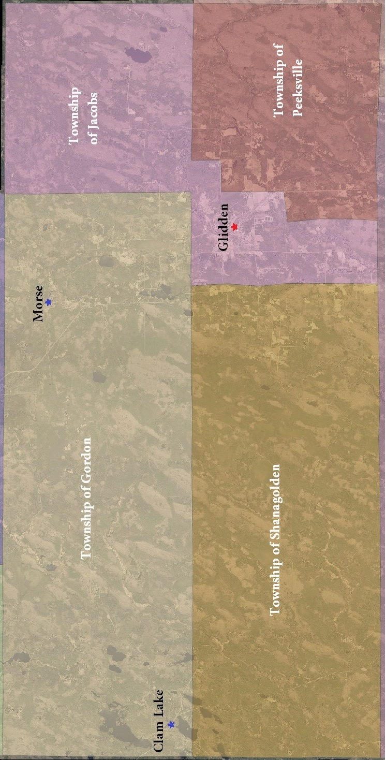
Appendix #2 – Topographical Map of the Four Townships
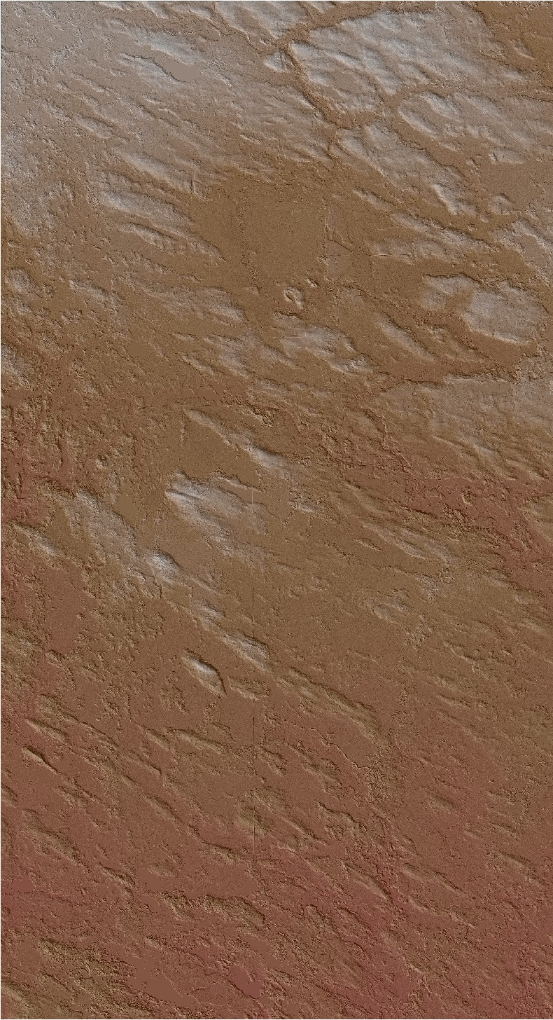
Appendix #3 – Lakes, Rivers, and Creeks
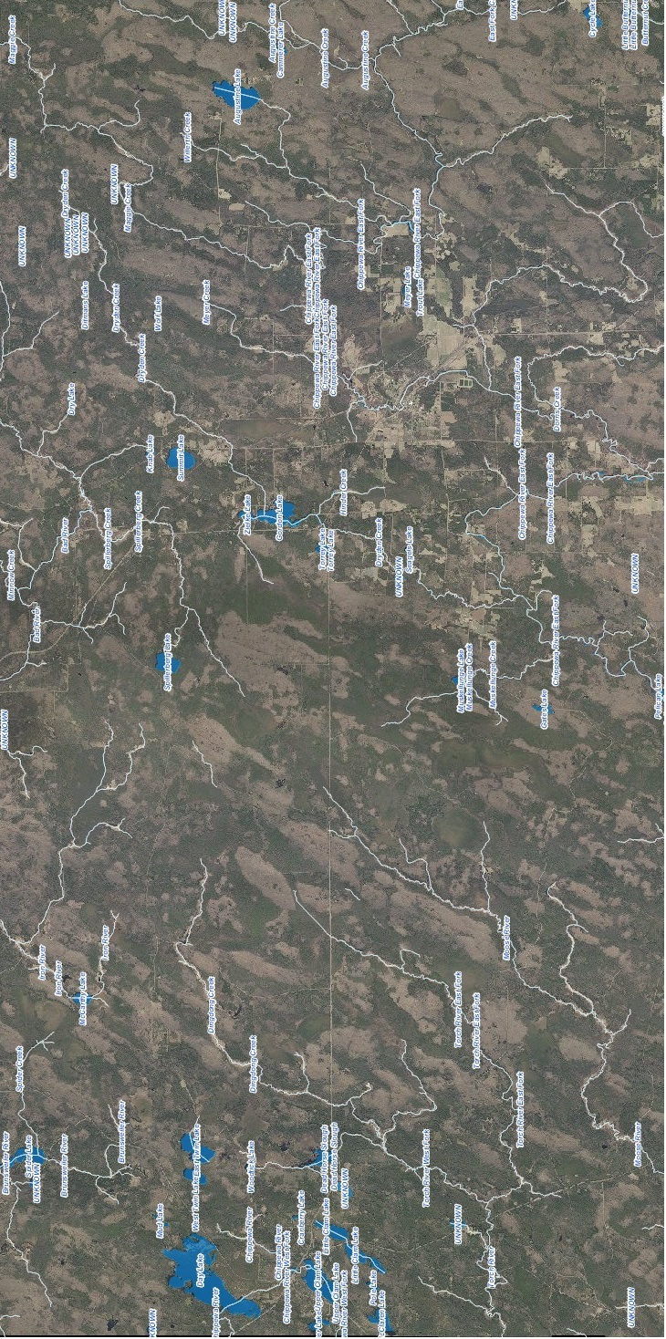
Appendix #4 – Chequamegon-Nicolet National Forest and Ashland County Forest
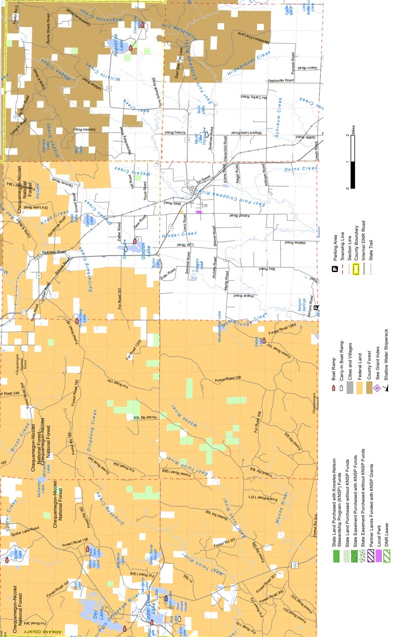
Appendix #5 – Ashland County Snowmobile Trails and Recreation Map
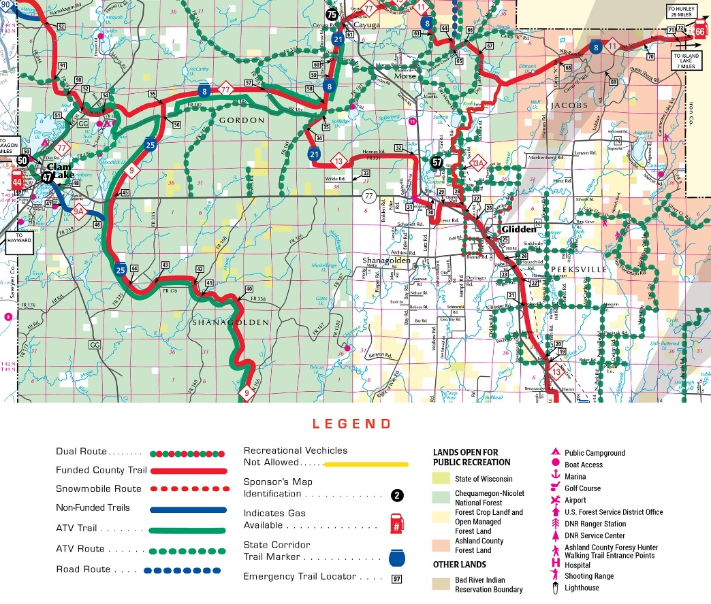

Appendix #6 – Soil conditions (source: Wisconsin Geological & Natural History Survey)
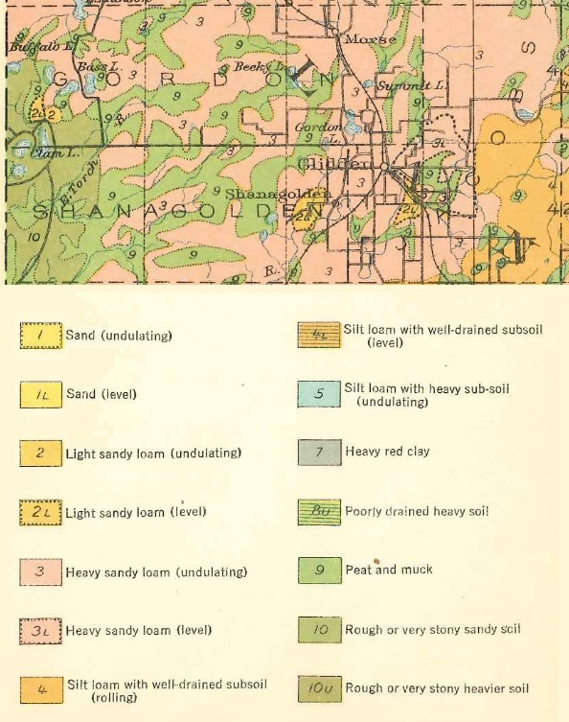

- FORMAL PLAN APPROVAL
