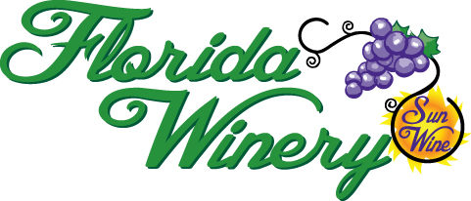

Music Schedule 2024

Saturday May 18 Mick Byrd
Saturday, May 25 Becky Denton
Sunday May 26 Banastre Tarleton
Saturday June 1 The Echos
Saturday June 8 Al Jolley
Saturday June 15 Michael Moore
Saturday June 22 Travis Hoffman
Saturday June 29 Mick Byrd
Saturday July 6 Meredith Shaw
Saturday July 13 Dr. Ferd Bianni
Saturday July 20 Steve Kempker
Saturday July 27 Al Jolley
Saturday August 3 Travis Hoffman
Saturday August 10 Michael Moore
Saturday August 17 Ron & Allen
Saturday August 24 Steve Kempker

Labor Day Weekend
Saturday August 31 Meredith Shaw
Sunday September 1 Dr. Ferd Bianni
Saturday September 7 Banastre Tarleton **
Saturday September 14 TBA **
Saturday September 21 Michael Moore **

Mark-a-Twain-a-Ville Party 12-7 PM
Ticket Required
Saturday September 28 Meredith Shaw (1-3)
The Echos (3:30-5:30)

All music performances are scheduled from 4-6 PM
(In September, the **performances are from 3-5 PM)
For questions, call the Winery 573-565-2400
Music Schedule is subject to change without notice.
Cover charges will be required for all performances.

