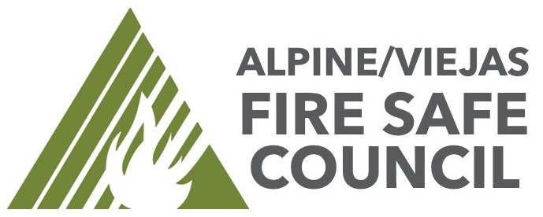

FIRE SAFE COUNCIL AGENDA
Date: November 13th , 10:00am to 11:00am
Located at Alpine Fire Station 1364 Tavern Road Alpine, Ca. 91901
Join Zoom Meeting: https://us06web.zoom.us/j/83911796849?pwd=aWavnE7NS5dLRjzEeFEkwksrUV4AWT.1

- Introductions - Online & in person

- Community Fire Hazards
  - Fuel Breaks – New & Existing – Jason
    - Awarded SPFMG CPG 2024 GRANT to move forward with proposed price from SLO-Mow to brush 50’ off both sides of the fire access road on Bullard Lane (West Side) of fire district. This road serves as access road for Type 3 engines on brush response lakeside, San Miguel and County Fire agencies.
(FB2024-003) HAS COMPLETED 11-8-2024
    - Awarded SPFMG CPG 2024 GRANT Fuel Break application for Viejas Creek Trail Fuel Break Grant funds may not be spent on Federal Land. I will work with USFS on best practice to address the one parcel.
(FB2024-001). IN PROCESS
    - Working on Sky Mesa Estates Hazardous Fuels Reduction: This is the Open Space areas throughout the homeowner’s area.
(FB2024-005). Received an estimate. Going to seek additional estimates.

  - County Roadside Clearing – County DPW (Matt Asche)
  - Cal Trans Mowing – Cal Trans (Dan Perez)

- Old Business
  - Community Outreach Town Hall meeting in February 2025 - Lynn

- New Business
  - Insurance Updates – Cat Modeling
  - 2025 Annual Operating Plan & Goals -
  - 2024 Annual Totals -

- Advisory Member Updates (Please inform members/residents we are looking for new faces)
  - Organizing rosters of emails and means for communication. NEW MEMBERS
  - Hosting events tailgate pop ups. This is for HOA meetings, cul de sac meetings. Call me.

- Next Steps – Roundtable Does anyone have any updates, comments, concerns.
- Adjourn

