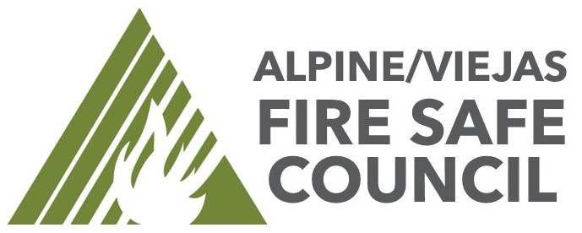

FIRE SAFE COUNCIL AGENDA
Date: November 15th, 2023 10:00 to 11:00
Located at Alpine Fire Station 1364 Tavern Road Alpine, Ca. 91901
Join Zoom Meeting

- Welcome

- Introductions - Online & in person

- Community Fire Hazards
  - Fuel Breaks (existing) - Bonnie
  - Fuel Breaks (new) – Bonnie
  - County Roadside Clearing – County DPW (If any updates)
  - Cal Trans Mowing – Cal Trans (If any updates)
  - Alpine Creek Fuels Reduction clearance – New ROE are needed. Work to possibly start October. Secured a contractor to handle all of the work.
  - Roadside fire starts occurring. Importance of fuels clearing along both sides of the road.

- Old Business
  - Action Plans:
    - Fuel Break Work – Jason -
    - Purchase New Vermeer BC1500 Chipper – Jason – Updated San Diego River Conservancy General Meeting Agenda Item – San Diego Regional Fire Foundation has submitted a grant to secure funds for the Alpine Fire Protection District to purchase outright the new chipper from RDO. Meeting was 11/9.
    - Community Engagement and Outreach – Jason
    - Continue Growth of Firewise USA – Jason / Jon Will be set up outside of Albertsons on November 17th from 9:00 – 12:00pm
    - Roadside Chipping/DSAP – Jason / Updated. Laying out plan for 2024

  - Articles of Incorporation done. Filing for tax emption status has been completed through Online Bookkeeping Services. All paperwork complete and filed with State and IRS.

  - By-laws have been reviewed and comments made by Board.

- New Business
  - Motion to Approve the By-Laws as submitted by Executive Board.
  - Grants worksheet updates. Will Post online a grants worksheet to showcase the projects that the FSC is seeking. Goal is to gain community support and participation.

- Advisory Member Updates
  - Organizing rosters of emails and means for communication.
  - Hosting events tailgate pop ups. This is for HOA meetings, cul de sac meetings. Call me.

- Next Steps – Roundtable Does anyone have any updates, comments, concerns.

- Adjourn

