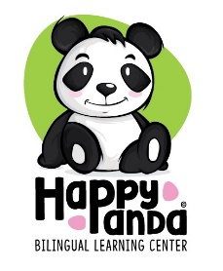

Your Signature bellow is an acknowledgement that you have reviewed our Operational Policies and Parent Handbook and are agreeing to follow the rules and regulations of Happy Panda Bilingual Learning Center.

Child(ren) Name: _________________________________________________Date:____________________

Parent or Guardian Name:____________________________________________Date:______________________

Parent or Guardian Signature:_________________________________________Date:______________________

Parent or Guardian Name:____________________________________________Date:______________________

Parent or Guardian Signature:_________________________________________Date:______________________

Director Signature:__________________________________Date:______________________