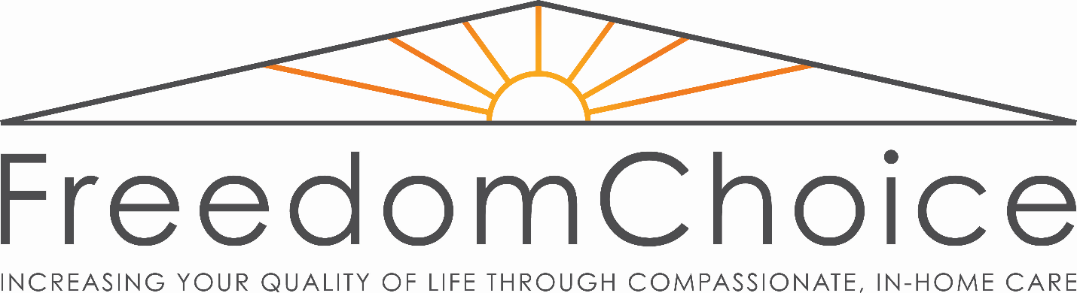
Policy Statement
• The full cost of each session will be billed directly to the client or to valid insurance that we are connected with.
• Payment is due at the start of each session including co-pay, and we will bill insurance if provided.
• Patients will be charged $40 for returned checks. If a check is returned, the client will be required to pay by cash or credit card for future sessions.
• Sessions begin at the designated appointment time. A standard appointment is 50 minutes in length. If the patient arrives late to the appointment, the full fee will be charged and time adjusted for remainder of time available.
• Cancellations must be made 24 hours prior to appointment. Any cancellations made less than 24 hours in advance will be charged the full fee.
• A no show or no call will be billed the full fee for your appointment time.
• Time spent preparing letters, misc. paperwork, court documents etc. on behalf of a client will be billed directly to the client at the rate of the clinician’s current fee schedule.
• Time spent on the phone or in correspondence will be billed in 15- minute increments at the rate of clinician’s current fee schedule.
By signing below, I signify that I have read and fully understand this Policy Statement, and that I agree to pay any charges that may be applied to my account as a result of these policies.

Signed: ___________________________________________________ Date: _______________
Printed Name: _____________________________________________

