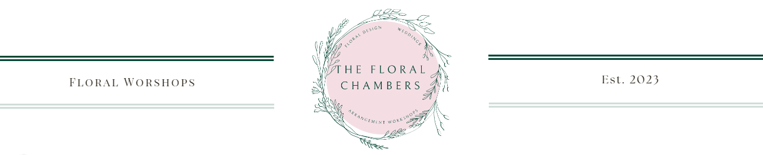
Booking and Cancellation Policy
1. Registration and Confirmation:
Participants are required to book flower arranging workshops and events in advance. Booking through the website will be open until 7 days prior to the event. If you wish to book onto an event with less than 7 days notice, please contact The Floral Chambers via Facebook messenger or Instagram and Sophie will advise if there is availability.
Payment in full is required to secure your place at the time of booking.
2. Cancellation by Participant:
Cancellations made more than 7 days prior to the workshop date will receive a full refund.
Due to the nature of the business and the high cost of the fresh floral products reserved for each place on the workshops, refunds cannot be given in response to cancellations of any nature within 7 days of the event. However, another person is welcome to attend the event/workshop in the original participant’s place – this must be arranged by the participant and not The Floral Chambers.
3. Workshop or Event Cancellation by the company:
We reserve the right to cancel a workshop or event due to unforeseen circumstances. In the unlikely event that this should occur participants will be notified with as much notice as possible, and full refunds for the value of the workshop/event will be given.
In case of unforeseen circumstances such as extreme weather conditions or force majeure, we reserve the right to reschedule the workshop or event. Participants will be notified of any changes as soon as possible.
5. Participant No-Show:
Participants who do not attend the workshop without prior notice will not be eligible for a refund or transfer.
7. Refund Processing:
Refunds will be processed within 5 business days after approval of the cancellation request.
The business owner will contact the customer directly to arrange the method of refund.
8. Modifications to the Policy:
This cancellation policy is subject to change without prior notice. Any modifications will be effective for all registrations received after the date of the policy update.
By registering for our workshops/classes, participants acknowledge and agree to comply with the terms of this booking and cancellation policy.

