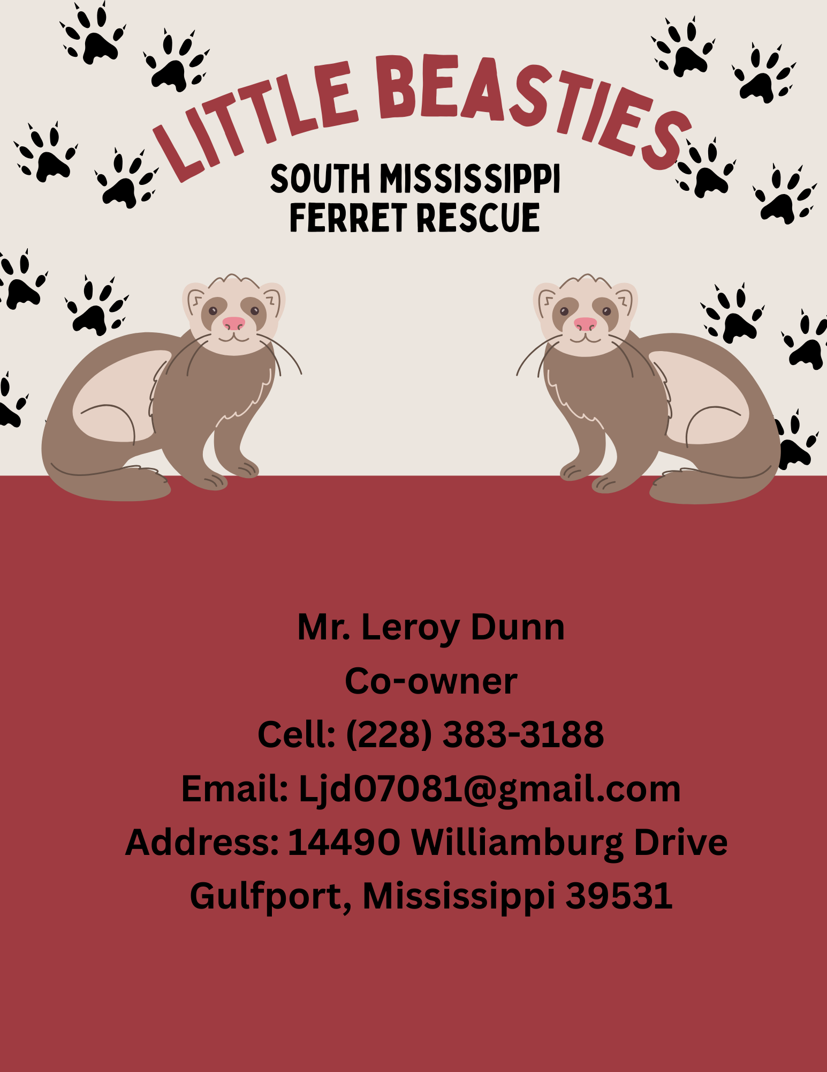

Ferret Adoption Application – Submission Instructions

Essential Adoption Requirements – Please Read Carefully
To begin and complete the adoption process, all of the following must be submitted and approved before pickup:

Step 1: Complete This Adoption Contract
Fill out all applicable sections of this contract. You do not need to sign the final page until the day of adoption, but all other sections must be fully completed before submitting your application.

Step 2: Include a Valid Photo ID
Attach a clear photocopy of a valid, government-issued ID for the primary applicant listed on this form. The name must match the legal name provided in the application.

Step 3: Submit a Video of Your Ferret Setup
You must provide a video tour of your complete ferret setup. This video should clearly show:
- The enclosure or cage (fully assembled)
- Food and water setup (including the brand of food you plan to use)
- Enrichment items such as toys, tunnels, hammocks, or dig boxes
- Sleeping and litter areas
- The location of the setup in your home
This video allows us to confirm that your environment is safe, enriching, and appropriate for ferrets.

Step 4: If Approved – Pickup Appointment and Carrier Requirement
If your application is approved, we will contact you to schedule a pickup appointment. This functions as a short meet-and-greet and final review. On the day of your appointment, you must bring a clean, escape-proof carrier or crate to safely transport your adopted ferret(s). No exceptions.

Where to Send Your Application
Please send the following:
- Completed adoption contract (this form)
- Photocopy of your ID
- Video of your ferret setup
to the following email address: Ljd07081@gmail.com

Ferret Adoption Application – Full Questionnaire

SECTION 1: Personal & ID Information
- Legal Name (as it appears on your ID): ________________________________________
- Type of ID Provided: ☐ Driver’s License ☐ State ID ☐ Military ID ☐ Other__________________
- ID Number: _________________________________
- Expiration Date of ID: _____________________________
- ☐ I have attached a copy of my ID with this application.
- Phone Number: _________________________________________
- Email Address: ___________________________________________
- Home Address: ______________________________________________________________
- City: ____________________________________
- State: _________________________
- Zip Code: ___________________________
- How long have you lived at this location? ___________________________________
- Do you: ☐ Rent ☐ Own
- Do you smoke in the home? ☐ Yes ☐ No

SECTION 2: Household Information
- How many adults live in your household? ________________________________
- How many children? (Include ages) _______________________________________
- Do you frequently have visitors (children/grandchildren/etc)? _______________
- If yes, how often and what are their ages? ____________________________________
- Are all household members aware of and on board with this adoption? ☐ Yes ☐ No
- Do you have adequate space for ferrets to safely play and explore? ☐ Yes ☐ No

SECTION 3: References and Emergency Contact Information
Family Ref8erence
Name: ___________________________________
Relationship: _____________________________
Phone: __________________________________
Email: ___________________________________
Non-Family Reference
Name: ___________________________________
Relationship: _____________________________
Phone: __________________________________
Email: __________________________________
Emergency Contact
(This person may be contacted in the event of an emergency or if you cannot be reached)
Name: __________________________________________
Relationship to you: _______________________________
Phone Number: ___________________________________
Email Address: ____________________________________
City & State: ______________________________________

SECTION 4: Current Pet & Veterinarian Information
- What pets do you currently own? (Species and ages):

- Are all current pets vaccinated? ☐ Yes ☐ No
- Are all current pets spayed/neutered? ☐ Yes ☐ No
- If NO to either, please explain why:

Veterinarian Information
- Name of your current veterinarian: _______________________________________
- Clinic Name: _______________________________________________________
- Phone Number: _________________________
- Clinic Address (City, State, Zip): __________________________________________
- Does this vet see exotic animals (ferrets)? ☐ Yes ☐ No
- If NO, what exotic vet will you be using for your ferret’s care?

SECTION 5: Ferret Knowledge & Experience
- How would you describe your ferret experience? ☐ Beginner ☐ Intermediate ☐ Experienced
- Have you owned ferrets before? ☐ Yes ☐ No
- If yes, when and how many? ______________________________________
- Do you still have them? ☐ Yes ☐ No
- If not, what happened to them? _______________________________________________
- What does “Forever Home” mean to you? ______________________________________________________________________________

SECTION 6: Responsible Pet Ownership & Ferret Knowledge
- Have you ever surrendered a pet? ☐ Yes ☐ No
- If yes, when and why? ________________________________________________________
- Under what circumstances would you move to a location that doesn’t allow ferrets? ______________________________________________________________________
- What would you do with your ferrets if that happened? ________________________
- Can ferrets get heartworms? ☐ Yes ☐ No
- Is there a treatment for heartworms in ferrets? ☐ Yes ☐ No
- Do ferrets receive vaccines? ☐ Yes ☐ No
- If yes, which ones and how often? ____________________________________________
- What should a ferret eat? ____________________________________________________
- How often should they be fed? _______________________________________________
- What treats/food are NOT safe for ferrets? ____________________________________
- How often should you refill their water supply? ________________________________
- What is ferret-proofing and how do you do it? ______________________________________________________________________________
- What is a good number of ferrets to own and why? _____________________________
- What is the minimum amount of time a ferret should be out of the cage each day?_________________________________________________________________________
- When should a ferret be in their cage? ________________________________________
- Name 3 common ferret illnesses, these symptoms and how you would treat each:
1.__________________________________________________________________________________________________________________________________________________________

2.__________________________________________________________________________________________________________________________________________________________
3.______________________________________________________________________________________________________________________________________________________________________

- Anything else we should know or questions you have for us?

SECTION 7: Ferret Information (Filled Out by Rescue)
(For each ferret, extra space on bottom for multiples)
- Name:________________________________________
- Sex: ☐ Male ☐ Female
- Age: ______________________________
- Breeder (if known): Marshalls farms, or other: ______________
- Color(s):______________________
- Personality Description: _____________________________________________
- Medical Notes: _____________________________________________________________________________________________________________________________________________________________________________________________________________________________________________

SECTION 8: Adoption Agreement – Please Read and Initial Each
The adopter agrees to the following conditions:
________1. I will provide high-quality food, clean water, and safe shelter at all times.
A. Ferret(s) will be kept indoors in suitable housing that allows exercise when not out, such as while I’m at work.
________2. I will provide proper medical care from a ferret-knowledgeable veterinarian to keep the ferret(s) in good health.
A. This includes keeping them up to date on vaccinations.
________ 3. I understand that Little Beasties Rescue can conduct a home check within the first 6 months.
A. The home check may be done:
• In person
• Via FaceTime/Duo
• By sending pictures or video
________ 4. I agree to follow all local animal ordinances and anti-cruelty laws.
________ 5. I am adopting the ferret(s) as a household pet and companion for myself—not for another person or resale.
________ 6. I will NOT sell, give away, or rehome the ferret(s).
If I cannot keep them, I will return them to Little Beasties Rescue only.
________7. If I can no longer spend time with the ferret(s), or if I am unable to provide proper care, I will contact Little Beasties Rescue for return arrangements.
________ 8. I will contact Little Beasties Rescue if I experience any problems or challenges. We will work together to resolve them.
________ 9. I understand that the adoption fee for this/these ferret(s) is $___________.
A. The adoption fee is non-refundable, even if the ferret(s) is/are returned to the rescue.
________ 10. I will notify Little Beasties Rescue immediately if the ferret(s) become lost.
________11. I will notify Little Beasties Rescue in the event of the ferret(s)’ death and share the cause if known.
________12. I agree to stay in touch with Little Beasties Rescue after adoption.
A. I will send updates at least every 6 months for the first year, including:
1. At least 2 photos of the ferret(s)
2. A short summary of how they’re doing (behavior, settling in, personality, etc.)
📸 Note: Photos and updates may be used on the rescue's website or social media.

SECTION 9: Legal Notice & Liability
________13. I understand that Little Beasties Rescue cannot guarantee the future health of any adopted ferret.
________14. I accept all financial responsibility for the ferret’s care after adoption.
________15. I agree to return the ferret if I fail to comply with this contract.
________16. I understand that any abuse or neglect will result in reclaiming the ferret and possible legal action.
________17. I understand that if the ferret(s) I adopt require additional care (for example, due to being a single ferret that cannot live with others, adrenal disease, behavioral challenges, or other medical conditions). I will take full responsibility for managing and meeting their specific needs. I agree to provide proper attention, vet care, and an environment that supports their health and well-being.

SECTION 10: Signatures
________18. I have read and agree to all the terms of this adoption contract.
- Adopter Signature: __________________________
- Printed Name: ______________________________
- Date: ___________________
- Rescue Representative Signature: __________________________
- Printed Name: ______________________________
- Date: ___________________

Note: All terms, agreements, and responsibilities outlined in this contract apply equally to all ferrets adopted under this application, including any additional ferrets listed on the attached pages.
By signing above, I acknowledge that I understand and agree to these conditions for each ferret adopted, whether listed on the primary page or in the attached addendum

Addendum: Multiple Ferret Adoption Details

- Name:________________________________________
- Sex: ☐ Male ☐ Female
- Age: ______________________________
- Breeder (if known): Marshalls farms, or other: ______________
- Color(s):______________________
- Personality Description: _____________________________________________
- Medical Notes: _____________________________________________________________________________________________________________________________________________________________________________________________________________________________________________

(For each ferret, extra space on bottom for multiples)
- Name:________________________________________
- Sex: ☐ Male ☐ Female
- Age: ______________________________
- Breeder (if known): Marshalls farms, or other: ______________
- Color(s):______________________
- Personality Description: _____________________________________________
- Medical Notes: _____________________________________________________________________________________________________________________________________________________________________________________________________________________________________________

- Name:________________________________________
- Sex: ☐ Male ☐ Female
- Age: ______________________________
- Breeder (if known): Marshalls farms, or other: ______________
- Color(s):______________________
- Personality Description: _____________________________________________
- Medical Notes: _____________________________________________________________________________________________________________________________________________________________________________________________________________________________________________

- Name:________________________________________
- Sex: ☐ Male ☐ Female
- Age: ______________________________
- Breeder (if known): Marshalls farms, or other: ______________
- Color(s):______________________
- Personality Description: _____________________________________________
- Medical Notes: _____________________________________________________________________________________________________________________________________________________________________________________________________________________________________________

- Name:________________________________________
- Sex: ☐ Male ☐ Female
- Age: ______________________________
- Breeder (if known): Marshalls farms, or other: ______________
- Color(s):______________________
- Personality Description: _____________________________________________
- Medical Notes: _____________________________________________________________________________________________________________________________________________________________________________________________________________________________________________

- Name:________________________________________
- Sex: ☐ Male ☐ Female
- Age: ______________________________
- Breeder (if known): Marshalls farms, or other: ______________
- Color(s):______________________
- Personality Description: _____________________________________________
Medical Notes: _____________________________________________________________________________________________________________________________________________________________________________________________________________________________________________

