
PHYSICAL THERAPY PROTOCOL
Achilles Tendinopathy
Nonoperative Rehabilitation — Pediatric & Adolescent Athletes

- This is an overuse (chronic load) tendon injury, not a tear or fracture. With activity modification and a structured, criteria-based loading program, the vast majority of pediatric and adolescent patients recover fully and return to sport without surgery.

Diagnosis & Anatomy
The Achilles tendon connects the calf muscles (gastrocnemius and soleus) to the heel bone (calcaneus) and transmits the force that allows push-off during walking, running, and jumping. Achilles tendinopathy is an overuse condition caused by repetitive tensile load — most often from rapid increases in running or jumping volume — that outpaces the tendon's ability to adapt and repair.
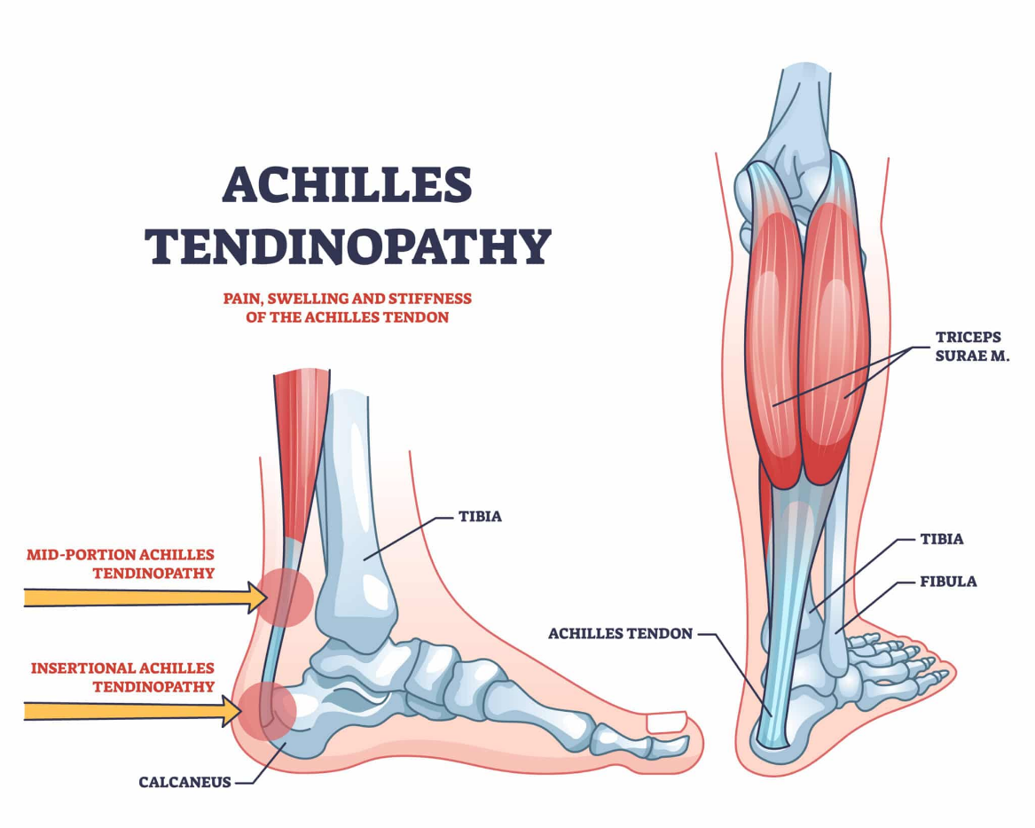
Tendinopathy can occur mid-substance (2–6 cm above the heel) or at the insertion onto the calcaneus. It is a different problem from Sever's disease (calcaneal apophysitis), which involves the growth plate at the back of the heel rather than the tendon itself; the two can occasionally coexist and should be distinguished on exam.

Natural History
Pediatric and adolescent Achilles tendinopathy is a self-limited overuse condition in the great majority of cases. Symptoms typically improve over 6–12 weeks with relative rest from aggravating impact activity and a progressive loading program. Continuing high-volume running or jumping through significant pain slows recovery and is the most common reason symptoms become prolonged or recurrent.

Diagnostic Notes
Imaging
- MRI is not routinely needed. The diagnosis is made clinically based on history and exam findings.
- Imaging (ultrasound or MRI) is reserved for atypical presentations, suspicion of partial tendon tear, or failure to improve with an adequate trial of structured rehabilitation.

Treatment Overview
Rehabilitation progresses through four phases based on the patient meeting specific clinical criteria, not on a fixed calendar. Progressive tendon loading — beginning with isometrics and advancing through eccentric and then plyometric exercise — is the evidence-based cornerstone of treatment and is what actually drives tendon healing. Adjunctive measures such as short-term CAM boot immobilization, an ASO ankle brace, and/or night splinting may be used at the treating clinician's discretion to manage severe symptoms or enforce rest, but they do not replace the loading program.

PHASE 1 · Protection & Symptom Modulation
Weight-Bearing / Immobilization  - For severe symptoms: a short period (typically 1–3 weeks) of CAM boot immobilization may be used to "force rest" and de-load the tendon  - For mild symptoms: an ASO-style ankle brace can be used instead  - A heel lift/insert may be used to decrease tendon stretch during ambulation  - A Night splint (dorsiflexion stretch splint) optional if morning stiffness or first-step pain is prominent | Goals & Interventions  - Relative rest from aggravating impact activity (running, jumping, cutting) — this is not complete immobilization; pain-free daily activity is encouraged  - Ice after activity for pain and irritation as needed  - Pain-free ankle range of motion  - Gentle, pain-free gastroc-soleus stretching (avoid aggressive stretch into pain)  - Begin submaximal isometric calf holds for pain modulation  - Ultrasound may be used as an adjunctive modality for symptom relief at therapist discretion  - Patient/family education on load management and footwear/training-surface factors
Criteria to Advance: Pain with daily activity < 3/10, no pain at rest, isometric calf holds well tolerated.

PHASE 2 · Eccentric Loading & Progressive Strengthening
Weight-Bearing / Immobilization  - Full weight-bearing, no brace required  - Continue night splint if it has been helpful for morning stiffness | Goals & Interventions  - Introduce eccentric heel-drop program (both straight-knee and bent-knee), beginning with body-weight loading and low repetitions, progressing gradually as tolerated  - Progress concentric and eccentric calf strengthening (double-leg → single-leg as tolerated)  - Continue gastroc-soleus and soleus-specific stretching  - Add hip and core strengthening to support lower-extremity mechanics  - Begin proprioception/balance training  - Continue activity modification for high-impact sport; low-impact conditioning (cycling, swimming, pool running) may continue throughout
Criteria to Advance: Pain-free single-leg heel raise x 10–15 reps, minimal discomfort (< 3/10) during eccentric program, improving tendon load tolerance.

PHASE 3 · Functional Strengthening & Return to Running
Weight-Bearing / Immobilization  - Full weight-bearing, no restrictions  - Night splint typically discontinued | Goals & Interventions  - Progressive resistance calf strengthening (weighted heel raises)  - Single-leg strength and control work; address any side-to-side asymmetry  - Gait and running mechanics assessment and correction  - Structured walk-to-run progression  - Sport-specific drills without jumping, cutting, or plyometric loading yet
Criteria to Advance: Pain-free jogging, single-leg heel raise strength approximately symmetric to the uninvolved side, no swelling or delayed soreness after activity.

PHASE 4 · Plyometrics & Return to Sport
Weight-Bearing / Immobilization  - Full weight-bearing, no restrictions  - No brace or splint | Goals & Interventions  - Progressive plyometric program: double-leg hopping → single-leg hopping → bounding → jump-landing mechanics  - Sport-specific agility and cutting drills  - Gradual, staged return to full-intensity training (increase volume/intensity no more than ~10% per week)  - Maintenance strengthening (eccentric/concentric calf program) continued 2–3x/week to reduce recurrence  - Hop testing and functional symmetry assessment prior to full clearance
Criteria to Advance: Full, pain-free participation in sport-specific drills at full intensity; symmetric strength and hop testing; no symptom recurrence through progression → discharge from formal PT.

Quick-Reference Timeline
Timeframes are typical ranges for planning purposes only. Every patient must advance based on meeting the clinical criteria above, not by the calendar.
Phase | Typical Timeframe* | Key Focus | Criteria to Advance
Phase 1 | Weeks 0–2 | Relative rest, isometrics, pain control | Pain < 3/10 with ADLs, none at rest
Phase 2 | Weeks 2–5 | Eccentric loading, calf strengthening | Pain-free SL heel raise x10–15
Phase 3 | Weeks 5–8 | Progressive strength, walk-run progression | Pain-free jogging, symmetric strength
Phase 4 | Weeks 8–12+ | Plyometrics, return to sport | Full-intensity sport drills, symmetric hop testing

Clinical Pearls
For the Treating Therapist
- Eccentric loading is the strongest evidence-based intervention for tendinopathy; dose it conservatively in adolescents compared with published adult (Alfredson) protocols and progress by symptom response.
- "Relative rest" means removing the specific aggravating impact load, not stopping all activity — pain-free low-impact conditioning should continue.
- Screen the contralateral limb; bilateral involvement is common in overuse Achilles tendinopathy.
- Review training load, footwear, and playing surface — a rapid increase in running/jumping volume is the most common modifiable contributor.
- Night splinting and ultrasound are adjuncts that may improve comfort and speed healing.
- A short course of CAM boot immobilization or an ASO ankle brace can be useful to manage severe symptoms or enforce rest in a child who will not otherwise offload the tendon. Wean out of the boot/brace as soon as symptoms allow and transition promptly into the progressive loading program, which is the actual driver of tendon healing.

Potential Risks, Complications & Red Flags
Refer back to the surgeon if:
- Sudden "pop," acute severe pain, or inability to perform a single-leg heel raise — evaluate for possible tendon tear/rupture.
- Symptoms fail to improve after an adequate trial (roughly 6–8 weeks) of structured, compliant rehabilitation.
- Significant swelling, warmth, or symptoms out of proportion to an overuse presentation.
- Recurrent symptoms with each attempt to return to sport despite appropriate progression.

With appropriate activity modification and adherence to a progressive loading program, prognosis is excellent and long-term complications are uncommon.

