REHABILITATION PROTOCOL — PEDIATRIC ORTHOPEDICS  Discoid Meniscus: Saucerization ± Repair  Post-Operative Rehabilitation Protocol | PT / Home Program | 

This is a general guideline for arthroscopic saucerization of a symptomatic discoid lateral meniscus, with or without peripheral rim repair. Progression is criteria-based, not strictly time-based. Individualize as needed based on intra-operative findings.

OVERVIEW & SURGICAL DESCRIPTION
A discoid meniscus is a congenital variant in which the meniscus — most commonly the lateral meniscus — is thicker and disc-shaped rather than the normal thin, crescent ("C"-shaped) form. Because of its abnormal shape and often deficient peripheral attachments, a discoid meniscus is more prone to tearing and to instability (excessive rim mobility), which can cause pain, mechanical symptoms, and swelling.
Surgical treatment is arthroscopic saucerization — contouring the abnormal disc-shaped meniscus down to a stable, normal C-shape while preserving as much healthy peripheral rim as possible. If the peripheral rim is unstable or torn, a meniscal repair (suture fixation of the rim to the capsule) is performed at the same setting to restore stability.

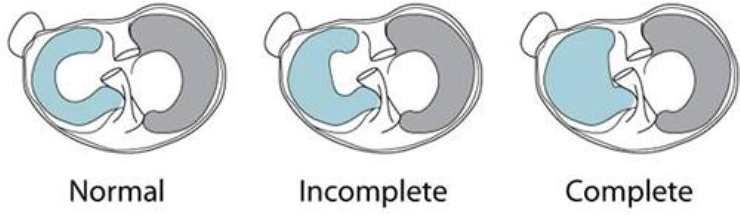
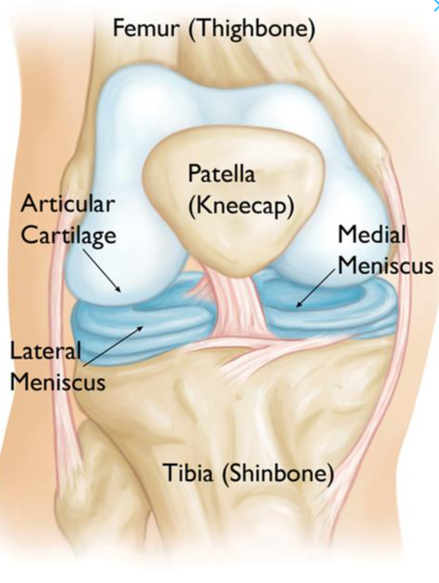
Meniscus Anatomy – Normal vs. Discoid

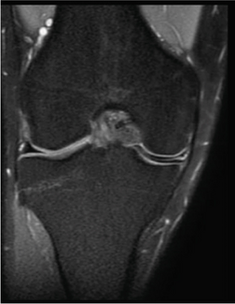
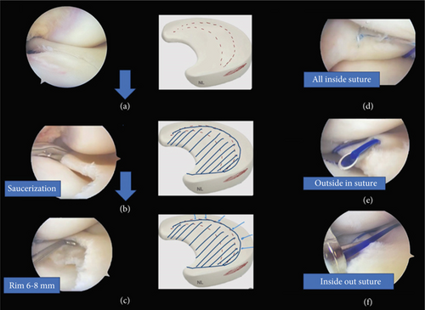
https://doi.org/10.1155/cro/1851165
STANDARD POST-OPERATIVE PARAMETERS
WEIGHT BEARING  WBAT (weight bearing as tolerated) immediately post-op. Crutches for comfort/gait control until quad control is achieved. | BRACING  Hinged knee brace, ROM limited 0°–90°. May be locked in full extension as needed for comfort during the first 2 weeks; unlocked thereafter through the full 6 weeks. | IMAGING  Routine post-operative MRI is not indicated. Progress is followed clinically.

What is NOT routinely needed:
Post-operative MRI is not required to confirm healing and should not be obtained routinely — clinical exam and functional milestones guide progression. Continuous passive motion (CPM) machines are not required.

PHASE-BASED REHABILITATION PROTOCOL
Phase 1 — Protection & Early Motion (Weeks 0–2)
WEIGHT BEARING / BRACE  - WBAT with crutches; wean crutches as quad control allows  - Hinged brace, ROM limited 0°–90°; may be locked in full extension as needed for comfort during this period | GOALS & INTERVENTIONS  - Control pain, effusion, and inflammation (ice, elevation, compression)  - Quad sets, straight leg raises, ankle pumps  - PROM/AAROM within brace limits (0°–90°)  - Patellar mobilization to prevent stiffness
Advance when: pain and effusion are controlled, active quad contraction without lag, and ROM progressing within brace limits.

Phase 2 — Progressive ROM & Strength (Weeks 2–6)
WEIGHT BEARING / BRACE  - Full WBAT, discontinue crutches once gait is non-antalgic and quad control is normal  - Hinged brace unlocked, ROM limited 0°–90° through the full 6 weeks; discontinued at the week-6 visit per surgeon | GOALS & INTERVENTIONS  - Continue AROM/AAROM within the 0°–90° brace limit (full ROM is not expected until the brace is discontinued at week 6)  - Closed-chain strengthening: mini-squats, step-ups, leg press, all within brace limits  - Stationary bike within brace ROM as tolerated  - Balance / proprioceptive training  - Normalize gait pattern off crutches
Advance when: full ROM restored after brace discontinuation at week 6, normal gait without assistive device, and quad strength approaching symmetry.

Phase 3 — Strength & Neuromuscular Control (Weeks 6–12)
WEIGHT BEARING / BRACE  - Full WBAT, brace discontinued at week 6  - No formal restrictions on daily activity | GOALS & INTERVENTIONS  - Progressive resistance training (quad, hamstring, hip, core)  - Single-leg balance and proprioceptive progression  - Initiate straight-line jogging program around 8–10 weeks if criteria met  - Sport-specific conditioning drills, low-impact cardio
Advance when: quad and hamstring strength ≥80% of contralateral limb, no pain/effusion with activity, and running program tolerated without symptoms.

Phase 4 — Return to Sport (Weeks 12–16+)
WEIGHT BEARING / BRACE  - Unrestricted | GOALS & INTERVENTIONS  - Cutting, pivoting, and plyometric progression  - Sport-specific agility drills  - Gradual return to practice, then full competition
Advance when: quad/hamstring strength ≥90% of contralateral limb, successful sport-specific agility testing, and no pain, swelling, or mechanical symptoms with full activity — typically 3–4 months post-op.

QUICK-REFERENCE TIMELINE
PHASE | TIMEFRAME | WEIGHT BEARING / BRACE | KEY MILESTONE
1 — Protection | Weeks 0–2 | WBAT; brace ROM 0–90° (may lock in extension for comfort) | Pain/effusion controlled, active quad set without lag
2 — Progressive ROM & Strength | Weeks 2–6 | WBAT; brace unlocked, ROM 0–90° continues, off crutches | ROM progressing within brace, normal gait
3 — Strength & Neuromuscular Control | Weeks 6–12 | Full WBAT, no brace | Strength ≥80%, jogging tolerated
4 — Return to Sport | Weeks 12–16+ | Unrestricted | Strength ≥90%, passes agility testing

CLINICAL PEARLS
- Repair vs. saucerization alone: Both follow this same brace/weight-bearing protocol; peripheral repairs simply require diligent adherence to the 0–90° flexion limit through Phases 1–2 to protect the healing rim.
- Quad activation is the rate-limiter. Early, consistent quad sets and SLR prevent arthrogenic muscle inhibition, the most common cause of a slow early recovery.
- Effusion drives inhibition. Aggressive early swelling control accelerates return of quad function and ROM.
- Discoid menisci are often bilateral. Counsel families that the contralateral knee may also be discoid, even if asymptomatic.

PRECAUTIONS, RISKS & RED FLAGS
- Call our office if: increasing pain, new locking or catching, significant new swelling, fever, wound drainage/redness, or inability to achieve motion goals on schedule.

