REHABILITATION PROTOCOL — PEDIATRIC ORTHOPEDICS  Knee Rehabilitation Following Distal Femur Osteochondroma Excision  General Post-Operative Therapy Guideline | Physical Therapy / Home Program | 

This is a general guideline for an uncomplicated excision of a benign distal femur osteochondroma near the knee. Progression is criteria-based, not strictly time-based — advance each phase only when the listed goals are met. This protocol should be individualized by the treating surgeon and therapist based on lesion size/location, proximity to the physis, extent of dissection, and intra-operative findings.

Surgical context: Osteochondroma excision near the distal femur is typically performed extraperiosteally with removal of the cartilage cap and stalk down to (but not into) normal cortical bone, taking care to protect the adjacent physis (growth plate) when the lesion is metaphyseal. Most patients do not have an osteotomy, joint violation, or internal fixation, so this is fundamentally a soft-tissue and periosteal healing protocol, not a fracture or osteotomy protocol — but the timeline below assumes a typical case and should be confirmed against the operative note.

Example: Distal femur osteochondroma before and after excision.
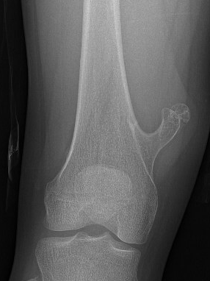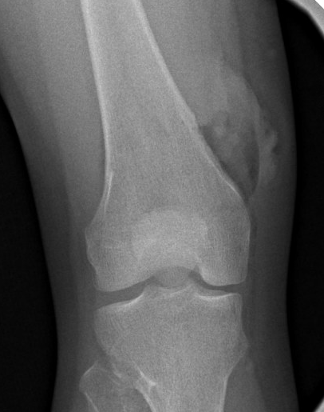

Phase 1 — Protection & Early Motion (Days 0–14 (Weeks 0–2))
WEIGHT BEARING  WBAT with crutches/walker  - Weight-bearing as tolerated (WBAT) on the operative leg.  - Assistive device (crutches or walker) for balance and comfort, not strict offloading.  - Wean assistive device as gait normalizes and pain allows, typically within 1–2 weeks. | GAIT TRAINING  - Practice reciprocal gait pattern with appropriate device; avoid hip-hiking or circumduction compensations.  - Emphasize heel-to-toe pattern and symmetric stance time as tolerated.  - Address any extension lag or quad inhibition affecting stance phase.
KNEE ROM  Goal: 0–90° by end of Phase 1  - Begin gentle active-assisted and passive ROM within 2–3 days post-op as incisional pain allows.  - Heel slides, seated passive knee flexion/extension, stationary bike with no resistance (seat raised) once incision allows.  - Full passive extension (0°) is a priority from the outset to prevent flexion contracture.  - Avoid forceful or end-range stretching directly over the surgical site in the first 10–14 days. | STRENGTHENING  - Quad sets, ankle pumps, and gluteal isometrics starting day 1.  - Straight leg raises (SLR) once quad set is performed without extensor lag.  - Multi-angle isometrics (quad, hamstring) within pain-free range.  - No active resisted knee extension or open-chain resistance directly stressing the excision site yet.
CRITERIA TO PROGRESS TO PHASE 2
Incision healed/clean and dry, minimal effusion, knee flexion ≥90°, full passive extension, independent and safe ambulation with device, good quad activation (no extensor lag with SLR).

Phase 2 — Motion Restoration & Early Strengthening (Weeks 2–6)
WEIGHT BEARING  WBAT, progress off device  - Continue WBAT; discontinue assistive device once gait is symmetric and pain-free, typically by weeks 2–4.  - Continue progressing off assistive device as gait normalizes. | GAIT TRAINING  - Refine gait mechanics — eliminate any residual antalgic pattern, Trendelenburg, or quad avoidance.  - Begin single-leg stance balance work and proprioceptive training on stable surfaces.  - Treadmill walking for endurance and gait symmetry once off assistive device.
KNEE ROM  Goal: Full, symmetric ROM by end of Phase 2  - Progress to full active and passive ROM, matching the contralateral knee.  - Stationary bike with gradually increasing resistance.  - Gentle soft tissue / scar mobilization once incision is fully healed (~3 weeks) to prevent adhesion and optimize quad excursion. | STRENGTHENING  - Closed-chain exercises: mini-squats, leg press (limited arc), step-ups (low step height), wall sits as tolerated.  - Progress SLR to multi-plane (flexion, abduction, extension) and add light ankle weight once extensor lag-free.  - Hip and core strengthening (bridges, clamshells, standing hip abduction) — important given the proximity of many distal femur osteochondromas to the muscle origins crossing the knee.  - Begin stationary bike resistance progression and elliptical (low resistance) if available.
CRITERIA TO PROGRESS TO PHASE 3
Full, pain-free active and passive ROM symmetric to contralateral side; independent ambulation without device or limp; closed-chain strength sufficient for controlled mini-squat and step-up without compensation; minimal to no effusion.

Phase 3 — Progressive Strengthening & Functional Training (Weeks 6–12)
WEIGHT BEARING  Full weight bearing, no restrictions  - Full, unrestricted weight bearing assuming radiographic confirmation of adequate cortical remodeling/healing at the excision site (surgeon-confirmed, typically 6–8 weeks post-op). | GAIT / FUNCTIONAL TRAINING  - Progress to community ambulation distances, stairs without rail, uneven terrain.  - Begin light jogging in a straight line once strength and confidence allow (typically not before 8–10 weeks and surgeon clearance).  - Dynamic balance and agility drills (lateral shuffles, controlled cutting) introduced late in this phase.
KNEE ROM  - Full ROM should already be established; focus shifts to maintaining motion under load and during dynamic activity.  - Continue scar/soft tissue mobility work if any residual tightness or adhesion is present. | STRENGTHENING  - Progressive resistance training: leg press, squats (increasing depth/load), lunges, step-downs, single-leg balance with perturbation.  - Eccentric quad and hamstring strengthening.  - Sport- or activity-specific strengthening based on the child's typical activities (running, jumping, cutting sports).  - Continue hip/core program — proximal stability reduces compensatory stress through the healing distal femur.
CRITERIA TO PROGRESS TO PHASE 4 / RETURN-TO-SPORT TESTING
Full strength (≥85–90% of contralateral limb on functional testing when available), no pain with jogging or functional movements, surgeon-confirmed radiographic healing of the excision site, full confidence with single-leg loading tasks.

Phase 4 — Return to Sport / Full Activity (Week 12+, Individualized)
- Weight bearing/restrictions: None — full activity assuming criteria above are met and surgeon clearance is given. Return to unrestricted sport requires surgeon sign-off, particularly for contact or pivoting sports.
- Strength & conditioning: Progress to plyometrics (double-leg, then single-leg hop progression), running progression (straight-line → curved → cutting → sport-specific drills), and sport-specific agility work.
- Functional testing: When available, single-leg hop tests (single hop, triple hop, crossover hop, 6-meter timed hop), isokinetic or hand-held dynamometry quad/hamstring strength, and a sport-specific movement assessment should all approach symmetry (≥90%) with contralateral limb before full clearance for cutting/contact sports.
- Typical full return-to-sport timeline: 12 weeks for routine osteochondroma excision, coinciding with the end of Phase 3.

MODALITIES & ADJUNCTIVE INTERVENTIONS
CRYOTHERAPY  Ice 15–20 min after sessions/activity, especially Phases 1–2, to control effusion and pain. | NMES  Neuromuscular electrical stimulation for quad re-education if extensor lag persists beyond expected timeline. | SCAR MOBILIZATION  Manual scar massage once incision fully closed (~3 weeks) to prevent adhesion-related motion loss. | COMPRESSION  Light compression wrap/sleeve in early phases as needed for swelling control; elevate when resting.
STATIONARY BIKE  Excellent early ROM and cardiovascular tool once seat height allows pain-free pedaling. | POOL / AQUATIC THERAPY  Useful adjunct once incision fully healed (typically ≥2–3 weeks) for low-impact gait and ROM work. | BRACING  Not routinely required for routine osteochondroma excision. | MANUAL THERAPY  Patellar mobilization and soft tissue work for the quadriceps/IT band as needed to restore normal arthrokinematics.

PRECAUTIONS & RED FLAGS
Hold or modify the program and contact our office if any of the following occur:
New or worsening pain at the surgical site, particularly with weight bearing, that is out of proportion to the expected post-operative course. Sudden increase in swelling, warmth, redness, or drainage from the incision (concern for infection or hematoma). Fever, especially combined with increasing pain or wound changes. New numbness, tingling, or weakness distal to the surgical site (neurovascular concern). Inability to bear weight or a new limp after previously ambulating well. Loss of previously achieved knee motion or a sudden mechanical block to motion. Avoid high-impact loading, jumping, and contact/collision activity until cleared by the surgeon, even if pain-free.

QUICK-REFERENCE TIMELINE
PHASE | TIMEFRAME | WEIGHT BEARING | KEY FOCUS
1 — Protection & Early Motion | Weeks 0–2 | WBAT w/ device | Pain/swelling control, ROM to 90°, quad activation
2 — Motion Restoration | Weeks 2–6 | WBAT, wean device | Full ROM, closed-chain strengthening, gait normalization
3 — Progressive Strengthening | Weeks 6–12 | Full WB (radiograph-confirmed) | Progressive resistance, light jogging, functional training
4 — Return to Sport | Week 12 (individualized) | Unrestricted | Plyometrics, agility, functional testing, surgeon clearance

CLINICAL PEARLS
- This is a soft-tissue protocol, not a fracture protocol — in the large majority of cases there is no osteotomy or fixation, so the rate-limiting step is wound healing, quad re-activation, and patient confidence rather than bone healing.
- Watch the extensor mechanism closely. Many distal femur osteochondromas lie near the quadriceps or hamstring origins/insertions; early, consistent quad activation work (quad sets, SLR) prevents the arthrogenic muscle inhibition that is the most common cause of a slow recovery.
- Recurrence is uncommon with complete excision including the cartilage cap and perichondrium, but any new bony prominence or mass after apparent healing warrants re-evaluation.

