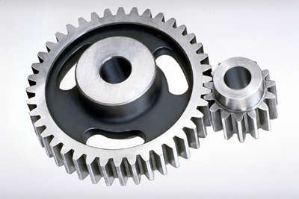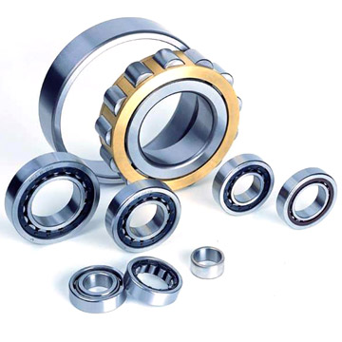

|  |
| --- |
|  |

**SOURCING SOLUTIONS FOR INDUSTRIAL DISTRIBUTION**

**PRODUCT CATEGORIES:**

* BEARINGS
* BELTS AND BELT DRIVES
* CHAIN
* SPROCKETS
* GEARS
* ADHESIVES / SEALANTS / LUBRICANTS
* GENERAL INDUSTRIAL SUPPLIES
* RADIAL SHAFT SEALS / O-RINGS / GASKETS / EXTRUDED CORD
* PIPE / VALVES / FITTINGS
* ELECTRICAL (MOTORS, SWITCHES, VFD’S)
* LINEAR MOTION
* FLUID POWER SEALS / CYLINDERS / FITTINGS
* HOSE AND FITTINGS
* MATERIAL HANDLING / CONVEYOR
* COUPLINGS
* GEAR BOXES
* CLUTCHES / BRAKES
* SAFETY
* HARDWARE
* MECHANICAL SEALS / BEARING ISOLATORS
* MACHINE AND ENGINE COOLANTS
* CUSTOM MACHINED PARTS

If your customer needs it, and you can’t find it easily, we can help!

Please contact us today at:

Telephone: 617-839-7713

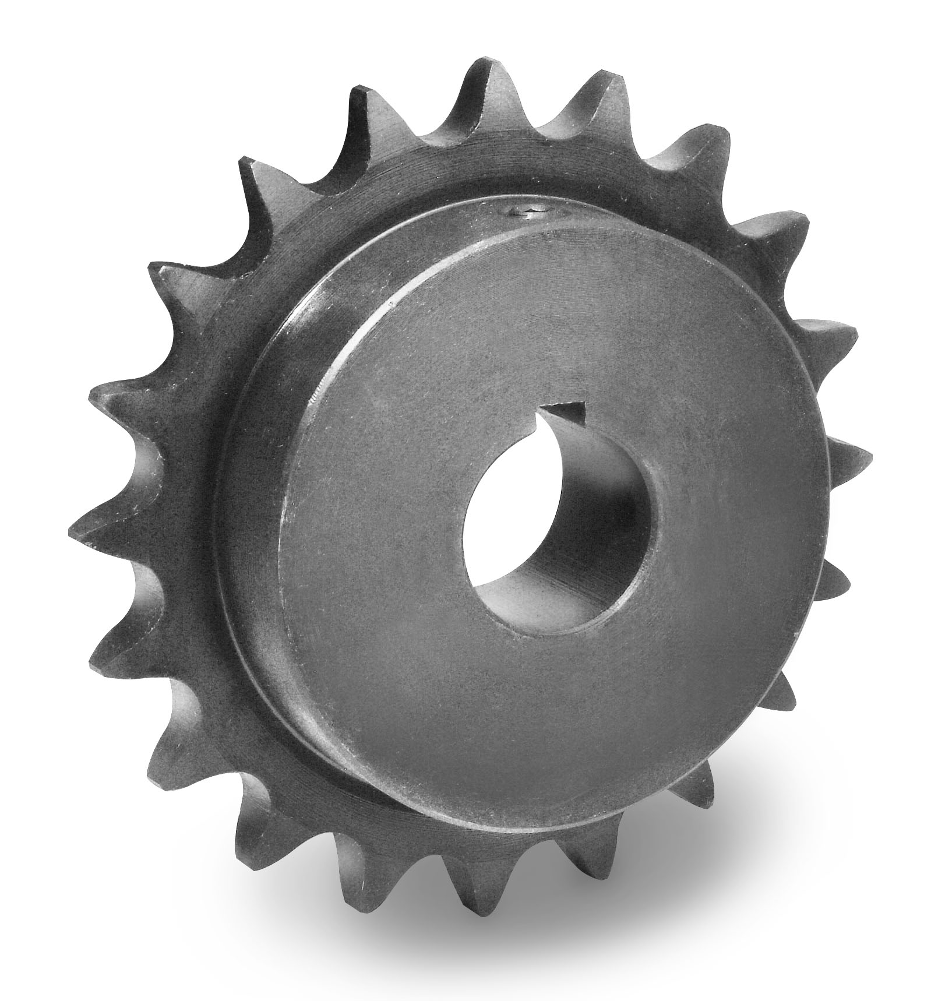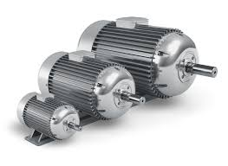 Email [DKillory@DK-Industrial.com](mailto:DKillory@DK-Industrial.com)