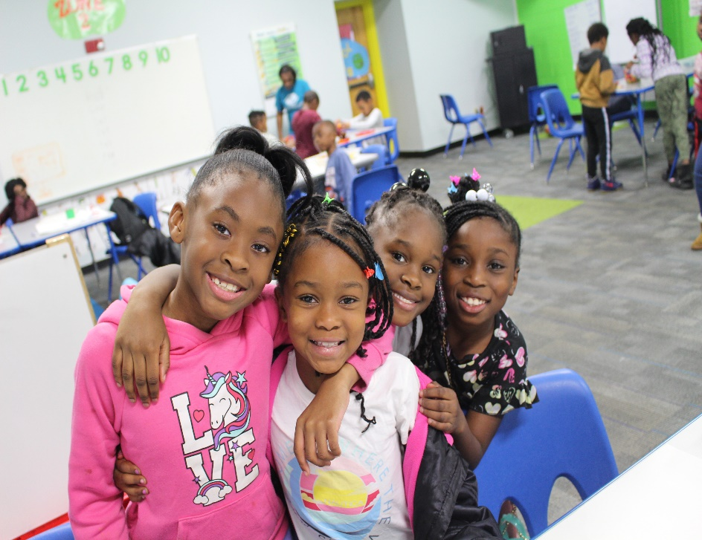

**54,949**

**204**

**34,715**

Meals Served

Total Visits

Days of Service

**383** YOUTH SERVED

For the past 21 years, The Boys & Girls Club has prioritized the approach of doing whatever it takes to Build Great Futures for the youth of Bulloch County. While we are still racing the challenges that were presented from the global Coronavirus Pandemic, The Boys & Girls Club worked diligently to ensure a safe environment with impactful programs led by caring adults is available each and every day to those who need it most.

The generosity of our many loyal supporters makes it possible for the Boys & Girls Club to make an impact during these continued unprecedented times. We sincerely appreciate the individuals and businesses that made it possible for us to continue to provide services for our children and their families.

**TO BUILD GREAT FUTURES**

**WHATEVER IT TAKES**

**2022**

**IMPACT REPORT**