

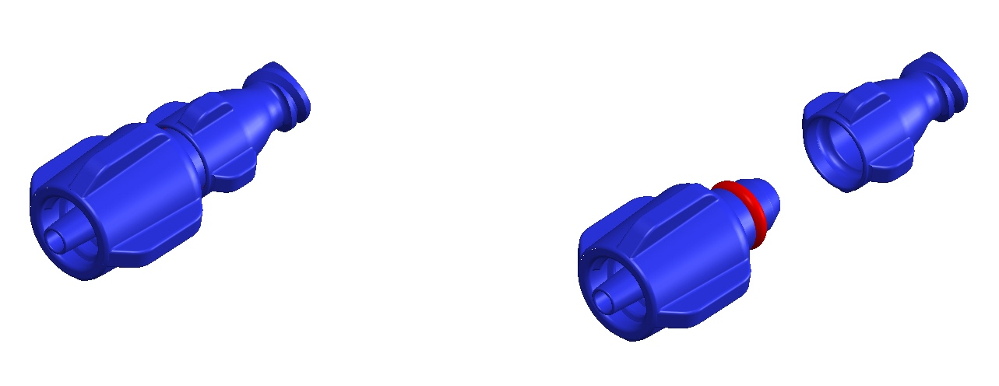

Patent Pending

External Ventricular Drain

This is a catheter introduced through the skull into the ventricles of the brain. It is used to

relieve elevated intracranial pressure due to hydrocephalus. The catheter rests within the

ventricles and allows cerebral spinal fluid (csf) to drain outside the body, thereby relieving any

obstruction and allowing the intracranial pressure to normalize. This catheter can also be used

to monitor the pressure in the brain.

This catheter can be inserted either in the operating room or at the bedside, eg. in the Intensive

Care Unit.

Patients requiring this treatment are often confused and they can inadvertently reach up and

grab the drain and accidentally remove it or dislodge it.

This can cause many problems such as

need for re-insertion of the catheter (reexposing the patient to the procedure risk)

potential bleeding in the brain from sudden catheter dislodgement

risk of infection and contamination

Because of this, these patients require constant monitoring by the attending nurses, which can

complicate their care, and make it challenging for staffing needs.

The use of this device does the following

it significantly decreases the possibility of premature dislodgement

by being able to detach easily and because of the one way valve, there is no risk of continued

fluid leak or infection

it significantly simplifies the nursing care required not just at the bedside, but gives added

confidence when transferring or moving patients from bed to stretcher for the multiple tests they

will need because of their illness.



[1704807.on.ltd@gmail.com](mailto:1704807.on.ltd@gmail.com)

www.msafetylocks.com