**Capitol Infusion Subscription and Package Deal Plans**

**Subscription Benefits**

At Capitol Infusion, we’re committed to helping you maintain your wellness routine without breaking the bank. Our subscription plans offer ongoing discounts, added perks, and the convenience of scheduled IV therapy

• Weekly Drips: 20% discount on IV infusions + a complimentary choice of a Wellness Booster or Ionic Foot Bath once a month.

• Bi-Weekly & Monthly Drips: 15% discount on IV infusions + a complimentary Wellness Booster once a month.

• Extra Drips: All subscribers enjoy a 10% discount on any additional drips purchased.

Subscription Terms & Policies

• Discount Begins on Second Infusion: The subscription discount is applied starting with your second drip.

• Commitment Period: Subscribers must sign up for either a 5-month or 10-month plan.

•. Self-Scheduling Policy: Clients are responsible for booking their own appointments. To ensure availability, we recommend scheduling multiple appointments in advance. Our scheduling system allows you to book, cancel, and reschedule appointments at your convenience. A minimum of 1 week’s notice is required to cancel or reschedule an appointment.

• No-Show Policy: Missed appointments cannot be redeemed or rescheduled.

• Automatic Payment: A valid credit card is required to be kept on file for automatic billing on a weekly, bi-weekly, or monthly basis, depending on your selected subscription plan.

If a payment is declined, the subscription will be automatically canceled. To resume services, clients must initiate a new subscription. Please note: any applicable subscription discounts will restart on the second infusion scheduled under the new subscription

**Package Deals**

Our package deals are designed for clients who want flexibility while still enjoying great savings. Whether you’re looking to stay on top of your wellness routine or share the benefits with loved ones, our packages provide the best value.

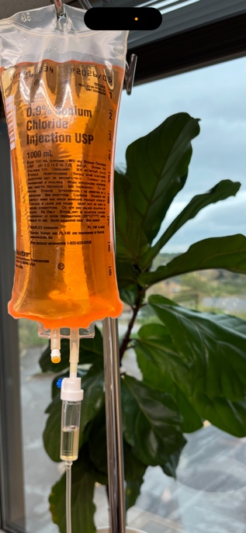**Package Deal Options**

• 10 Pack Deal: 10 IV infusions of your choice (mix and match allowed) at a 20% discount, plus 2 complimentary Wellness Boosters. Expires after 5 months from the purchase date.

• 5 Pack Deal: 5 IV infusions of your choice (mix and match allowed) at a 15% discount, plus 1 complimentary Wellness Booster. Expires after 3 months from the purchase date.

Package Deal Terms & Policies

• Upfront Payment Required: All package deals must be paid in full at the time of purchase.

• Mix & Match Flexibility: Choose from any IV infusions in our offerings.

• Shareable: IVs can be transferred to friends and family members.

**With these plans, we aim to keep your wellness journey consistent, affordable, and hassle-free. Ready to subscribe? Contact us today to get started! 301-494-3350**