BRIAR RIDGE SPRINGERS 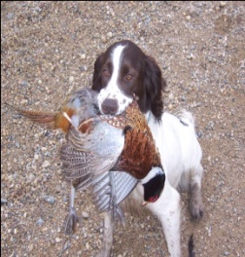

Reference List

**Jason Pepi**

978-387-6649

[jfp1972@comcast.net](javascript:window.top.openSendEmail('jfp1972@comcast.net','','','');)

Massachusetts

**Bill Hackett**

978-317-6297

[williamhackett@hotmail.com](mailto:williamhackett@hotmail.com)

Massachusetts

**Dennis Webb**

909-592-6375

kwebbslinger@verizon.net

California

**Jessica Webb**

909-282-8364

babegurlvlcm21@aol.com

California

**Casey Dillon**

415-722-1517

casdillon@yahoo.com

California

**Tom Florey**

949-861-1864

TomFlorey1@aol.com

California

**John Davis**

951-634-4829