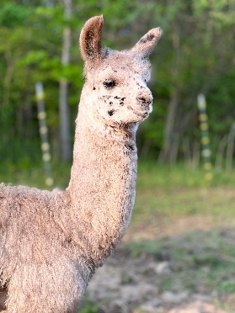

**Be a sponsor for the 2025 Mid-Michigan Llama Show!!**

***Sponsorships are always needed and welcomed!***

**Do you have a farm banner?**

Please bring it for display in the show area for all to see!

$25 Class Sponsor You get to pick the class (first come, first pick). Your name/farm in the show book, announcement on the website and Facebook page

$50 Grand/Reserve Sponsor: You get to pick the division (first come, first pick). Your name/farm in the show book, announcement on the website and Facebook page. Preferential stalling behind BOS and SLM the sponsors.

$100 Best of Show Sponsor: You get to pick the Best of Show (first come, first pick). Your business card, name/farm in the show book, announcement on the website and Facebook page. One free stall and preferential stalling.

Anything over $150 makes you Smitten by the Llama Mitten! You would be a Smitten Llama Mitten Guest of Honor!!!

You will be dragged from the crowd and receive public ohhh’s and ahhh’s from your peers! You will get a round of applause for your amazing effort! Your one-page business ad, name/farm in the show book, announcements on the website and Facebook page. Two free stalls and preferential stalling.

2025 MLA Mid-Michigan Sponsor Form



[This Photo](https://www.picpedia.org/chalkboard/s/sponsor.html) by Unknown Author is licensed under [CC BY-SA](https://creativecommons.org/licenses/by-sa/3.0/)

Name:______________________________________________________________

Farm Name:_________________________________________________________

Address:____________________________________________________________

Email:______________________________________________________________

Phone:______________________________________________________________

|  |  |  |
| --- | --- | --- |
| $25.00 Class Sponsor |  |  |
| $50.00 Grand/Reserve Sponsor |  |  |
| $100.00 Show Sponsor |  |  |
| $150.00 Best Of Show Sponsor |  |  |
| Other |  |  |
| Total |  |  |

Mail Sponsorship to:

Zane Hardy

16783 230th Ave

Big Rapids, MI 49307