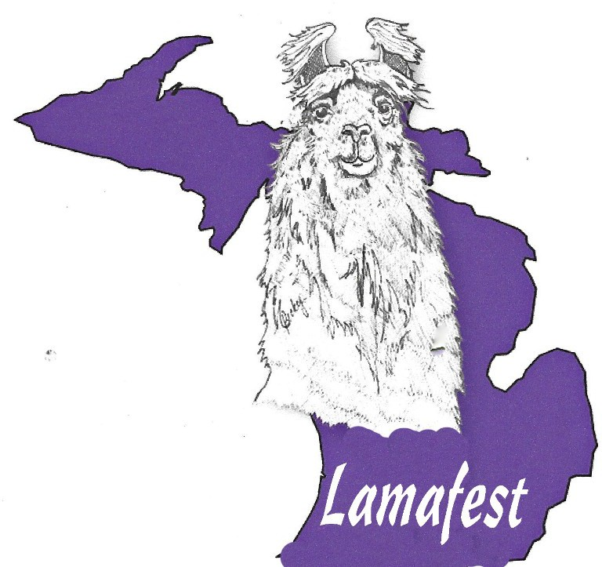
Michigan Llama Association
Double ALSA and Double ILR-SD

August 30- 31, 2025

Lenawee County Fairgrounds

Judges: Cathy Kindler
Kohl Yankovsky

New this year at Lamafest 2025 is the addition of Classic
Classes. Also new for this year is a new Location! We moved to the Lenawee County Fairgrounds due to MSU pricing. This is a quad show. ALSA and ILR Halter classes will run together on Saturday and Performance will be Saturday evening and Sunday.

MLA is now accepting PayPal for entries.
Make your reservations EARLY! We reserved a block of 15 rooms at the Comfort Inn and Suites in Adrian Michigan. We have a special rate of $139 / night (almost $75 off the normal price for that weekend). The room block is named “Lamafest”. Their phone number is 517.759.3410
Silent Auction always has wonderful items, thanks to your generous donations. Items can be dropped off beginning 11:00 am Friday at Silent Auction tables. Be sure to include your name or business card. The auction will open for bidding Saturday at 9:00 am
Please read the Show Rules and Registration paperwork. It is very important for you fill in all the information requested to process your entry correctly. Please use correct class numbers

Lamafest would not be possible without our Sponsors and volunteers. Sponsor packages are listed on the right. We are confident there is an option just for you!
If you would like to volunteer, even just for an hour, it would be greatly appreciated
Lenawee County Fairgrounds will be open for loading in Friday 8/30/24 at 12 noon.

Sponsorship Opportunities:

Platinum Sponsor $500.00 Complimentary Farm Display + 1 Free stall or 2 free stalls
Your farm banner hung in show ring (up to 6’) Full page ad in the program
Recognition in Program and all event promotions

Gold Sponsor $250.00
1 free stall
Your farm banner hung in show ring (up to 4’)
½ page ad in the program
Recognition in Program and all event promotions

Silver Sponsor $150.00
1 Free Stall. Signage at your Stall recognizing your contribution ¼ page ad in the program Recognition in Program and all event promotions

Supporting Sponsors - $100.00
Signage at your Stall recognizing your contribution
¼ page ad in the program
Recognition in Program and all event promotions

Class Sponsor $50.00
Signage at your Stall recognizing your contribution Recognition in Program and all event promotions

Program Advertisement $50.00
½ page ad Ad in Program

Custom Sponsorship
Individualized sponsorship available
For Sponsorship questions contact: Corky Dubois egflamas@yahoo.com or 616-902-2382

Lamafest 2024 August 30- 31, 2025
Lenawee County Fairgrounds Adrian, MI
These shows are sanctioned by ALSA and ILR. The shows will run according to rules/guidelines in the ALSA 23rd edition Handbook, and the current edition of ILR Show Division Guidelines. Visit www.alsashow.org to review complete ALSA handbook and www.lamaregistry.com Show Division to review complete ILR handbook. Where a conflict occurs rules and guidelines will follow ILR.
All llamas and alpacas 5 months and older are eligible to participate. All animals must be registered with the ILR for Halter classes. Non ILR registered animals participating in ALSA Performance and Adult Non-Breeder classes must have a ALSA tracking number for ALSA classes.or a ILR Tracking number for ILR-SD classes. To obtain tracking number contact ALSA and ILR office
Entry registrations must include ILR number and/or tracking numbers for each animal. ALSA member number, or Youth ALSA number is required. Copies of pending registration must be presented at check-in. Deadline: Entries must be postmarked by August 15, 2024. Stalls are assigned.
Out of state animals must have a health certificate within 30 days of the show and list microchip number on certificate. The certificate must be presented at check-in. Microchips may be read at registration. Michigan llamas and alpacas do not need a health certificate.
Youth Age Divisions Youth age as of Jan. 1, of current year Sub junior - 4 thru 6 yrs Youth Junior *-7 thru 11 yrs. 7 yr olds may show as of their birthday
Youth Intermediate - 12 thru 14 yrs Youth Senior – 15 thru 19 yrs.**
*Juniors may not show intact male llamas age 18 months or older
** When a senior youth reaches their 20th birthday before the show they are no longer eligible to show in the youth division at all
Halter Classes: Animal’s age as of the first day of the show Juvenile – 5 months through 12 months
Yearling – 12 months through 24 months
Two Year Old – 24 months through 36 months Adult – 36 months and older
Llama wool description and group classes Please enter your llamas in the appropriate wool divisions as outlined below. No wool class changes made at the show except by the judges
- Suri – Lustrous, cool hand, lack of crimp and minimal loft, locked fiber that drapes over the llama’s body.
- Silky - Very soft or silky handle, may be straight or have some wave or crinkle but not crimp
- Classic Abundant guard hair visible on the body and neck of the animal, with short and minimal “downy” undercoat,
Minimal Fleece on legs/head
- Light – Minimal body wool, short neck wool with smooth legs.
- .Medium – Moderate to long body wool, minimal to moderate neck wool, smooth to moderate and leg wool.
- Heavy – Abundant body and neck wool with minimal to abundant leg wool. (leg wool at least to knee and hock).
- Produce of Dam – Two offspring by the same dam, either sex, and produce may represent the same sire. Produce must be shown in appropriate halter class.
- Get-of-Sire – Three offspring by the same sire, either sex, by at least two different dams. All “Get” must be shown in appropriate halter class.
If you do not own the dam or sire, bring written permission from the owner for you to show in “Produce-of-Dam” or “Get-of-Sire”
Performance Classes: Handlers may enter five animals. An animal can only go through a course one time, Youth, Novice, Advanced or Master. Youth may exhibit only one entry per youth class. To qualify for Youth Performance Champion, the youth must show in Obstacle, PR, and Pack and MUST USE THE SAME ANIMAL in all three classes. Youth must show a different animal if entering Novice, Advanced, or Master classes.

Saturday
8:00 am Costume Class: Approx. 12PM Noon on both days
Opening Ceremonies and Exhibitors meeting
Showmanship will begin immediately after the opening ceremonies and the meeting.
ALSA and ILR Halter Classes run together
Performance will start at the end of Halter classes and will continue on Sunday
Youth Judging will start at the end of the activities

Sunday
8:00 am Performance Classes begin

Showmanship | Silky Female | Classic Male | Meduim Wool Female | Heavy Wool Male
1. Junior | 13. Juvenile | 25. Juvenile | 37. Juvenile | 49. Juvenile
1. (a) Sub Jr | 14. Yearling | 26. Yearling | 38. Yearling | 50. Yearling
2. Intermediate | 15. Two-Year Old | 27. Two-Year Old | 39. Two-Year Old | 51. Two Year Old
3. Senior | 16. Adult | 28. Adult | 40. Adult | 52. Adult
4. Adult | Gr/Res | Gr/Res | Gr/Res | Gr/Res
Suri Female | Silky Male | Light Wool Female | Meduim Wool Male | Non- Breeder
5. Juvenile | 17. Juvenile | 29. Juvenile | 41. Juvenile | 53. Yearling
6. Yearling | 18. Yearling | 30. Yearling | 42. Yearling | 54. Two-Year Old
7. Two-Year Old | 19. Two-Year Old | 31. Two-Year Old | 43. Two-Year Old | 55. Adult
8. Adult | 20. Adult | 32. Adult | 44. Adult | Gr/Res
Gr/Res | Gr/Res | Gr/Res | Gr/Res
Suri Male | Classic Female | Light Wool Male | Heavy Wool Female | 56. Produce of Dam
9. Juvenile | 21. Juvenile | 33. Juvenile | 45. Juvenile | 57. Get of Sire
10. Yearling | 22. Yearling | 34. Yearling | 46. Yearling | 100. Costume
11. Two-Year Old | 23. Two-Year Old | 35. Two-Year Old | 47. Two Year Old
12. Adult | 24. Adult | 36. Adult | 48. Adult | Best of Show Female
Gr/Res | Gr/Res | Gr/Res | Gr/Res | Best of Show Male
 | Obstacle  58. Novice | Public Relations  65. Novice | Pack  71. Novice | Youth Judging  77. Junior
 | 59. Junior | 66. Junior | 72. Junior | 78. Intermediate
 | 60. Sub Junior | 67. Intermediate | 73. Intermediate | 79. Senior
 | 61. Intermediate | 68. Senior | 74. Senior
 | 62. Senior | 69. Advanced | 75. Advanced
 | 63. Advanced | 70. Masters | 76. Masters

64. Masters

