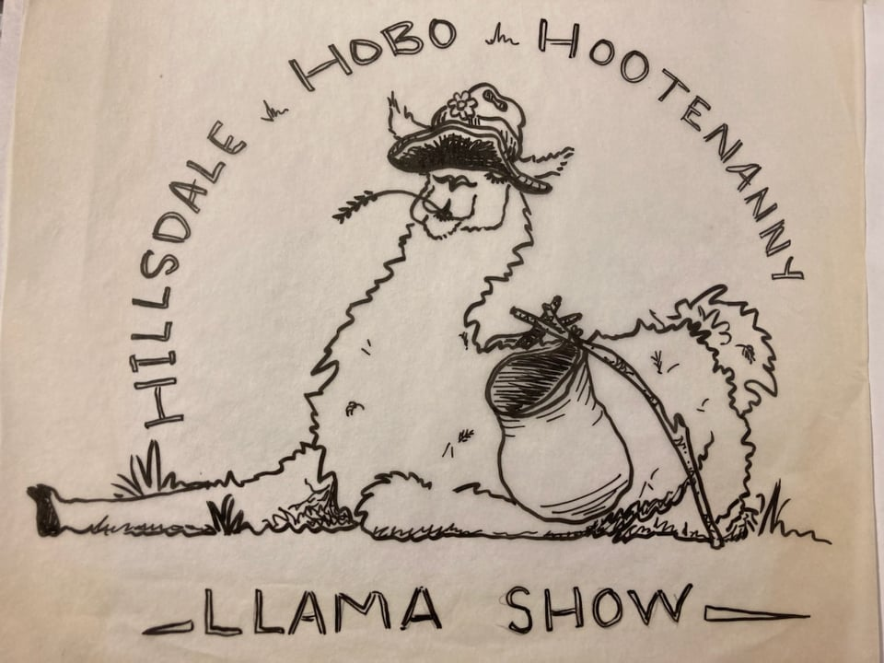
Sponsorships are always welcomed!!!

Be a sponsor for the 2022 Hillsdale Hobo Show!!

Do you have a farm banner?
Please bring it for display in the staging area for all to see!!

$25 Class Sponsor You get to pick the class (first come, first pick). Your name/farm in the show book, announcement on the website and Facebook page

$50 Grand/Reserve Sponsor You get to pick the division (first come, first pick). Your name/farm in the show book, announcement on the website and Facebook page. Preferential stalling behind BOS and the Hobo Royalty sponsors.

$100 Best of Show Sponsor You get to pick the Best of Show (first come, first pick). Your business card, name/farm in the show book, announcement on the website and Facebook page. One free stall and preferential stalling.

Anything over $125 makes you Hobo royalty! You would be a Hobo of Honor!!!
You will be dragged from the crowd and receive public ohhh’s and ahhhs from your hobo peers! You will get a big ole Hobo “yee haw” for your amazing effort! Your one page business ad, name/farm in the show book, announcement on the website and Facebook page. Two free stall and preferential stalling.

