Comprehensive Single-Lesson Plan For
CIRTL Practitioner Teaching Certificate, Fall 2025
Copyright of Binita Saha
Do not reproduce without permission
Course/Code  Fundamentals of Macromolecular Sciences, MACR 5015  Instructor  Binita Saha | Lesson Title  Polymers in Biomedical Applications:  Physiological Interactions and Design Considerations  Duration  One class (90 minutes)
Table 1: Lesson Overview (for detailed description go to Section II: Detailed Lesson Plan)
Duration | Lecture Segment/Concept | Learning Activity involved (if any) | Learning Objectives addressed | Efficacy and Accessibility considerations
0 – 10 min | Introduction to  Biomedical Polymers  Link to slide deck here Pages 4-6 | Mentimeter poll to list everyday polymer items and  Mentimeter Poll link here | 1 | Digital platform accessible via smartphone/laptop browser and anonymous responses allowed. Enables quieter students to also participate; enables student “pre-conditioning” to orient them to lecture.
10 – 20 min | Overview of common  Biomedical Polymers  Slide deck Page 8 | Short interactive segment covering biomedical polymers, accompanied by animated visual aids | 1, 5 | Animations to support clarity; Slides available 24 h before class and in-lecture annotation to support practiced learning.
20 – 40 min | Interdisciplinary nature of  Biomedical Polymer  Research &  Development  Slide deck Page 9 | Quad-Squad Share. Small group discussions about interdisciplinary contributions, followed by sharing key highlights with class.  Jump to Discussion  Prompts | 2 | Inclusive small-group discussion to facilitate neurodivergent/reluctant students. Participation promoted through structured roles within groups facilitated by discussion prompts.

40 – 60 min | Fate of a polymer in physiology  Slide deck Pages  10 – 15 | Interactive Mentimeter sequencing of physiological responses upon polymer implantation.  Mentimeter  Sequencing Quiz Poll | 3, 4 | Slides visually rich and animated; Activity offers immediate formative assessment; it is interactive and anonymous to allow diverse participation; it offers the instructor opportunity to ask in-class to elaborate on the cellular roles and cascades, if needed.
60 – 75 min | Polymer Design &  Regulatory  Considerations (Case-study based learning)  Slide deck Pages  16 – 24 | After this discussion,  students are introduced to a reflection homework assignment to write an abstract on a biomedical polymer success or horror case study of choice using guided prompts.  LMS Homework Description, Rubric and Guidelines | 5,6 | Visually rich slides, case studies and YouTube videos offer learning pathways for visual learners. Reflection style structured discussion in summative homework  assignment will allow for higher recall; choice of case studies enforces values of student voice and choice. Rubric provided guided effort and longer assessment-taking duration helps commitment to long-term memory.

I. SMART Learning Objectives
- List and clearly describe at least three and at most six types of polymers most prevalent in biomedical applications.
- Explain the interdisciplinary contributions from engineering, bioethics, and regulatory sciences involved in polymer design and biomedical applications.
- Identify the roles and importance of specific immune cells (neutrophils, macrophages, fibroblasts) in polymer-tissue interactions.
- Accurately sequence and describe the key cellular and physiological responses occurring upon polymer implantation (protein adsorption, neutrophil recruitment, macrophage adhesion, fibroblast encapsulation).
- Match polymer properties (biocompatibility, mechanical properties, degradation profile, surface properties and sterilizability) to relevant biomedical applications with respect to physiological response cellular cascades, demonstrating clear understanding of design considerations in polymer design
- Summarize how design considerations, regulatory requirements, and interdisciplinary collaboration influence biomedical polymer development outcomes.

II. Detailed Lesson Plan

1. Introduction & Interactive Poll (0-10 min)
Students participate in an interactive Mentimeter poll that prompts them to list everyday polymer items. The instructor projects responses to discuss the ubiquity and relevance of polymers. This segment addresses objective 1 by initiating active engagement, connecting prior knowledge, and contextualizing biomedical polymers. This segment takes into consideration accessibility and inclusivity by applying Mentimeter as it is a device-agnostic tool and supports anonymous participation. Visual and auditory instructions are provided clearly. Low-stakes engagement encourages all students to contribute. This allows the instructor to reorient the students (who may be preoccupied with previous/next class/homework) to the flavor of the class discussion.

2. Overview of Biomedical Polymers (10-20 min)
Students learn through a brief lecture utilizing PowerPoint slides with visuals of key biomedical polymers, their chemical structures, and real-world applications. This segment aligns with objectives 1 and 5 by presenting fundamental polymer types and their biomedical relevance clearly. To ensure accessibility, slides will be made available through email or ideally a Learning management System (LMS) prior to class offering students the ability to print or access them through their laptop/iPads for annotation. This is especially useful for students that learn via handwriting/annotating. This lecture segment was prepared with clear, jargon-free terminology keeping in mind interdisciplinary background of students in the Macromolecular Science and Engineering program cohorts. The visuals provided in the slides include names, chemical structures and images of polymer use-case in each category, also supporting visual learning styles. The interactive format of lecture will also allow for frequent comprehension checks.

3. Interdisciplinary Nature of Biomedical Polymers & Quad-Squad-Share (20-30 min)
Students first receive structured input via a lecture slide that provides an overview of the various disciplines that play a role in polymer design and regulation. This segment specifically targets objective 2 by explicitly exploring interdisciplinary connections and fostering collaborative understanding. This helps students understand the national/international interest in biomedical polymers and interdisciplinarity. Students then participate in a small-group activity, students individually consider provided prompts, do structured discussion, and then share insights regarding interdisciplinary roles in polymer design. To improve accessibility, prompts will be displayed on slides. For additional efficacy, groups can be deliberately structured for heightening diverse student interactions. This segment supports multiple expression formats such as verbal, written, and collaborative and offers chance to diverse learners to capture key takeaways.
Discussion Prompts for Quad-Squad-Share
‒ Identify two disciplines significantly contributing to biomedical polymer applications.
‒ How can the collaboration of these two fields improve biomedical polymer design?
‒ What disciplines play a role in ensuring polymer composition/design safety and effectiveness?
‒ Predict how increased interdisciplinary collaboration might shape future polymer applications.

4. Fate of Polymer in Physiology & Sequencing Poll Activity (Formative Quiz)
Students first experience guided “deep dive” into the physiology with the instructor to study the roles and cellular processes that drive the fate of a polymer upon implantation. The various timescales at which these occur are also discussed. The students then engage with a structured Mentimeter poll to correctly sequence key physiological responses (protein adsorption, neutrophil recruitment, macrophage adhesion, fibroblast encapsulation) upon polymer implantation. Each response is discussed interactively, providing immediate formative feedback. This segment directly addresses objective 3 and 4 reinforcing accurate sequencing and understanding of physiological responses and enhancing students' grasp of cellular interactions. To improve accessibility and inclusive learning, graphical representations, and interactive polling is applied. Post-activity class discussions encourage active participation and immediate clarification.

5. Polymer Design & Regulatory Considerations (Case-study based learning)
Students receive a brief discussion of polymer design considerations (biocompatibility, degradation, mechanical integrity, sterilization), FDA regulatory classifications (Class I–III), sterilization methods, and regulatory pathways (PMA, 510(k)). The lecture ended with a real-world case study heralding the successful Gliadel® wafer for post-surgical glioblastoma chemotherapy supporting learner’s memory and recall and also offering them a chance to appreciate a summative application of concepts learned in class translated to real world. This lecture is concluded with a summative homework assignment where students are asked to develop a written (~250 words) abstract or a 1 minute reel-style video reflecting on a polymer design scenario. They will clearly detail interdisciplinary contributions, safety considerations, and application outcomes, referencing provided cases and optional external literature. Multiple submission formats (written or recorded explanation) supports student voice and choice. One week duration of reflection allows for stronger consolidation of concepts in student long term memory. Rubric provided structure and direction for how much effort they should put in each graded category of homework.
Rubric:
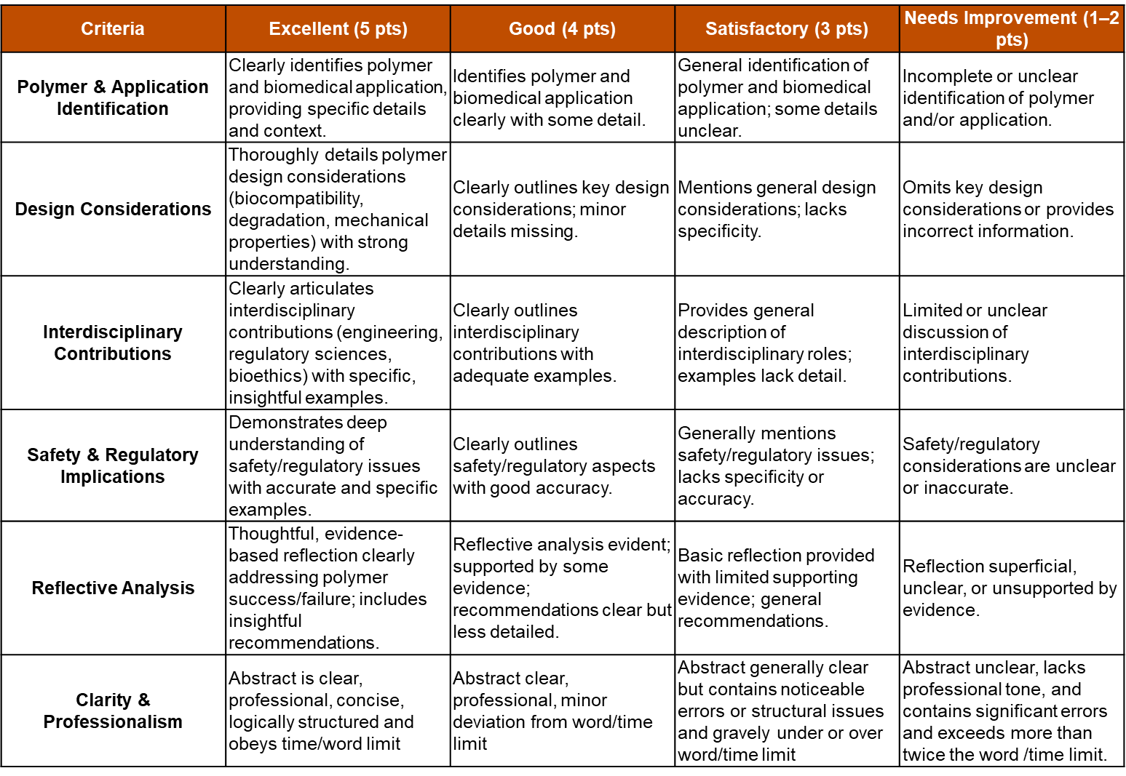
Closing remarks: This detailed, structured lesson plan supports inclusive, engaging, and comprehensive learning aligned with Universal Design for Learning (UDL) principles.

