WINDY KNOLL FARM
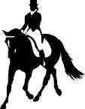
FALL SCHOOLING SHOW
Windy Knoll Farm
www.windyknolldressage.com
franwkf@gmail.com
713-703-9433
Sept 19, 2026!!!
Offering:
- Into thru FEI Dressage
- Western Dressage (Test of Choice)
- USCTA (Combined TrainingTOC)
- Working Equitation (TOC)
- Dressage Equitation
- Materiale
- RIDE A TEST Offered Sept 18,2026
JUDGE...... Fran Kehr
ON SITE STABLING AVAILABLE

Location: Windy Knoll Farm….32118 Old Hempstead Rd., Magnolia, Tx 77355

CLOSING DATE Sept 7, 2026. Entries postmarked or emailed after 9/7 add $25 late fee.
Print & Email entry form and use PayPal, Venmo, or Zelle. (Friends & family please) OR snail mail with a check to Windy Knoll Farm. Entries NOT accepted without fees! NO show office, no changes after show is scheduled.

KELLY McCHESNEY OFFICIAL PHOTOGRAPHER FOR WKF SHOWS. THIS FALL SHOW WILL BE 20 YEARS THAT KELLY HAS BEEN OUR PHOTOGRAPHER!!!!

ROBIN GAINES OFFICIAL VIDEOGRAPHER!!!

RAIN DATE Sept 26, 2026
-2-

ALL ENTRIES MUST BE COMPLETED, SIGNED AND PAID FOR PRIOR TO THE SHOW!!!
THERE IS NO SHOW OFFICE… NO CHANGES AFTER SHOW IS SCHEDULED!!!!!

- NO CONCESSIONS, PLEASE BRING YOUR OWN FOOD & DRINKS
- A PICTURE OF YOUR TEST SHEET WILL BE SENT TO YOU IN AN EMAIL OR TEXT AFTER YOUR TEST. RIBBONS AND TESTS AVAILABLE AFTER CLASS ENDS
- THOSE THAT PAY FOR STABLING WILL HAVE STALLS ON FIRST COME FIRST SERVE BASIS. STALLS WILL NOT BE PRE-ASSIGNED. THERE IS NO OFFICE, SO DECIDE BEFORE YOU ENTER IF YOU WANT STABLING AND EXTRA SHAVINGS. STALLS WILL HAVE SOME INITIAL SHAVINGS.

FEES:
- All classes are $30/class. Late Fee, $25/show. Postmarked after 9/7/26…. LATE FEE APPLIES!!!!
- Office Fee per entry $30; CLASS FEES $30
- Overnight Stabling $35/nite (initial bedding provided)
- Day Stall. $25 (initial bedding provided)
- Additional Shavings $6/wheelbarrow
- Limited RV Hook-ups $35/day
- Grounds Fee $15/horse (when not stabling)
TESTS OFFERED IN: OPEN, AMA, & JR..
Ribbons 1st-6th in each division.
HIGHEST AVERAGE SCORE COMBINING TWO TESTS IN ANY LEVEL WITH SAME HORSE & RIDER COMBO IN O-A-J (not counting freestyle scores) wins a Windy Knoll Saddle Pad !!!!!!
IF YOU HAVE WON A PAD ALREADY AT THE LEVEL, YOU ARE NOT ELLIGIBLE!!! YOU MUST MOVE UP A LEVEL IF YOU HAVE PREVIOUSLY WON A PAD WITH THAT HORSE. HONOR SYSTEM!!
NOTATE YOUR DIVISION (O-A-J) ON THE ENTRY FORM …. Also check if you are eligible for a saddle pad. We award 4 championship saddle pads! Open Amateur and Junior lSaddle pad for the High Percentage Intro Rider

SADDLE PAD SUMMER SHOW WINNERS:
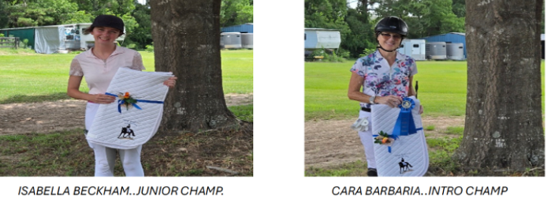
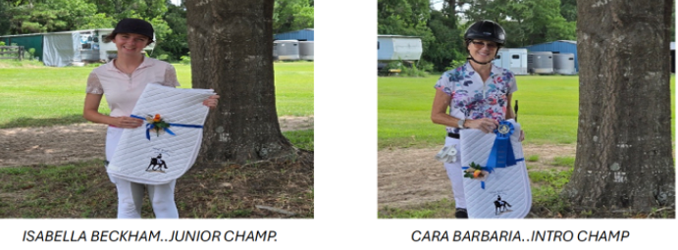

-3-
DRESSAGE USDF TESTS:
- Introductory A, B, C
- Training Level 1, 2, 3
- First Level 1, 2, 3
- Second Level 1, 2, 3
- Third Level.1, 2, 3
- Fourth Level 1, 2, 3
- FEI TOC (test of choice)
- Equitation
- Freestyle TOC
- Materiale

WESTERN DRESSAGE
- Intro. TOC
- Basic. TOC
- Level 1 TOC
- Level 2 TOC
- Level 3 TOC

USEA EVENTING TESTS
- Beginner Novice TOC
- Novice TOC
- Training TOC
- Preliminary TOC
- Intermediate TOC

WORKING EQUITATION DRESSAGE TESTS
- Introductory TOC
- Novice TOC
- Intermediate TOC
- Advanced TOC
- Masters TOC

Specify your division (O,A,J). and WHAT TEST YOU ARE RIDING ON YOUR ENTRY FORM

