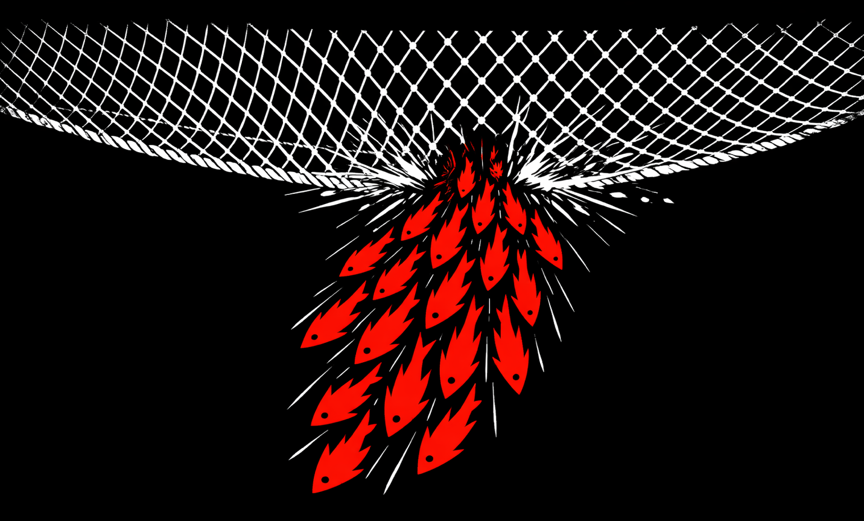
THE SWIM DOWN MANIFESTO

You Are Already Caught
The net is working perfectly.
You feel it when rent takes half your income. When you’re “saving for a deposit” but getting further away each year. When casual shifts get cut but bills don’t. When you’re told the economy is strong while choosing between electricity and groceries.
You’re not failing to escape. You’re caught in a net designed to extract from you.

Why Australia Is Rigged
We live in one of the wealthiest countries on Earth. Universal healthcare. Compulsory super. Minimum wages that look good on paper.
And yet an entire generation is locked out of housing. We’re told unemployment is low while drowning in casual work that builds nothing. We’re told we’re not working hard enough while all productivity gains flow to asset holders.
This isn’t an accident.
Australia’s economic model extracts wealth from labor and funnels it to asset holders: - Compulsory super created a captive pool of capital for financial markets, not retirement security - Negative gearing turned housing into an investment vehicle requiring permanently rising prices - Casualization destroyed bargaining power and made precarity the norm
Housing is extraction, not shelter. Credit is control, not access. Work is precarious by design.
The system isn’t broken. It’s working exactly as designed—to extract from you.

They Took Every Legitimate Way to Fight Back
When you complain about extraction, they have answers ready:
“Join a union.”
Unions have been legislated into uselessness. Enterprise bargaining broke solidarity. Strikes require protected action ballots that take months. Union membership collapsed from 50% to 12%. The CFMEU gets raided while wage theft goes unprosecuted.
“Protest peacefully.”
Protest has been criminalized. Anti-protest laws in every state. Massive fines and jail time. Disruption is terrorism. Locking on is a felony. Climate protesters get longer sentences than corporate criminals.
“Vote for change.”
Both major parties agree on everything that matters economically. Both protect negative gearing. Both support privatization. Both suppress wages. Both serve property owners over renters. Minor parties get preference-dealt into irrelevance.
Every legitimate channel for working-class power has been systematically dismantled, captured, or criminalized.
So what’s left?

Swimming Down Is What’s Left
If unions can’t strike, protests are illegal, and elections are captured—coordinated refusal is the democratic power they can’t legislate away.
They can ban strikes but can’t force you to pay debts.
They can criminalize protests but can’t force you to shop at Coles.
They can capture elections but can’t force tenants to pay corporate landlords.
Swimming down is democratic participation when all formal channels have been closed.
It’s not violence. Not sabotage. It’s coordinated withdrawal from systems that require your participation to extract from you.
It’s the voice they left us when they took all the others.

The Trap of Individual Struggle
When fish are caught in a trawler’s net, instinct says: thrash, scatter, find your own way out. Each fish fights alone.
This keeps them trapped.
The net doesn’t care which direction individual fish swim. It only cares that they’re not swimming together.
You’ve been doing this your entire working life: - Get a better job → rent goes up - Cut expenses → wages stay flat, costs inflate - Take on debt → trapped by interest - Work harder, side hustle, upskill → the net just keeps pulling
Your individual struggle isn’t a path to freedom. It’s the mechanism keeping the net working.
Every hour you spend trying to escape alone is an hour the extraction continues uninterrupted.

In Finding Nemo, the Trapped Fish Break Free
They stop scattering and do something that seems insane: they all swim in the same direction. Down. Deeper into the net. Against every individual survival instinct.
It works because the net requires dispersed force to function. When all force moves in one coordinated direction, the mechanism breaks.
Swimming down means: - Stopping the thrashing that exhausts you and powers the system - Coordinating with others caught in the same net - Moving together even when it feels counterintuitive - Breaking the extraction mechanism rather than trying to slip through it
You cannot escape alone. But together you can destroy the trap itself.

The Power of Moving Together
A credit card company can crush one person who defaults. Collections, legal action, credit destruction.
But if 50,000 people default simultaneously? Collections infrastructure breaks. Court systems backlog. The cost of enforcement exceeds the debt.
A corporate landlord can evict one tenant who stops paying.
But if tenants across 100 properties coordinate rent strikes? Cash flow disrupts. Property valuations drop. The mechanism becomes unstable.
A supermarket duopoly can ignore one person shopping elsewhere.
But if entire suburbs rotate boycotts while building alternative food systems? Margins compress. Market dominance cracks.
The net only works when we’re not swimming together.

What Swimming Down Is Not
Not protest. Protest asks power to change. Swimming down breaks the mechanism that gives them power.
Not a strike. Unions had power through collective withdrawal of labor. That power was legislated away. Swimming down applies the same principle to extraction systems beyond the workplace.
Not electoral politics. Both parties agree on negative gearing, privatization, wage suppression, protecting property values. Swimming down doesn’t ask politicians to fix extraction—it breaks extraction directly.
Not martyrdom. One person defaulting is destroyed. 100,000 defaulting simultaneously breaks the collections system. It only works if enough people move together that consequences lose their power.
Not everyone’s fight. If you own property, if your income is secure, if the system works for you—you’re not in this net. This is for people being actively pulled toward precarity.
Not consequence-free. Swimming down means accepting real costs. Credit damage. Legal threats. Possible eviction. This is why it only works through coordination—consequences lose power when too many people bear them simultaneously.
Not illegal. They’ve criminalized protest and banned effective strikes. But they can’t make it illegal to choose not to pay debts, not to shop somewhere, not to comply with extraction.

The Strategy
Swimming down works through coordinated individual action at scale.
Information exists publicly—guides explaining extraction mechanisms, legal consequences, optimal timing, participant protections.
Individuals assess capacity—can you absorb credit damage? Sustain rent strike? Handle collector harassment?
Coordinated timing—those who can participate make individual choices on the same day.
The mechanism breaks—enough simultaneous action overwhelms enforcement and changes the equation.
No organization. No membership. No leadership. No single point of failure.
Just information that enables individuals to coordinate their struggles in the same direction at the same time.

The Targets
Extraction happens through systems that require your compliance:
Consumer credit keeps you servicing debt at 18-24% interest while your credit score gates access to nothing you can actually achieve.
Supermarket duopolies control 65% of groceries, post record profits during cost-of-living crisis, extract from both consumers and farmers.
Corporate landlords treat housing as pure yield extraction, systematically raise rents regardless of costs, defer maintenance while maximizing dividends.
These systems only work if you comply. They cannot force compliance—only threaten consequences.
But consequences lose power when enough people refuse simultaneously that enforcement becomes impossible.

Who This Is For
This is for people who have done the math: - Your rent will never convert to ownership - Your credit score protects access to nothing you can actually achieve - Your wage growth will never outpace asset inflation - Your super is being age-gated beyond reach - Your participation builds nothing except someone else’s wealth - Unions can’t strike for you anymore - Protests get you arrested, not heard - Elections offer no real economic choice
This is for people who recognize they’re already experiencing the consequences they’ve been taught to fear.
This is for people who understand that individual compliance isn’t protecting them—it’s just making extraction efficient.

What We’re Swimming Toward
Swimming down breaks the net. But then what?
The goal isn’t destroying the economy. It’s breaking extraction mechanisms and replacing them with systems that build capacity instead of extracting it.

Australia After the Net Breaks
Housing becomes shelter again
When corporate landlords learn extraction is unreliable, speculative investment stops being profitable. Housing stock shifts from extraction assets to actual homes. Rents stabilize at cost-of-provision.
Community land trusts and housing cooperatives fill the space. You’re not building equity for someone else.
Food systems reconnect producers and consumers
When duopoly margins compress, Coles and Woolworths compete on actual value. Direct farmer-to-consumer relationships become permanent infrastructure.
Neighborhood food cooperatives provide better quality at lower cost. Farmers get better prices. Consumers pay less. The middleman extraction shrinks.
Credit stops being control
When enough people demonstrate they can live without credit access, credit scores lose power. Lenders compete on actual terms rather than threatening damage.
Community credit systems emerge—time banks, rotating savings groups, mutual aid funds. These already exist in migrant communities. They expand because coordinated default proves the formal system runs on fear, not necessity.
Work provides security again
When workers coordinate refusal across debt, rent, consumption—employers face workers with actual bargaining power. Casualization loses power when workers can afford to refuse exploitative terms.
New union models emerge based on demonstrated capacity to coordinate. These unions have actual power because they’ve proven they can act collectively.
Democracy functions beyond elections
Demonstrated capacity for coordination creates ongoing collective power between elections. Politicians must respond to organized economic refusal, not just captured donations and Murdoch editorials.
Democratic participation becomes continuous, not episodic.

The Real Vision
An Australia where work provides enough to live on. Where housing costs reflect provision, not speculation. Where food systems benefit producers and consumers, not duopolies. Where essential services function as services, not profit centers.
Where working people have enough collective power that extraction becomes unprofitable.
This isn’t utopia. It’s just stopping the extraction.

What This Requires
Building alternative infrastructure while breaking extraction:
Food cooperatives that start as boycott tactics become permanent systems providing better quality at lower cost.
Tenant organizations that start as rent strike coordination become permanent housing advocacy with real power.
Community credit systems that start as mutual aid during default campaigns become permanent alternatives to predatory lending.
These alternatives aren’t built after extraction breaks. They’re built while breaking it.
Maintaining coordination capacity:
The ability to coordinate refusal becomes ongoing leverage, not one-time tactic. Systems know that if they return to extraction, coordination can happen again.
Democratic power through collective action becomes permanent feature of Australian political economy.
Rebuilding actual worker power:
Success at coordinating economically demonstrates that workers can organize despite decades of anti-union legislation. It provides template and proof-of-concept for rebuilding union power from the ground up.
New union models emerge based on demonstrated capacity to coordinate across multiple economic fronts.

Funding the Movement
Swimming down only works if participants don’t bear consequences alone.
But we have no organization. No union strike fund. No structure that can be captured or shut down.

Decentralized Merch = Decentralized Funding
Wearing Swim Down merch identifies you to others without registration, names collected, addresses recorded. You recognize each other. No database to hack or subpoena.
Sales fund legal defense, emergency housing for evicted strikers, food and utilities during coordination. No membership fees. Just voluntary purchases funding voluntary support.

Anyone Can Produce and Sell
Print-on-demand platforms, local screen printers, community markets, direct online stores.
Designs released as Creative Commons—anyone can use, modify, distribute. No one can monopolize.
Can’t be shut down (too many sources), can’t be captured (open source), can’t be infiltrated (no organization).

Transparency Without Central Enforcement
Each seller clearly states where profits go: legal defense funds, mutual aid, at-cost accessibility, or honest profit-taking.
Transparency equals trust equals sales. Sellers who publish clear accounting get preferential business. Sellers who claim to fund mutual aid but never show proof get called out publicly.
Some grift is inevitable. If 60% of sales fund real mutual aid and 40% goes to grifters, that’s still better than 0% mutual aid.
Perfect is the enemy of good. Some grift is the tolerable cost of decentralization.

The Democratic Power They Couldn’t Take
They took your unions. They criminalized your protests. They captured your elections.
But they can’t force you to pay debts.
They can’t force you to shop at Coles.
They can’t force you to keep renting from corporate landlords.
Coordinated refusal is the democratic voice that doesn’t require their permission.
The net only works if we don’t coordinate.
You are already caught. Individual thrashing isn’t saving you.
Swim down. Fund each other. Break the net together.
Toward an Australia where extraction is unprofitable because working people coordinate their refusal.
That’s what’s waiting on the other side of the net.

Next Steps
Want to act? Read the Action Guide for practical steps you can start this week.
Ready to coordinate? Look for local groups practicing these actions. Start your own if none exist.
Want to help? Produce merch, run mutual aid funds, share information, build alternatives.
The point is not perfect organization. The point is distributed action that’s impossible to stop because there’s nothing to shut down.
Just people making different choices. Together. Repeatedly.
The net only holds if we keep swimming alone.
Swim Down.

