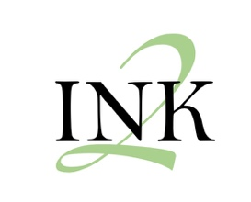

I Need to Know Suicide

Prevention Training for Tattoo Artists

  - Empowering Tattoo Artists to Help Save Lives Through Awareness and Support

Program Overview
IN2K, which stands for "I Need to Know," is a groundbreaking suicide prevention training program created specifically for tattoo artists. The name reflects its dual purpose: emphasizing the importance of recognizing warning signs and understanding how to help those at risk, while also encouraging the courage to ask direct questions, such as "Are you thinking of killing yourself?" IN2K operates on the belief that suicide is preventable—especially when people are educated to spot signs and risks that indicate someone may need help. By equipping tattoo artists with practical knowledge and tools, the program empowers them to be direct, nonjudgmental, and supportive to clients, friends, loved ones, and community members. IN2K’s ultimate goal is to foster a community where everyone looks out for one another, potentially saving lives through awareness and action.
The motivation behind IN2K comes from Patrick and Suanna Cummings of A Beautiful Mind, have both felt the helplessness and complicated grief that comes from losing a friend or loved one to suicide. Their experience inspired them to help others feel empowered to offer support when it’s needed most, and to prevent the loss of more lives when feelings of overwhelm and hopelessness could be alleviated with intervention. They recognize that it can be frightening to hear someone express suicidal thoughts or share a plan. This fear often stops people from acting—worried about offending the person, causing more stress, or feeling unqualified due to lack of professional credentials. IN2K addresses these fears head-on, providing facts and tools that anyone can use, regardless of their profession.

Why Tattoo Artists?
Tattoo artists are often more than just skilled professionals; they become trusted confidants for their clients. The process of getting a tattoo is deeply personal, and clients frequently share stories, emotions, and experiences with their artists. Recognizing that these moments of connection offer opportunities for intervention, IN2K empowers tattoo artists to recognize signs of distress and guide clients toward professional help.

Training Features
- Free and Accessible: IN2K offers suicide prevention training at no cost, ensuring all tattoo artists can participate without financial barriers.
- Education on Signs and Risks: The program covers key indicators of suicidal ideation, risk factors, and behaviors that may signal a need for support.
- Guidance for Intervention: Artists learn how to approach conversations sensitively, provide reassurance, and connect clients with professional resources.
- Community Support: IN2K fosters a culture where artists actively watch out for one another and their clients, promoting safety and well-being within the tattoo community.

Impact and Vision
The goal of IN2K is to create a ripple effect of awareness and intervention throughout the tattoo industry. By educating and empowering tattoo artists to act, IN2K enables them to become valuable allies in suicide prevention. Through vigilance, support, and connecting people to help, the program makes it possible for lives to be saved—one conversation and one tattoo at a time.

Conclusion
IN2K stands as a testament to the power of community and education in preventing suicide. By acknowledging the unique role tattoo artists play in their clients’ lives and providing them with specialized training, IN2K helps turn moments of vulnerability into opportunities for support. When we all watch out for one another, we create a safer, more compassionate world.

Frequently Asked Questions
Can the IN2K training be customized for groups outside the tattoo industry?
Yes, IN2K suicide prevention training can be customized to address the distinct challenges and strengths of any group. This program provides education for individuals of all backgrounds and knowledge levels on identifying signs of distress, understanding risk factors, and offering sensitive support to clients who may require assistance.
Who can participate in the free training?
The program is open to anyone interested in helping prevent suicides in their communities, with no cost or required background. This training can be tailored for compassionate individuals aged 13 and up. Individuals under 16 should attend with an adult.
What topics are covered in the training?
The training covers key indicators of suicidal ideation, risk factors, behaviors signaling a need for support, guidance on approaching conversations, and steps to connect clients with professional resources.
How can the training help me support people at risk if I am not a mental health professional?
The training teaches participants—regardless of their background or profession—to recognize signs of distress, understand risk factors, and learn appropriate ways to intervene by connecting individuals at risk with licensed professionals. It is not designed to turn anyone into a mental health expert or professional, nor are participants expected to be experts after completing the program. Instead, this training is intentionally created for non-professionals and serves as a foundation for lifelong awareness and engagement in suicide prevention.
Is there ongoing community support after completing the training?
Yes, A Beautiful Mind is committed to supporting groups as they put their training into action. We offer consultations to help you connect your community with valuable resources, provide guidance and support to those who have intervened, and ensure access to professional therapeutic services for anyone interested in beginning counseling. In the event of a death by suicide, we are available for crisis support. We understand that you may have questions along the way, and we are here to work with you every step of the journey to find the answers you need.

Presenters
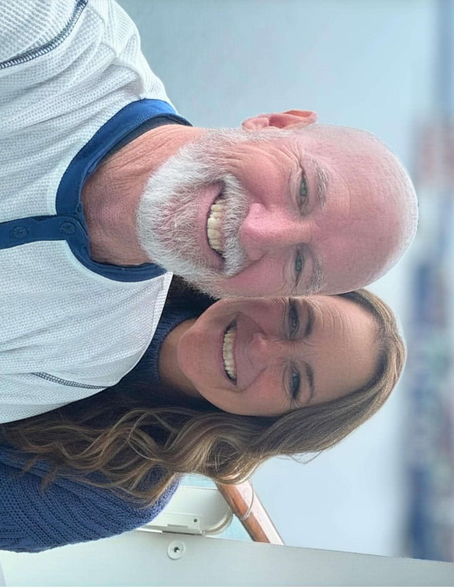
IN2K training was developed in 2018 by Patrick and Suanna Cummings, who bring a compassionate, personal approach to every group experience. As owners of A Beautiful Mind and as administrative and clinical directors respectively, their deep commitment to fostering understanding of overall mental wellness—especially the need for support in suicide prevention—continues to shape the program's welcoming and practical approach. Other therapists from our practice may also participate and lead sessions, allowing us to offer this valuable resource to groups across both Tennessee and Nevada.

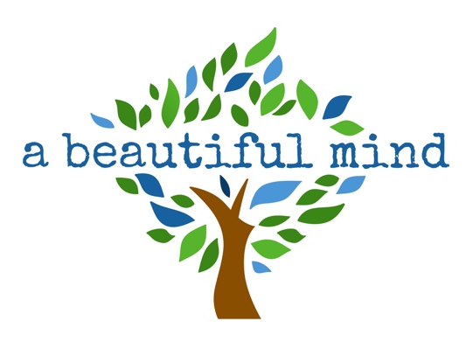
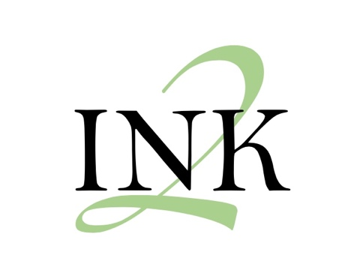
Call today to learn more about our services and follow us
on your socials for updates and mental wellness tips!
@abeautifulmindlv
702-680-7623 (NV)
731-503-3190 (TN)

