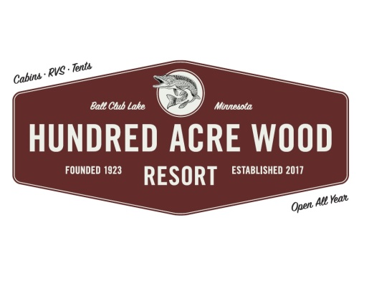

Welcome! We are glad you are staying with us!

- Office Hours are from 8 a.m. to 8 p.m. Office and game room closed all day Monday (unless checking in or out). Office closed Sat. until 12 p.m. while we clean and prepare cabins. Gas, firewood, and ice are available. Please make your plans accordingly.
- You are financially responsible for your entire reserved stay. This includes late arrivals and early departures. Check-in time is 3pm. A $62.50 fee will be applied for unapproved early arrivals and/late departures.
- Access and use of all resort amenities, facilities and grounds are restricted to the registered guests of the resort. People visiting need to stop and check-in at office and pay a $5 fee.
- Please settle your bill the night before your departure; office closes at 8 p.m. Check out of the cabin before 10 a.m. so we can prepare for the next guests.
- You will be charged for damage done to the cabin & contents, boats & motors rented from us. As well as excessive cleaning of the cabin (Unwashed dishes will be a $50 charge.) No fish cleaning in cabin. Please use the fish house.
- All cabins are Non Smoking! A $750 fee will be applied to the credit card on file due to potential loss of the following reservation.
- Use toilet paper provided, quilted and 2 ply toilet paper plugs up our septic systems. No flushing of tampons, napkins or diapers/baby wipes. You will be responsible for repairs of plugged toilets and drains.
- Do not drive around the cabins, across the lawn. Parking is allowed next to each cabin. Drive slowly (5 mph) on the roads through our camp as children and pets are present.
- Use existing fire pits – firewood is available for sale at the lodge. Minnesota prohibits the transportation of wood into our area from more than a 50 mile radius of the Resort.
- Please respect your neighbor’s vacation, (Quiet hours are 10 p.m. to 7 a.m.).
- $10 charge will be imposed for misplaced or lost keys.
- Please do not move dishes between cabins or rearrange the furniture in the cabins.
- No lifeguard on duty. No diving from docks, throwing rocks in the water or swimming in the harbor. All water activities must be in the area left of the harbor on the swim beach (all activities are at your own risk).
- Dogs must be leashed & cleaned up after. Please keep pets off of the furniture and beds. Keep dogs kenneled if left alone in cabins. Clean up all PET HAIR before you leave. There will be charges for extra cleaning and damages done by dogs.
- Bear in camp! Dump your grease in the main dumpster by the front gate or in a container/coffee can provided. Do not put grease down the kitchen drain. Do not leave food in coolers outside. No fish or fish guts in trash… use the fish house! We will pick up the trash in the evening…6 pm or so.
- In the rare case of a tornado, the shelter is in our basement. It is the green door on the driveway side of the lodge underneath the overhang.
- Do not litter, (including cig. butts and candy wrappers). Our beautiful lake and resort depend on you to stay beautiful!
- Children 13 and under must be accompanied by an adult over 18 when in the lodge.
- If you have a need please ask. We will be happy to accommodate you. Thank You for choosing us for your stay!

Resort WiFi…HAWR…Password… 2182468520 Weather Channel…302 & 303.

