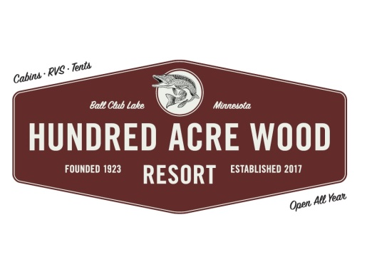



Welcome! We are glad you are staying with us!

- Office Hours are from 8 a.m. to 8 p.m. Office and lodge closed all day Monday (unless checking in or out). Office closed Sat. until 12 p.m. while we clean and prepare cabins. Gas and ice are available. Please make your plans accordingly.
- You are financially responsible for your entire reserved stay. This includes late arrival and early departures.
- Access and use of all resort amenities, facilities and grounds are restricted to the registered guests of the resort. People visiting need to stop and check-in at office and pay a $5 fee.
- Please settle your bill the night before your departure; office closes at 8 p.m. Check out of the cabin before 10 a.m. so we can prepare for the next guests.
- You will be charged for damage done to the cabin & contents, ice houses, augers, etc. As well as excessive cleaning of the cabin (Unwashed dishes will be a $50 charge). Please use newspaper provided for fish cleaning. Use caution and do not allow scales and entrails down the drain. PLEASE DO NOT put fish in sink. Fish slime WILL clog the plumbing. Dispose of fish guts in garbage can outside of cabin. More black garbage bags available upon request. You are responsible for any damages to the plumbing, plugged drains, toilets, or extra cleaning charges. Please do not wear ice cleats inside cabins.
- Dump your grease in the main dumpster by the front gate or in a container/coffee can provided in the cabin. Do not put grease down the kitchen drain. We will pick up the trash in the evening…6 pm or so. There is a dumpster located at the main entrance if you would like to dispose of any garbage.
- All cabins are Non Smoking! A $750 fee will be applied to the credit card on file due to potential loss of the following reservation.
- Use toilet paper provided, quilted and 2 ply toilet paper plugs up our septic systems. No flushing of tampons,
Napkins, diapers/baby wipes, etc. You will be responsible for repairs of plugged toilets and drains.
- Do not drive around the cabins or across the lawn. Parking is allowed next to each cabin. Cabins 1-4, park on the right side of your cabin, if possible. Drive slowly (5 mph) on the roads through our camp as children and pets are present.
- Please respect your neighbor’s vacation, (Quiet hours are 10 p.m. to 7 a.m.).
- $10 charge will be imposed for misplaced or lost keys.
- Please do not move dishes between cabins or rearrange the furniture in the cabins.
- Dogs must be leashed & cleaned up after, please keep pets off the furniture and beds. Keep dogs kenneled if left alone in cabins. Clean up all PET HAIR before you leave. There will be charges for extra cleaning and damages done by dogs.
- Do not litter, (including cig. butts and candy wrappers). Our beautiful lake and resort depend on you to stay beautiful!
- If you have a need, please ask. We will be happy to accommodate you. Thank You for choosing us for your stay!

Resort WiFi…HAWR Password…2182468520 Weather Channel…302 & 303

