ELECTRON CONFIGURATION

principal quantum number n = 1

principal quantum number n = 2

principal quantum number n = 3

principal quantum number n = 4

principal quantum number n = 5

principal quantum number n = 6

principal quantum number n = 7

principal quantum number n = 8
azimuthal azimuthal azimuthal azimuthal quantum quantum quantum quantum number l = 0 number l =1 number l = 2 number l = 3

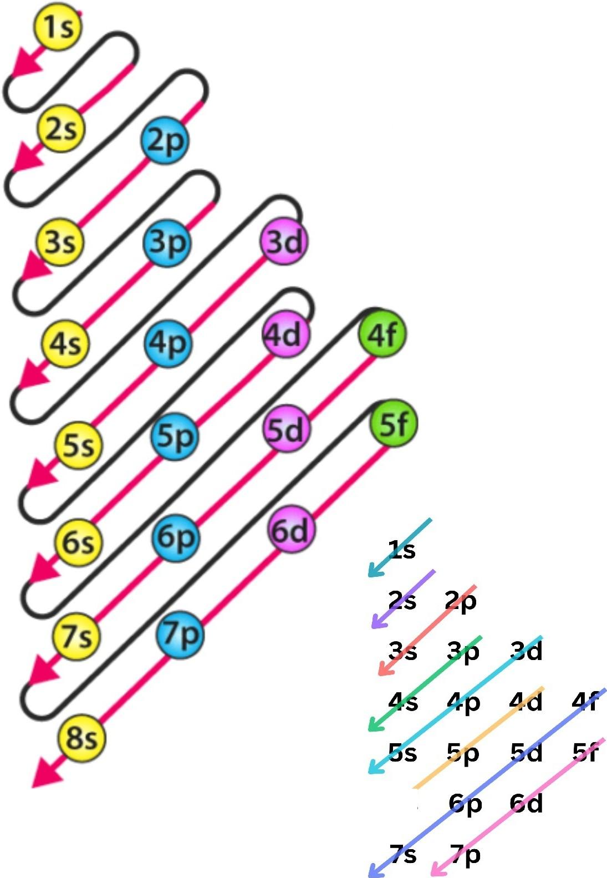
Chemistry
5s

1s 2s 2p 3s 3p 4s 3d 4p 5s 4d 5p 6s 4f 5d 6p 7s 5f 6d 7p

