CHRISTMAS in Nicaragua 2023
Helping so many that have so little!

WHERE: Leon, Nicaragua
WHEN: December 7-12 & 14 -19, 2023
LEADER: Rick Reed / Samantha
COST: $1100 – Price includes: Breakfast, dinner, air conditioning, clean water, lodging, roundtrip ticket, transportation to and from the airport, transportation, Ministry support, training, and translators. You may want to bring $50 for miscellaneous items.

IMPORTANT DATES

Deposit Due - October 1, Final payment – December 1

Come celebrate Christmas with our friends and family in Leon, Nicaragua. We will celebrate with the children at Faithbridge Dayenu, La Leona & Casa De Tabla. We will help so many that have so little.

- Dry Feeding Christmas gifts for students
- Bibles and supplies Teachers Conference
- Christmas Party Parenting Conference
- Street Witness Marriage Conference
- Men’s Conference Women’s Conference

Why Nicaragua?
We have been blessed to watch Pastor Joe Sevilla grow in the Lord and feel called to plant a Church. Pastor Joe has a heart for the students and young adults of Leon. His love for evangelism, community outreach, and discipleship is a reflection of his heart to serve and minister to the people of Nicaragua. We will stay at The Garden of Leon Mission House in downtown Leon and serve in the communities in and around Leon. www.thegardenofleon.com

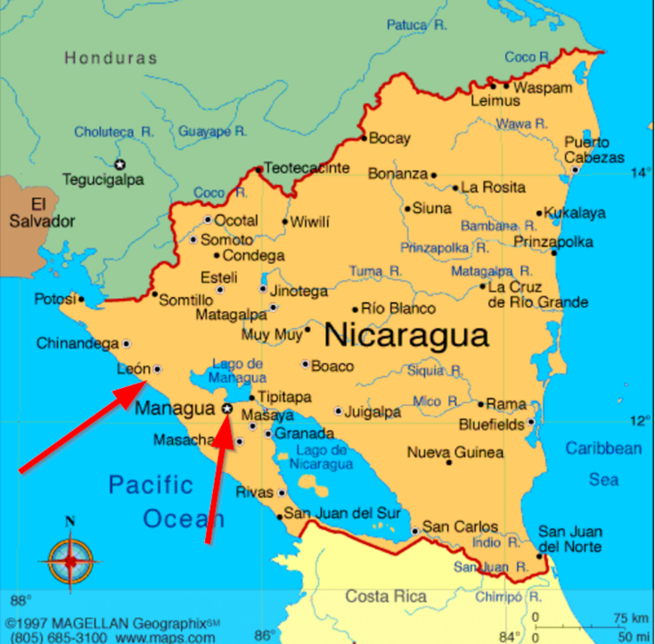

About Nicaragua

Nicaragua is the largest country in Central America and it offers great opportunities for every type of traveler. Nicaragua is a country rich in history, culture, and natural resources. It borders Honduras to the north and Costa Rica to the south and it houses two big lakes: Lake Managua and Lake Nicaragua. Lake Nicaragua is the biggest lake of Central America and has the only fresh-water sharks in the world! Nicaragua is a word from the Nahualt, an Aztec language. It was used to describe the land occupied by the isthmus between the Pacific Ocean and Nicaragua Lake. It was taken from Chief Nicarao, who ruled the lands during the late 1400s and early 1500s. Nicaraguan land was inhabited during pre-Colombian times by many indigenous peoples, such as the Nicaraos, Chorotegas, Chontales and Miskitos. Christopher Columbus was the first European to explore Nicaraguan land during his fourth and last journeys to America. After Columbus, many Spanish conquerors settled on these lands. Hernández de Córdoba, from whom Nicaragua's currency is named, discovered Nicaragua Lake and founded the cities of Granada and León in 1524. In 1625, the English arrived in Nicaragua and declared it a British Protectorate called the Mosquito Kingdom, which extended from Belize to the San Juan River. The British stayed until 1894. Nicaragua belonged to the Spanish Mexican Viceroyalty and later to the Central America United Provinces Federation, which received independence from Spain in 1821. However, the country did not achieve full independence until 1838.

