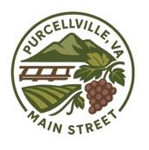 Purcellville Main Street (PVMS)
501(c)3 - 39-2443226

Thank you for volunteering with Purcellville Main Street. Our organization is focused on the revitalization and support of Purcellville’s historic downtown. We appreciate your support and willingness to volunteer in your community.

Name of Volunteer:

Event Volunteering:

Date of Volunteering:

Hours of Service:

___________________ ____________________
Marycel Tuazon, Board Member, PVMS Date

