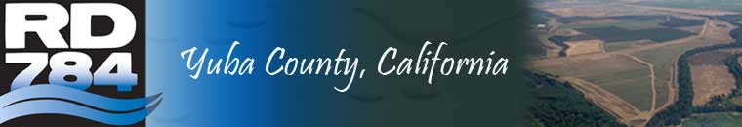

PUBLIC RECORDS REQUEST

IF YOU WISH TO HAVE ANY PUBLIC RECORDS PRODUCED, PLEASE WRITE IN THE SPACE BELOW THE NAME OF THE DOCUMENT OR DOCUMENTS REQUESTED.
PLEASE BE AWARE THAT UNDER CALIFORNIA GOVERNMENT CODE §6250 ET SEQ., THE RECLAMATION DISTRICT 784 HAS TEN (10) DAYS AFTER YOU SUBMIT THIS FORM TO DETERMINE WHETHER THE RECORD(S) YOU HAVE REQUESTED ARE SUBJECT TO DISCLOSURE UNDER THE PUBLIC RECORDS ACT. AFTER THE RECLAMATION DISTRICT 784 HAS MADE THIS DETERMINATION, YOU WILL BE IMMEDIATELY NOTIFIED OF THE DETERMINATION AND THE REASONS THEREFORE.
IF THE RECLAMATION DISTRICT 784 DETERMINES THAT THE DOCUMENTS YOU HAVE REQUESTED ARE SUBJECT TO DISCLOSURE, THEY WILL BE PRODUCED WITHIN A REASONABLE TIME THEREAFTER.

PLEASE NOTE: YOU WILL BE CHARGED 25 CENTS PER PAGE FOR THOSE RECORDS YOU REQUEST TO BE COPIED.

DESCRIPTION OF THE REQUESTED DOCUMENT(S):
___________________________________________________________________________________________________________________________________________________________________________________________________________________________________________________________________________________________________________

Signature Date
_____________________________ ____________________
Print Name
_____________________________________________________ WILL PICK UP ________
Address
_____________________________________________________ PLEASE MAIL ________
Phone
_____________________________________________________

THIS FORM SHOULD BE SUBMITTED TO THE DISTRICT OFFICE MANAGER AT THE ADDRESS LISTED BELOW. FOR OFFICE USE ONLY
DATE RECEIVED:_________________________
DATE NOTIFIED:__________________________
DATE RECORDS PRODUCED:_______________________ SIGNATURE:______________________________________

