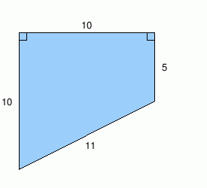
- What is the area and perimeter of the trapezoid below?

- What is the area of a circle with circumference 8π?
- What is the area and perimeter of a rectangle with base = 5 and height = 8?

- What is the volume of the cylinder below?
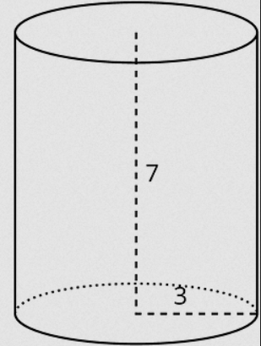

- What is the surface area and volume of a sphere with radius = 4?

