 Eva Christina Vollmer

An era comes to an end

1903-1918

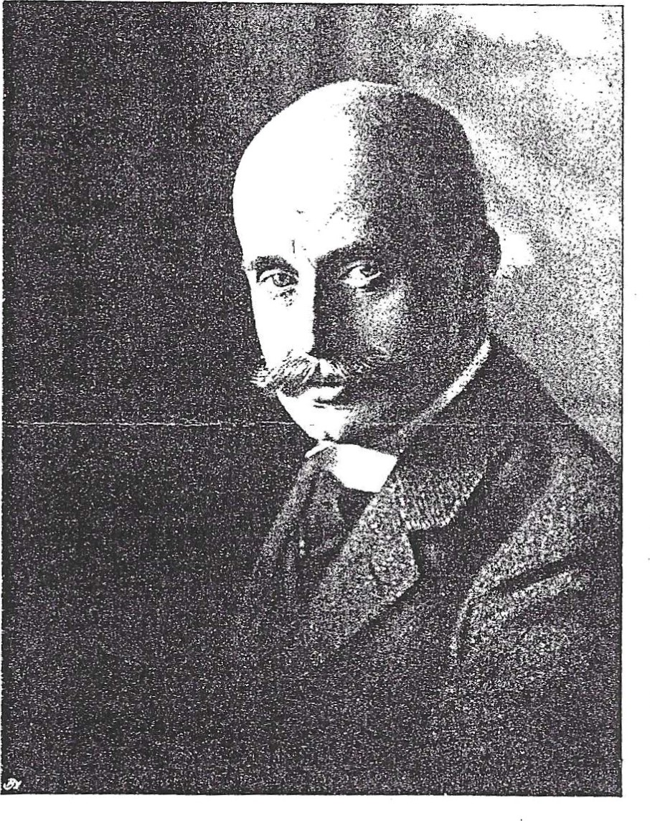

Last Court Theater Director

Kurt von Mutzenbecher

In 1903, Georg von Hülsen left Wiesbaden and, following his father's example, took over the general management of the Prussian theaters in Berlin. His successor in Wiesbaden was chamberlain Dr._jur. Kurt von Mutzenbecher. Mutzenbecher, who came from a patrician family in Hamburg, studied law in Bonn and then embarked on a military career. However, after several years of service, he left the army and was appointed deputy director of the court theater by Count Hülsen in June 1903; after Hülsen's departure, he took over his position. In 1918, Dr. von Mutzenbecher resigned from his post and moved to Berlin.

The development that had been initiated by Adelon in 1889/90 but had been partially interrupted by Hülsen's repertoire design was continued by Mutzenbecher in a way that partly deviated from Hülsen's conception of the play. Modern trends found their way into the repertoire with characteristic examples, such as Gerhart Hauptmann's dramas with their characteristic mixture of naturalistic and neo-romantic-symbolist features ("Rose Bernd" 1904, "Elga" 1905, "The Beaver Coat" 1908, "The Bow of Odysseus" 1914, "College Crampton" 1914), George Bernard Shaw's socially critical comedies ("Heroes" 1912, "The Doctor at the Crossroads" 1913, "Pygmalion" 1913) and Oscar Wilde's social comedies with their sparkling aphorisms and malicious aperqués ("To be earnest is everything", also: "Bunbury" 1906, "An Ideal Husband" 1907, "A Florentine Tragedy" 1908). Also represented were Nicolai Gogol with the first socially critical comedy of Russian drama "The Inspector General" (1904), Hugo von Hofmannsthal ("The Adventurer and the Singer" 1903, "Everyman" 1915), Arno Holz ("Dream of Us" 1904), Stefan Zwe ig ("The Transformed Comedian" 1914), Arthur Schnitzler ("The Lonely Way" 1914) and Max Halbe ("The Stream" 1915). Hermann Bahr's comedy "The Principle" was premiered on October 19, 1912.

Henrik Ibsen's drama took up a relatively large space, which mainly dealt with the life lies of a late bourgeois society. No fewer than nine of Ibsen's plays were premiered on the Royal Stage in the short period of 12 years ("Rosmersholm" 1903, "The Wild Duck" 1904,

"Hedda Gabler" 1906, "Baumeister Solness" 1909, "Die Kronprätendenten" 1913, "Die Helden auf Helgeland" 1915), whereby Mutzenbecher and Köchy even dared to include the sharp satires "Ein Volksfeind" and "Der Bund der Jugend" (1913), as well as Ibsen's most pessimistic drama "John Gabriel Borkman" (1908) in the repertoire. However, there is a fly in the ointment in this impressive list of contemporary dramas when one looks at the performance figures of the works mentioned. Many of the plays were only performed a few times in the year of their first performance (at most in the following season) and then disappeared into obscurity again (Wilde's "Florentine Tragedy" only had one performance, i.e. the first performance was not even followed by a repeat!). Exceptions were

79

plays", on November 13th, the same place read: "Nassauisches Landestheate?" However, the Wiesbaden theater was only called that for a short time.

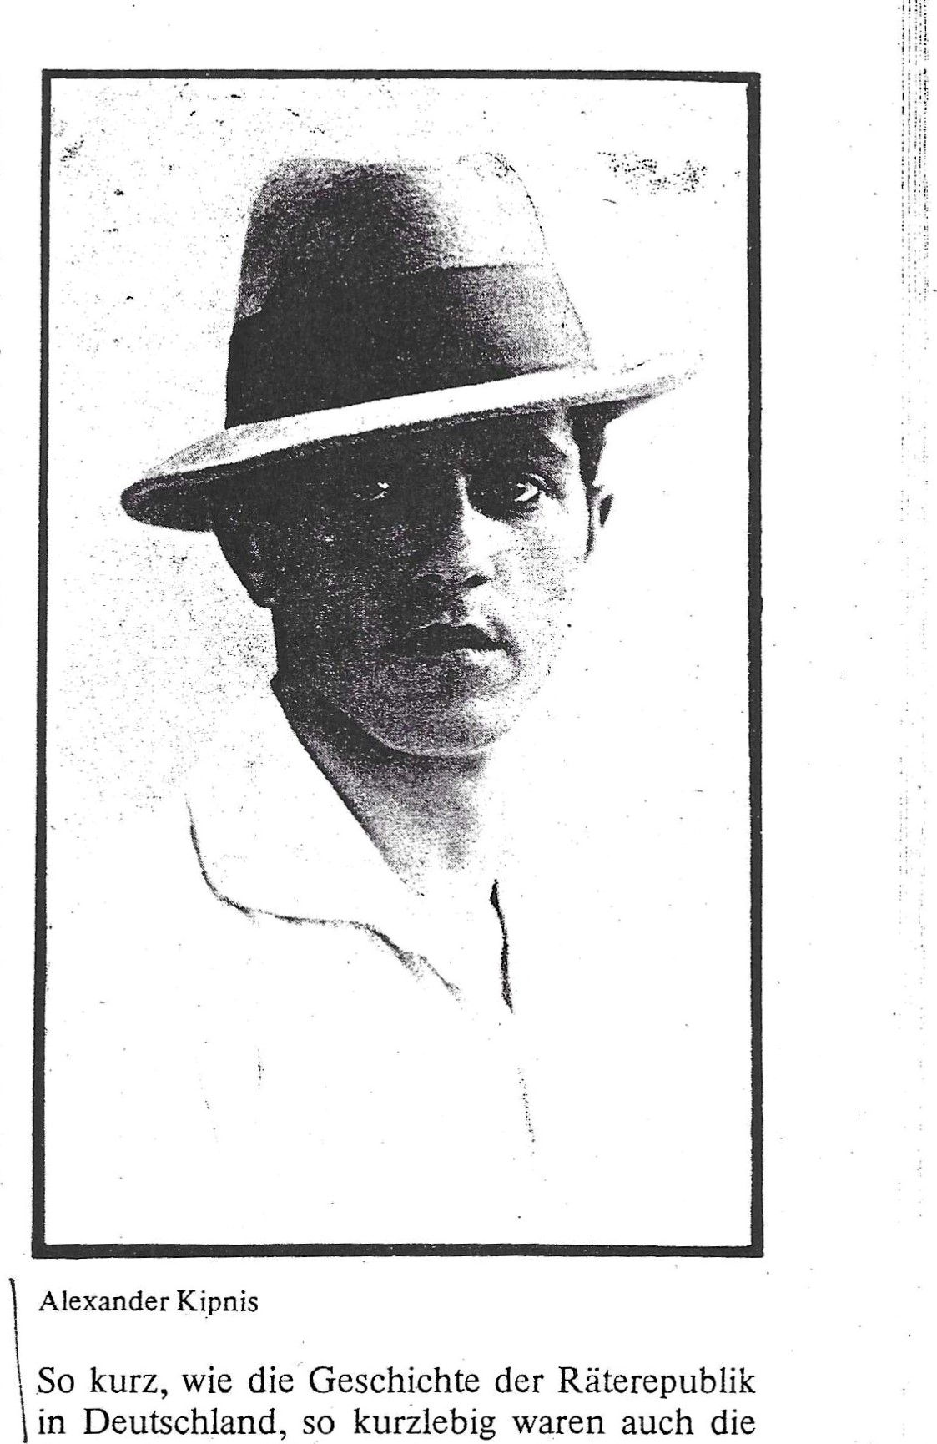Legal's assumption of office brought about a noticeable change in the repertoire concept, with the drama, which had been neglected in terms of performance numbers during the court theatre era, taking up more space. The entire "Wallenstein" was performed again, as well as Schiller's previously undesirable bourgeois tragedy "Intrigue and Love". Legal staged "Hamlet", "Everyman" as a special tribute to the revered Max Reinhardt, and Hebbel's "Judith" with Carl Ebert in the role of Holofernes.

The repertoire of the court theatre period remained dominant in the opera, not least because the French, who had occupied the Rhineland after the peace treaty and were particularly strongly represented in Wiesbaden as members of an Allied commission, wanted to see the pompous curiosities of that time again and again; they were particularly fond of Hülsen-Lauff's "Oberon" creation.

But there were also new, contemporary pieces, such as Puccini's "Manon Lescaut", Pfitzner's "Christelflein" or Goldmark's "Queen of Sheba".

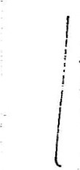The musical direction remained with Schlar and Mannstaedt, but alongside them appeared such top-class musicians and conductors as Max von Schillings, Eugene d'Albert, Hans Pfitzner, Erich Wolfgang Korngold and Richard Strauss, who continued to come to Wiesbaden well into the 1920s.

The opera ensemble included tenor Fritz Scherer, an enthusiastically acclaimed audience favorite, as well as Alexander Kip-



nis, five years at least. Here the Ukrainian bassist began a world career that was unparalleled; in 1946 he ended his singing career at the Met. Kipnis now lives in the USA.

In its eventful theater history, Wiesbaden has always had a particularly strong and, in some cases, justified charisma as a city of music. The love of Wiesbaden theatergoers belongs first and foremost to music, and especially to opera, whereas acting has always had to provide a kind of proof of ability.

There have been many great conductors in Wiesbaden, but great and idiosyncratic theater directors are rare, and Legal was one of them.

As short as the history of the Soviet Republic in Germany, so short-lived were the attempts to test forms of co-determination in the theatre, to ensure the ensemble a broad participation not only in solving social questions, but also in the development of artistic concepts. For Wiesbaden, this meant that after lengthy

After negotiations and under public pressure (see Robert Prechtl), the Prussian state finally decided to take over the Wiesbaden Theater as the Prussian State Theater. The role that Wiesbaden played as the seat of the Allied Rhineland Commission certainly influenced this decision to a considerable extent. The Social Democratic Minister for Art, Science and Education Konrad Haenisch dismissed Ernst Legal and appointed the director of the National Theater Mannheim, Dr. Carl Hagemann, as sole stage manager again.

87



and running holidays! Into the fire with all the junk! . . . Let the director do as he pleases. Give him unlimited authority. And the deficit? It should not be one million, but preferably three million! And the city should not contribute a penny and thereby gain the right to have a say. The theater in Wiesbaden is going down the drain . city garden nothing . That is one common German matter . A Reich matter !

And then what comes into play here is what has living forces within it, what embodies the German spirit, what is steeped in the past and points the way to the future.

This is what Robert Prechtl wrote in November 1919 in the cultural magazine "Der Spiegel" and in the "Vossische Zeitung". Despite all the welcome commitment to the preservation of the Wiesbaden Theatre, to a new beginning under changed circumstances after the collapse of the Empire,



the tone of the tongue is affected. Once again there is talk of battle, of revenge, and how the world is to be healed by the German spirit. Much more carefully, and more accurately , in view of what was shattered here after a devastating world war, the renowned theatre critic Siegfried Jacobsohn expresses himself on the same topic in the same place:

"I am also in favor of the Wiesbaden theater not becoming French. If it really did play Büchner and Hauptmann and Kleist and Mozart, foreigners, and especially the French, would get a different picture of Germany than Clemenceau showed them. But I remain, for your mercy, a skeptic . . . A long road from Wilhelm II to art! May it be bravely followed, in the good German way, and completed successfully!"

Karl Scheffler sums up the problem in the same place : reconciliation with yesterday's enemies and the restoration of a national self-understanding through a kind of general propaganda, such as was carried out before the war and during the war, which was not good for our self-esteem and brought no prestige.

It is a matter of completely different tasks. What we need has nothing or very little to do with art. And one should ask whether all the noisy art-mongering of the last few decades has not ultimately been self-deception, a pretext for not seeing the essential, the truth. More important than what the French, English, Americans or even Italians think of us is that we remain completely silent for a number of years and learn to understand how we think about ourselves, or at least how we should think about ourselves."

Why this broad and passionate discussion about the continued existence and redefinition of the Wiesbaden stage? The end of imperial glory also brought an end to payments; a new legal entity had to be found. The Prussian state, which was responsible for the former royal Prussian court theaters, wanted to be free of financial obligations and shift the burden to the municipalities. The fact that things ultimately turned out differently is certainly thanks to men like Robert Prechtl and their activities. Before that, however, there was a short phase of determined attempts to democratize the theater, including in Wiesbaden, in the wake of the November Revolution of 1918.

|  |
| --- |
| bill, a thorough rethinking of the police , from the Russian occupying power to |

In many theatres, councils were formed from the ranks of the theatre staff and tasked with representing their interests. These councils of workers, employees and artists achieved a right of co-determination in economic and artistic matters. In Wiesbaden, an artists' council elected the new artistic director from the ranks of the ensemble. It was the head of the theatre, Ernst Legal, who later became famous in Berlin primarily as an actor, artistic director of the Berlin Linden Opera from 1933 to 1936, then removed by the Nazis.

tic history of this country:

“In your essay 'Wiesbaden' you have - very

suggestively - asked whether it would not be desirable to show the foreigners in Wiesbaden the best that German music, poetry and acting are capable of. I think: no, it is not desirable at all. Your suggestion, your demand, tastes too much like the 'business' of peacetime, of that intrusive 'cultural

86

# brought back

The last cavalier utensil of the old school, Kam-



Merherr von Mutzenbecher, urged on by the ensemble, voluntarily resigned on November 14, 1918; from then on, the director's chairs were occupied by noble court officials and no longer by reserve officers available.



On 11 November 1918, the last theatre ticket appeared with the imprint “Royal Theatre