XL Barcode Scanner Kit Install Guide
This guide explains how to connect an XL Barcode Scanner Kit to an XL Productivity Appliance.

Step 1 – Unpack XL Barcode Scanner Kit
The XL Barcode Scanner Kit contains the following components:
- Handheld barcode scanner.
- DB-9 serial cable.
- A/C adaptor with power cord.
- 25’ serial connector cable part 93-0184 (DB-9 to pigtail).
- In a wireless scanner kit - wireless charging base.

Step 2 – Remove Access Plate
SHOCK HAZARD: This product has more than one source of power. Relay outputs may be at mains potential from a secondary power source. Always disconnect power from all power sources before installing or servicing the XL device, and before opening the user access plate. Do not reapply power until the access plate has been reinstalled and securely closed. Failure to follow these precautions could result in personal injury or death due to electric shock.
CAUTION: Keep mains-connected wiring (including relay output wiring) separate from signal and I/O wiring. Use the left knockout(s) for mains-connected wiring (including relay output wiring) and the right knockout for signal and I/O wiring.
CAUTION: Take care to pass all wiring through the back panel knockouts using cable glands that meet local electrical code. Make sure that any unused knockouts are plugged using hardware that meets local electrical code.

- Position the XL device so the back panel is facing you.
- Verify that all sources of power have been completely disconnected from the XL device.
- Remove and save the screws holding the access plate (eight to ten screws depending on model).
- Gently pull the access plate away from the XL device. The access plate will remain connected to the XL device via its grounding strap.

Step 3 – Wire 93-0184 Cable to Device
- Remove the 5-pin terminal block from the RS-232 connector on the XL device logic board (diagram shown is for an XL410, XL610, or XL810):
- Feed the 25’ serial connector cable through a knockout in the XL Access Plate, so the exposed wires are on the inside of the Access Plate.
- Wire the 25’ serial connector cable wires to the 5-pin terminal block:
- Red wire to pin 1 (RxD1 ~ XL Receive Data).
- Green wire to pin 2 (TxD1 ~ XL Transmit Data).
- Black wire to pin 3 (GND ~ XL Ground).
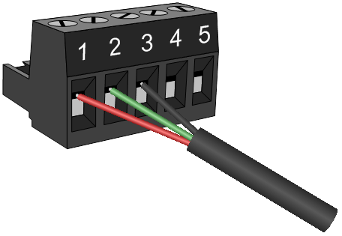

- Plug the male 9-pin D-sub connector at the end of the 25’ serial connector cable into the female 9-pin D-sub connector of the barcode scanner:
- Wired Scanner: Plug the barrel connector of the AC adapter into the DC power receptacle on the back of the D-sub connector:
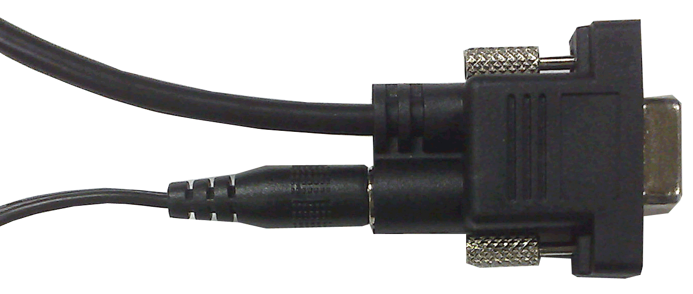
- Wireless Scanner: Plug the barrel connector of the AC adaptor into the DC power receptacle located on the base unit.

Step 4 – Reinstall Access Plate
- Position the XL device so the back panel is facing you.
- Check that the grounding strap is securely connecting the access plate to the XL device.
- Fasten the access plate to the back panel using the screws that were removed previously.

Step 5 – Apply Power
SHOCK HAZARD: This product must be grounded. Never defeat the ground conductor or operate the product in the absence of a suitably installed ground conductor.
ATTENTION: This product is suitable for connection to a TN-S power distribution system (AC Hot and AC Neutral lines with a separate protective grounding conductor).
ATTENTION: Refer to Install XL guide; Appendix C – Specifications for power requirements.

- Apply mains power to the XL device.
- Apply mains power to the barcode scanner A/C adapter.
- Verify that the XL scoreboard begins showing data.

Step 6 – Test the Barcode Scanner
If the barcode scanner is connected to an XL410, XL610, or XL810, scan:
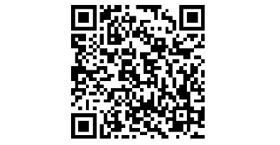
If the barcode scanner is connected to an XL400, XL600, or XL800, scan:
The barcode scanner will beep, and the XL scoreboard will show the text “Barcode Pass” for 5 seconds:

Print Barcodes
To learn how to create and print barcodes for your XL device, please refer to the Configure XL guide.

Need Help?
Please feel free to contact our technical support team:
- Email: Support@Vorne.com
- Call: +1.630.875.3600

Itasca, IL USA | +1.630.875.3600 | www.vorne.com

