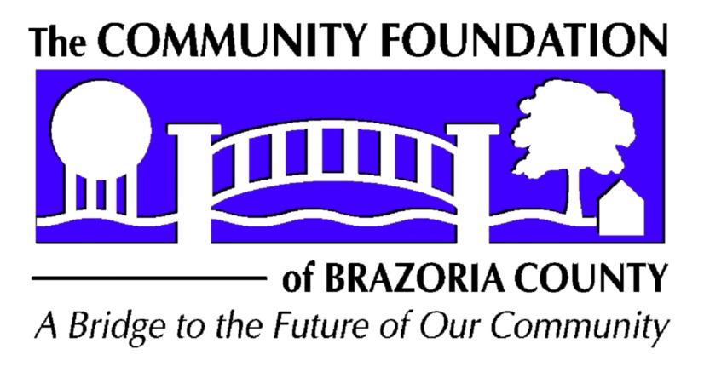

REQUEST FOR PROPOSAL

COMMUNITY FOUNDATION OF BRAZORIA COUNTY

LOWREY GRANT

2025 - GUIDELINES & APPLICATION

To be considered, requests must address Health and/or Human Service issues and must be for projects in Brazoria County.

What is the Community Foundation Lowrey grant Timeline?
Grant Applications must be received in the Community Foundation office or post marked by, March 15, 2025. An announcement of decisions will be made in May 2025.

Who is eligible to apply for Community Foundation Lowrey funding? To be eligible for a grant from the Lowrey Grant Fund, organizations must be located in and must serve Brazoria County, TX. Organizations must have 501(c) (3) nonprofit status. An organization may serve as a fiscal sponsor for a charitable organization that does not have 501(c) (3) tax-exempt status if a cooperative relationship between the two can be clearly demonstrated. The fiscal sponsor must be willing to administer the grant if awarded.

How do we apply for a Community Foundation Lowrey grant?
Grant Applications should be no more than 5 pages. Applications should be printed on 8½ x 11 paper and should be double spaced, with 1” margins on all sides. Type size should be 12 point. Attachments will not be counted in the 5 pages.

Please submit 1 hard copy and 1 electronic copy (by email).

How much can we request?
The Lowrey Grant fund may grant up to $20,000 per grant. If an organization received a grant in 2024 of $20,000, they may only request $10,000. Organizations may only receive 3 grants in a 5-year period.

What is the grant period? Generally, grants are made for one year.

What are the reporting requirements? By accepting the grant, you will be agreeing to submit a report and allow a site visit to show the use of the funds. For all grants over $10,000, the first report is due, and a site visit may take place on or before November 1, 2025. A final report is due, and a site visit may take place on or before March 1, 2026. For all other grants, a final report is due on or before March 1, 2026. Subsequent reports may be requested. The reports should consist of no more than 3 pages and contain an explanation of how the funds were/are being used, how the stated goals are being met and the impact on the community.

What types of projects will the Community Foundation Lowrey grant fund?
- Requests having a life-skills, health and education component
- Requests addressing county-wide problems
- Projects leading to self-sufficiency
- Projects having a collaborative component

What will Community Foundation Lowrey grants not fund?
- Religious Organizations for Sectarian Purposes
- Lobbying efforts
- Political Campaigns
- Profit-making Organizations
- Organizations utilizing Third Party Fundraisers
- Deficit financing
- Other endowments or foundations.
- Salary or ongoing operating expenses

What criteria will the Grant Committee use in evaluating a grant application?

1. Need and Purpose
1.1 Is the need for the proposed project/program clearly stated?
1.2 Is the purpose of the proposed project/program clear?
1.3 How will the proposed project/program help meet the need?
1.4 Who will be served by the project/program? Are specific target population identified?
1.5 Is the project/program a new or innovative way to address the identified need?

2. Project/Program Evaluation
2.1 Are the specific goals or outcomes of the project/program clearly defined?
2.2 Are there checkpoints along the way to monitor the project/program?
2.3 What will demonstrate “success” of the project/program?

3. Collaborations
3.1 Does the project/program effectively use community resources?
3.2 Have collaborative efforts been established with other organizations?

4. Sustainability
4.1 Is the project/program timeline realistic?
4.2 How will the proposed project/program be supported after the requested grant expires?

5. Budget
5.1 Is the proposed budget for the project\program realistic?
5.2 Have other funding sources been identified?

6. General Criteria
6.1 Is the budget added correctly, and does the budget detail match with the amount requested?
6.2 Is the application complete, or were there portions left unfinished? Has it been proofread?

Questions? Please contact: Debby Soltesz, Executive Director,
Community Foundation of Brazoria County
979-848-2628 email: cfbr@sbcglobal.net

All decisions are made by the Lowrey grant committee and affirmed by the CFBC Board of Directors.
The Lowrey grant committee reserves the right to reject any grant application and
to defer granting any or all of the current funds.

APPLICATION
Lowrey Community Service Grant

Deadline: March 15, 2025

Organization information (May be completed by hand)

Group/organization name
Mailing address
Contact person Phone number
Fax number E-mail address
Name of person completing application and title

Eligibility
□Tax-exempt charitable organization – IRS 501 (c)(3). Attach copy of IRS determination letter.
□ Affiliated with tax-exempt organization (like a church) or a government unit.
□Other – Please explain

Project/Program Information
Project/Program Title
Amount Requested $
Name of Project/Program Director
Contact information (if different than organization information)

Grant Narrative should include:
Primary Purpose of group/organization and any background information you would like to include (no more than 1 page)

Description of the Project/Program
1. Need and Purpose. Please explain the need your project/program addresses. What is the project/program’s purpose and how will it help meet the identified need. Please list the specific individuals or groups who will benefit from the project/program. (No more than 1 page.)

2. Project/Program Evaluation. What are the specific goals or outcomes you expect from this project/program? Are there checkpoints along the way? How will you know if you have been successful?

3. Collaborations. Describe your use of community resources and partnerships with other organizations.

4. Sustainability.
Project/Program Timeline: Start date End date
What is your plan for continuing the project/program after the grant funds expire?

5. Project/Program Budget Please provide a budget for the use of the funds that you are applying for.
- Describe how the grant funds will be used, with cost sharing by other funds if appropriate.
- Are you requesting or have you received funds for this project/ program from other sources? If yes, from whom and what amount have you requested and/or received?
- Will there be other income associated with the project/program?
- Be sure to clearly differentiate your requested budget for funding from Community Foundation Lowrey funds versus total funding for your project.

