**­­**

**FRA BRANCH 367 San Miguel, Zambales**

|  |
| --- |
|  |

**GENERAL MEMBERSHIP MEETING** held on 02 April 2025, was called to order at 10:00 AM. Present were: President Lee Vatter, Vice President Bob Price, Secretary Pat Winston, Treasurer David Johnson, and Shipmates John Corbin, Ken Zuelke, Steve Wilson, Bill Bay, Marty Jones, Jessie Sailors, David Seltzer, Pete Loveland, Steve Wilson. Visitors are Keith Porter, Frazer Galloway, and John from the “Greasy Plate Grill and Restaurant.”

**CONDUCTED OPENING CEREMONIES**

**MINUTES:**

* The minutes from the most recent GMM were posted and distributed. Pat Winston motioned to accept the 05 March 2025 GMM minutes, second by John Corbin. The 26 February BOD minutes were read by President Vatter. John Corbin motioned to accept the BOD minutes, seconded by Jesse Sailors. Both GMM and BOD minutes were approved unanimously.

**COMMUNICATIONS:**

* Secretary Winston reported FRA Branch 367 membership stands at 113. Welcome Thomas ‘TJ” Johnson (transferred Membership to Branch 367), and our newest FRA Member, Robert Adams.
* Communication was held between the 1st Branch 367 President (Scott Withrow) and the Present Branch President (Lee Vatter). Scott was kind enough to share San Miguel Origination and History since 1978. See the PDF attachment to read more & view pictures of the 1st Branch 367 members.
* Bob Price identified a FRA shot glass manufacturer. We hope to sell them at the 4-6 FRAlic’s.

**STANDING COMMITTEE REPORTS:**

* **Wall Ads:** Wall ad renewals are due April 2025. P14,500 has been collected. P1500 not paid. Pat Winston power washed all wall adds in preps for the April FRAlic’s.
* **Canteen & Building Maintenance:** If you see something that needs repairing at FRA San Miguel, notify President Vatter or John from the Greasy Plate Grill and Restaurant. Termite extermination will be conducted on 7 April.
* **Treasurer:** The Treasurer’s Report was read by David Johnson. Bill Bay motioned to accept the report, seconded by Jesse Sailors. Approved unanimously.

**UNFINISHED AND DEFERRED BUSINESS:**

* All US Branch 367 members have until May 4th to submit your vote to Secretary Pat Winston, to retain “San Miguel” or change our name to “Hayden Spalding Branch 367”. The final vote will take place at the 7 May GMM.
* President Vatter requested nominations for FRA Branch 367 officers for 2025-2026.
* Four fiberglass bar chairs have been repaired. There are now 12 additional chairs that require minor repairs after the April FRAlic’s (4 at a time). The remaining bill will be discussed at the 07 May GMM.
* Bob Price reported that enough FRAlic Raffle tickets have been sold to pay the Winners. There are plenty of tickets left. 1st Winner gets P50,000.
* Keith Porter, Cathy Anies-Campisi, and Mercy will hold a meeting after lunch today to discuss game plan for the 6 April Beauty Contest Beauty Contest.

**NEW BUSINESS:**

* John Corbin motioned to authorize P27,000 on 6 April FRAlic Beauty Contestants Winning Prizes, Jesse Sailors 2nd the motion. Approved Unanimously.

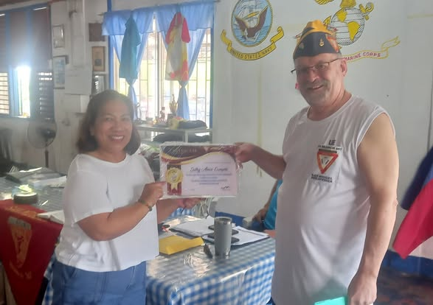

* Certificate of Appreciation presented to Catherine Anies-Campisi and Carmen M. Hendricks for their numerous contributions as former Unit 367 President and Ladies Support Group Leader in support of the FRA Branch 367 mission.

**GOOD OF THE ORDER:**

* President Lee Vatter: 1) Branch 367 members are encouraged to support other service organizations and represent the FRA. 2) Members are urged to do at least one good deed each year to improve our branch facility. 3) Encourage qualified persons to sign up or transfer membership to Branch 367. 4) Branch 367 has a set of golf clubs, crutches, and a wheelchair available to “LOAN” to members/family if the need arises.
* VFW Post 11447 Meeting at 10:00 AM, 2nd Wednesday of the month. MOC Meeting is at 2:00 PM, 1st Thursday of the month.
* American Legion Post 4 Meeting is at 7:00 PM on the 4th Monday of the month.
* Subic Bay RSL Sub Branch meets at Mangoes every Tuesday at 2:00 PM (1400). Any US Service Member can join the RSL.
* Special Forces Association Ch 46 (Angeles City) meets on the 2nd Saturday of the month at Garfields at 2:00 PM. FRA members can become a “Friend” of the SFA.

**UPCOMING EVENTS:**

**FRAlic's INFO:** Pay for FOOD with cash for the restaurant and Filipino food vendors. Pay for DRINKS with Tickets. Tickets are good for two weeks after the FRAlic’s.  Please do not bring alcohol onto the FRA San Miguel facility.

* 4 April FRAlic’s: Golf POC’s Scott Paul, Dave Karr. Lots of items to be raffled off after the Tournament.
* 5 April: Chili Cook-Off (POC is Pat Winston), Social Bingo starts at 1pm.
* 6 April: Beauty Contest POC’s are Cathy and Mercedes (DJ: Keith Porter). The Submarine Force 125th Birthday will be celebrated and the FRAlic Raffle Winners will also be drawn.
* "On Memorial Day, Branch 367's Pat Winston, alongside members of the VFW, MOC, and AL, will serve as representatives at Clark Cemetery, presenting wreaths for deceased veterans.

The next FRA 367 BOD meeting will be April 30. The next GMM will be 07 May. Both meetings will start at 10:00 AM.

**CONDUCTED CLOSING CEREMONIES:** The meeting adjourned at 10:54 AM.

Submitted by:                                                      Approved by:

Patrick Winston                                                  William “Lee” Vatter

Secretary                                                              President

FRA Branch 367                                                   FRA Branch 367