**Board of Directors Meeting 1000 AM, 30 October, 2024.** Present: President Lee Vatter, Vice President Bob Price, Secretary Pat Winston, Treasurer David Johnson, Shipmates, Bill Bay, Robert Krauth, visitor Fraser Galloway, and John Stanton from the “Greasy Plate Grill and Restaurant”.

FRA Branch 367 Membership is currently at 115

**ITEMS DISCUSSED**

* From the FRA NW Region Convention minutes (Sept 7th 2024). **NW Region Hospital, Welfare & Rehabilitation Committee**: PRPNW Burke reported into the record. **Awarded (Group V)** **1st  place to Branch 367 San Miguel, Philippines**.
* The San Miguel East Dirita School supplies donation from FRA Br 367 and LAFRA Unit 367 were delivered on October 9th.
* 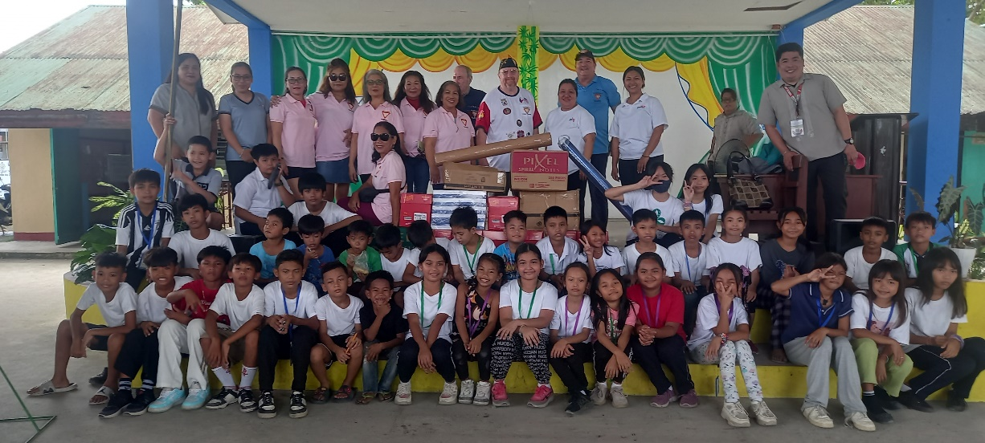
* Bill Bay reported two used AFN boxes ($50 each). They will be tested prior to the November 06 GMM.
* Nov 5th Election results can be monitored at the November 6th GMM.
* Help sell the remaining Thanksgiving Raffle Tickets. The drawing is after the Thanksgiving Pot luck & P50K is up for grabs. Winners are not required to be present.
* Order and start selling April 2025 FRAlic’s Raffle tickets in January.
* The December BOD meeting is 24 December at 10am, then we will make our annual gift giving to the San Marcelino Hospital immediately after.
* Jan GMM has been changed to January 3rd, 10am.

**UPCOMING EVENTS**

* November 28: Thanksgiving Pot Luck & Raffle
* La Union 3-Day Fundraiser & Chili Cook-Off: Travel on Nov 29, Chili Cook-Off & Beauty Contest on 30 Nov. Join Lee V, Pat W, Bob S, and their wives for this fun event.
* December 14 is Veterans Day: Try to attend at SBMA HELLSHIPS MEMORIAL, 11am.

The next GMM is 06 November, and the next BOD Meeting is 30 October. Both meetings start at 10 am. The group discussion ended at 1031 AM.

**Submitted**: **Approved:**

Patrick Winston, Lee Vatter,

Secretary, FRA Br 367 President , FRA Br 367